L.O: To have an understanding of adaptation and how particular organisms have adapted.
HOM: Thinking and Communicating with Clarity and Precision

Adaptation is a special characteristic that allows an organism to survive in a particular environment.
Adaptations may be:
physical appearance (morphology)
internal systems (physiology)
something an organism does (behaviour)
Use a dictionary to find the definition of ORGANISM:
________________________________________________________________________________________________________________________________________________________________________________________________________________________________________________________________________________________
Organisms that live in only one habitat or particular environment usually show many adaptations to that environment.
Organisms that live in a variety of different habitats usually do not have as many adaptations.
How many different types of habitat can you think of? Make a list.
________________________________________________________________________________________________________________________________________________________________________________________________________________________________________________________________________________________________________________________________________________

Did you come up with any of these?
Marine
- Arctic
- Desert: hot & cold
- Woodland / forest
- River / lake
- Tropical rainforest
- Grasslands
- Rocky
- Bogs / marshes
- Urban (gardens / parks) / farmland
Let’s think about the marine habitat:
- Seas and oceans
- Salty water
- Warm and cold water

Now let’s think about the shark that lives in a marine habitat.

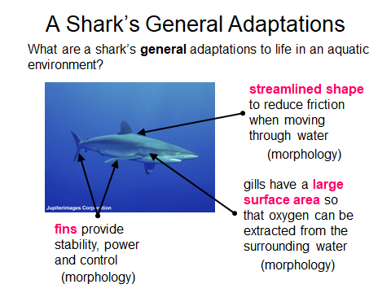
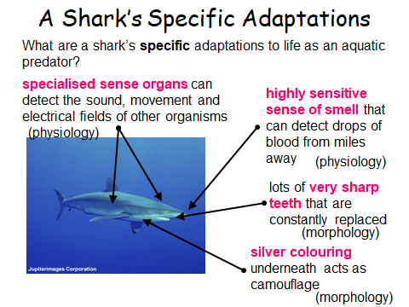

How do you think these animals adapted to live where they live?
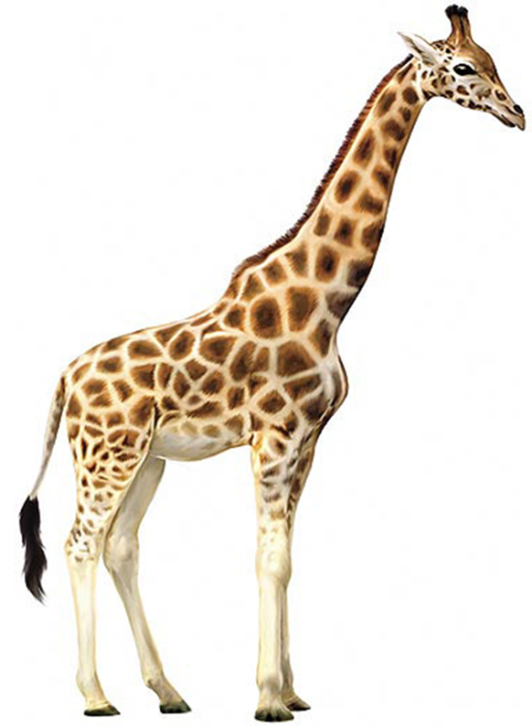 | 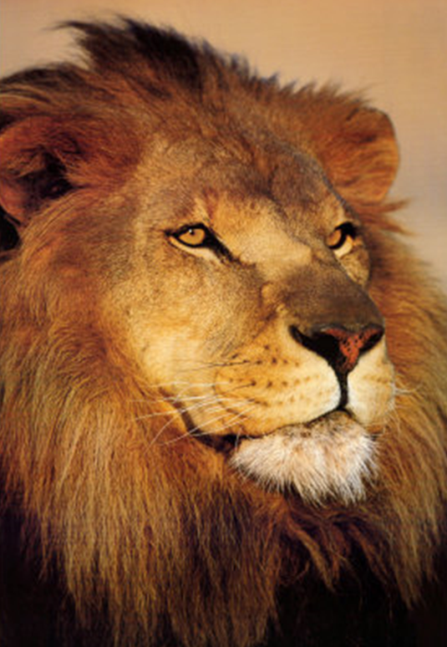
Look at the statements below which ones explain how the giraffe and lion have adapted to their habitat. Sort them and write them in the correct column. Some statements don’t fit.
It has a camouflaged coat of golden fur to help it hide in the African  savanna. | With no arms and legs it can slither  through grass and rocks silently to  creep up on its prey. | It has good eye sight for hunting at night. | It has a camouflaged coat with spots of  different sizes to help it hide in the African  savanna.
It has long curved teeth that can be used  to make deep wounds in its prey. | It has a fringed tail to keep flies away | It has a long neck to reach leaves in tall  acacia trees | It has powerful back legs to help it run  fast to catch its prey.
It has a long tough tongue to help it get  leaves off the trees | Its mane helps protect its neck when 2  male lions fight. | It has a long body that can wrap itself  around its prey and squeeze it to death. | It can stretch its jaws and skin so that it  can swallow animals much bigger than  itself
Choose an animal – draw it or stick in a picture, label its adaptations. Look back at the labelled images of the shark and how it has adapted to help you.

