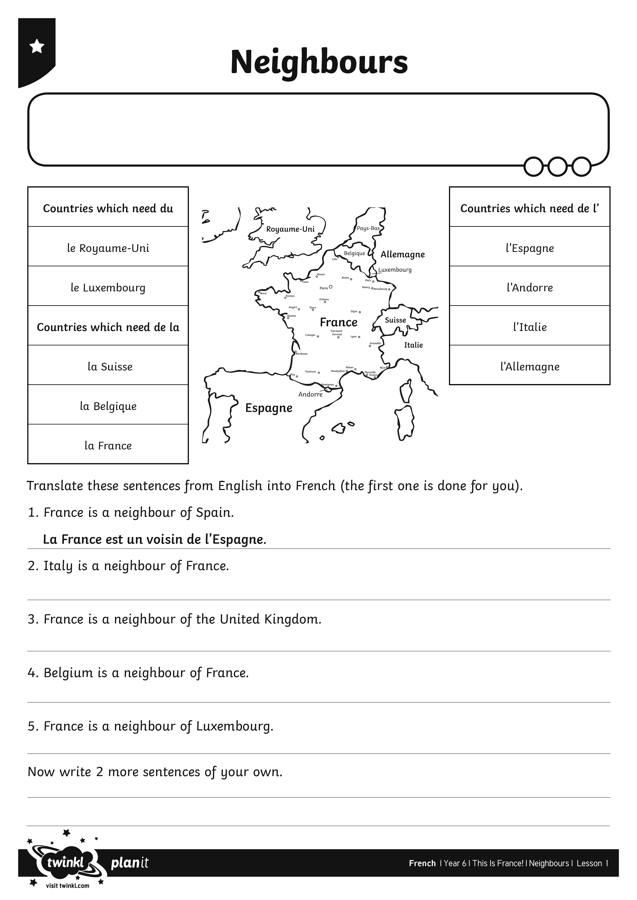
I can write a sentence using the correct form of ‘de’.
I can write a sentence using the correct form of ‘de’.

