Focus Question: Does it matter how you bring about God’s kingdom? Nelson Mandela’s dream for the world AT 1 (iii)
I am examining how Mandela lived a life of faith in God.
HOM- Responding with wonderment and awe.
WHITE HAT: What did Nelson Mandela do?
____________________________________________________________________________________________________________________________________________________________________________________________________________________________________________________________________
RED HAT: What does this show about what he thought about people?
_____________________________________________________________________________________________________________________________________________________________________________________________________________________________________________________________________________________________________________________________________
WHITE HAT: How did Mandela’s belief about people connect to what he believed about God?
____________________________________________________________________________________________________________________________________________________________________________________________________________________________________________________________________
He believed in the Gospel values and wanted everyone to be treated fairly.

Complete the double bubble map. You will be comparing Nelson Mandela and Pope Francis lived in faith of God. Try to recall what you learnt about Pope Francis in our last topic.

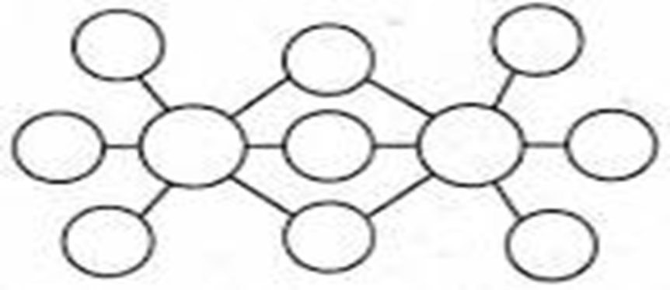

Using what you now know and the double bubble map complete the table:
Have the actions of Pope Francis & Nelson Mandela bought about God’s kingdom?
POPE FRANCIS | NELSON MANDELA
Answer: Yes/No and Why?
If building the kingdom is like planting a mustard seed, what ‘seeds’ did they plant?

Explain the similarities and differences from your double bubble map.
_______________________________________________________________________________________________________________________________________________________________________________________________________________________________________________________________________________________________________________________________________________________________________________________________________________________________________________________________________
Describe what you have included in your table- explain the actions of the men. Link these actions back to their faith.
_________________________________________________________________________________________________________________________________________________________________________________________________________________________________________________________________________________________________________________________________________________________________________________________________________________________________________________________________________________________________________________________________________________________________________________________________________

Nelson Mandela
Pope Francis

