LO: To understand why rationing was introduced and that it was a major change for the people of Britain.
HOM: Listening with Understanding and Empathy
What do you already know about rationing?
RATIONING
WATCH THESE CLIPS:
https://www.youtube.com/watch?v=gb9U9Qq_T0Q
https://www.bbc.co.uk/teach/class-clips-video/history-ks2-a-soldiers-tale/zhr9jhv
https://www.youtube.com/watch?v=-AI_4qCnh3Q

Why do you think rationing had to take place?
________________________________________________________________________________________________________________________________________________________________________________________________________________________________________________________________________________________________________________________________________________________________________________
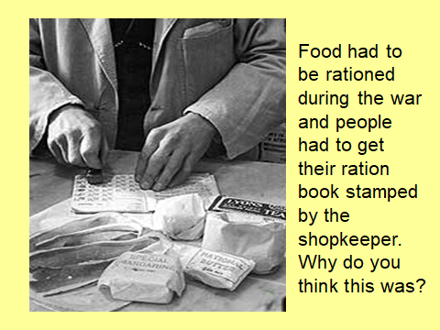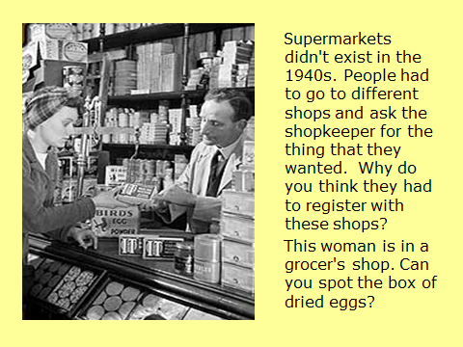

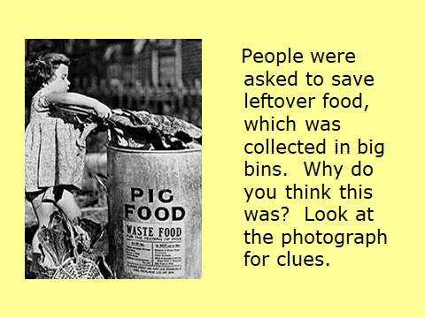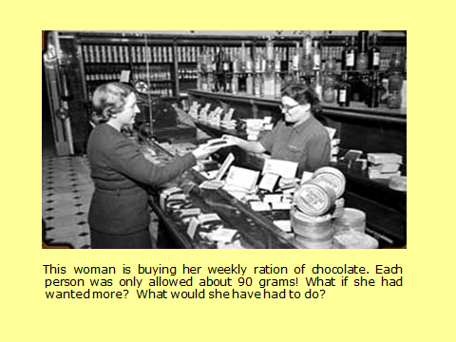
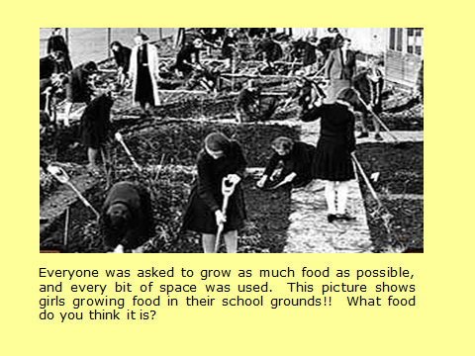

LOOK AT THESE IMAGES OF RATIONING TABLES:

You are going to create a week’s worth of meals for a family of 4. You will need to keep a tally of how much of your food you have used so that you don’t use too much.
What tactics will you use to ensure you get the best from your food?
____________________________________________________________________________________________________________________________________________________________________________________________________________________________________________________________________________________
Will people be eating left-overs? Why?
____________________________________________________________________________________________________________________________________________________________________________________________________________________________________________________________________________________
Do people have to eat less than they usually would? Why?
____________________________________________________________________________________________________________________________________________________________________________________________________________________________________________________________________________________

Look closely at the table below:
Rations for a family of 4

Butter – 200g | Bacon – 400g | Margarine – 400g
Sugar – 900g | Meat – 500g | Milk – 8 pints (2200ml)
Cheese - 200g | 4 fresh eggs | Tea – 200g
Jam - 225g | Dried eggs – 400g | Sweets – 350g

On the next page you will need to complete your meal plan for a family of 4. Remember to look at your rationing table, keep to quantities stated on the table.

 | Monday | Tuesday | Wednesday | Thursday | Friday | Saturday | Sunday
Breakfast

Lunch

Dinner
Supper

