Focus Question: Does it matter how you bring about God’s kingdom? Nelson Mandela’s dream for the world AT 1 (iii)
L.O To recognise and understand the 7 Principles of Catholic Social Teaching.
HOM- Remaining open to continuous learning.

The 7 principles of Catholic Social Teaching have been created by the church to explain how Catholics should respond to situations of INJUSTICE!
Pope Francis and Nelson Mandela are two men who have acted against situations of INJUSTICE.

The Catholic Church is also against situations of injustice and has created 7 STATEMENTS to show how we as Catholics should respond to situations of injustice.

Over the past 100 years, the Church has developed teachings that set out a vision for how the Christians and the Church should respond to situations of injustice. These teaching may be summarised in the following statements. The language used to express these principles is quite formal or churchy, but they express important truths about what Christians believe about being human. In many ways, the first principle establishes the reason for the other 6!
WHITE HAT: What do you think are the 7 Principles of Catholic Social Teaching?
_________________________________________________________________________________________________________________________________________________________________________________________________________________________________________________________________________________________________________________________________________________________________________________________________________________________________________________________________________________________________________________________________________________________________________________________________________

SUMMARY of THE SEVEN PRINCIPLES OF CATHOLIC SOCIAL TEACHING
Over the past 100 years, the Church has developed teachings that set out a vision for how the Christians and the Church should respond to situations of injustice. These teaching may be summarised in the following statements. The language used to express these principles is quite formal or churchy, but they express important truths about what Christians believe about being human. In many ways, the first principle establishes the reason for the other 6!
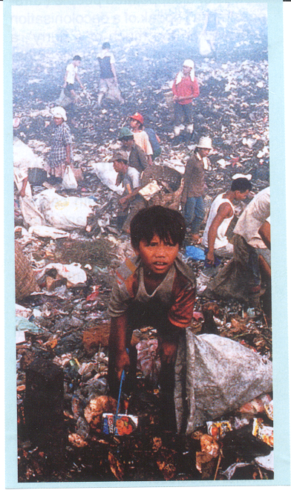
- The Life and Dignity of the Person
Every person is made in the image and likeness of God. Belief in the personal dignity of humans means that people should never be treated as objects to be used to ‘get what you want’. All life is precious; that is why the Church believes in an ‘ethic of life’ that opposes the taking or destruction of life.
- The Rights and Responsibilities of the Person
Every person has a basic dignity that includes rights and responsibilities. Some of these rights are the right to life, to a worthy standard of living, to freedom, to raise a family, to education, to work, and to worship according to one’s beliefs and conscience. The rights are equal for men and women.
- The Call to Family, Community and to Participation
Families are precious and need to be supported. It is where we learn our values and how to interact with society. We are called to live in community. People have a right to actively participate in the decisions that affect their lives. It means acting in responsible ways to build up the whole community.
- The Dignity of Work and the Rights of Workers
The right to work is an expression of human dignity. Work enhances self-esteem and enables individuals to live fully human lives. The Church supports workers in their struggle for just wages and more equitable working conditions.
- The Option for the Poor and Vulnerable
Jesus made the poor the centre of his ministry. Christians are called to reach out to those who are poor, marginalised or the victims of injustice. Serving the poor is matched by working to question situations of injustice and to eek to change the social and economic structures that deny people their dignity and rights.
- Solidarity
Solidarity helps us to treat others not as ‘others’ but as our neighbours. Solidarity is not a vague feeling of concern for others but a determination to work for the common good. It is the realisation that we all depend on each other. Love of God and love of neighbour are central to the Christian life and in building up the Kingdom of God.
- The Universal Destination of Created Goods
The goods of the earth are meant for all. It is the Church’s teaching that the right to ownership or private property has social obligations. Across the world this principle has asked people to think about their use of resources (the earth and wealth) and to seek justice for those taken from their land. Complete the table with the information you have learnt.

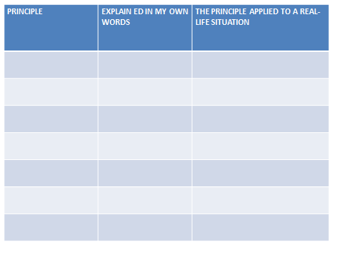

OO

DESIGN A POSTER FOR ONE OF THE PRINCIPLES

