LO: To answer the question: ‘What was the blackout?’
HOM: Thinking Flexibly
Today you are going to use picture evidence to find out as much about the blackout as possible.
What do you already know about the blackout in World War II?
__________________________________________________________________________________________________________________________________________________________________________________________________________________________________________________________________________________________________________________________________________________________________
On the next few pages you will see images linked to the blackout. What specifics can you find out about the black outs from them? Make notes
NOTES:
______________________________________________________________________________________________________________________________________________________________________________________________________________________________________________________________________________________________________________________________________________________________________________________________________________________________________________________________________________________________________________________________________________________________________________________________________________________________________________________________________________________________________________________________________________________________________________________________________________________________________________________________________________________________________________________________________________________________________________________________________________________________________________________________________________________________________
Picture evidence:
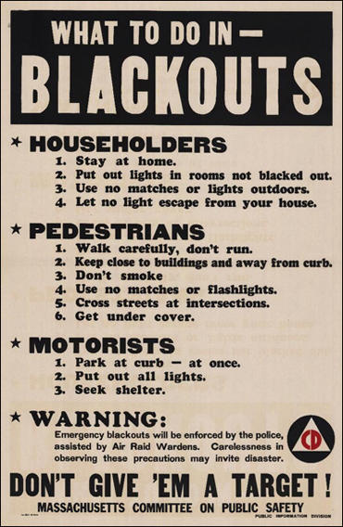

You may want to do some research of your own. Explain what you have found out about blackouts.
Answer the question : ‘What was the blackout?’
________________________________________________________________________________________________________________________________________________________________________________________________________________________________________________________________________________________________________________________________________________________________________________________________________________________________________________________________________________________________________________________________________________________________________________________________________________________________________________________________________________________________________________________________________________________________________________________________________________________________________________________________________________________________________________________________________________________________________________________________________________________________________________________________________________________________________________________________________________________________________________________________________________________________________________________________________________________________________________________________________________________________________________________________________________________________________________________________________________________________________________________________________________________________________________________________________________________________________________________________________________________________________________________________________________________________________________________________________________________________________________________________________________________________________________________________________________________________
WHAT WAS THE BLACK OUT?
http://www.primaryhomeworkhelp.co.uk/war/blackout.htm

