LO: To show an understanding of how people protecting themselves during the Blitz
HOM: Thinking and communicating with clarity and precision.
Reminder of what we know about the blitz and blackouts in World War II.
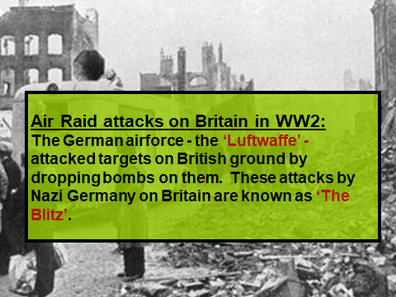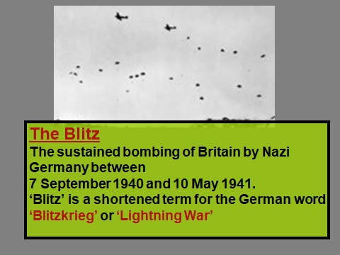

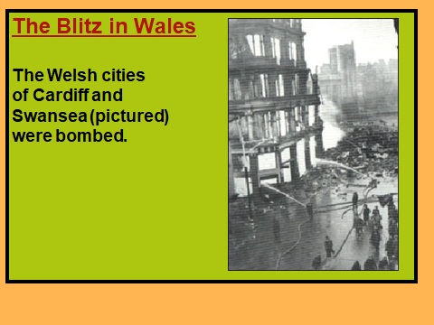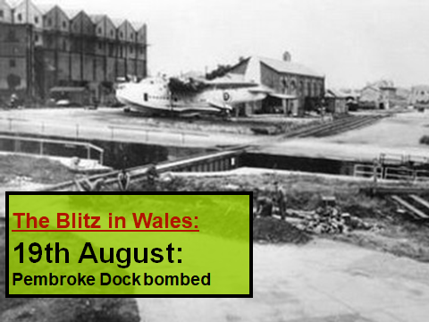
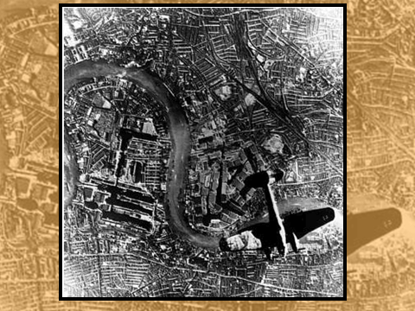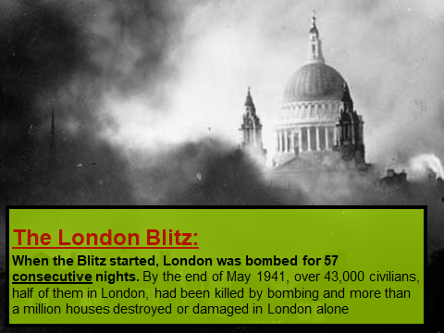

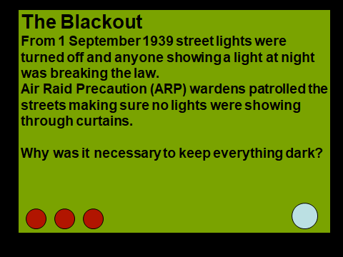
_______________________________________________________________________________________________________________________________________________________________________________________________________________
The blackout was one way of protecting the citizens of Britain. What might have been another?
____________________________________________________________________________________________________________________________________________________________
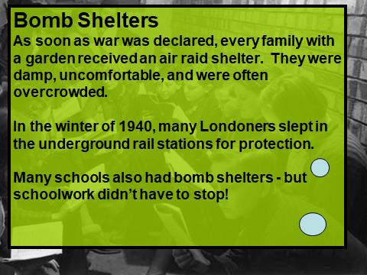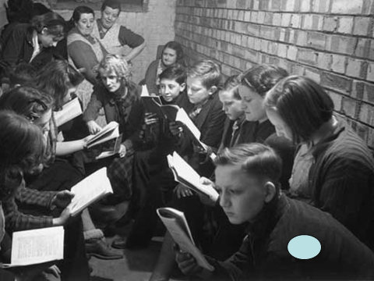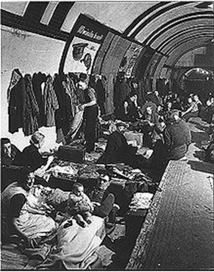

How might people have been able to protect themselves within their home?
____________________________________________________________________________________________________________________________________________________________________________________________________________________________________________________________________________________
Air raid shelters were also known as bomb shelters and were created to protect people during bomb attacks from the enemy air craft.
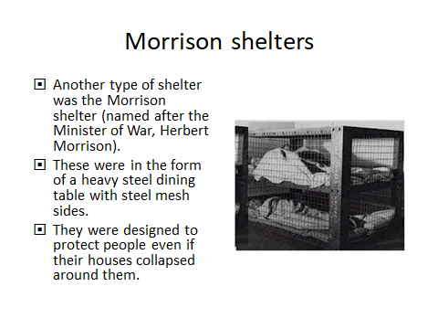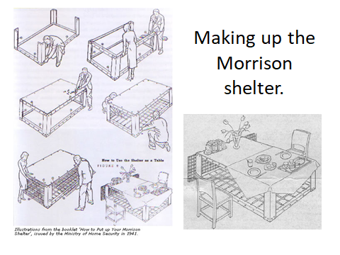

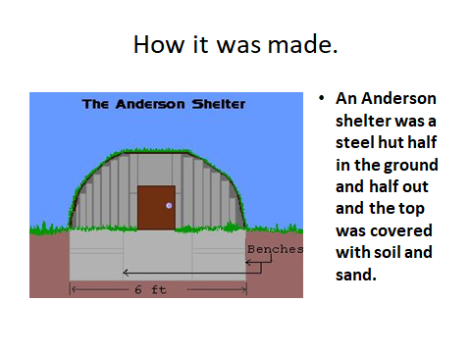
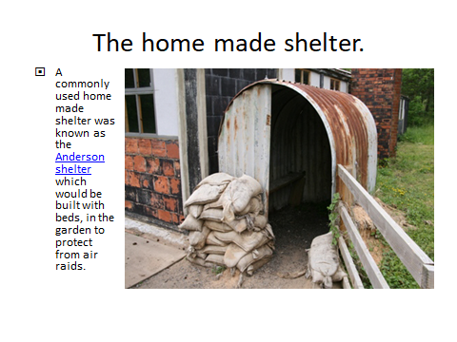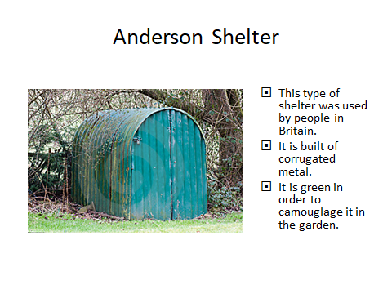

On the next two pages there is information about two types of shelters – The Anderson and The Morrison. You will need to read the information and create a fact file for each. You will need to design and produce your fact file on the blank pages provided. You can also do your own research.

Anderson Shelter Facts
Here are some facts about Anderson Shelters, popular air raid shelter used during the Blitz.
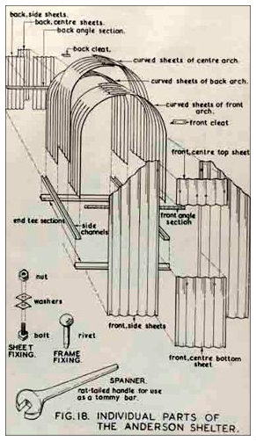
- The Anderson shelter was designed in 1938.
- It was named after Sir John Anderson, the man responsible for preparing Britain to withstand German air raids.
- Anderson shelters were designed for 6 people.
- The construction of the shelter was reasonably simple. The main part of the shelter was formed from six corrugated steel panels. Flat corrugated steel panels were bolted on to form the sides and end panels (one of which contained the door).
- The shelters measured 1.4m wide, 2m long and 1.8m tall. They were quite cramped and someone taller than 6ft would not have been able to stand up in one.
- Once constructed, the Anderson shelters were buried over 1 meter in the ground and then they were covered over with a thick layer of soil and turf.
- Anderson shelters were free to those with an annual income of less than £250. For those who didn’t fall into this category, the price was £7.
- Approximately 3.5 million Anderson shelters were built either before the war had started or during the conflict.
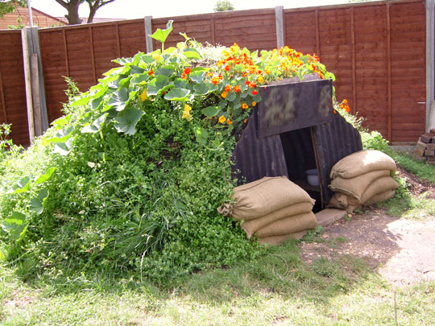
- Anderson shelters were very effective at saving lives and preventing major injuries during air raids, but they were really cold during the winter months. To try to prevent people going back to their warm houses at night when the weather got colder, the Government issued some guidelines about how to make the Anderson shelters more comfortable. They also developed the Morrison shelter which could be used indoors.
- Many Anderson shelters have survived to this day. Lots were dug up and used as garden sheds.
- Families were provided with the materials and were expected to construct the Anderson shelters from a set of instructions.

Morrison Shelter Facts
Here are some facts about Morrison shelters, or, to use it’s official name, the ‘Table (Morrison) Indoor Shelter’.
- The Morrison shelter was designed by John Baker and named after the Minister of Home Security, Herbert Morrison.
- The shelters came in kits which could be assembled (bolted together) in the home.
- Morrison shelters were 2 metres in length, 1.2 metres in width and 75 cm tall. It was designed to be slept under at night and used as a table for the rest of the time.
- The shelter had over 350 parts, but mainly consisted of a steel top (like a table top) and wire mesh sides (one of which could be lifted open and acted as the door).
- The Morrison shelter was not designed to survive a direct hit from a bomb, but it was really effective at protecting people from the effects of a bomb blast.
- Over 500,000 Morrison shelters were made and they were given free of charge to families who earned less than £350 a year.

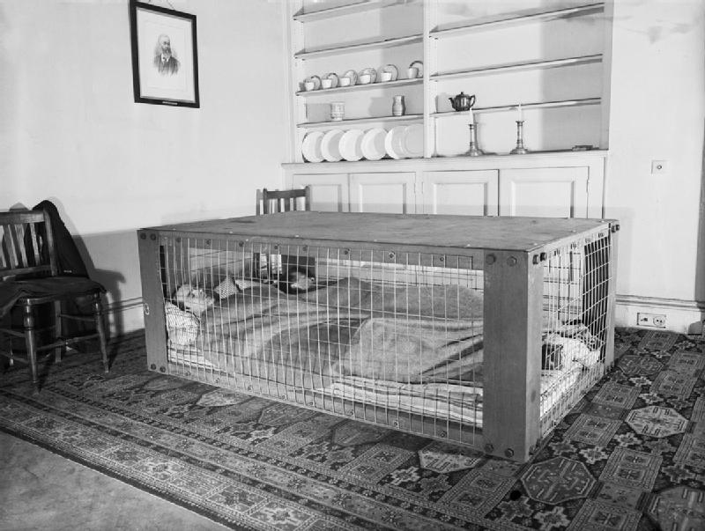
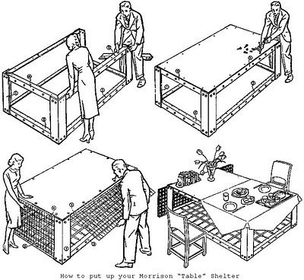

Fact file 1

Fact file 2

