Before we start today, think about what the artists you learnt about last week. Look at the paintings below. THINK about the questions you are being asked.
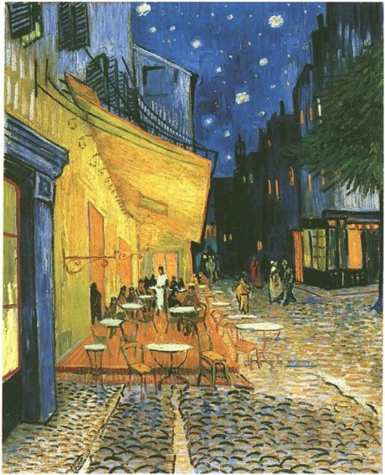  Is this by William Morris? If yes, why do you think this?  If no, can you guess the artist and explain why you think this?  A | 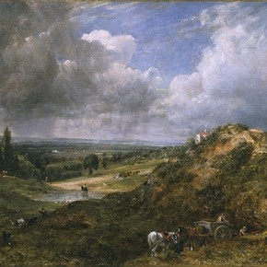  Is this by William Morris? If yes, why do you think this?  If no, can you guess the artist and explain why you think this?  B | 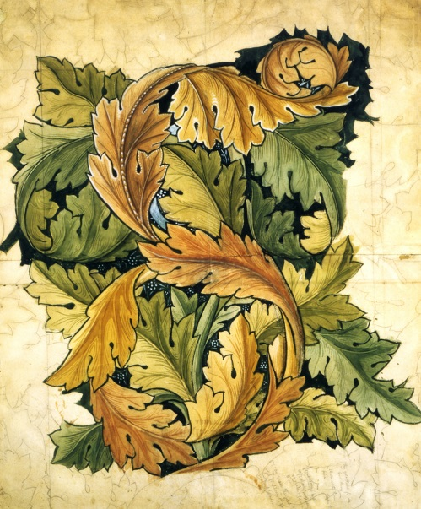  Is this by William Morris? If yes, why do you think this?  If no, can you guess the artist and explain why you think this?  C
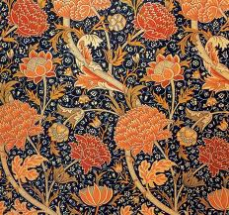  Is this by William Morris? If yes, why do you think this?  If no, can you guess the artist and explain why you think this?  D | 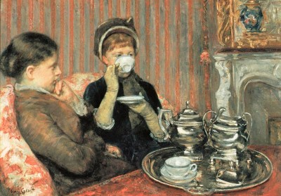  Is this by William Morris? If yes, why do you think this?  If no, can you guess the artist and explain why you think this?  E | 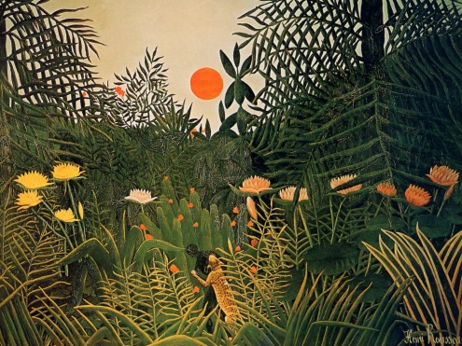  Is this by William Morris? If yes, why do you think this?  If no, can you guess the artist and explain why you think this?  F
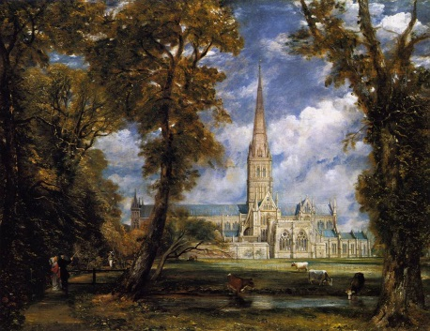  Is this by William Morris? If yes, why do you think this?  If no, can you guess the artist and explain why you think this?  G | Is this by William Morris? If yes, why do you think this?  If no, can you guess the artist and explain why you think this?  H | 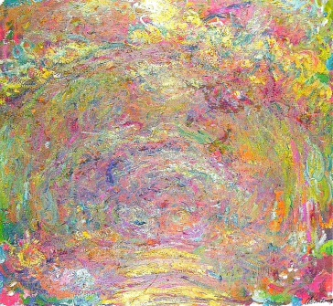  Is this by William Morris? If yes, why do you think this?  If no, can you guess the artist and explain why you think this?  I

Now you have studied the images, answer the questions in the table below.
painting | Is this by William Morris? If yes, why do you think this? | If no, can you guess the artist and explain why you think this?
A
B
C
D
E
F
G
H
I

Today we are thinking about experiment with ways in which surface detail can be added to drawings and applying simple use of pattern and texture in a drawing.
HOM: Creating, imagining innovating
What can you remember about William Morris’ art?
______________________________________________________________________________________________________________________________________________________________________________________________________________________________________________________
We are going to use Morris as a starting point for designing our own print to make a sample of wallpaper. Watch the video clip
https://www.youtube.com/watch?v=fAy_imtiqVM
Pick one of the patterns on the next page; they have been split into 4 parts. Using the grid on page 6 of the booklet, try sketching Morris’ pattern. Look for symmetry. Remember to lightly sketch in pencil first, then add colour if you wish.

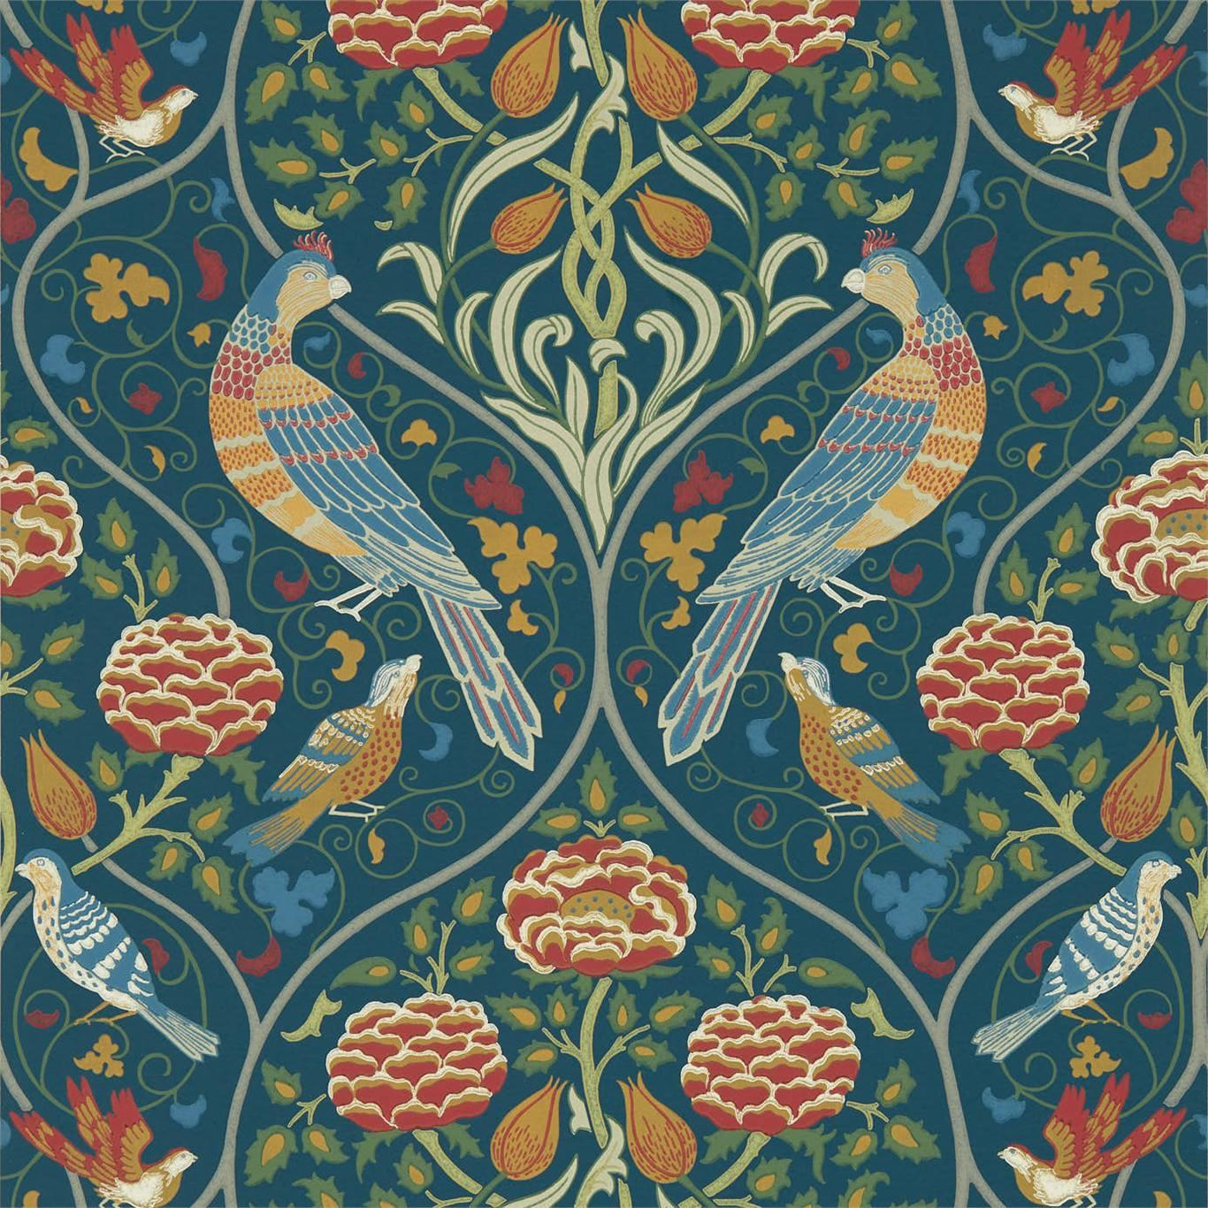
Do you notice the symmetry?

