To explore the role and impact of William Morris.
HOM: Remaining Open to Continuous Learning
Use the information below on Morris’ life and look at his key work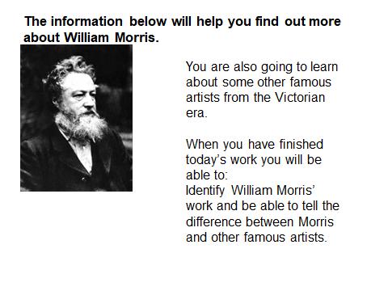
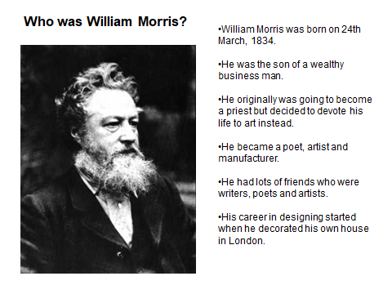

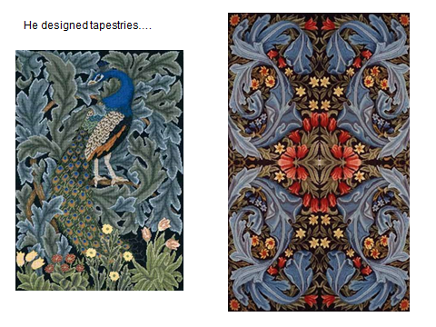
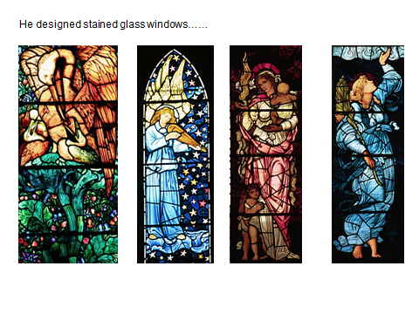

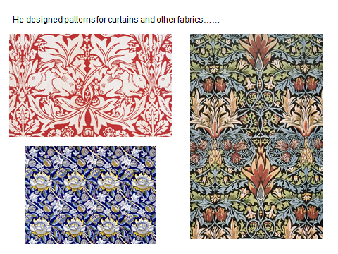

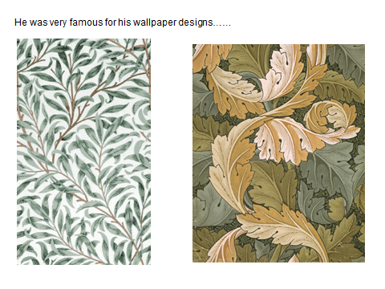

What do you think is special about Morris’ individual style?
__________________________________________________________________________________________________________________________________________________________________________________________________________________________________________________________________________________________________________________________________________________________________________________________________________________________
Can you spot any themes in his work?
__________________________________________________________________________________________________________________________________________________________________________________________________________________________________________________________________________________________________________________________________________________________________________________________________________________________

On the next page you will find information on William Morris and some other artists. Read in the formation:

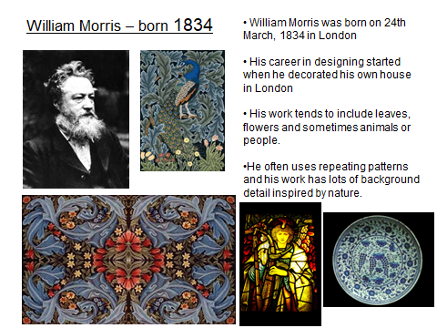
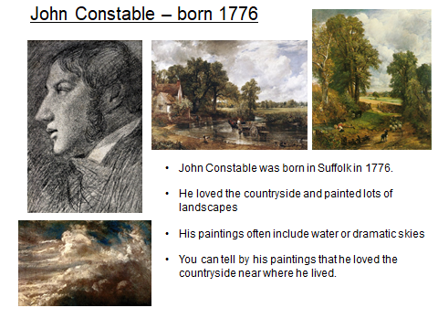
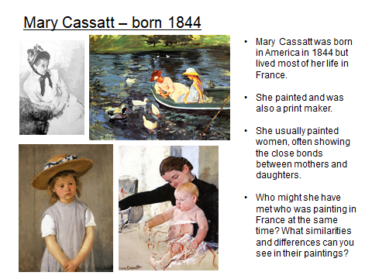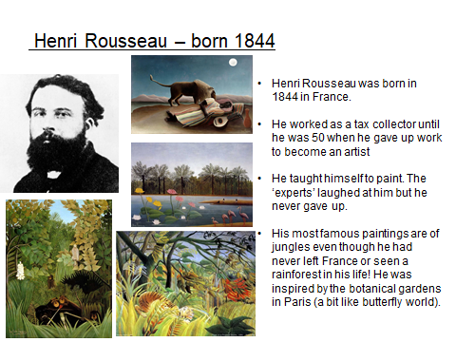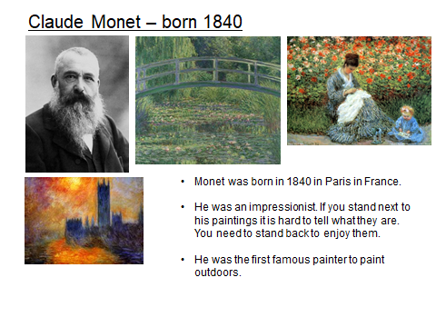

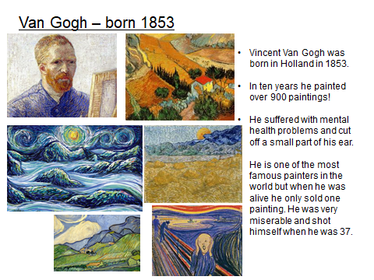

Turn this page landscape – create a time line of these artists and their work.
1900
1750

What do you notice about the painting style over the 100 years? Does it become more modern? Has the use of colour changed? Techniques?
____________________________________________________________________________________________________________________________________________________________________________________________________________________________________________________________________________________________________________________________________________________________________________________________________________________________________________________________________________________________________________

