To investigate schooling in the Victorian period.
HOM: Gathering Data through all the senses

Were children always expected to attend school? What are your thoughts?

Many children in early Victorian children didn’t go to school at all and more than half of children grew up unable to read or write.
What may have caused children not to go to school?
________________________________________________________________________________________________________________________________________________________________________________________________________________________________________________________________________________________________________________________________________
In your answer you may have thought about:
Disease, poverty, inequality and gender.

Read the information on the next page. You could also visit https://victorianchildren.org/victorian-schools/
https://primaryfacts.com/9/facts-about-victorian-schools-and-classrooms/
clips to watch:

Victorian school children

Look at what the children are wearing is it similar or different to what you wear to school?
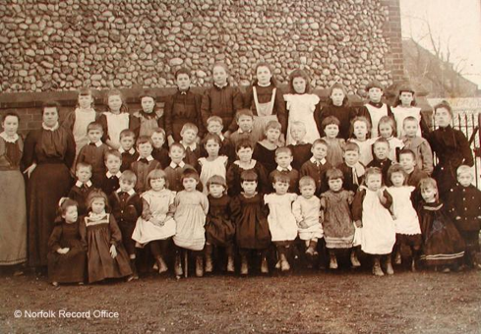

Children had to pay to go to school. If they didn’t bring the money they were turned away.
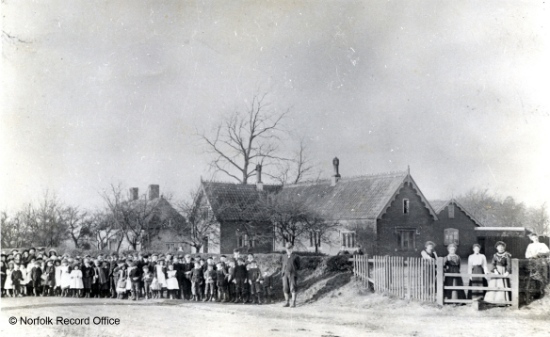

Who went to school in Victorian times?
In early Victorian England, most children never went to school at all and grew up unable to read or write. Instead they were sent out to work to earn money for their families. Only children whose families had lots of money went to school.
Rich Children
Children from rich families were taught at home by a governess until they were 10 years old. Once a boy turned ten, he went away to Public schools like Eton or Harrow. There were very few schools available for girls, however, until near the end of the Victorian time. Wealthy girls were mostly educated at home.
Where did poor children go to school?
Poor children went to free charity schools or 'Dame' schools (so called because they were run by women) for young children. They also went to Sunday Schools which were run by churches. There they learnt bible stories and were taught to read a little.
What did the children learn?
Typical lessons at school included the three Rs - Reading, WRiting and, ARithmetic and Dictation.
In addition the children were taught once a week geography, history and singing. Girls were taught how to sew.
Schools did not teach music or PE in the way that schools do now. Children sometimes did 'drill' in the classroom. Drill was a series of exercises that were done by the side of a desk.
What was it like to go to school in Victorian times?
- There could be as many as 70 or 80 pupils in one class, especially in cities.
- The teachers were very strict.
- Children were often taught by reading and copying things down, or chanting things till they were perfect.
What was a Victorian School day like?
The day usually began with prayers and religious instruction. Morning lessons ran from 9a.m. to 12p.m. Children often went home for a meal, then returned for afternoon classes from 2p.m. to 5p.m.
School Teacher
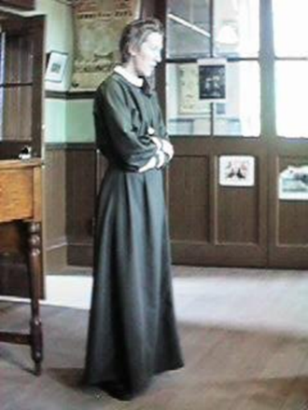
Children were often scared of their teachers because they were very strict. Children as young as thirteen helped the teacher to control the class. These “pupil teachers” scribbled notes for their lessons in books .They received certificates which helped them qualify as teachers when they were older. In schools before 1850 you might see a single teacher instructing a class of over 100 children with help of pupils called “monitors”. The head teacher quickly taught these monitors, some of them as young as nine, who then tried to teach their schoolmates. Salaries were low, and there were more women teaching than men. The pale, lined faces of older teachers told a story. Some taught only because they were too ill to do other jobs. The poor conditions in schools simply made their health even worse. Sometimes, teachers were attacked by angry parents. They shouted that their children should be at work earning money, not wasting time at school. Teachers in rough areas had to learn to box!
School Pupils
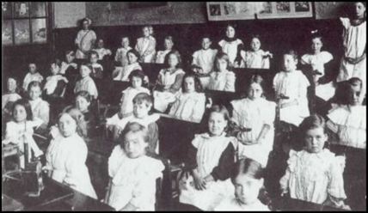
After 1870, all children from five to thirteen had to attend school by law. In winter in the countryside, many children faced a teeth chattering walk to school of several miles. A large number didn’t turn up. Lessons lasted from 9am to 5pm, with a two hour lunch break. Because classes were so large, pupils all had to do the same thing at the same time. The teacher barked a command, and the children all opened their books. At the second command they began copying sentences from the blackboard. When pupils found their work boring, teachers found their pupils difficult to control.

There were different types of school:
1) The governess – richer children may have a governess teach them within the comfort of their own home
2) Public schools – boys when they reached 12 would go to a school like Eton or Rugby. Girls would then be expected to stay at home
3) Sunday schools – run by churches for children from different backgrounds
4) Dame school – young poor children would be educated in a room of a woman’s house
5) Day schools – for older children
6) Schools run by churches or charities
7) Ragged schools – for orphans or very poor children

Can you identify similarities and differences between education today and in the Victorian times?
Similarities | Differences

Look at this Victorian timeline and they key dates concerning the education of children:

Use the timeline of reforms and do some research to answer this question:
Imagine you are going to feedback to your class write a speech discussing the likely impact of these reforms for children and their parents.
________________________________________________________________________________________________________________________________________________________________________________________________________________________________________________________________________________________________________________________________________________________________________________________________________________________________________________________________________________________________________________________________________________________________________________________________________________________________________________________________________________________________________________________________________________________________________________________________________________________________________________________________________________________________________________________________________________________________________________________________________________________________________________________________________________________________________________________________________________________________________________________________________________________________________________________________________________________________________________________________________________________________________________________________________________________________________________________________________________________________________________________________________________________________________________________________________________________________________________________________________________________________________________________________________________________________________________________________________________________________________________________________________________________________________________________________________________________________________________________________________________________________________________________________________________________________________________________________________________________________________________________________________________________________________________________________________________________________________________________________________________________________________________________________________________________________________________________________________________________________________________________________________________________________________________________________________________________________________________________________________________________________________________________________________________________________________________________________________________________________________________________________________________________________________________________________________________________________________________________________________________________________________________________________________________________________________________________________________________________________________________________________________________________________________________________________________________________________________________________________________________________________________________________________________________________________________________________________________________________________________________________________________________________________________________________________________________________________________________________________________________________________________________________________________________________

