L.O To identify the key ideas of the theory of evolution.
HOM: Remaining Open to Continuous Learning
READ this information before completing the tasks at the end.
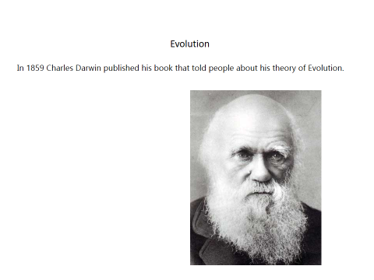
His research showed that all life on Earth:
People
Ants
Whales
Camels
Monkeys
Birds
All came from the same animals.

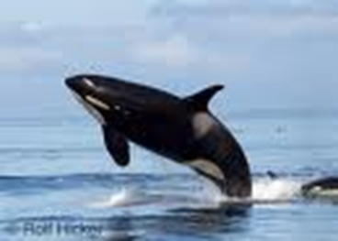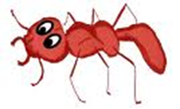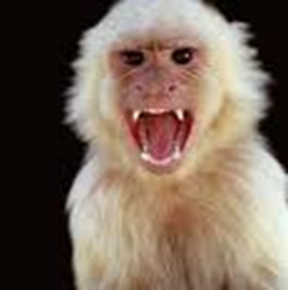

This caused disagreements with the Church. They believed that God created all life on Earth.
The very first life on Earth looked like this!
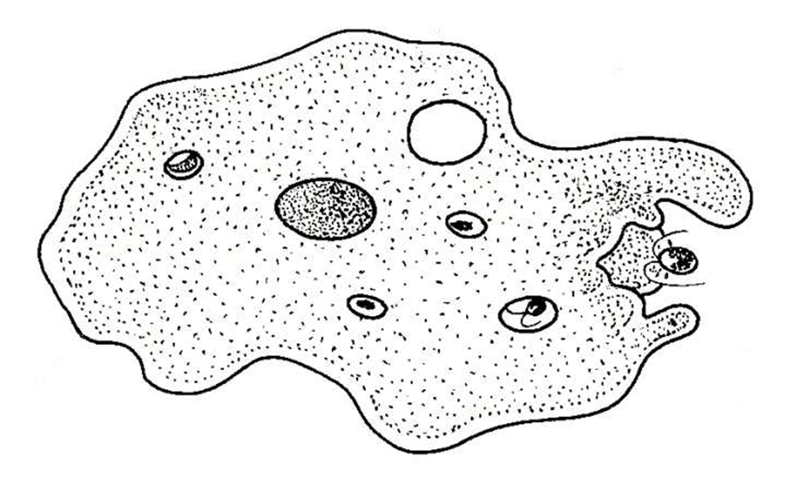

This is cell – It’s alive but it doesn’t look like it does it?

Over time the cells changed. New ones were born which were different to its parents and better at finding food!
Because they were better at finding food they grew stronger and reproduced – they had more babies!
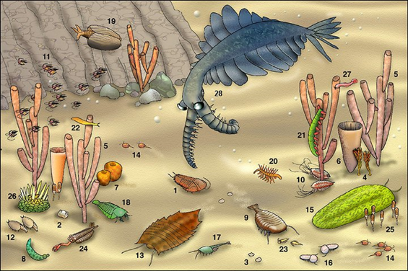
As more and more were born there were little differences between them – just like you and your friends are different.

Some were good at catching other animals to eat and they grew stronger.

Some were good at scavenging for food and they grew stronger.
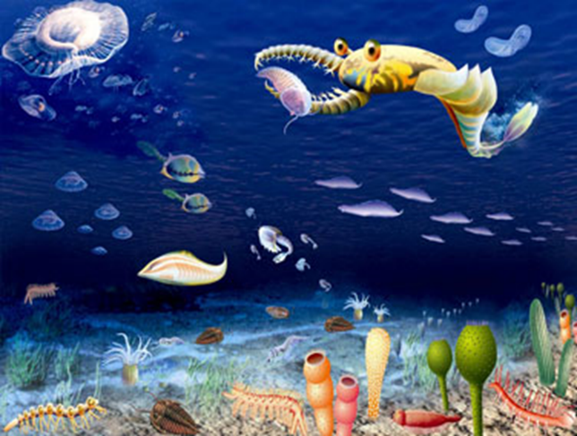
Some had shells or weapons to stop being eaten. They grew stronger!
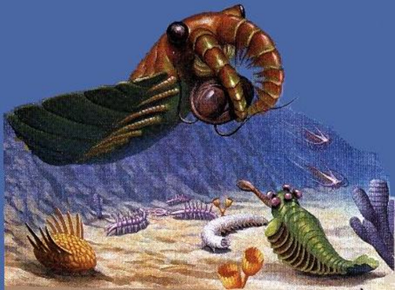
The more they changed and were successful the more they reproduced.
After millions and millions of years there were lots of different animals living in lots of different places in the world.
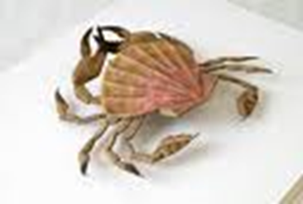
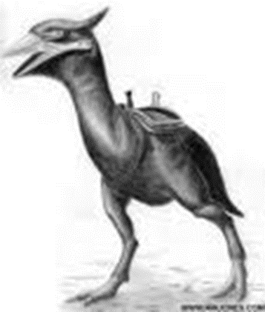 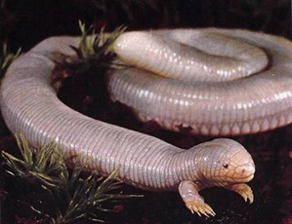
Some lived in the sea because they had features that made that a good environment to live in.
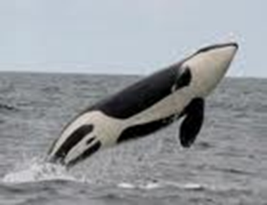
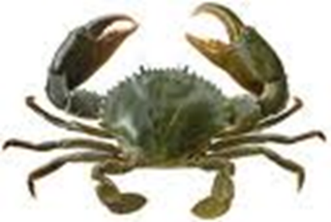

Some lived in the snow because they had features that made it easier to live there.
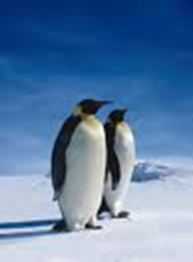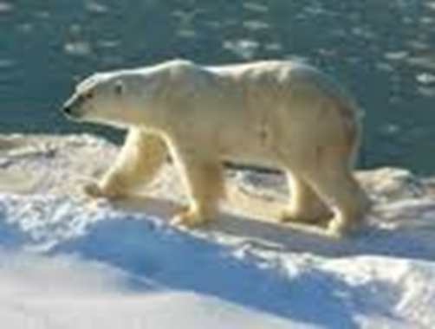
Some lived in the air because they had features that made it a good environment to live in.
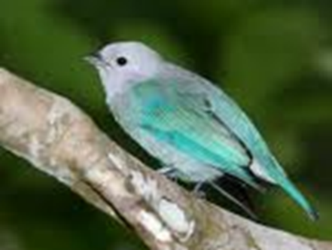
Some lived in the desert because they had features that made that a good environment to live in.
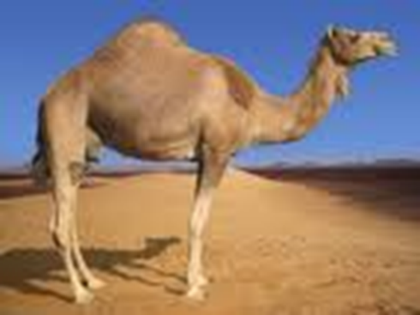
They all came from the first type of life on Earth even though they looked so different!
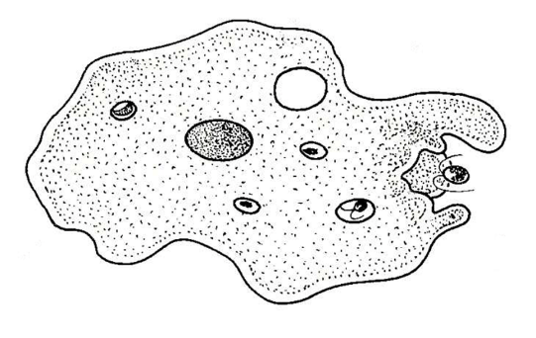
Today there are thousands of different animals in the world and they look so different BUT scientists still believe we came from the first type of life on Earth.
Scientists think we evolved from the same animals as monkeys did. They think that millions of years ago there were two animals.

They think that millions of years ago there were two animals.
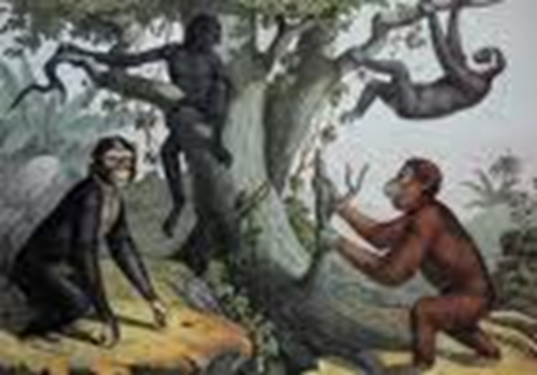

One went to live in the trees (his environment) where he lived on the fruits that grew there. He had to be good at climbing and had a tail to help him.
The other lived on the ground (a different environment). He needed to walk on his legs and didn’t need a tail. He also couldn’t see danger from up in the trees so he needed to talk to his family to warn them.

Recap – how does evolution work?
Each time a new one is born it was a little bit different to its parents, just like you are!
- It might be faster
- It might be more intelligent
- It might be better protected
These changes make the animal more likely to survive and reproduce. The ‘better’ animals would have more babies and the ones that weren’t as fast, clever or sneaky would die out.

Think about the animals you learnt about last week and how they adapted to their environments.
Design a creature which has evolved to suit its environment. Label it to show how it has evolved and adapted. Turn your page landscape.

In what environment does you animal live?

