Focus Question: How do people live the Spirit of Pentecost? AT 1 (iii)
To revise the story of Pentecost and retell it from the viewpoint of a disciple.
HOM- Thinking and communicating with clarity and precision.
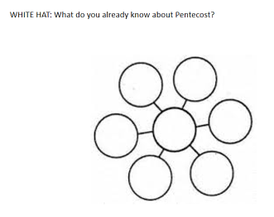
After the resurrection, Jesus appeared to his disciples commissioning them to go into the world and baptise people. (Matthew 28:16-29) Matthew’s gospel then ends. In Luke’s Gospel (Lk 24:50-53) though Jesus blesses the disciples and returns to God in spirit form. We celebrate this event in the feast of the ascension, on May 21, 2020. Luke also tells us that Jesus would send the Holy Spirit to the disciples to be their support and guide (Lk 24:49) – their advocate (one who speaks on their behalf.) This happens in Acts 2:1-4 when Luke tells us the spirit came during the Jewish festival of Shavuot or Pentecost.
https://www.youtube.com/watch?v=7ugvJSYnXXI
Watch this re -enactment of Shavuot in the times of the Temple. This re -enactment was done by the Temple Institute in Jerusalem. They are hopefully that one day the Temple will be rebuilt in Jerusalem and that Jews will be able to worship there as they did during the time of Jesus.
Remind pupils that the only account of Pentecost in the Bible is found in Acts of the Apostles and written by Luke; Matthew does not have a story of the coming of the Holy Spirit. Luke records that while the disciples were in Jerusalem for Shavuot, something unusual happened. Read Acts 2:1 -11

Acts 2:1 -11
The Coming of the Holy Spirit
When the day of Pentecost had come, they were all together in one place. And suddenly from heaven there came a sound like the rush of a violent wind, and it filled the entire house where they were sitting. Divided tongues, as of fire, appeared among them, and a tongue rested on each of them. All of them were filled with the Holy Spirit and began to speak in other languages, as the Spirit gave them ability.
Now there were devout Jews from every nation under heaven living in Jerusalem. And at this sound the crowd gathered and was bewildered, because each one heard them speaking in the native language of each. Amazed and astonished, they asked, ‘Are not all these who are speaking Galileans? And how is it that we hear, each of us, in our own native language? Parthians, Medes, Elamites, and residents of Mesopotamia, Judea and Cappadocia, Pontus and Asia, Phrygia and Pamphylia, Egypt and the parts of Libya belonging to Cyrene, and visitors from Rome, both Jews and proselytes, Cretans and Arabs—in our own languages we hear them speaking about God’s deeds of power.’

______________________________________________________________________________________________________________________________________________________________________________________________________________________________________________________________________________________________________________________________________________________________________________________________________________________________________________________________________________________________________________________________________________________________________________________________
How the disciples may have dealt with some of the questions asked by the people from the other nationalities:
WHITE HAT: Who is this Jesus?
_________________________________________________________________________________
WHITE HAT: What did he promise?
_________________________________________________________________________________
WHITE HAT: What was his message?
____________________________________________________________________________________________________________________________________________________________________
YELLOW HAT: How is this Holy Spirit going to help me?
____________________________________________________________________________________________________________________________________________________________________
Below are some examples of answers you may have given:
He is the Saviour, Messiah.
He promised eternal life.
To love one another in all that we say and do.
The Church believes that the Spirit, which came at Pentecost, remains in the Church and world today. Just as it energised and enabled the disciples to speak to the crowds in Jesus’ day, it now guides Christians today. The Spirit is the ‘life force’ that helps us and guides us. It inspires us to live our lives as followers of Jesus.

WRITING TASK
Write a diary entry from a disciples point of view:
• Set the scene
• Explain what happened when the Holy Spirit came
• What would they have said about ‘the wonderful marvels of God?’
• How would they have turned the awful death of Jesus into a message of Good News?
You can also use your answers from the questions just answered to help you. Use the next page to write your letter.

________________________________________________________________________________________________________________________________________________________________________________________________________________________________________________________________________________________________________________________________________________________________________________________________________________________________________________________________________________________________________________________________________________________________________________________________________________________________________________________________________________________________________________________________________________________________________________________________________________________________________________________________________________________________________________________________________________________________________________________________________________________________________________________________________________________________________________________________________________________________________________________________________________________________________________________________________________________________________________________________________________________________________________________________________________________________________________________________________________________________________________________________________________________________________________________________________________________________________________________________________________________________________________________________________________________________________________________________________________________________________________________________________________________________________________________________________________________________________________________________________________________________________________________________________________________________________________________________________________________________________________________________________________________________________________________________________________________________________________________________________________________________________________________________________________________________________________________________
Focus Question: How does Pope Francis/St Jerome live the Spirit of Pentecost? AT 1 (iii)
L.O I am learning about Pope Francis.
HOM- Remaining open to continuous learning.
The Church believes that the Spirit, which came at Pentecost, remains in the Baptised, the Church and world today. Just as it energised and enabled the disciples to speak to the crowds in Jesus’ day, it now guides Christians today. The Spirit is the ‘life force’ that helps us and strengthens us.
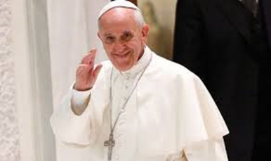
WHITE HAT: Who is this person?
___________________________________________________________________________
WHITE HAT: What is his name?
___________________________________________________________________________
WHITE HAT: What does he do?
___________________________________________________________________________
WHITE HAT: What is he wearing?
___________________________________________________________________________
WHITE HAT: Why does he wear white?
___________________________________________________________________________
WHITE HAT: Why is he important?
___________________________________________________________________________
Create a fact file on Pope Francis – you will need to do some research. Think carefully about how you will set out your fact file.

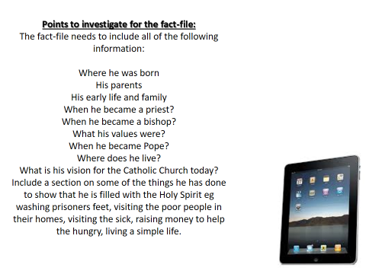

FACT FILE

