LO- To explore Mary Anning and her contribution to Science.
HOM- Remaining open to continuous learning.
Success Criteria:
I can:
1. Talk about Mary Anning’s contribution to palaeontology.
2. Understand that fossils found in Lyme Regis originated at the bottom of a sea.
3. Describe Mary Anning’s life.
WHITE HAT: What are fossils?
Not many plants and animals are lucky enough be turned into fossils.
When an animal or plant dies its remains usually rot away to nothing. Sometimes though, when the conditions are just right and its remains can be buried quickly, it may be fossilised. There are several different ways fossils are formed. Here we go through the five steps of fossilisation to make a typical 'mould and cast' fossil.
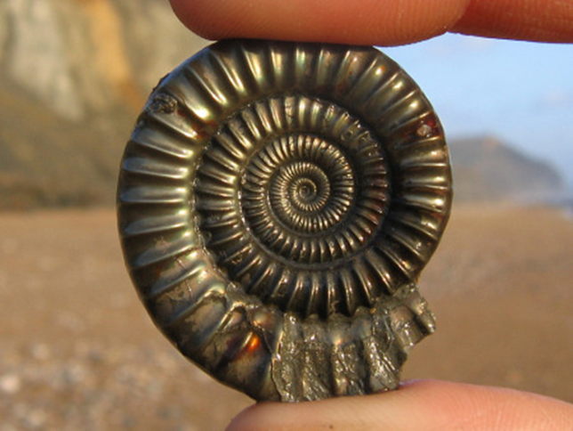
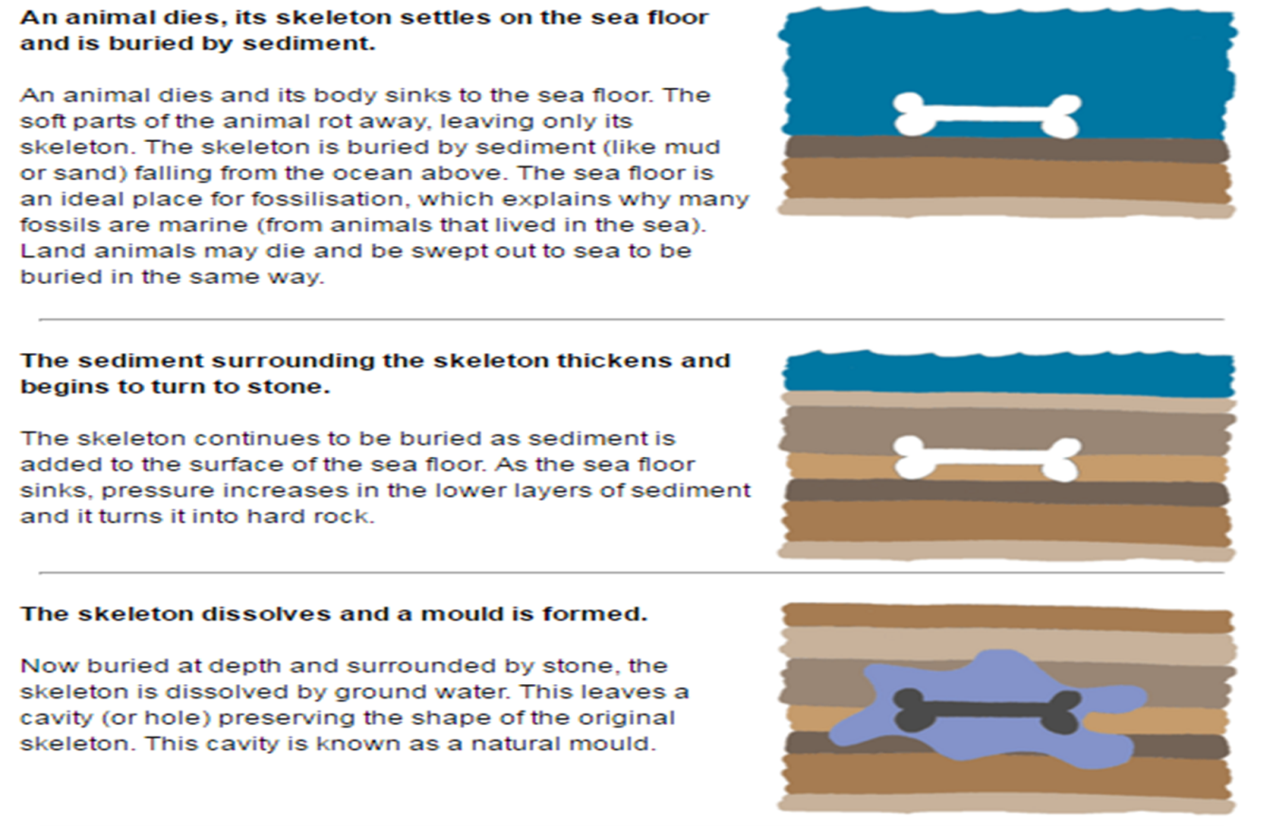
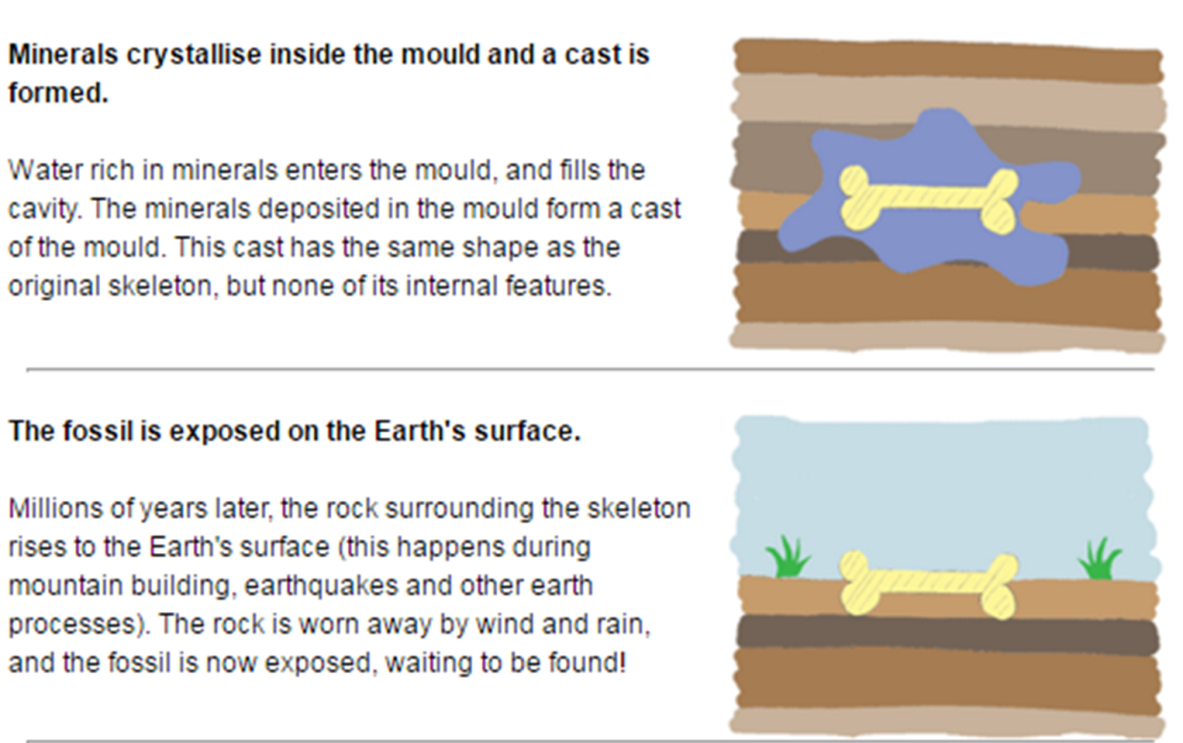

Complete the flow map below using the information you have just read explaining fossilisation. You will need to turn the page landscape.
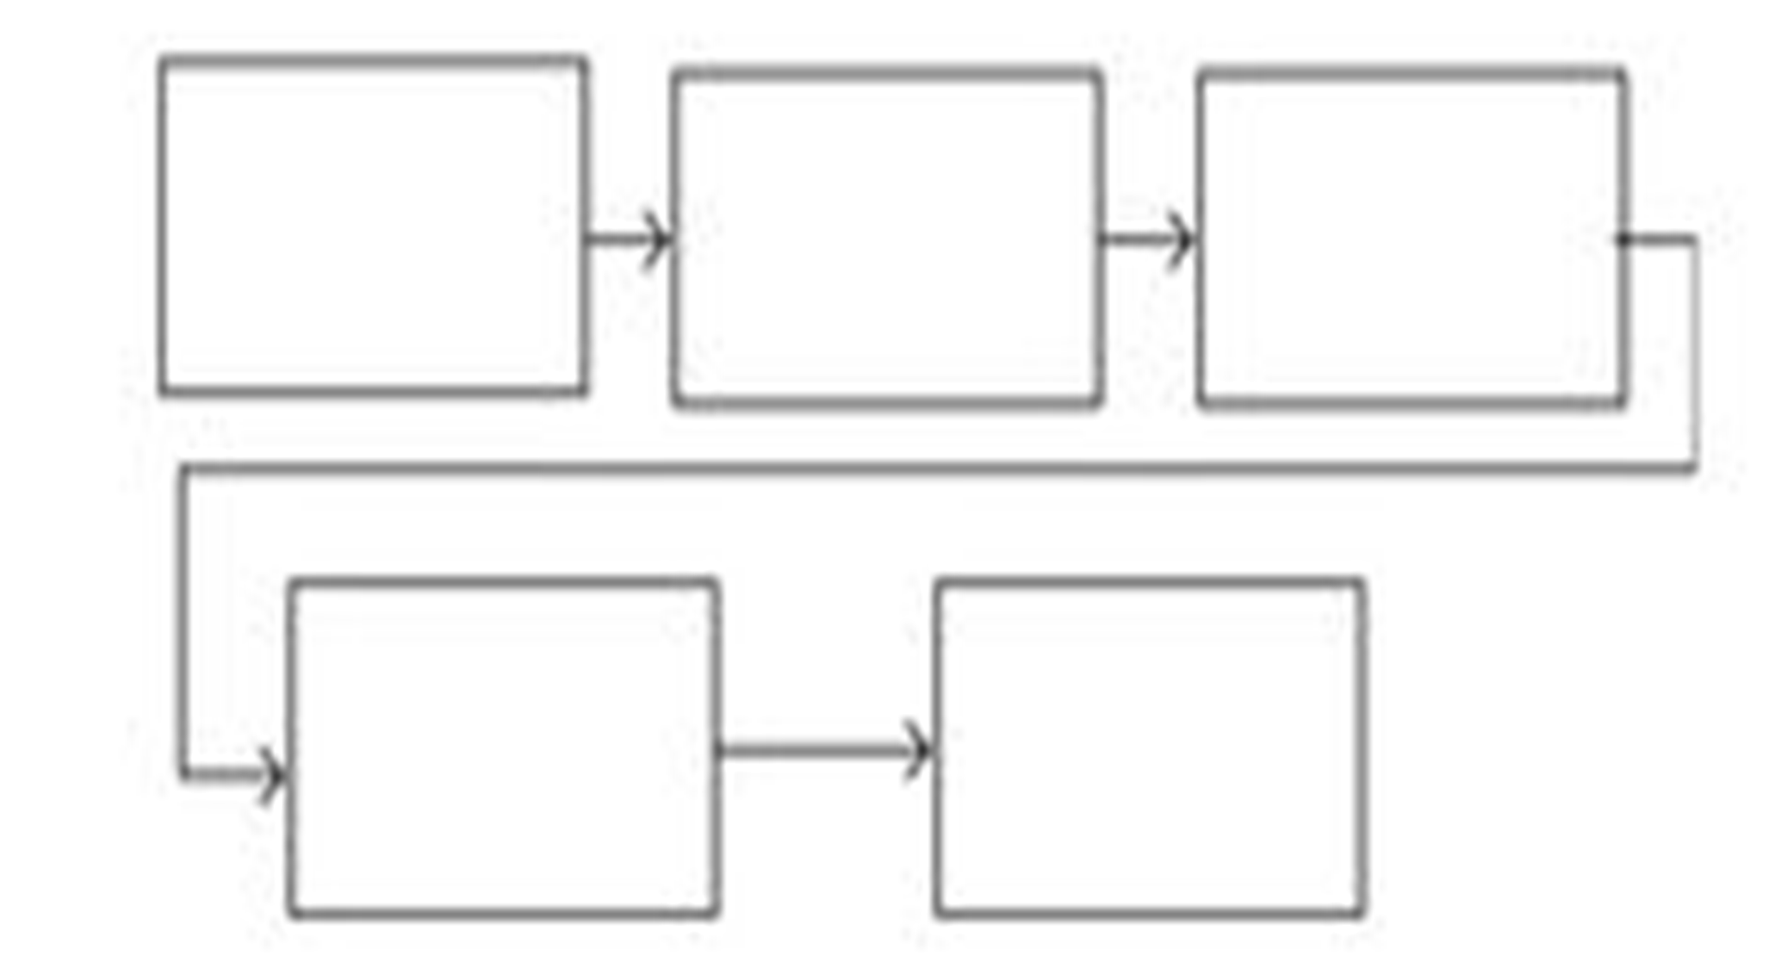
A SIGNIFICANT INDIVIDUAL

MARY ANNING
Invstigate Mary Anning, make notes using the websites listed below
https://www.bbc.co.uk/bitesize/topics/zd8fv9q/articles/zf6vb82
https://www.youtube.com/watch?v=qNOh-85_Dmc
Make your notes on the next page.

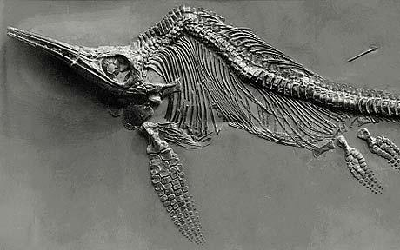
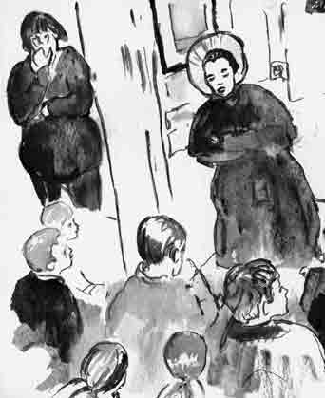
Mary was born...
Mary Anning was famous for finding ....
Many years after her great discovery Mary...
When she was...
As a young child she used to...
Mary Anning Biography

Using the information you have collected you are going to write a biography for Mary Anning.
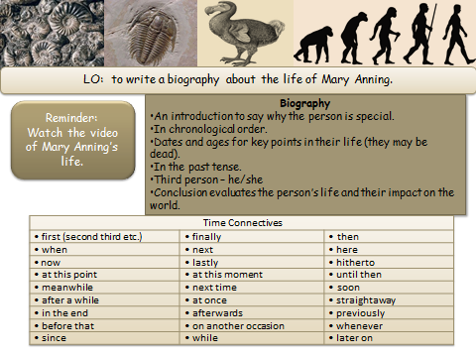
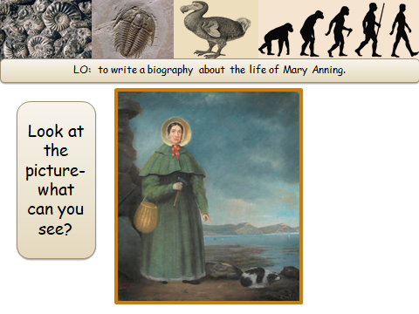

Use the next few pages for Mary Anning’s Biography

