L.O To understand what electricity is, how it is generated and how different charges interact
HOM: Remaining Open to Continuous Learning
What you already know about the topic of electricity, what can you remember from learning about it in Year 4 ?
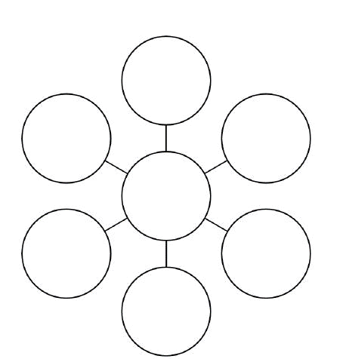

KEY WORDS

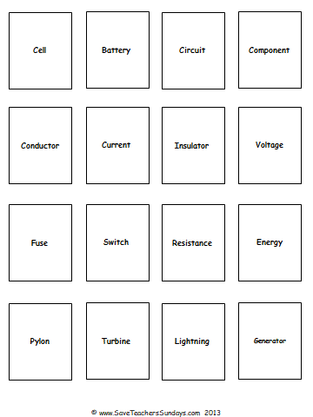
Can you match the key word to the correct definition?

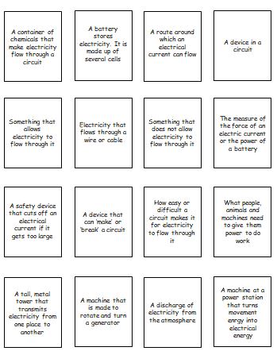

Using the balloon to rub it against your hair and see what effect does this have?
You will be watching a video that explains why hair stands up when they rub it with a balloon.

Watch these clips:
https://www.youtube.com/watch?v=fT_LmwnmVNM (watch up to 4 minutes 20 seconds)
https://www.youtube.com/watch?v=ZAFW4zdXpbY
https://www.youtube.com/watch?v=sRPejoNktKE watch up to 30 seconds
https://www.youtube.com/watch?v=VnnpLaKsqGU
You are going to read some information linked to what you have just watched. Annotate the text below and make notes for yourself.
Electricity
Introduction
Electricity is crucial to how we live our lives today. Most of the technologies that generate light, heat, sound or movement are powered by electricity. Can you think of some of these? There are plenty of them! So what is electricity, where does it come from and how is it measured? Read on to find out the answers to these questions, as well as lots of other information!
What is electricity?
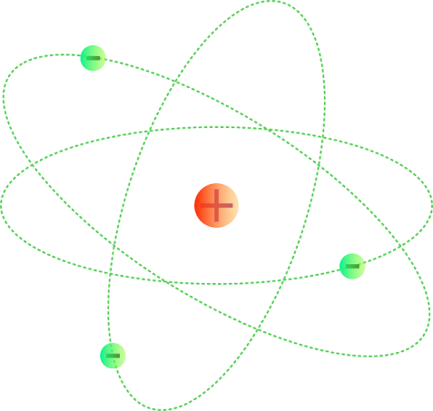
Electricity is a type of energy. Energy gives things the power to work; for example, the energy that animals get from food allows them to move. Everything around us is made from matter. Matter is made from tiny atoms, which are so small that over a thousand billion of them could fit on the point of a pin. Incredibly, these atoms are made up of even tinier particles called neutrons, protons and electrons. Protons have a positive charge, while electrons contain a negative charge; therefore a substance containing more protons than electrons is positively charged, whereas a substance with more electrons than protons is negatively charged. However, substances naturally want to have an equal balance of protons and electrons. Electrons can move from one atom to another atom. When electrons move from negatively charged matter to positively charged matter, this movement generates electricity!
An atom: the negative electrons travel around the positive nucleus
How is electricity generated naturally?
Electricity can be generated naturally (without people doing anything deliberately to generate it). Have you ever received a small shock when you touch something or someone else? This is caused by static electricity. Static electricity is generated by two things rubbing against each other, which transfers electrons from one thing to the other. This can lead to electricity occurring when the electrons move from the negatively charged thing to the positively charged thing. In a thunderstorm, ice crystals in the clouds rub together, leaving the bottom of the cloud negatively charged. A lightning bolt occurs when electrons move from the bottom of the cloud to the positively charged ground! Animals also generate electricity (find out why they do this later in the text).
How do two positively charged things interact?
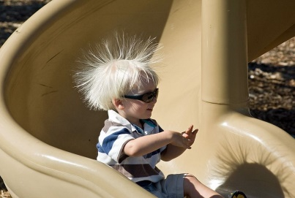
Static electricity is generated when electrons move from a negatively charged thing to a positively charged thing. In other words, positively charged things attract negatively charged things. Can you remember where else in science we see opposites attract? We see something similar with magnets, when unlike poles attract. Can you remember what happens when the north pole of a magnet is moved close to the north pole of another magnet, or the south pole of a magnet is moved close to the south pole of another magnet? They repel each other. This is the same with positively charged and negatively charged things. In the picture, the boy’s positively charged hairs are repelling each other, making them stand up! So remember, like charges repel, whereas unlike charges attract.
The boy’s positively charged hairs repel each other
How is electricity generated for us to use?
Naturally occurring electricity is not what we use to power the technologies that we use in our lives. There are two main sources of electricity for this: mains electricity and batteries.

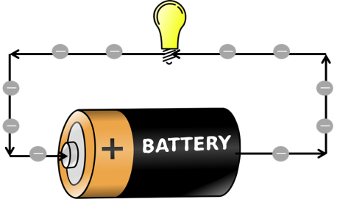

Electrons travelling from a battery and around a circuit

Mains electricity is what comes from plug sockets in the wall, whereas batteries are portable (they can be carried around). Power stations generate heat energy from a fuel; the heat energy is used to create steam; the steam is used to turn a turbine and a generator converts the movement energy into electricity. This electricity is then brought to our homes along cables. These cables can be underground, in the air supported by pylons or in walls. Batteries store chemical energy, which they then convert to electrical energy. The electrons flow from the negative side of the battery to the positive side. A battery has gone ‘flat’ when all of this chemical energy has been converted. Rechargeable batteries can be plugged into the mains, so that they can be used again. Some people have microgeneration systems that produce electricity, such as solar panels or wind-turbines on their roofs.

Read the questions below there is an answer sheet on page 8 for you to fill in.
Date Understand the nature of electricity and its sources

- What is electricity?
- Is a substance with more electrons than protons positively charged or negatively charged?
- Do most substances want to have more protons, more electrons or an equal balance of protons and electrons?
- What is it the movement of that generates electricity?
- What causes static electricity?
- Why does lightning occur?
- What happens if two positively charged things come close to each other?
- What are the two main sources of the electricity that we make use of?
- Why do we sometimes need to use batteries instead of plug sockets?
- Name two types of energy that are converted in the process that generates and transports mains electricity to our homes.
- What type of energy is stored in a battery and converted to electrical energy?
Extension
- What two types of energy is electrical energy converted into during a thunderstorm?
- If the ground were negatively charged, to the same point as the bottom of a cloud, would lightning occur? Why / why not?
- In addition to the two types of energy you mentioned for question 10, can you name two more types of energy that are converted in the process?
- Why do you think very strong winds can cause power cuts?

Understand the nature of electricity and its sources

- A substance with more electrons than protons is
- Most substances want to have
- The movement of generates electricity.
- Static electricity is caused by

- Lightning occurs

- If two positively charged things come close to each other

- The two main sources of the electricity that we use are

- We sometimes need to use batteries instead of plug sockets because

- Two types of energy that are converted in the generation and transport of
mains electricity are
- is stored in a battery and converted to electrical energy.
We will provide the answers with next week’s lesson.

