To be able to explain how lives of the poor were improved in Victorian times.
HOM: Thinking and Communicating with Clarity and Precision.
Success Criteria:
• I can research the work of Dr Barnando and Lord Shaftesbury
•I can explain why their achievements were so important
•I can research the developments that improved Victorian life.

Fill in the bubble map on the next page, use these questions to help you:

What do we know about the lives of the Victorian poor so far?

What advancements had helped them so far?

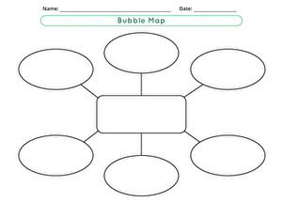
The banning of boys used as chimney sweeps in the 1930s
What I know about the lives of the poor and the advancements that helped them.

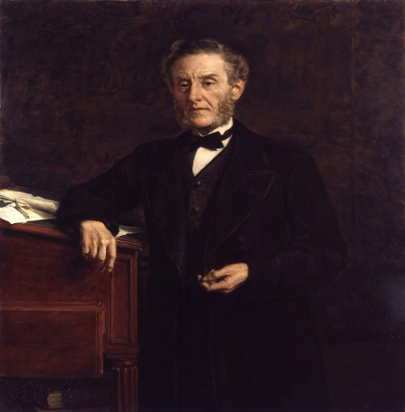
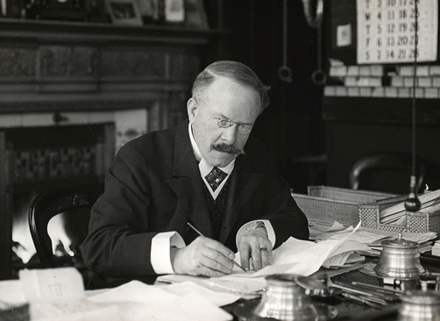

Dr Barnardo Lord Shaftesbury

Just look at the images, what type of person they consider these men to be ?
________________________________________________________________________________________________________________________________________________________________________________
Dr Barnardo
When a cholera epidemic swept through the East End, leaving 3000 people dead and many orphaned children, Barnardo felt an urgent need to help.
His first step, in 1867, was to set up a ‘ragged school’ where children could get a free basic education.
Lord Shaftesbury was a politician who was particularly interested in factory workers, especially the child labourers and their wellbeing. He was involved in passing the factory acts of 1847 and 1850. He also helped to set up the ‘Ragged Schools’.
You will need to do a little research to answer the following questions:
Ragged school: What type of school would this be?
____________________________________________________________________________________________________________________________________________________________________________________________________________________________________________________________________________________________________________________

Why would this, the development of ragged schools, have been important to the lives of the poor in Victorian Britain?
________________________________________________________________________________________________________________________________________________________________________________________________________________________________________________________________________________________________________________________________________________________________

Challenge – What happened during the 1860s that affected Victorian London so heavily?
____________________________________________________________________________________________________________________________________________________________________________________________________________________________________________________________________________________________________________________
Take a look at these websites:
https://www.barnardos.org.uk/who-we-are/our-history
http://www.primaryhomeworkhelp.co.uk/victorians/famous.htm
Watch these clips:
https://www.bbc.co.uk/programmes/p015jf2y
https://www.bbc.co.uk/programmes/p011lqq9
Tasks :
- Create an information poster that describes the work of Lord Shaftesbury explaining his effect on the poor of Victorian Britain.
- Write a newspaper article about Dr Barnando and his work using the information and history of the charity.

