LO: To design a wrap and write a persuasive pitch.
HOM: Creating, Imagining, Innovating
First you need to design your wrap. How big will it be? What food will it contain? What will your wrap be called ? – is there a theme? (Mexican, Thai, Chinese, British, Caribbean etc. ) on the nxt page there are pictures of some wraps to help you.
Before filling in the boxes think about how you will set them out, what literacy skills will you use?
Method :
_________________________________________________________________________________________________________________________________________________________________________________________________________________________________________________________________________________________________________________________________________________________________________________________________________________________________________________________________________________________________________________________________________________________________________________
Ingredients:
_________________________________________________________________________________________________________________________________________________________________________________________________________________________________________________________________________________________________________________________________________________________________________________________________

What will your wrap look like? Draw and label it below

Vegan Mediterranean Grilled chicken Caesar wrap
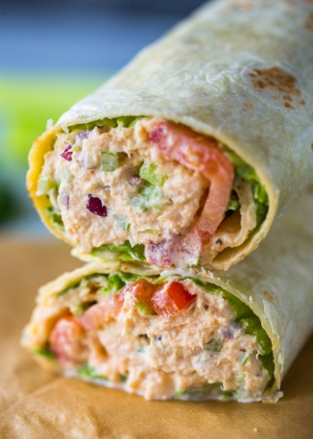
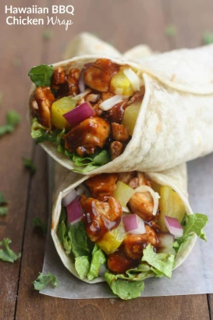
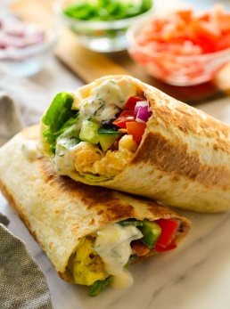
Hawaiian BBQ Chicken Wrap Spicy Tuna Wrap

Italian Chicken Wrap Cheesy Roast Beef Wrap
