Resource 8: Pope Francis material
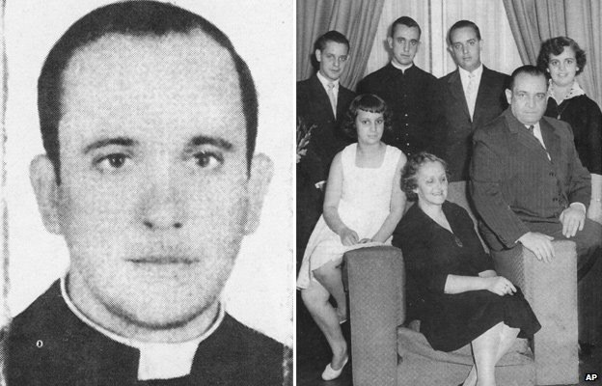

Jorge Mario Bergoglio was born on 17 December 1936 in Buenos Aires, Argentina. His father was an Italian immigrant railway worker. He became a Jesuit priest when he was 32, and a Bishop in 1992. He was made Archbishop of Buenos Aires in 1998.
Further information: http://www.bbc.co.uk/news/world-europe-21777141
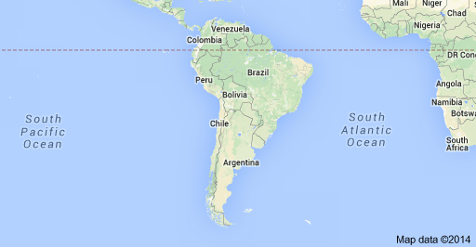

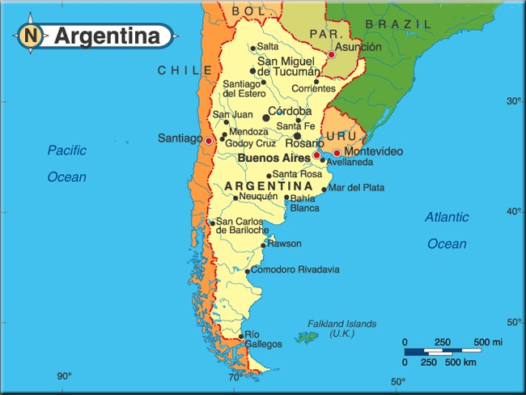

Where Pope Francis choses to live

Argentina is a very beautiful but rather poor country. While he was an Archbishop and a Cardinal in Buenos Aires Bishop Jorge was well known for being humble. He lived in a modest apartment, rather than his luxurious official residence. In his sermons, he often stressed that society needed to be more inclusive of all people – he criticised governments which did not help those on society's margins, describing the poverty in Argentina as "immoral and unjust".

From: http://www.bbc.co.uk/news/magazine-24210906

In [a] six-hour interview, after he became Pope, Pope Francis explained why, when he first set eyes upon the papal apartment on the top floor of the Apostolic Palace, he decided he could not live there.

"The papal apartment is old, tastefully decorated and large, but not luxurious.

"But in the end it is like an inverted funnel. It is big and spacious, but the entrance is really tight.

"People can come only in dribs and drabs, and I cannot live without people. I need to live my life with others."

Instead, the pope chose to live in the Domus Marthae, a residence for clerics and official Vatican guests close by Saint Peter's Basilica where he occupies a modest, three-roomed suite.

He takes his meals in a common dining room, using the formal papal quarters only for official receptions and meeting heads of state.

"The people of God want pastors, not clergy acting like bureaucrats or government officials," Pope Francis said.

"I see the church as a field hospital after battle. It is useless to ask a seriously injured person if he has high cholesterol and about the level of his blood sugars! You have to heal his wounds. "Then we can talk about everything else. Heal the wounds, heal the wounds... And you have to start from the ground up."
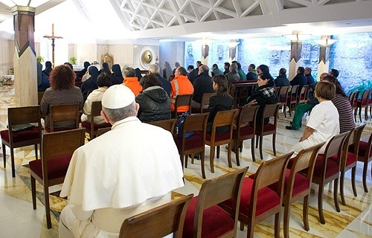

Pope Francis sitting at the back of the Chapel in Domus Marthae to pray.

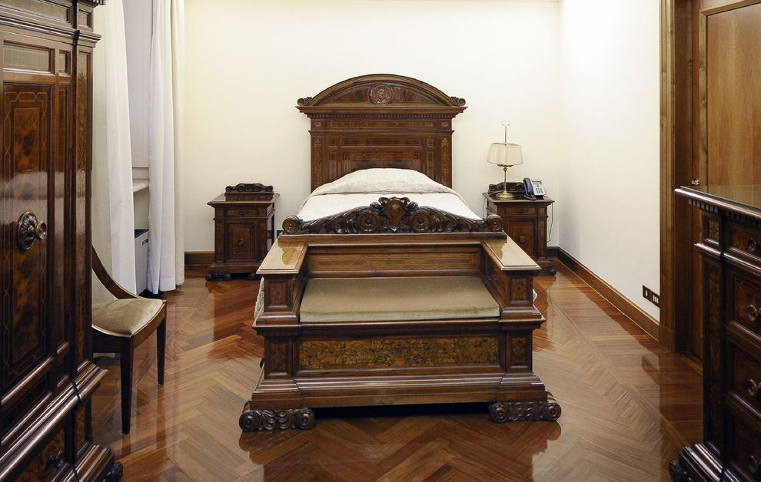

The bedroom Pope Francis uses at Domus Marthae.

see link for more details:
http://news.nationalgeographic.com/news/2013/02/130328-pope-francis-vatican-casa-santa- marta-apartment-rome-catholic/

Excerpt of article in Australian Catholics

This symbol indicates input for pupils. This may be given verbally; on the IWB or as a series of handouts for older pupils.

In the Church with Pope Francis
Going out of the house
The Pope sees the Church’s business as going out into the streets. For him, faith is a door through which we allow Jesus in. Jesus then invites us to go outside to greet other people. We are not to settle down within a comfortable church but to go out to people who are hungry.

- Explore the word ‘hungry’. Some people in the world are literally hungry, others are figuratively ‘hungry.’ (eg hungry for friendship; for justice; for respect.)

- During the Year of Mercy Pope Francis asked us to make a door of mercy. In this quote, Pope Francis asks us to ‘go outside’. Talk about how faith can be like a door – it can be the ‘point of entry’ into thinking a particular way and acting in a particular way. Have pupils use local newspapers and their own knowledge of the community to list things people are ‘hungering’ for. Write these words artistically and place them ‘behind’ a door, so that when it opens the needs of a hungry world are revealed. What hungers would we see if we looked outside our doors?
What kind of a Church does Pope Francis want?
When Pope Francis goes out [into the world] he is not simply an individual but a follower of Jesus in his Church. He wants us, too, to be part of a Church that goes out to those in need. He says the Church should be like a ‘field
hospital’ in a time of war, where people can find care and compassion for the wounds that threaten their lives.

Because he wants the Church to meet people compassionately, the Pope addresses many of his words to people who are ministers in the Church, especially bishops and priests. He tells them that they are shepherds, and so they should smell like the sheep. He sees their great temptations to be careerism, greed, clerical privilege and fussiness about churchy things. These qualities stop us from going out simply to others.

We can see what Pope Francis wants the Church to look like when he leaves the papal car and his security guards to greet and bless people in wheelchairs, and when he leaves the cathedral of Rio de Janeiro to go into the slums to mix with the ordinary people there. By doing this he shows that the centre of the Church lies outside itself and that Christ is found in his brothers and sisters to whom the good news has not yet reached, and especially the poor.

It is hard to go out to ordinary people and to show God’s compassion if

we live in a mansion, dine out every night and drive a Rolls Royce. So Pope Francis dresses simply, travels simply, eats simply, and lives in a guest house. When he speaks of the poor he comes across as someone who knows the poor. He is one of God’s people, not their boss. This is how he would like the Church to be. Although his simplicity of life is a personal choice, we find ourselves wondering whether any other style of life cuts it in a Church going out to the poor.
The following links may help you explore the ideas represented in the content above. You MUST look at these sites in advance of using them with your pupils to determine suitability for your age group. Google more recent examples of what Pope Francis is doing…and don't forget Laudato Si!

Youtubes/articles of events.

- Pope Francis washes the feet of prisoners https://www.youtube.com/watch?v=4OOkBIrW60w

- articles and video of Pope Francis speaking about refugees

http://www.theguardian.com/world/2013/jul/08/pope-globalisation-of- indifference-lampedusa (Guardian article - Lampedusa)

http://www.reuters.com/article/us-pope-palmsunday- idUSKCN0WM0FU

http://www.reuters.com/article/us-europe-migrants-pope-refugees- idUSKCN0XI1SE

- Pope plays with a little boy who wandered onto the stage during a meeting with Catholic families from around the world http://www.youtube.com/watch?v=MI5GwdFjnJA

- article - Pope embraces two disfigured men http://www.dailymail.co.uk/news/article-2510595/Pope-Francis- compassion-brings-joy-disfigured-man.html

- articles – Pope Francis invites homeless men to his birthday. http://www.news.com.au/world/pope-francis-invites-homeless-to- breakfast-at-vatican-on-his-77th-birthday/story-fndir2ev- 1226785397475

http://www.ndtv.com/article/world/pope-francis-invites-homeless-for- birthday-breakfast-459860

- article – Pope Francis phones people

http://www.catholicherald.co.uk/news/2013/09/16/pope-phones- people-all-the-time-says-vatican-official/

- article – Pope Francis ‘sneaks’ out to feed homeless in Rome http://rt.com/news/pope-francis-disguise-homeless-rome-670/
Showing God’s compassion
Pope Francis wants us to express God’s compassion to the world. He speaks of compassion more through gestures than words. He follows the advice of his namesake St Francis of Assisi who said ‘Preach the
Gospel but only use words if you have to.’

We are most struck by compassion when we feel that the person who is compassionate to us is more important than we are. Because we expect them to be a little distant, we are surprised when they put themselves on the same level as us. It is impossible to stand on your dignity and show compassion.

People experience the Pope’s compassion when he walks among them and speaks their ordinary language. And we speak most

https://www.australiancatholics.com.au/article.aspx?aeid=50145#.WHvF6GnlyeA
powerfully of God’s compassion when we go out among people, are friendly, speak colloquially, and don’t judge them.

