ANSWERS FOR LAST WEEK’S QUESTIONS:
- Electricity is a type of energy.
- A substance with more electrons than protons is negatively charged.
- Most substances want to have an equal balance of protons and electrons.
- The movement of electrons generates electricity.
- Static electricity is caused by by two things rubbing against each other, which transfers electrons from one thing to the other.
- Lightning occurs when electrons move from the negatively charged bottom of a cloud to the positively charged ground.
- If two positively charged things come close to each other, they will repel each other.
- The two main sources of the electricity that we use are mains electricity and batteries.
- We sometimes need to use batteries instead of plug sockets because
batteries are portable so we can use them when we are on the move.
- Two types of energy that are converted in the generation and transport of mains electricity are chemical (from the fuel) / heat/ movement (turbines) / light (from fire), electrical – any two from these
- Chemical energy is stored in a battery and converted to electrical energy.

Extension
- Light (lightning) and sound (thunder).
- Lightning would not occur, as the electrons would not want to move to somewhere that was equally as negatively charged as the bottom of the cloud.
- See answer to questions 10
- Wind causes power cuts by bringing down tress, which bring down power cables, which breaks circuits

L.O To understand why electricity is useful and the social issues around it
To understand how circuits work and how we use them
To know the units of measurement related to electricity and what each of them measures.

What information can you recall from last lesson? Complete the bubblemap:
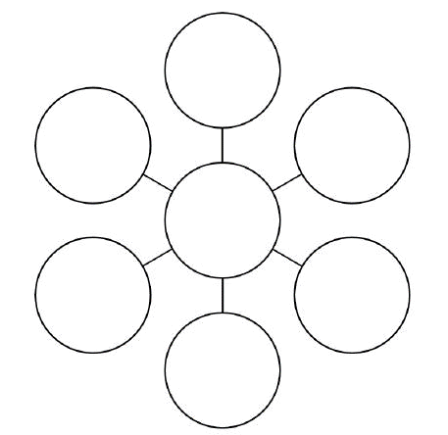

Read the information below, annotate it and make notes.
Why is electricity useful?
Electricity from the mains and from batteries is useful for us because it can be easily changed into other forms of energy, such as light, heat, sound and movement. For example, electricity is converted in to light in a light bulb, in to heat in a radiator, in to sound in a radio and in to movement in a robot. The human body also uses electrical signals that move along nerves to carry messages to and from the brain. Some animals use electricity to navigate or communicate; others, like the electric eel and the electric catfish, use electricity as a weapon!
Elephantnose fish use electrolocation to find their way in murky water

What are sources and consumers of energy and electricity?
Items that require electricity in order to work, like mobile phones and lights, are consumers of electricity and energy. Batteries and power stations are sources of electricity. These sources of electricity need their own energy sources to work. There are many sources of energy that we convert into electrical energy, including the chemical energy in batteries, fossil fuels (gas, coal and oil), nuclear energy, solar power, wind power, wave power, geothermal energy (from the Earth’s inner heat) and hydroelectric power (from dams and waterfalls).

Which source of energy for electricity is best?
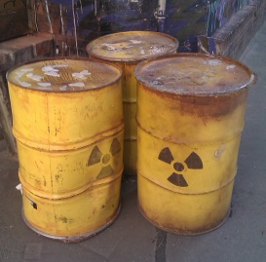
Different sources of energy have different strengths and weaknesses. For instance, gas coal and oil can be used all year around, but most scientists believe that they cause global warming. Nuclear energy can be used all year around too and does not cause global warming, however it does produce highly toxic waste that is expensive and dangerous to store. Renewable sources of energy do not have the problems of nuclear power or burning fossil fuels, yet they are not as reliable, are not an option in all places and can cause other problems. For example, people often think that wind farms spoil scenery and dams often need to flood land where people live and work.
Nuclear waste

What are circuits and how do they work?
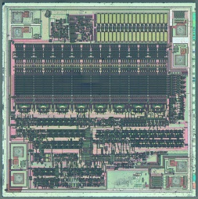
A circuit is made up of a power source and an unbroken pathway of a conducting material. In the circuit on page 2, the power source is the battery and the conducting material is electrical wire. The type of electricity in a circuit is called current. Current electricity flows from one place to another, such as from the negative side of the battery to the positive side. (Static electricity does not have current, as the electrons jump instead of flowing). Conductors are substances that allow electricity to flow through them easily, whereas insulators are substances that do not allow electricity to flow through them easily. Most metals are good conductors, while most non-metals like rubber and plastic are insulators. A switch can be used in a circuit to stop or allow the current to flow. If the switch is used to break the pathway, the current will stop flowing. On / off switches on plug sockets and devices work in the same way – by completing or breaking a circuit. Bulbs, buzzers and many other devices can be added to circuits. Such devices are known as components and they convert the electrical energy into heat, sound or light. Modern computers contain millions of tiny circuits called microchips.
Microchips are tiny circuits

What units of measurement are used for electricity?
The reason that current flows is because of the ‘potential difference’ between the positive charge at one point and the negative charge at the other point. The size of this difference is measured in volts (V) and is called voltage. The bigger the voltage is, the stronger the current will be. Current is measured in amperes (amps). Different devices need different levels of current. For example, an iron might need 5 amps, while an electric heater might need 10 amps. The amount of electrical energy that a device uses is measured in Watts (W). The other main unit of measurement related to electricity is resistance, which is measured in ohms (Ω). Resistance is the ability of a substance to restrict the flow of electricity. Insulators will have a higher level of resistance than conductors, although there will also be differences in the level of resistance between different conductors. For example, copper provides lower resistance than iron, so copper is better as a conductor. Using a metal with greater resistance to electricity in a circuit means that more energy is lost as heat and / or light than would be lost if a metal with lower resistance was used. Thicker wires also provide less resistance than thinner wires; similarly, shorter wires provide less resistance than longer wires.
What social problems are there related to electricity?
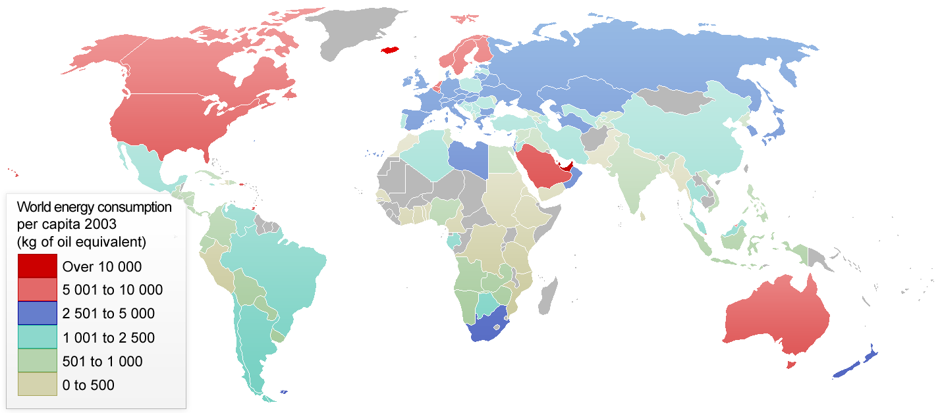
Eventually fossil fuels will run out, so we need to start planning for this before it happens. Every person can help reduce the amount of electrical energy that is needed by not wasting it; for instance, by not leaving lights on when they’re not needed, by not leaving devices on standby and by using energy-efficient light bulbs. Scientists and engineers are constantly trying to make devices more energy-efficient and trying to find new ways of generating electricity. There are also still more than 1.5 billion people on Earth that still do not have access to electricity. Can you imagine having to live without it? Think of all of the things that you would no longer be able to use!
Global energy use per person – red is high,
blue is medium and grey is low

Summary
Electricity is an incredibly useful type of energy for us, as it can be converted into heat, sound, light and movement energy. It occurs when electrons move from one atom to another. With static electricity, which is the cause of lightning, the electrons jump. With current electricity, which is the type of electricity that we make use of, the electrons flow. Current electricity comes to us through mains electricity or it comes from batteries. Animals use electricity to send messages from their brains and through their nervous systems, while some animals use electricity to find their way around or as a weapon. In order for us to have electrical energy, we need a source of another form of energy which can then be converted to electrical energy. There are a number of such energy sources, but none of them are perfect. Once electrical energy is generated, it is brought to our homes through a circuit. For a circuit to carry current, it needs a power source and an unbroken pathway made from a conducting material. There are several units of measurement related to electricity: potential difference is measured in volts (V), current is measured in amperes (amps), the amount of energy that a device uses is measured in Watts (W) and levels of resistance are measured in Ohms (Ω). Society also faces a number of electricity-related challenges for the future, such as sustainability and providing access to electricity for everyone in the world.
Read the questions, you have an answer sheets on page 7,8 and 9. Pick one extension activity to complete.
Understand more about electricity

- Why is electricity from the mains or from batteries so useful for us?
- How does the human body use electrical signals?
- Give two things that some animals use electricity for.
- Give two examples of consumers of electricity and two examples of sources of electricity.
- Give three sources of energy that we convert into electrical energy.
- Give one strength and one weakness of an energy source that we convert to electricity.
- What is a circuit made up of?
- How is current electricity different to static electricity?
- Explain what a conductor is and give an example of a material that is a conductor.
- Explain what an insulator is and give an example of a material that is an insulator.
- How does a switch prevent or allow current to flow in a circuit?
- What are components and what do they do with electrical energy?
- What causes current?
- Give the four units of measurement that are used in relation to electricity and what each of them measures.
- Give two ways of reducing the resistance in a circuit.
- What effect does using a wire made from a higher-resistance metal have?
ANSWERS

- Electricity from the mains or from batteries is useful for us because

- The human body uses electrical signals to

- Some animals use electricity
- Two consumers of electricity are and two sources of electricity are
- Three sources of energy that we convert into electrical energy are

- One strength of

- A circuit is made up of

- Current electricity

- A conductor .
is an example of a conductor.
- An insulator
is an example of an insulator.
- A switch prevents or allows current to flow in a circuit by

- Components

- Current is caused by

- The four units of measurement and what they measure are:

- Two ways to reduce the resistance in a circuit are to

- Using a metal made from a higher resistance metal

Extension

Choose one of these things to research:
- Find out why energy-saving lightbulbs are more efficient than old filament-based ones.
- Find out what a defibrillator is and how it works
- Find out how an electric eel generates and uses electricity.
- Find out how a photocopier works.
- Find out how nuclear energy is generated.
- Find out what an electrocardiogram (ECG) is and how it works.

