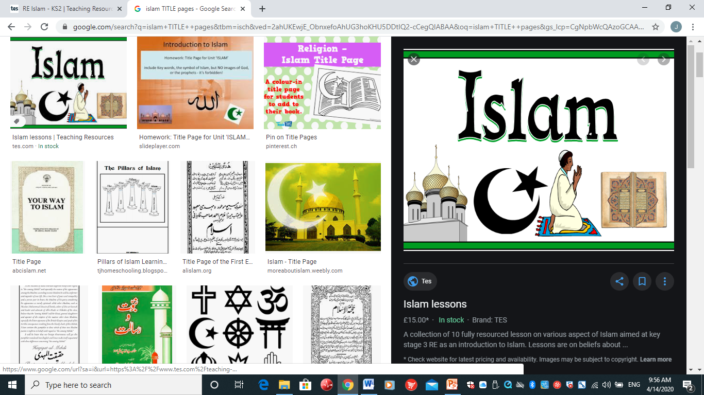

NAME ……………………..

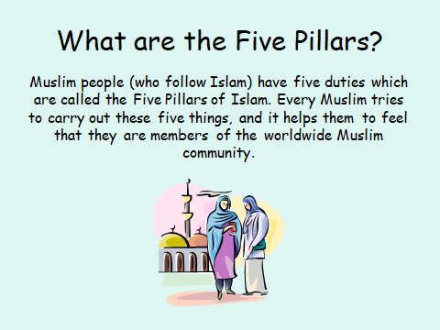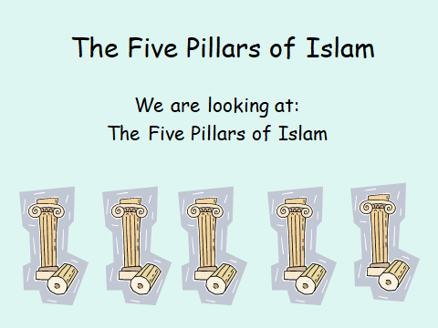

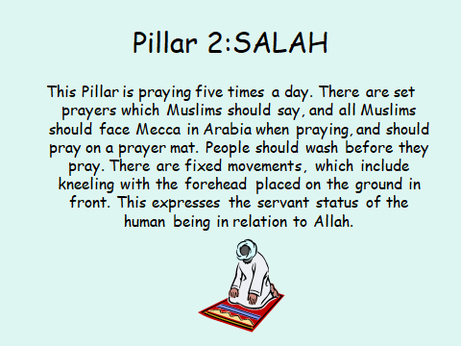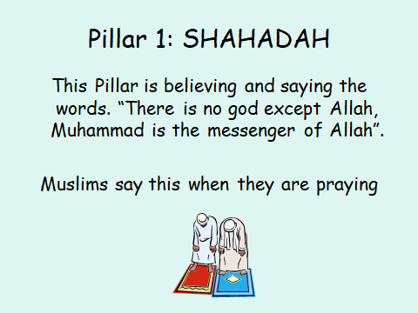

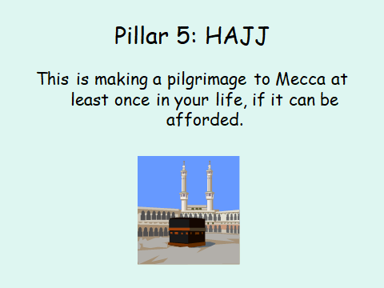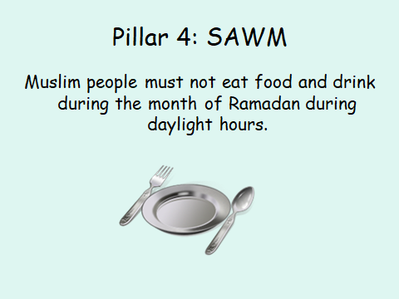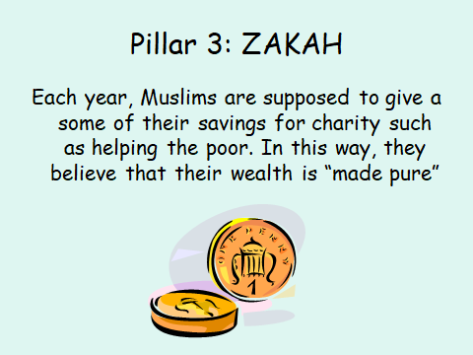

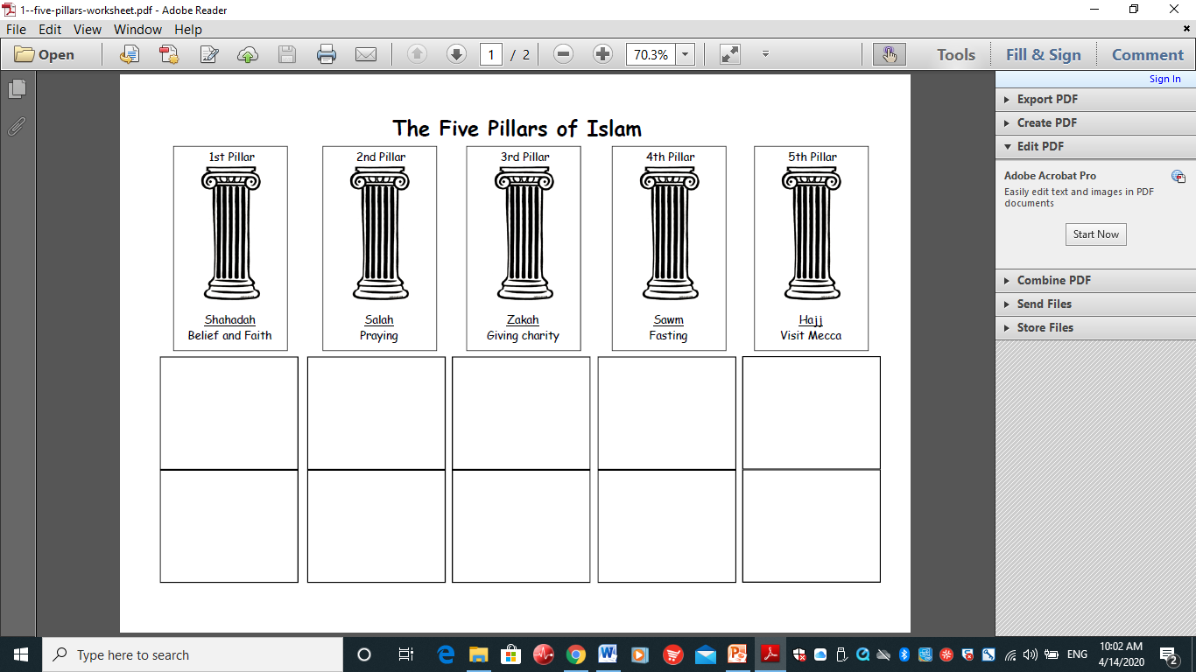

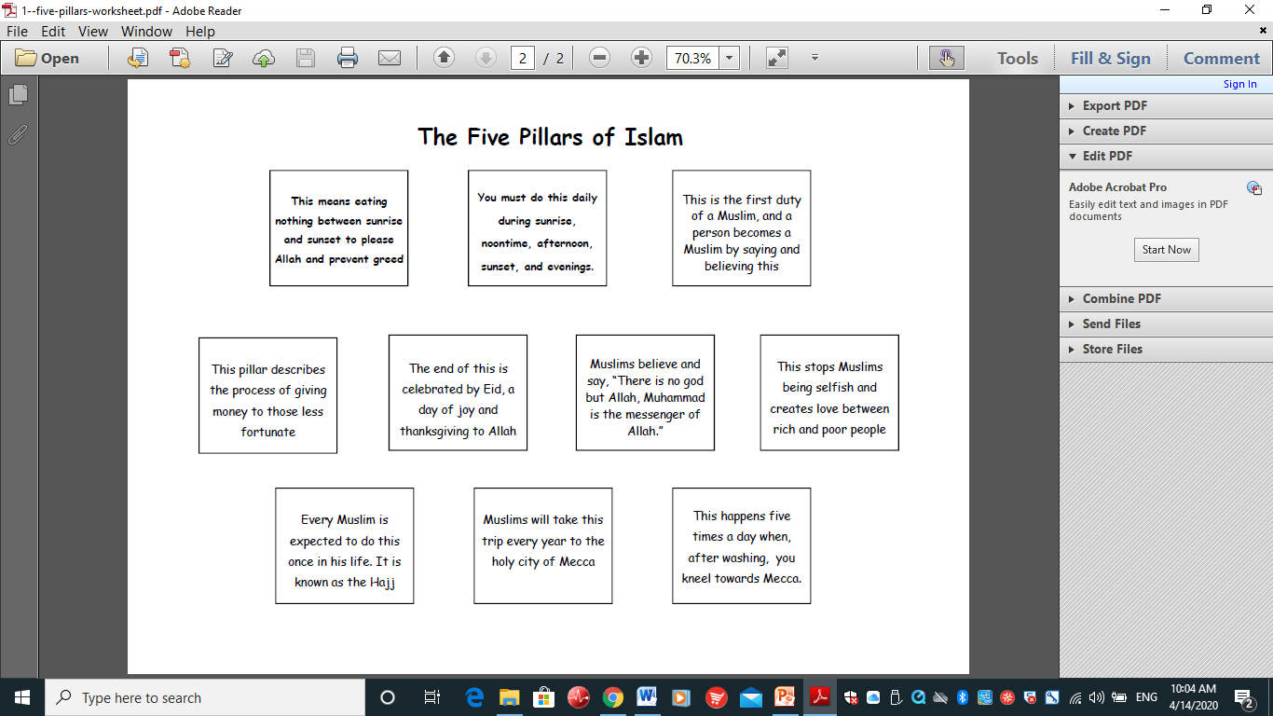

Lesson 2

L.O : To research the Muslim pilgrimage to Mecca, the Hajj and create an information leaflet to demonstrate my understanding.

HOM: Remaining Open to Continuous Learning

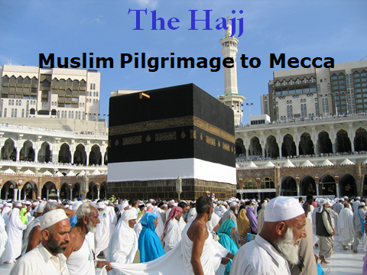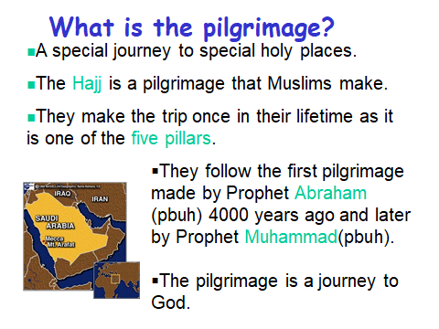

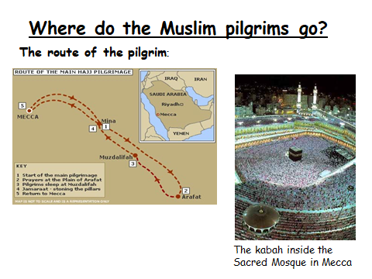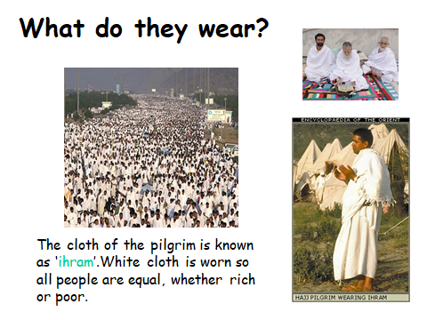

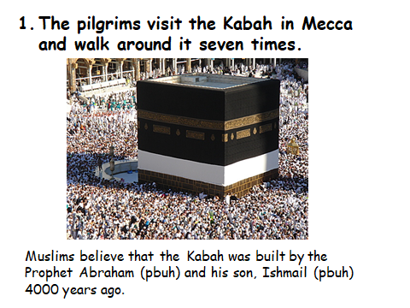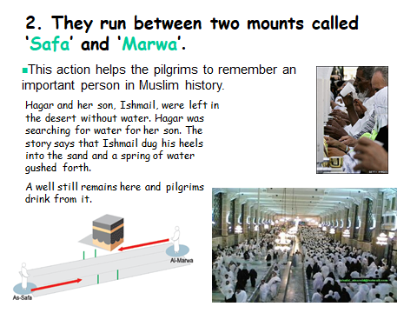

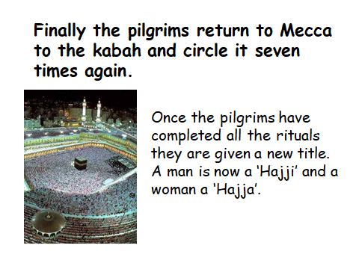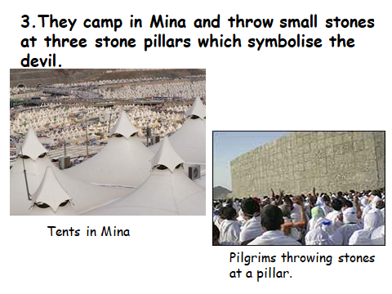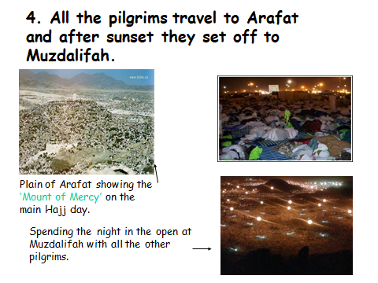

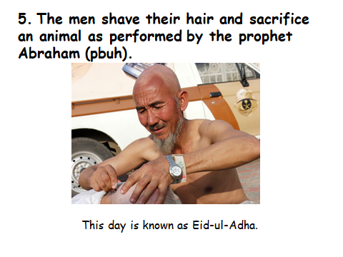

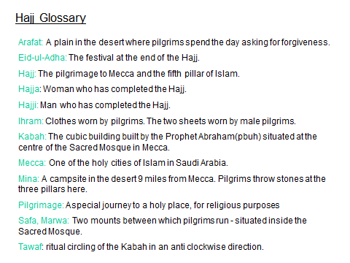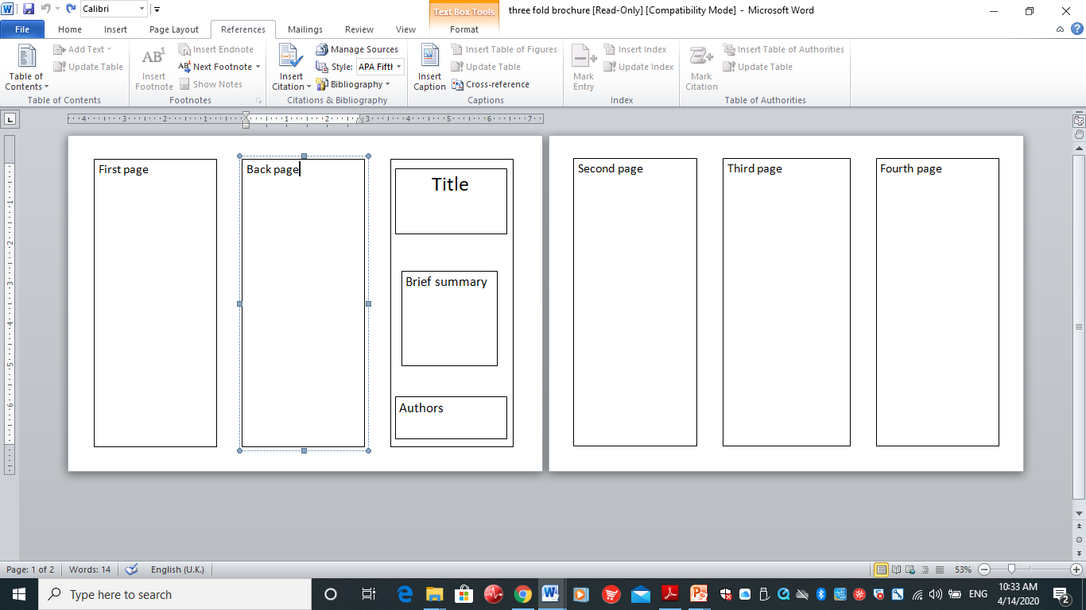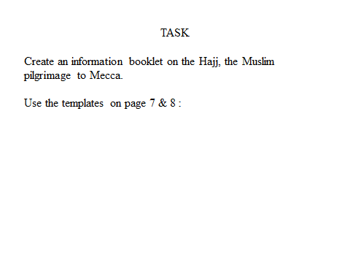

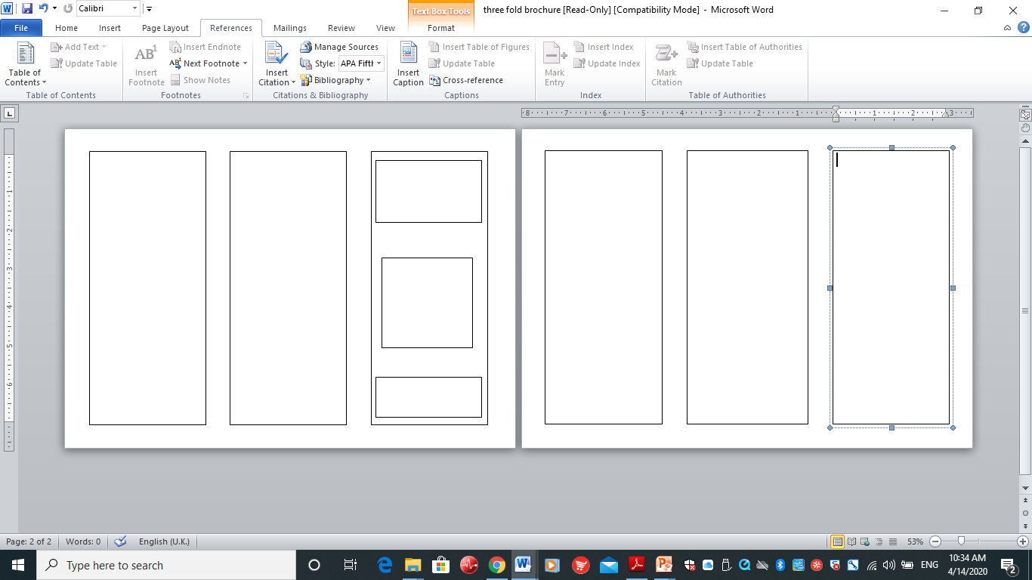

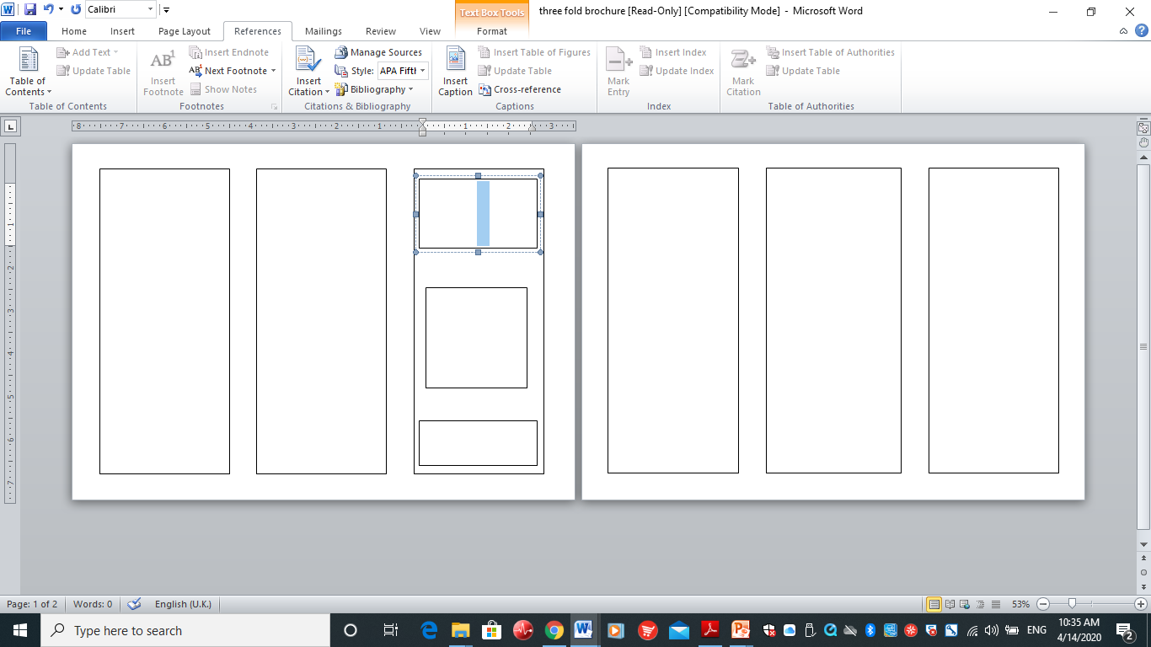

Lesson 3

To know why Muslims fast at Ramadan and reflect on how that feels.

HOM: thinking and communicating with clarity and precision.



