Lesson 2
Designing your wrapper
Now you have designed your wrap, thought about what it will taste and look like, the ingredients needed and its size you now need to think about how it will be wrapped:
Below here are pictures of a selection of food packaging examples:
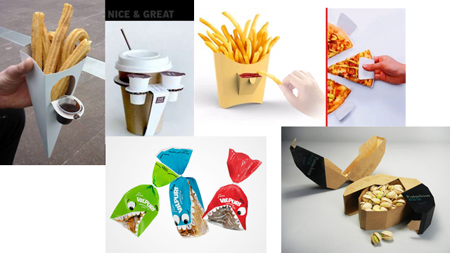
Skill: investigating an existing project
For each package evaluate:

What makes it attractive?
Is it easy to get into?
Is it practical?
Does it help keep the food ok?
Does it provide good information about the food?

On the next page create a table to evaluate and compare these different items using the criteria above as headings.

When designing the packaging you need to think about:
The Design of the packet
Is it easy accessible?
Is it designed to attract?
Is the packaging environmentally friendly?
Think about the front and back - make sure the name of your wrap is clear and that you have space for ingredients and nutritional values (we will be focusing on this in the next lesson).
Give reasons for your design – use the questions above to help you.
_____________________________________________________________________________________________________________________________________________________________________________________________________________________________________________________________________________________________________________________________________________________________________________________________________________________________________________________________________________________________________________________________________________________________________________________________________________________________________________________________________________________________________________________________________________________________________________________________________________________________________________________________________________________________________________________________________________________________________________________________________________________________________________________________________________________________________________________________________________

FRONT (remember to label your design)

Now design the back-remember to label it!

Give reasons for your design – use the questions above to help you.
_______________________________________________________________________________________________________________________________________________________________________________________________________________________________________________________________________________________________________________________________________________________________________________________________________________________________________________________________________________________________________________________________________________________________________________________________________________________________________________________________________________________________________________________________________________________________________________________________________________________________________________________________________________________________________________________________________________________________________________________________________________________________________________________________________________________________________________________________________________________________________________________________________________________________________________________________________________________________________________________________________________________________________________________________________________________

