L.O. To identify the main reasons for World War II
To recall important events in chronological order
To research WWII using a range of sources
HOM: Thinking and Communicating with Clarity and Precision
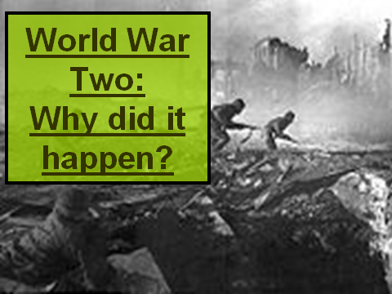
On June 28, 1914, a Serbian nationalist named Gavrilo Princip assassinated Franz Ferdinand, the Archduke of Austria, in Sarajevo. Exactly one month later, Austria-Hungary declared war on Serbia. The war divided Europe into two armed camps - on one side was the Triple Alliance made up of Germany, Austria-Hungary and Italy, and their enemy was the Triple Entente of France, Russia and Great Britain. As other countries began to join sides, the Triple Alliance became known as the Central Powers and the Triple Entente became the Allied Forces.
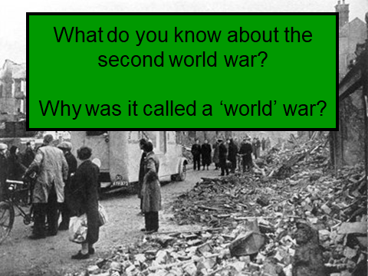
________________________________________________________________________________________________________________________________________________________________________________________________________________________________________________________________________________________________________________________________________________________________________________________________________________________________________________________________________________________________________________________________________________________________________________________________________________________________________________________________________________________________

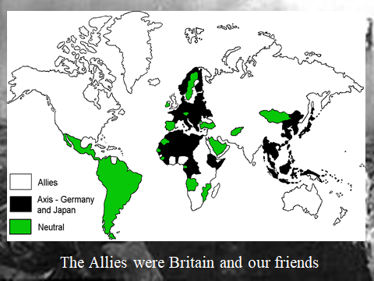
Mozambiqie, Angolia, Saudi Arabia, Mexico, South America, Sweden, Mongolia = Neutral

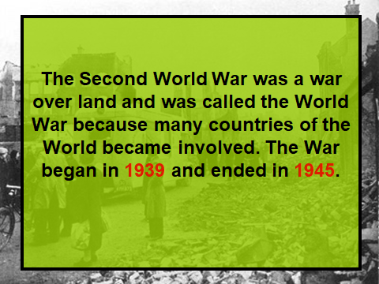
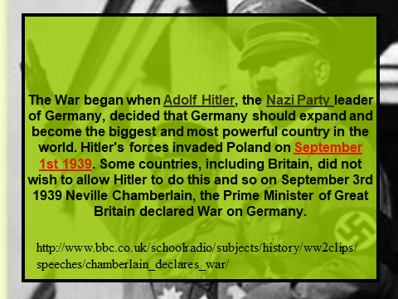 http://www.bbc.co.uk/schoolradio/subjects/history/ww2clips/speeches/chamberlain_declares_war/
Extra information:
Conflicts: During the 1930's there were many wars erupting in the world. Civil war had broken out in Spain. Japan and China were at war over land and Germany started to reclaim what it saw as its land. The First World War: Germany lost the First World War to Britain and her allies. Germany had to pay a fine, over £6 000 000, for starting the war and give up some of its land and could only have a few soldiers and a small navy. They also had to sign rules on how to behave, this was called 'The Treaty of Versallies'. The Depression: During the 1930's, millions of people lost their jobs around the world. Money became hard to find and so did food. It became so bad in one town called Jarrow that some men marched to London to tell the Prime Minister how unhappy they were. Banks closed and people lost their savings. In Germany, a whole suitcase of money could only buy a basket of shopping. Adolf Hitler: Adolf Hitler became leader of a party of people called Nazis. They believed that Germany should take the land back that they had to give away after the First World War. He told people if they followed him they would have jobs. He said he would reclaim land and money for the German people.

Write a short speech explaining which reason you think is the main one for causing the World Wars.
___________________________________________________________________________________________________________________________________________________________________________________________________________________________________________________________________________________________________________________________________________________________________________________________________________________________________________________________________________________________________________________________________________________________________________________________________________________________________________________________________________________________________________________________________________________________________________________________________________________________________________________________________________________________________________________________________________________________________________________________________________________________________________

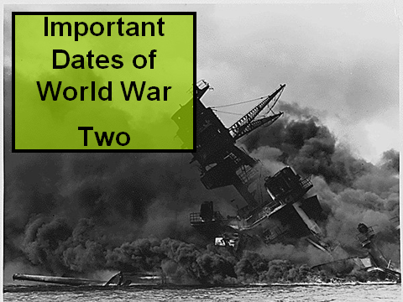
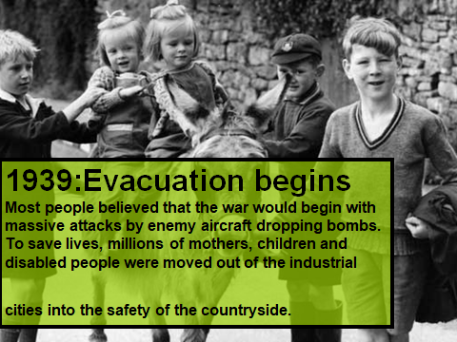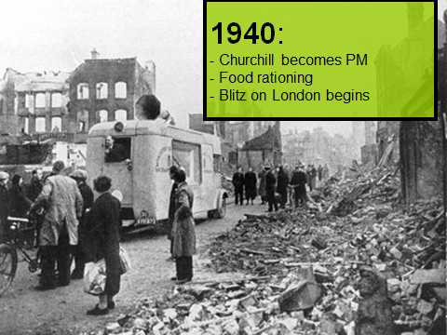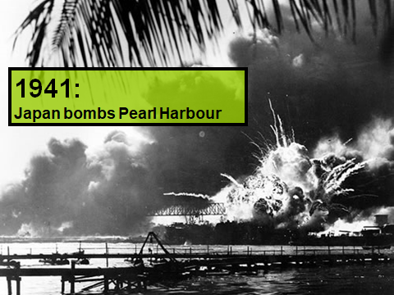
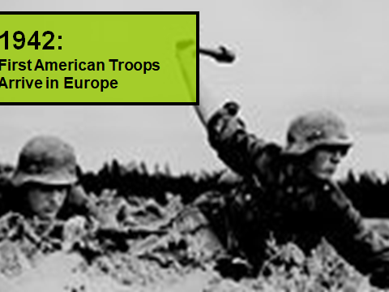
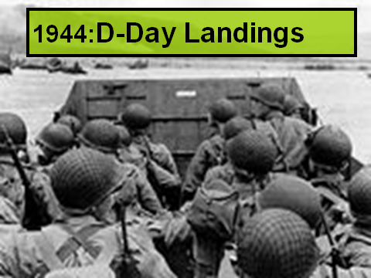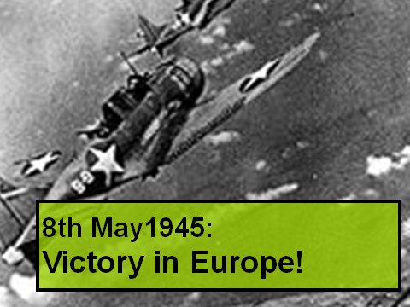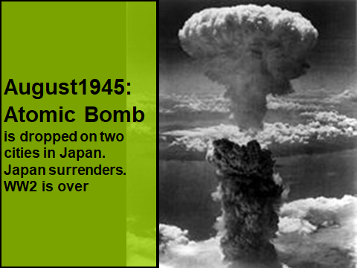
Take a look at the timeline for lesson 1. Read through it to get a sense of timing and the events that occurred.
Take a look at these sites and video links:
https://libguides.tts.edu.sg/c.php?g=358385&p=2420110
https://www.youtube.com/watch?v=6jSsk3NtMLo
https://www.youtube.com/watch?v=8Ku2BYMLkH4
http://www.primaryhomeworkhelp.co.uk/Britain.html
https://www.natgeokids.com/uk/discover/history/general-history/world-war-two/
https://www.dkfindout.com/uk/history/world-war-ii/
Write a newspaper article using your research from today’s lesson. Later on in the unit you can look back at this article and edit adding new facts, biased viewpoints etc. Write the article as if it is the first time anyone has heard of WWII so it needs to include the key facts: what/when/where/who/why? Make sure to ensure you engage the reader (use quotes, vary sentences etc).
The very last page of this pack has some key facts. Check that you have included them.

World War 2 Facts
1939
- Hitler invades Poland on 1 September. Britain and France declare war on Germany two days later.
1940
- Rationing starts in the UK.
- German 'Blitzkrieg' overwhelms Belgium, Holland and France.
- Churchill becomes Prime Minister of Britain.
- British Expeditionary Force evacuated from Dunkirk.
- British victory in Battle of Britain forces Hitler to postpone invasion plans.
1941
- Hitler begins Operation Barbarossa - the invasion of Russia.
- Japan attacks Pearl Harbour, and the US enters the war.
1942
- Singapore falls to the Japanese in February - around 25,000 prisoners taken.
- American naval victory at Battle of Midway, in June, marks turning point in Pacific War.
- Mass murder of Jewish people at Auschwitz begins.
1943
- Surrender at Stalingrad marks Germany's first major defeat.
- Italy surrenders, but Germany takes over the battle.
- British and Indian forces fight Japanese in Burma.
1944
- Allies land at Anzio and bomb monastery at Monte Cassino.
- D Day: The Allied invasion of France. Paris is liberated in August.
1945
- Auschwitz liberated by Soviet troops.
- Russians reach Berlin: Hitler commits suicide and Germany surrenders on 7 May.
- Truman becomes President of the US on Roosevelt's death, and Attlee replaces Churchill.
- After atomic bombs are dropped on Hiroshima and Nagasaki, Japan surrenders on 14 August.

