L.O To know the unit of measurement for (electrical) power
To be able to estimate the wattage of household appliances
HOM: Remaining Open to Continuous Learning

All of the electrical appliances in our homes have a wattage, and the wattage of an appliance tells us how much power is needed to operate it – the higher the wattage, the more power is needed to operate the appliance
Have you ever noticed the wattage of an appliance, and if you have, what was the appliance was and what wattage was it?
__________________________________________________________________________________________________________________________________________________________________________________________________________________________________________
Have a look around your home can you find some appliances that you think would have a low wattage, why do you think this is?
__________________________________________________________________________________________________________________________________________________________________________________________________________________________________________________________________________________________________________________________________________________________________

Can you find some appliances around your homes that you think would have a high wattage, and why do you think this is?
_____________________________________________________________________________________________________________________________________________________________________________________________________________________________________________________________________________________________________________________________________________________________________________________________________________________________

Appliances that are louder / hotter / brighter / move more, usually require more energy (although newer more energy efficient appliances may actually outperform older less energy efficient appliances, due to improvements in their design e.g. energy efficient light bulbs).
Different types of the same appliance will have different wattages, the wattages given on the worksheet you are going to use today are rough averages
On the next page you will find pictures of appliances and some wattages. Can you match the appliance to the correct wattage?
NOTE: the clothes dryer is one that uses hot air, as opposed to a tumble dryer or a washing machine.

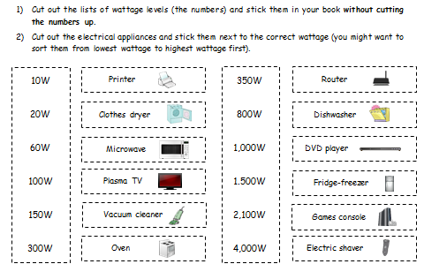

L.O To know the dangers of electricity
To know how to keep safe around electrical items
Remaining Open to Continuous Learning
Fill in the bubble map with what you know about the dangers of electricity and how we can stay safe around electrical items.
Watch the video on the dangers of electricity at http://www.bbc.co.uk/education/clips/zg84d2p
https://www.bbc.co.uk/bitesize/clips/z8kc87h
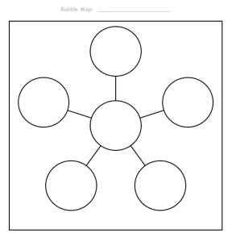

Read through the information text on ‘The Dangers of Electricity’. Annotate the text especially noting definitions for words you don’t know.
The Dangers of Electricity!
Introduction
The human body is a good conductor of electricity. This is helpful for the brain when it wants to send signals through our nervous system, but it makes us vulnerable in other situations, as our bodies are not designed to conduct high levels of current. When someone receives a harmful electric shock, this is known as electrocution. If someone is being electrocuted (even though you will want to help the person) you should never touch him or her, as this will mean that you will be electrocuted too. Here you will find out why electricity is dangerous, what electrical experts do to keep us safe and what you can do to keep yourself safe.
Electricity warning sign
Lightning
A bolt of lightning contains a huge electrical charge, which is strong enough to destroy buildings, bring down trees, start fires and even to kill people! Since lightning always takes the shortest route to Earth, tall things like buildings and trees are most likely to be hit. Because of this, lightning very rarely strikes people. Buildings often have a lightning conductor fitted to the top of them, which safely diverts the charge. When the lightning strikes the rod, the charge is carried along cables from the rod and into the ground, where it does no damage. Conducting a dangerous charge into the ground in this way is called ‘earthing’. To stay safe in an electrical storm, people should stay away from trees and not use umbrellas, as the metal in the umbrella can act as a lightning conductor. Wearing wellies also protects people, as the rubber in the wellies is an insulator and acts as circuit-breaker, preventing a complete circuit between the person wearing them and the ground.
Tree damaged
by lightning
Water
Water is actually a good conductor of electricity. While this might be helpful for animals like the electric eel or the elephantnose fish, it makes using electrical devices near water dangerous for us (unless they have been specially adapted to be used in or near water). Because of this, you should never use devices that have not been adapted in this way near water, like in the shower or in the sea. Also make sure that your hands are always dry when you use anything electric.
Pylons
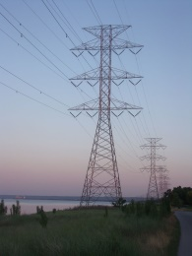
Steel pylons carry cables that have very high levels of current running along them. As it is a metal, steel conducts electricity. If the cable was just left touching the steel pylon, the pylon would conduct the electricity. Any person or animal that touched the pylon would be severely hurt or killed. To avoid this, ceramic disks are placed between the pylon and the cables. As an insulator, the ceramic tiles prevent the current flowing through the pylon, making it safer for people and animals. However, if someone climbs the pylon and touches a cable or does this by accident with a kite or a pole, they will be at severe risk. Overhead railway lines are dangerous for the same reasons.
Pylons
Electrical wire
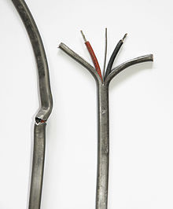
Electrical wire is made from conducting materials (most often copper), but is wrapped in material that is an insulator, like plastic. This allows us to handle the electrical wire without getting an electric shock. You should never pull or cut the insulation around a wire or a cable, as this makes you vulnerable to being electrocuted. If a wire becomes exposed due to an accident or because of ‘wear and tear’, it needs to be repaired or replaced.
Damaged insulation

Fuses
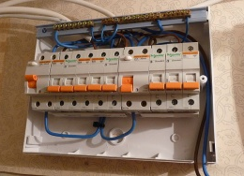
So that they do not waste energy, electrical cables have low resistance. However this also makes them potentially dangerous, since it means that they can carry large currents. If precautions are not taken, a surge of current can damage equipment or start a fire. One precaution that is found in all electrical plugs is a fuse. Most fuses melt when the current gets too high. This breaks the circuit and stops the current flowing. For the device attached to the plug to work again, the plug needs to be replaced. Our homes also contain fuse boxes, with fuses for different parts of the home. If someone needs to work on the wiring in a particular part of the house, they can turn the electricity off to that part of the property by flicking a switch. Have you ever been home and all of the electricity has turned off suddenly, like when a light bulb stops working? This is because the fuse box has turned off the supply of electricity to keep you and your home safe.
Fuse
Fuse box

Plugs
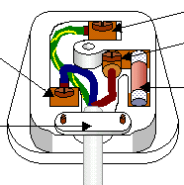
In the UK, plugs contain three wires: the live wire, the neutral wire and the earth wire. The live wires and the neutral wires carry the current. The earth wire is a safety device. By providing a path to the ground if the current gets too large, it keeps us safe. Plugs also contain a fuse. In other countries, plugs only have two pins and two wires: the live and the neutral ones. Never put anything into a plug socket or mess around with them!
UK plug wiring
Electricity as a weapon
Like some animals, people also use electricity as a weapon sometimes. Some police carry taser guns, which immobilise people by delivering a strong electric shock. Although taser guns are supposed to be non-lethal, people have died after being shocked by them, making them controversial. Electrofishing is a form of fishing where the fish in an area are stunned by delivering a current into the water. Scientists used it to survey the fish population in an area of water, as the fish recover and can be returned to the water unharmed. Criminals have been put to death in an ‘electric chair’. In some states in the USA, death by electrocution is still an option. In Ancient Greece, people believed that lightning bolts were a weapon used by the Greek God Zeus!
Taser gun
Medicine
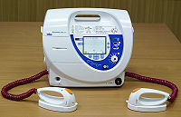
While electricity can be used to harm people, it can also be used to help them. A defibrillator can re-start a person’s heart if it has stopped by delivering a small electric shock. Electrocardiograms (ECGs) are also used by doctors to detect the rhythm of the electrical activity in a person’s heart to check for heart problems.
Defibrillator
Summary
So remember that although electricity is incredibly useful, it is also potentially very dangerous, and even lethal! As long as you remember the advice and the tips that you have read, you will be perfectly safe, so don’t worry too much! If you have younger siblings or relatives, you can help to keep them safe by teaching them what you have learnt. Even some adults that should know better still take risks with electricity, so don’t be afraid to tell them if you see them doing the wrong things!

On the next two pages are the questions and answer sheet to go with today’s lesson. Please answer all the questions carefully to demonstrate your understanding of today’s work.
Know the dangers of electricity
- Give two reasons that the human body is vulnerable to electricity.
- What is electrocution?
- Why should you not touch someone who is being electrocuted?
- What is the process of conducting a dangerous charge into the ground called?
- Name two things that you should not do when there is lightning.
- What property of water makes it dangerous to use electricity near or in it?
- Why is it dangerous to fly a kite near a pylon or a railway line?
- Why is it dangerous to use anything where the cable’s insulation is damaged?
- How does a fuse keep us safe if there is a surge of current?
- What two safety features does a UK plug have?
- What is a taser gun designed to do?
- How does a defibrillator work?
Extension ( pick 2)
- Why can birds sit on electrical cables without being electrocuted?
- Why do people sometimes need to bring plug adaptors with them when they travel?
- Why is electrofishing preferable for scientists to fishing with hooks?
- Why might people with heart problems be particularly susceptible to dying after being shot with a taser gun?
Know the dangers of electricity

- The human body is vulnerable to electricity because

- Electrocution is
- You should not touch someone who is being electrocuted because

- The process of conducting a dangerous charge into the ground is
- Two things that you should not do when there is lightning are

- Water’s ability to

- It is dangerous to fly a kite near a pylon or near a railway line because

- It is dangerous to use anything where the cable’s insulation is damaged
because
- A fuse keeps us safe if there is a surge of current by

- A UK plug has two safety features:
- A taser gun is designed to
- A defibrillator works by

