Lesson 3
The final part to designing your package is the nutritional label on the back. The next page has some examples.
It must clearly show:
The ingredients.
Nutritional value – look online to work these out.
Allergy advice

What will your label look like?

If you can make your wrap at home, maybe take a picture and send it to us at the school email address.

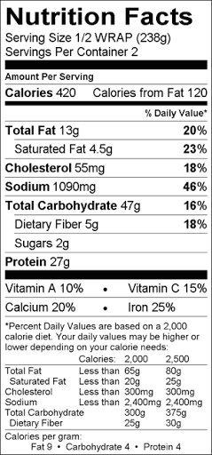
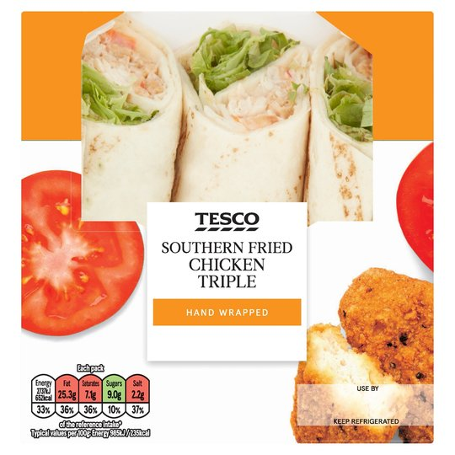

Now you need to write your pitch.

When facing the dragons you will need to prepare a script outlining – what your product is
- Why it is healthy (nutritional values) ?
- Why it is affordable?
- What makes it unique from the other designs?
- Why your packaging is not wasteful?
Create a script for this. Remember to be persuasive!
__________________________________________________________________________________________________________________________________________________________________________________________________________________________________________________________________________________________________________________________________________________________________________________________________________________________________________________________________________________________________________________________________________________________________________________________________________________________________________________________________________________________________________________________________________________________________________________________________________________________________________________________________________________________________________________________________________________________________________________________________________________________________________________________________________________________________________________________________________________________________________________________________________________________________________________________________________________________________________________________________________________________________________________________________________________________________________________________________________________________________________________________________________________________________________________________________________________________________________________________________________________________________________________________________________________________________________________________________________________________________________________________________________________________________________________________________________________________________________________________________________________________________________________________________________________________________________________________________
Think ahead:
What questions might you be asked by the dragons?
__________________________________________________________________________________________________________________________________________________________________________________________________________________________________________________________________________________________________________________________________________________________________________________________________________________________________________________________________________________________________________________________________________________________________________________________________________________________________________________________________________________________________________________________________________________________________________________________________________________________________________________________________________________________________________________________________________________________________________________________________________________________________________________________________________________________________________
What answers would you give?
__________________________________________________________________________________________________________________________________________________________________________________________________________________________________________________________________________________________________________________________________________________________________________________________________________________________________________________________________________________________________________________________________________________________________________________________________________________________________________________________________________________________________________________________________________________________________________________________________________________________________________________________________________________________________________________________________________________________________________________________________________________________________________________________________________________________________________________________________________________________________________________________________________________________________________________________________________________________________________________________________________________________________________________________________________________________________________________

