L.O. To identify the main figures in World War II
HOM: Remaining Open to Continuous Learning
Read these slides to gather some information on the leaders during World War II.
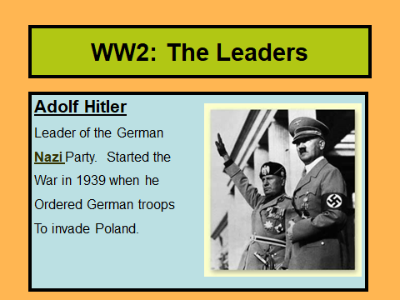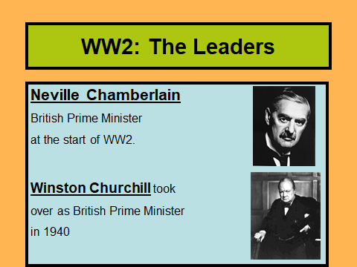
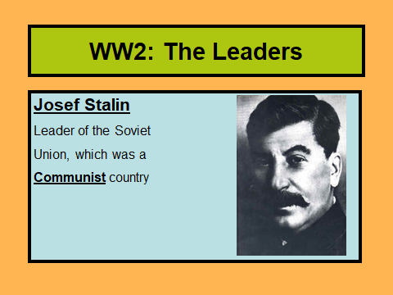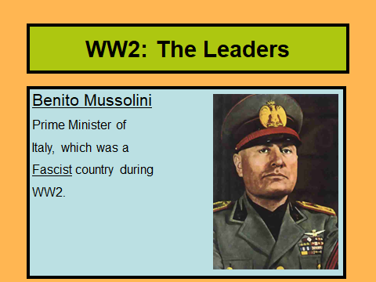
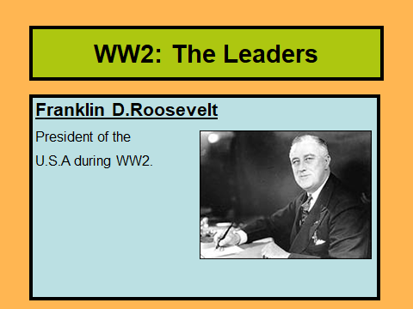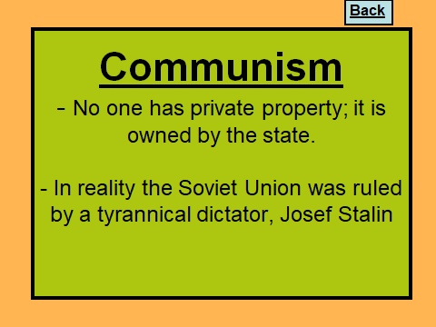
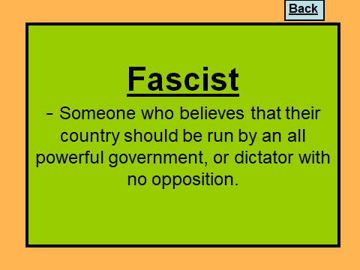
Let’s find out more about these key figures involved in World War II.
-Adolf Hitler served in the Bavarian army during World War I and rose to become the leader of Nazi Germany during World War II. Under his leadership, the Nazis sought to make Germany the most powerful empire in the world and exterminate all they viewed as inferior. In pursuit of this, he ordered the extermination of over 11 million people, the majority of them Jewish, but also including Roman Catholics, Roma (gypsies), Jehovah's Witnesses, homosexuals, the physically and mentally handicapped, and any others who did not meet Hitler's standards for "racial purity."
-Arthur Neville Chamberlain was Prime Minister of Great Britain in September 1939 at the start of World War II. In May 1940, after the disastrous Norwegian campaign, Chamberlain resigned and Winston Churchill became prime minister. Members of the House of Commons saw him as an uninspiring war leader. He was blamed for loss of Norway to the Germans. Chamberlin realised that a National Government of all political parties was mandatory. In May 1940 members of the Labour Party and Liberal Party refused to serve in his proposed National Government. Chamberlain resigned realisng that a National Government would not be possible as long as he was leader. He was replaced by Winston Churchill.
-Winston Churchill was Prime Minister of Great Britain during most of the war, from 1940 to 1945, Churchill led Britain to victory. During the Battle of Britain, Churchill's speeches boosted the British morale during the darkest moments.
Take a look at these links for more information, make notes:
http://resources.woodlands-junior.kent.sch.uk/homework/war/leaders.html
http://www.bbc.co.uk/schools/primaryhistory/famouspeople/winston_churchill/

What impact do you think World War II has had on our lives today? Support your views with factual evidence.
________________________________________________________________________________________________________________________________________________________________________________________________________________________________________________________________________________________________________________________________________________________________________________________________________________________________________________________________________________________________________________________________________________________________________________________________________________________________________________________________________________________________________________________________________________________________________________________________________________________________________________
Choose either Adolf Hitler or Winston Churchill, you are going to write their biography.
This is a link to an example of a biography for Adolf Hitler:
http://www.biography.com/people/adolf-hitler-9340144
Think about how you will set out your work, how will you ensure it is in chronological order? Do you need subheadings?

