L.O. To identify patterns in codes , code breaking

HOM: THINKING FLEXIBLY

You will need to read the following slides first:

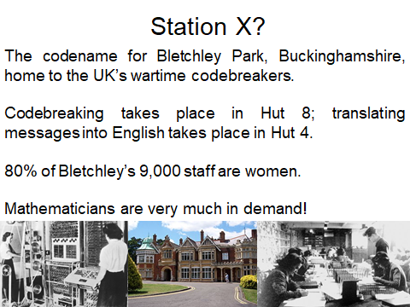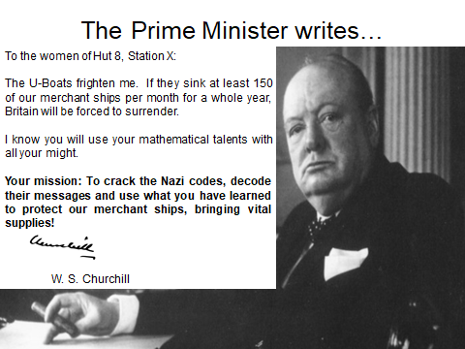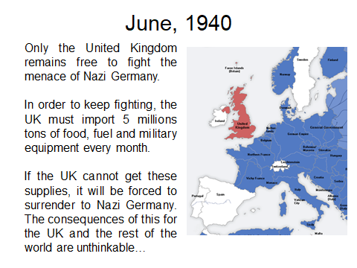  


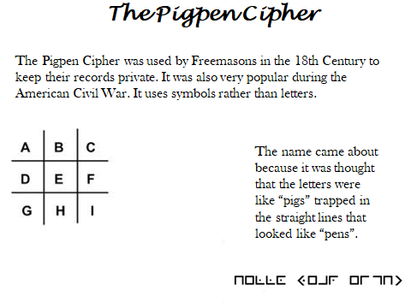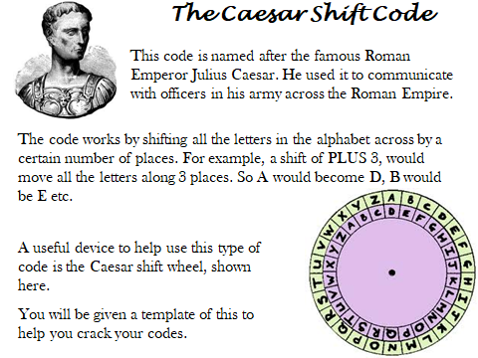

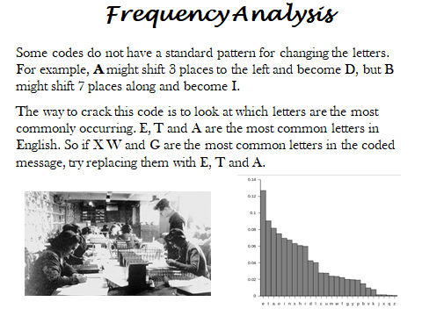

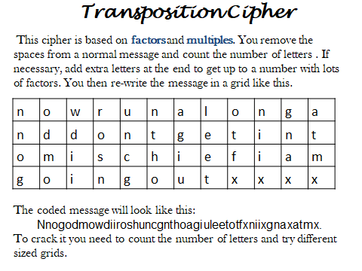

Have a look at this maths link; it also explains code breaking similar to above.

<http://nrich.maths.org/2197>

CAN YOU BREAK THE CODES ON THE NEXT PAGE?



**The Caesar Shift Code**

Use your Caesar Shift Wheel to help you crack these codes. Write out the coded message giving yourself LOTS OF SPACE in you book. Spread out the letters in each word, but leave a big gap between the words so that they don’t get muddled up. Then write out the de-coded message underneath.

**(*Tip – to figure out how many places the wheel has moved, pick a three letter word and try common three letter words such as THE, AND, HAS and USE.)***

**1) Message from 1940**

XLI YO LEW MRZEHIH MGIPERH WS XLI VEJ GER YWI MX

EW E FEWI XS TVSXIGX WLMTW MR XLI GIRXVEP

EXPERXMG

**2) Message from 1941**

QVSSF NVVK ZOVD! OHZ OTZ IBSSKVN OHZ JHWABYLK

H B IVHA, PUJSBKPUN HU LUPNTH JVKL THJOPUL!

**3) Message from 1945**

LZW OSJ AK GNWJ. 3,500 MC EWJUZSFL KZAHK OWJW

KMFC, SFV 25% GX LZWAJ UJWOK OWJW CADDWV

**EXTENSION: CREATE YOUR OWN CAESAR SHIFT WHEEL**