LAST WEEKS CODE ANSWERS:
1940. The UK has invaded Iceland so the RAF can use it as a base to protect ships in the central Atlantic.
1940 XLI YO LEW MRZEHIH MGIPERH WS XLI VEJ GER YWI MX EW E FEWI XS TVSXIGX WLMTW MR XLI GIRXVEP EXPERXMG (ceasar shift)

1940. The Royal navy uses new technology to try to detect U boats before they attack.
1940 tnnorcbehaelyteyevwotufarytgobotoueydortyscteaeaaehotttclsnteshk (transposition 8x8)

1941. Operation ULTRA has been set up at Bletchley Park to break German codes and locate their U Boats.

1941. Jolly good show! HMS Bulldog has captured a U Boat, including an Enigma Code Machine!
QVSSF NVVK ZOVD! OTZ IBSSKVN OHZ JHWABYLK H B IVHA, PUJSBKPUN HU LUPNTH JVKL THJOPUL! (ceasar shift)

1942. The situation is critical. U Boats are hunting our ships in groups called wolf packs.

1942. The use of rationing in the UK means imports are reduced by 50 percent.
tomafhnerieiaefunnrtsgseyeiidponmueftpcrhoecaerdetutbniksyt
(transposition 5 x 12)

1943. The situation is critical. UK fuel supplies are dangerously low. Germans change Enigma codes.
FHXZAFUTAAANBZUDIMPUMLSBCRUXSKGPISAQSTYWPAGNWDONZDKLHDRSEKTSZSVOSZGXLFUGFHUADXZR (Vignere square using keyword MATHS)

1943. The UK and USA build another forty two million tons of merchant ships
RBU XI MTN XVM ZXESN MTWRBUK CWKRP RJW GESSEWT RWTV WC GUKYBMTR VBEDV (mono-alphabetic cipher – can only be cracked by looking at letter frequencies and commonly occurring words. This sentence contains the words “the” and “and” which should be used as clues, as well as the words UK and USA)

1945. The war is over. 3,500 UK merchant ships were sunk, and 25% of their crews were killed.
LZW OSJ AK GNWJ. 3,500 MC EWJUZSFL KZAHK OWJW KMFC, SFV 25% GX LZWAJ UJWOK OWJW CADDWV (cesar shift)

1945. Eighty seven percent of German U Boats were destroyed, and eighty two percent of their crews killed or captured.
etvengaowdrdetocoeridariyertenaeeoaiypefielopegrncorutrsyngtentrwlrtdhepefmbsetedhwrthckecux (transposition 23 x 4)

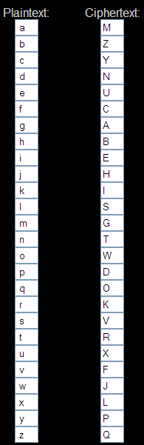

LESSON 4
L.O. To compare and contrast the lives of the children in WW2 with children today
HOM: Thinking and Communicating with Clarity and Precision
What do you think it would have been like for children in WWII?
______________________________________________________________________________________________________________________________________________________________________________________________________________________________________________________________________________________________________________________________________________________________________________________________________
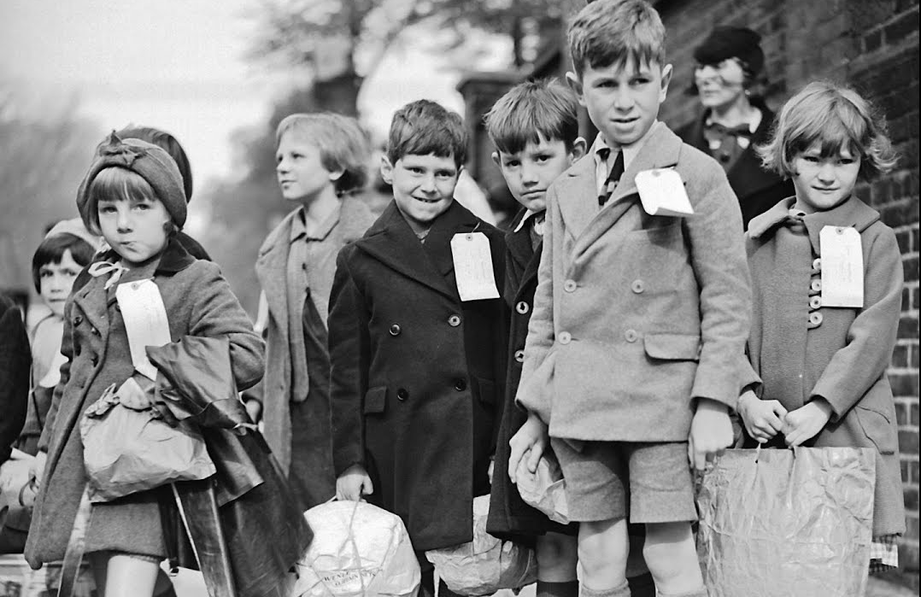
Who was an evacuee? The evacuation of civilians in Britain during the Second World War was designed to protect people, especially children, from the risks associated with aerial bombing of cities by moving them to areas thought to be less at risk
What questions would you ask these evacuees?
_________________________________________________________________________________________________________________________________________________________________________________________________________________________________________________________________________________________________________________________________________________________________________________________________________________________________________________________________________________________________________________________________________________________________________________________________________________________________________________________________________________________________________________________________________________________________________________________________________________________________________________________________________________________________________________________________________________________________________________________________________________________________________________________________________________________________________________________________________________
Have a look at these links:
https://www.youtube.com/watch?v=HFBlvWkNEKU
https://www.thehistorypress.co.uk/articles/the-evacuation-of-children-during-the-second-world-war/
https://www.youtube.com/watch?v=ijh7_OrM23I
http://www.historylearningsite.co.uk/children_and_world_war_two.htm
Make notes on the life of an evacuee.
Complete the double bubble map on the next page comparing the life of children in WWII to the life you have.
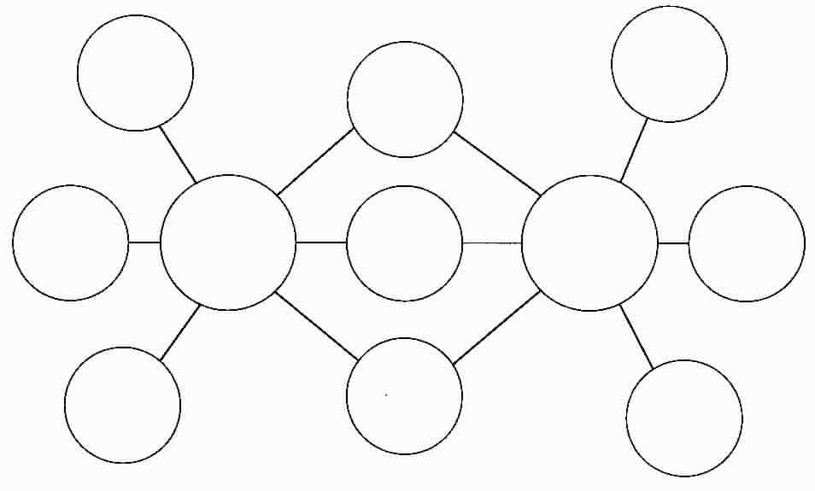
Using your notes on the life of an of a child in World War II. You are going to write a diary entry from the point of view of an evacuee. Your diary entry should think about the daily routine of an evacuee, their emotions, and who do they miss? Please stick to the factual evidence you have found out about the life of an evacuee.
On the next few pages are examples of some diary entries. Please do not copy them.
Friday 23rd September 1940
Dear Diary,
Well… somebody picked me… and I wasn’t even last!
Though I’m afraid the good news stops there.

When we arrived at Penzance, we had to walk with our cases and gas masks and all of our other belongings down a lane to a large village hall. There, we had to line up and wait until somebody chose us. I watched all the grown-ups enter and immediately decided on the ones I wanted to pick me. They were a handsome looking young couple with big smiles on their faces and they seemed genuinely excited about taking home a little child. You won’t honestly believe this diary but they took home smelly Jimbo Hargreaves! My heart sank into my stomach. I guess they must have wanted a dirty little boy to destroy their home!

I got chosen not long after by quite an old, but admittedly very kind looking lady, who told me to call her Granny Fisher. We walked through the village all the way to the giant house at the top of the hill and I thought ‘Wow – haven’t I done well here?!’ It really is ginormous – the size of my school back in London! It’s beautiful too. All the floors are polished wood, giant gold-framed portraits hang on the walls and all the curtains and seats are covered in plush red velvet.

However it turned out that Granny Fisher is simply the house maid and I got taken to meet the man who actually owns the house and he wouldn’t even look at me. His name is Mr Grant and I think he is miserable and sour because his son has been sent off to fight and he never writes to him. I think maybe he’s worried that he won’t come back.
Anyway, he won’t talk to me and all he likes me to do is sit and read silently. You know I love to read diary, but no one can possibly do it as much as he’d like me to. I suppose I don’t do any reading at school so I should sometimes. If you can even call it school! All of us evacuees have to return to the church hall each day where we get taught by the local reverend. He’s very kind but utterly hopeless at controlling those raucous boys so we never do any learning.
I’m wondering when I’ll be allowed to go home. I shan’t be able to stay here for very long, otherwise I might lose my voice from lack of speaking! Perhaps I’ll go and find Granny Fisher and she might talk to me.
So long diary, Lauren

Friday 16th September 1940

Dear Diary,
I can’t believe this has actually happened. I’m on a train heading south and I have to stay there for a very long time. It’s called evacuation- that means sending the children away to the country to avoid all of the bombing.

I can understand why they are doing it but I am still utterly miserable. Mother says that it might only be for a little while but I don’t think she was quite telling the truth. The Germans are bombing London and all of the other cities day and night and whatever Prime Minister Churchill says on the wireless, I know that victory parties are a very long way off. Mr Hitler is proving much more trouble than we first thought!

I’m going to somewhere called Penzance in Cornwall and that’s all I really know. I tried to be brave when Mother and little Peter took me to the platform and put me on the train. I even kept my composure when Mother told me ‘Stay safe. I love you my darling’ but now I’m in a train carriage all by myself and I can’t hold back the tears anymore.

Some of the boys from my class at school are racing around, laughing raucously and shouting about what an amazing adventure it is. Silly boys. Obviously they don’t know that when we get there, we’ll be taken to a hall and people only pick the nice looking children. No one will ever pick smelly Jimbo Hargreaves. He looks and smells like he lives with Farmer Gibbins’ pigs!

I must get myself together or I’ll look an awful state by the time we get there and no family shall want to take me home. That’s my biggest worry. What if no one wants me? What if I’m just left there like the stray dog nobody wants? My heart is filled with anxiety and distress and I can’t get myself together.

I wish I could see it all as an adventure…
I’ll write in you later diary, when hopefully someone might have chosen me!
Lauren

Saturday 10th September 1940
Dear Diary,
It seems like so long ago that Prime Minister Chamberlain made his speech over the wireless to declare that we were at war; however it only seems real now that bombs are falling like rain every hour of the day.
Yesterday, I was just half way to school when the piercing sirens slammed against my ears and I was forced into a decision about whether to run back home or carry on to school. Just a few moments thinking about that damp, dark Anderson shelter at the bottom of the garden had me running as fast as my legs would carry me onwards to school. I don’t mean to sound truly horrid, but with father away at war and mother looking after little Peter, there really is no one to talk to me and comfort me when the sky fills with fire! The shelter at school is so packed with children, but at least I can have whispered conversations with my friends.
The sound of the dreaded bombs dropping doesn’t fill me with quite so much fear anymore. It used to have me cowering in a corner but I have grown used to it now, as it has become part of everyday life. Almost like the measly rationed food and this cumbersome gas mask which I must carry everywhere. The only exception is when the bombs drop close by. Then you can hear the deafening explosions and see the sky turn red and that is simply miserable.
I must go now diary. The Williams family has had to move in with us, since their house was flattened by a bomb just a few days ago. It is simply rotten that they have nowhere to live, but I’m not sure that it makes it acceptable for the boys to run around screaming like maniacs – I can’t even think straight! I wish we were at school so Mrs Hardacre would belt them with the cane…
…Ok, maybe that was too mean. But they keep thrusting bubble gum in my face that they got from the yanks when they convoyed past school yesterday and I’m starting to feel a little bitter. I’m sharing my home and they can’t even share their sweets…
Anyway diary, I must go.
Lauren
Dear Diary,
_______________________________________________________________________________________________________________________________________________________________________________________________________________________________________________________________________________________________________________________________________________________________________________________________________________________________________________________________________________________________________________________________________________________________________________________________________________________________________________________________________________________________________________________________________________________________________________________________________________________________________________________________________________________________________________________________________________________________________________________________________________________________________________________________________________________________________________________________________________________________________________________________________________________________________________________________________________________________________________________________________________________________________________________________________________________________________________________________________________________________________________________________________
__________________________________________________________________________________________________________________________________________________________________________________________________________________________________________________________________________________________________________________________________________________________________________________________________________________________________________________________________________________________________________________________________________________________________________________________________________________________________________________________________________________________________________________________________________________________________________________________________________________________________________________________________________________________________________________________________________________________________________________________________________________________________________________________________________________________________________________________________________________________________________________________________________________________________________________________________________________________________________________________________________________________________________________________________________________________________________________________________________________________________________________________________________________________________________________________

