How to do Lectio Divina (Holy Reading)
Lectio Divina is Latin for "Divine Reading" and is the practice of scriptural reading, meditation and prayer to deepen knowledge of God's Living Word.

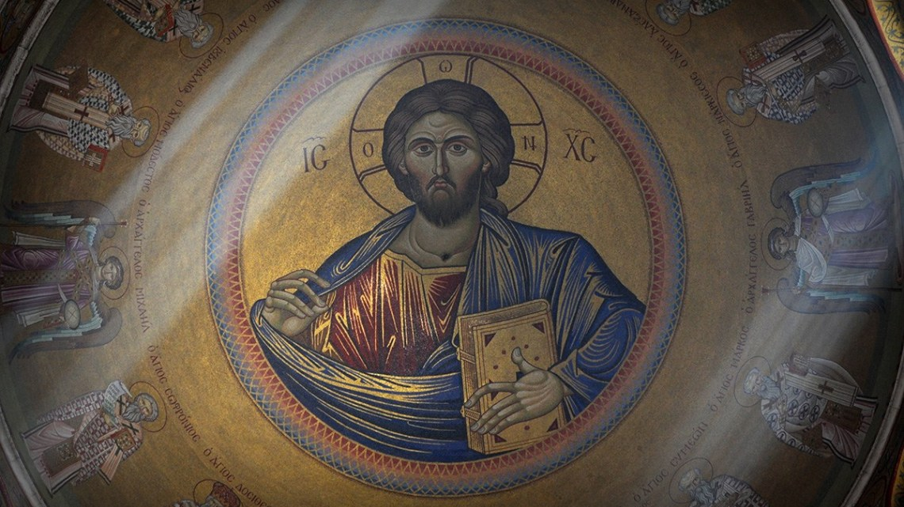
There’s no strict method to Lectio Divina, but the steps in this article may help you pray with the Scriptures on your own or in a group.

Choose a short Bible passage
Decide how long you are going to set aside for prayer.

Opening Prayer
Opening prayer from a Psalm or your heart. Sitting comfortably, invite the Holy Spirit to guide your reading and to open your heart and mind.

First reading (Lectio)
Read the passage aloud or in silence, then sit for a while in silence. Be open to God’s presence in stillness. What is God saying through this text and the events of this day? What did the text mean to its first readers/listeners, and what does it mean today?

Second reading (Meditatio)
A time of reflection. Note any word or phrase that touches your heart. Reflect silently why it might be significant for you. You may wish to speak just that word or phrase aloud.

Third reading (Collatio)
A time of sharing, if praying with others. Share some of your impressions and reactions about the text if you wish. This is not a time for debate or study, but rather for personal and community reflection.

Fourth reading (Oratio)
A time for spoken or silent prayer of the heart. Your prayer may be one of repentance, thanksgiving, intercession, or however the Spirit moves you.

Fifth reading (Contemplatio)
Spend a good while resting in God. As much as is ever possible, try to clear your mind – even of the text itself – and enter into the silence where God is seeking you. Giving God your ‘intention’ is more important than your ‘attention’, so if you get distracted gently give back your intention to God by silently saying your chosen word or phrase.

Sixth reading (Actio)
In silence try to discern if God is calling you to make some kind of action or commitment in your life. How will the Word bear fruit?

Closing prayer
A time in prayer to thank God for this encounter with the Word.

