St.Mary’s Nursery Spring Term 2024

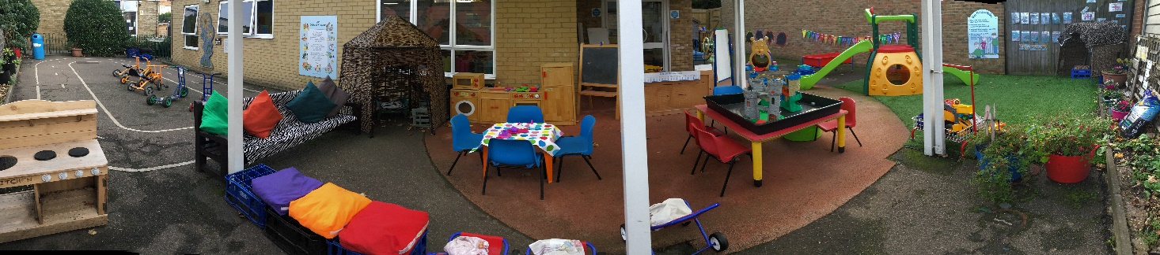

Dear Parents/Carers,

Welcome back to a new term in Nursery.

We hope you are all safe and well.

This Spring term we will –

Be investigating and exploring the season of Spring, looking at the changes in weather, plants, trees and new life.

We will have a Traditional Tales focus each week, starting with Goldilocks and the three bears. Activities will be linked to both literacy and maths concepts.

**RE Topic will include –**

**Term 1 ‘Galilee to Jerusalem’**

We will be exploring the feast of the Epiphany.

We will learn the ‘Glory Be’ prayer and talk about what the words mean.

We will look for God in the people who care for us and the world around us.

**Term 2 ‘Dessert to Garden’**

Shrove Tuesday – making pancakes

Ash Wednesday – receiving ashes

Lent – colour purple, promises for lent

Palm Sunday- making palm leaves, acting out story

Holy Thursday – foot prints, washing of feet

The Last Supper – acting out story

Good Friday- making a cross

Easter Sunday – make an Easter garden

Please ask us any questions and give us feedback.

Many Thanks

Best wishes

Nursery Team