St.Mary’s Nursery Summer Term 2025

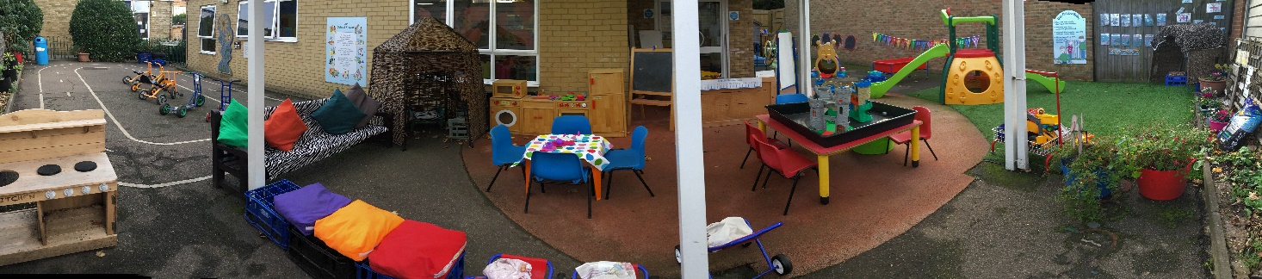

Dear Parents/Carers,

Welcome back to a new term in Nursery.

A warm welcome also to all of our new families starting in our nursery this term.

**First half term our focus books we will be.**

Little Red Riding Hood – first two weeks

The Very Hungry Caterpillar – middle two weeks

The Three Billy Goats Gruff – last week

Activities will be linked to these stories to cover all areas of the Early Years curriculum.

**RE Topics are;**

**First half Term - ‘To the ends of the Earth’.**

We will be learning about Ascension and Pentecost.

We will come to know that the Holy Spirit is our friend who looks after us.

**Second** **Half Term – ‘Dialogue and Encounter’**

We will hear about St Peter and St Paul, friends of Jesus.

We will talk about our faith with others and why our faith is important to us.

**Second half term our focus books will be –**

First week back – continue with the Three Billy Goats Gruff

The Frog Prince – next two weeks

Dinosaurs Day Out – week four

Dear Zoo – week five

Maisy’s Holiday – week six

Grandma’s Beach – week seven

Activities will be linked to these stories to cover all area of the curriculum.

**After May half term, we will be thinking about days out and holidays.**

We will be investigating and exploring the season of Summer, looking at the changes in weather, plants, sunflowers and minibeasts.

Towards the end of the Summer Term we will have a pretend beach outside in our garden.

Please ask us any questions and give us feedback.

Thank you for your continued support.

Many Thanks

Mrs Whytock