ST MARY’S CATHOLIC PRIMARY SCHOOL

NEWSLETTER July 2020

Welcome to a new month in school, the month of the Precious Blood of Our Lord Jesus Christ. I hope you and your family are well and that all is going well at home.

It is just a little under three weeks to go now to the end of the school year, a very different year for all of us – a time to value family and friends more than ever and to reach out to help others when we can.

Classes for next year

Nursery: Mrs Whytock and Mrs Linnane

Reception (Hope): Mrs Rowley

Reception (Grace): Mrs Healy

Year 1 (Wisdom): Mrs Keevil (Reception 2019 children)

Year 2 (Fatima): Miss Beckles (Year 1 Green 2019 children)

Year 2 (Faith): Miss Morgan (Year 1, Orange 2019 children)

The infant classes will have new names in September. All names are titles for Our Lady.

Amber = Hope (Our Lady of Hope)
Red = Grace (Our Lady of Grace)
Green = Wisdom (Our Lady Seat of Wisdom)
Yellow = Fatima (Our Lady of Fatima)
Ruby = Faith (Our Lady of Faith)

Year 3 (St. Cecilia): Miss Sheehan (Year 2, Yellow 2019 children)

Year 3 (St. Bernadette): Mrs Falzone (Year 2, Ruby 2019 children)

Year 4 (St. Paul): Ms Joseph (Year 3, St. Bernadette 2019 children)

Year 4 (St. Peter): Miss Soto (Year 3, St. Cecilia 2019 children)

Year 5 (St. Anthony): Miss McAuley (Year 4, St. Peter 2019 children)
Year 5 (St. Joseph): Miss Mullahy (Year 4, St. Paul 2019 children)

Year 6 (St. Catherine): Mrs Martin (Year 5, St. Anthony 2019 children)

Year 6 (St. Christopher): Mrs Brennan (Year 5, St. Joseph 2019 children)

We will say goodbye to Miss Treacy at the end of this school year as she plans to move home to Ireland to live. We wish her well as she moves on to begin a whole new chapter in her life.

We would very much like to welcome all of our children back to school during the last week of the school year.

Although groups of children from all of the groups highlighted by the government (Key Workers, Years 6, 1, R and N) attend school we are very aware that not everyone has had this opportunity and we would like all of our children to have the chance to spend time in school. They will spend this time in their new September classroom with their new class teacher but also hopefully will have the opportunity to say hello and goodbye to their current class teacher.

Of course we will need to do this carefully as the coronavirus is still around so the children will come in in small groups over the last week of the term (from Monday 13th July). Because we have a lot of children at St. Mary’s each group will come in for one session. Start and finish times will be staggered for the groups and we will try to ensure that they will only mix with the children in their own year groups.

In order for this to happen all of the groups which are currently operating in school will have their last week in school next week. Nursery, Reception, Year 1 and Year 6 groups will finish their term on Thursday 9th July and the Key Worker children will finish on Friday 10th July (all of these children will of course also be invited to spend time with their teacher for September too).

Most of these groups are really full now so I regret that we will not be able to add any more children to these groups from Monday 6th July.

We will be in contact with you to let you know when your child’s group is due to be in school to spend time with their new teacher.

Home Learning

As before the half-term break the home learning plan continues to be to make new work available every two weeks which can be accessed on the school website http://stmarysenfield.co.uk/welcome .
Just click on the Home Learning tab on the left hand side of the Welcome page. Scroll down under the relevant year group heading to find the newest work.

You can also look on the class page for additional links which may be helpful. The BBC Bitesize site now also has some good home learning support. https://www.bbc.co.uk/bitesize/dailylessons

The Oak National Academy has recently launched its online classroom and resource hub. The Academy offers 180 video lessons each week for schools to use, across a broad range of subjects. The lessons cover children in Reception through to Year 10 and are free to use by both teachers and young people.
The Oak National Academy can be accessed here:
https://www.thenational.academy/
Please just work through any school work you do at your own child’s pace. Don’t worry if you are not up to date. Just do the best you can. Remember that if you or your child has difficulty accessing the work please contact the school office and we can arrange to have a pack printed off for you to collect from the school.

If you have any questions about the work, need any support or just want to say hello please contact the teacher via the year group e-mail address or via the school address or call us at school. I know the teachers would love to hear from you.

Year Group Addresses:

nursery@stmarys.enfield.sch.uk

reception@stmarys.enfield.sch.uk

year1@stmarys.enfield.sch.uk

year2@stmarys.enfield.sch.uk

year3@stmarys.enfield.sch.uk

year4@stmarys.enfield.sch.uk

year5@stmarys.enfield.sch.uk

year6@stmarys.enfield.sch.uk

Weekly Phone Calls

Continue to expect a call home from your child’s teacher. This is simply to say hello and to keep in touch. Our staff are really enjoying the calls and having the opportunity to catch up with you and your child. They will make their last weekly phone calls for this school year on the week beginning Monday 6th July.

Wednesday Word

Have you started to read ‘The Wednesday Word’ yet?

The Wednesday Word is a gift to you and your family because of your connection with our Catholic school.
Every Wednesday, a ‘word’ (inspired by the Sunday Gospel) will be suggested for you and your family to talk about in your home.

This weekly Family Time is structured around the Sunday Gospel because evidence shows that Gospel values really do help family relationships to thrive.
Regularly spending quality time with children is without doubt one of the most important aspects of parenting. The Wednesday Word seeks to support you in this important task: to help you and your children maintain a special closeness throughout the school years.
The Wednesday Word 'Family Time' leaflet is designed to ensure that all family members feel included. It presents an effective way for even the busiest of parents to enrich relationships with their children through spending a very special 5 or 10 minutes together each week.
We suggest Wednesdays for Family Time because it is the day that the Catholic Church dedicates to St Joseph – the Patron Saint of Families. But rather than miss out, any other night would do just as well.

The Wednesday Word is currently available online:

http://www.wednesdayword.org/index.html

100% Attendance Spring 2020

190 pupils had 100% attendance! Well done children and parents! This is excellent!

Please note that any coronavirus related absence (fear to travel, possible exposure, worry about passing the virus on to other family members etc.) did not affect any child’s attendance record prior to the lockdown in the spring term.

The Angelus

In the summer term we try to learn / say The Angelus each day at 12 noon in all classes from Year 2 (from summer term) – Year 6. This is a wonderful prayer which reminds us that God the Son became man in order to save us.
You might like to say this prayer with your child at home. It can be said in the morning, at noon or in the evening.

The Angelus
The Angel of the Lord declared to Mary:
And she conceived of the Holy Spirit.
Hail Mary…

Behold the handmaid of the Lord:
Be it done to me according to your word.

Hail Mary…

And the Word was made Flesh:
And dwelt among us.

Hail Mary…
Pray for us, O Holy Mother of God.
That we may be made worthy of the promises of Christ.

Let us Pray.
Pour forth, we beseech you, O Lord, your grace into our hearts, that we, to whom the Incarnation of Christ, your Son, was made known by the message of an angel, may be brought by his passion and cross to the glory of his resurrection, through the same Christ our Lord. Amen.

May the divine assistance remain always with us and may the souls of the faithful departed, through the mercy of God, rest in peace. Amen.
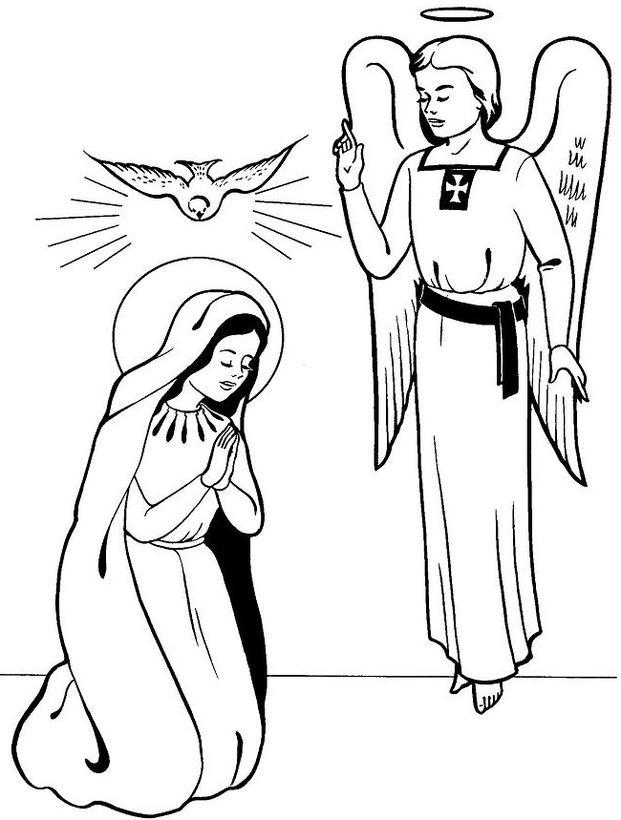

Online Safety at Home
You might find the following links helpful:
Sharing images: new video guides for parents and carers

These new video guides explore the positives and the risks of sharing images online and offer practical advice for parents and carers on:
- What they can do to reduce risks and;
- How they can seek help if they're concerned about an image that's been shared.

Access the videos

Screen time and boosting digital resilience

Surveys have shown that screen time has been a key concern for many parents and carers over the lockdown period.
However, high-quality screen time can offer opportunities for learning, staying connected and boosting digital resilience.

Two new Parent Info articles take a look at:
- What questions parents and carers should be asking about screen time
- 6 fun online activities to boost your child's digital resilience

Handwashing Advice

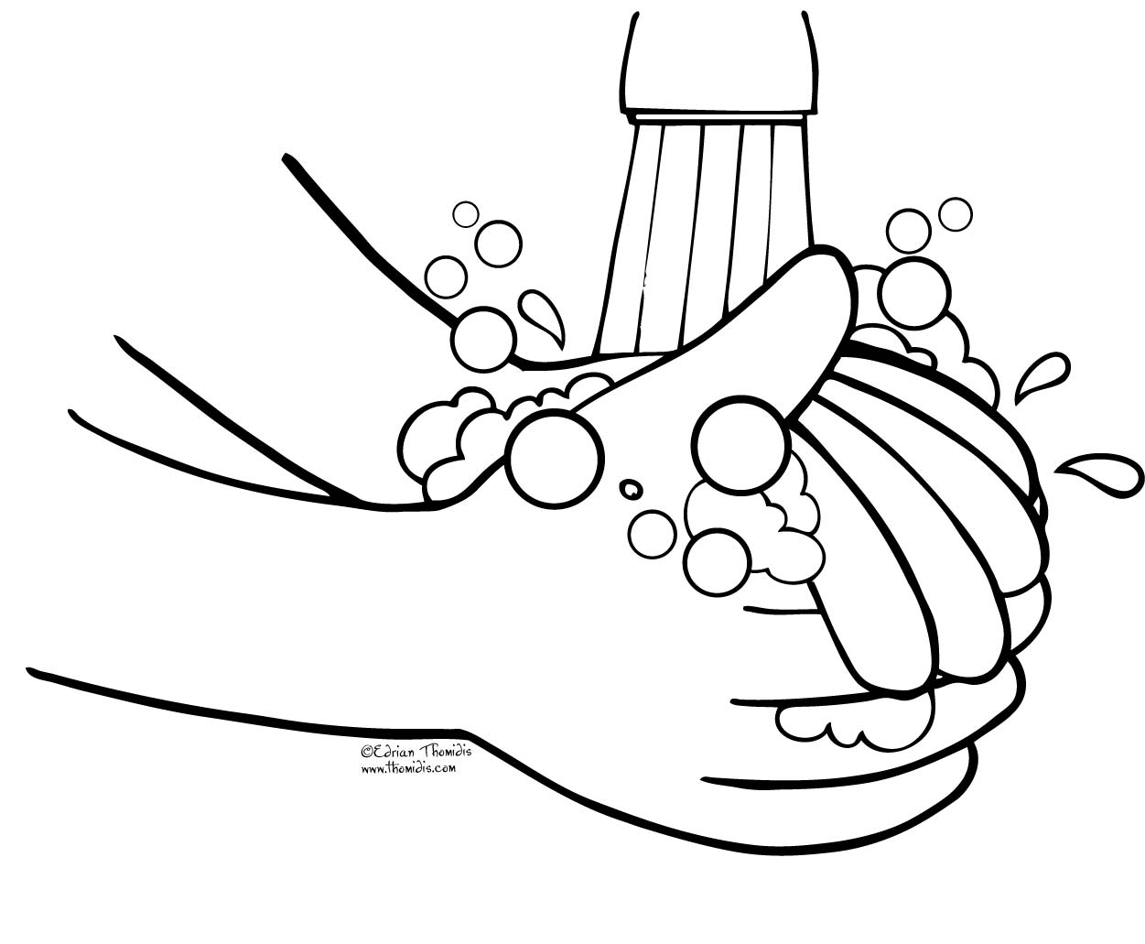

We know that it is essential that everyone washes their hands more often, using soap and water for at least 20 seconds. Hand washing with soap employs mechanical action that loosens bacteria and viruses from the skin, rinsing them into the drain. Drying hands afterwards makes the skin less hospitable to the virus. Hand sanitiser can be effective if soap is not available or the situation makes using soap less feasible (i.e. when outside) but using hand sanitiser provides none of the virus-destroying friction that rubbing your hands together and rinsing with water provides.
The latest guidance and video on hand washing can be found at: https://www.nhs.uk/live-well/healthy-body/best-way-to-wash-your-hands/

Safer travel guidance for passengers
It is now the law that you must wear a face covering when travelling in England on public transport including a bus, coach, tram or train. Where travel with children is necessary, such as to an education setting, consider whether children could walk or cycle, accompanied by a responsible adult or carer, where appropriate. The law requiring passengers to wear face coverings does not apply to children under the age of 11. Face coverings should not be used by children under the age of 3, for safety.
Children, even if they are over 11, are not required to wear face coverings on school transport. School transport is that provided by local authorities, academy trusts or schools for the specific purpose of transporting children to and from their home and school.
The Department for Transport’s guidance can be found here:
https://www.gov.uk/guidance/coronavirus-covid-19-safer-travel-guidance-for-passengers

Christian Meditation

We appreciate what a challenging time this is for many children and their families.

Recently the World Community for Christian Meditation (WCCM) has worked to develop videos which provide short meditation sessions which children and young people can participate in, whether in school or based at home. These sessions are inspired by meditation in the tradition of John Main OSB.

Full details are available here: https://www.cathchild.org.uk/meditation-with-children-young-people/

Participating in Mass during the Coronavirus Outbreak
Please see the website for the Diocese of Westminster https://rcdow.org.uk/ for links and further information or follow the links on our school website (Religious Education page or Parents’ page).

Resuming Public Liturgies – Cardinal Vincent

https://www.youtube.com/watch?v=CLsyL5yggVI&feature=youtu.be
In this video, the Cardinal describes that we are not going back to the normal and familiar, emphasises the need for new volunteers and says that Mass in the short-term will be simpler and a bit shorter than usual.

Support for Prayer from Ten Ten
- Sunday Liturgy for Families - https://www.tentenresources.co.uk/sunday-liturgy-for-families
- Daily Prayers for Home - https://www.tentenresources.co.uk/daily-prayers-for-home

Short Story Competition

We are encouraging Enfield young authors in years 1-8 to enter and they can do this from home.

The link to the attached materials is below:

https://traded.enfield.gov.uk/thehub/enfield-learns-together/short-story-competition

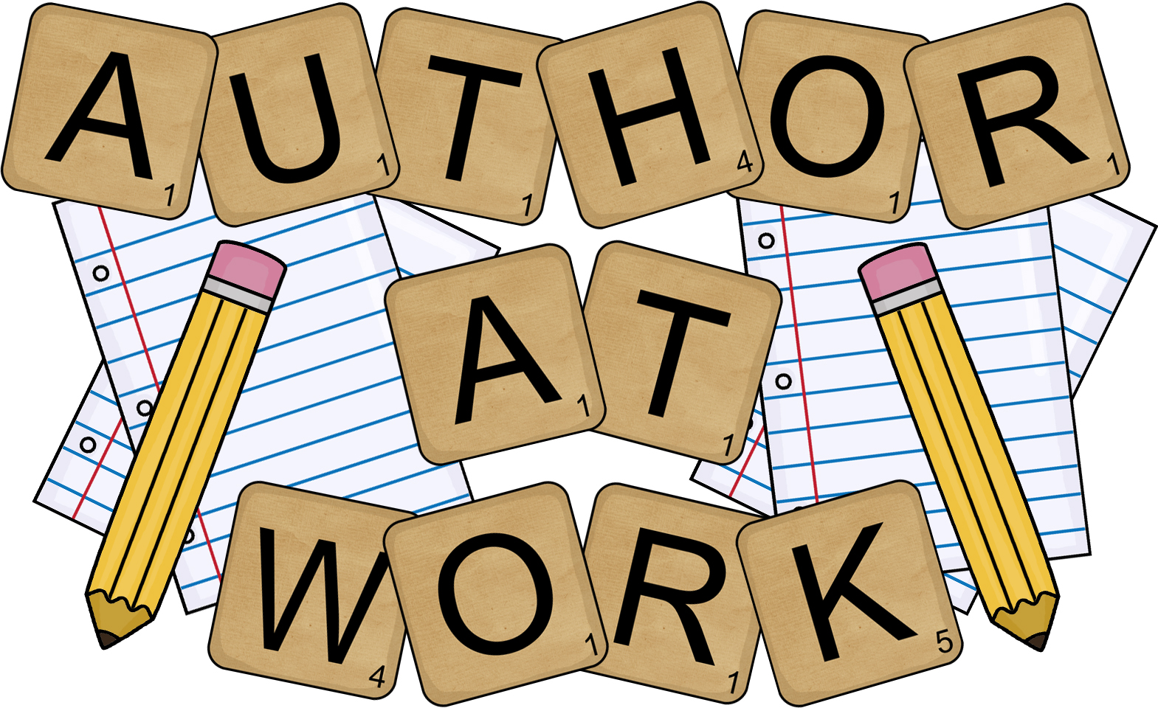

A new national creative writing competition for ages 7-17, has been launched today on Life in Lockdown. Until midnight on Friday the 17th of July, you can submit a piece of writing about what life has been like in lockdown and during the coronavirus.

This could be a personal experience, a poem, or a creative story. All of you will have had a unique experience that is only yours, and only you can capture in words.

Your entry should be 700 words or under and you should submit in your age category.

Your work will then be read by a published author, who will then pick out the five best entries from your age group. These entries will then be included in a book published by John Catt Educational called ‘Generation Lockdown Writes.’

For further information go to generationlockdown.co.uk.

PLEASE SUPPORT OUR PARISH!
Because churches are currently closed at present donations to our church have fallen considerably and the bills continue to come in!
Father John knows that times are not easy at the moment but if you can please
just put your money in a parish collection envelope or any envelope and pop it through Father John’s letterbox or
drop your donation in to us at school and we will pass it on to Father John.

Best Wishes

Thank you so much for the support you have shown both to me and to the staff of St. Mary’s over the last year. It is greatly appreciated by everyone in school always but especially now during this time of uncertainty.

Thank you to all who volunteered in school as helpers in class, with activities or outings before the time when the country went into lockdown. I know the teachers have really valued your support.

Thank you children for making every day in school interesting, enjoyable and different.
I hope you have a safe and happy time over the summer.

With God’s help I look forward to seeing you all on Monday 7th September ready for a new school year. We will keep you informed if / when we hear any news.

Good luck in your new schools Year 6! You have been an excellent group all the way through school. As we have said to you many times, we are so proud of all of you and your secondary schools will be so lucky to have you as part of their community in the new academic year. We will miss you.

Miss M Creed
Headteacher

Dear God,

We thank you for giving us your peace.
Help us to spread peace at home by loving and caring for one another.
Help us to spread peace by listening to one another, even when we don’t agree.
Help us to spread peace by sharing our time with those who are lonely and who need a friend.
Help us to spread peace by thinking and praying for children who have no food or who are frightened and live in fear.
Let us pray every day for peace for our families, for our friends and for ourselves. Amen.

