ST MARY’S CATHOLIC PRIMARY SCHOOL

NEWSLETTER June 2020

Welcome to a new month and half-term in school, the month of the Sacred Heart of Jesus. I hope you and your family are well and that all is going well at home.

As before the half-term break the home learning plan continues to be to make new work available every two weeks which can be accessed on the school website http://stmarysenfield.co.uk/welcome .

Just click on the Home Learning tab on the left hand side of the Welcome page. Scroll down under the relevant year group heading to find the newest work.

You can also look on the class page for additional links which may be helpful. The BBC Bitesize site now also has some good home learning support. https://www.bbc.co.uk/bitesize/dailylessons

The Oak National Academy has recently launched its online classroom and resource hub. The Academy offers 180 video lessons each week for schools to use, across a broad range of subjects. The lessons cover children in Reception through to Year 10 and are free to use by both teachers and young people.
The Oak National Academy can be accessed here:
https://www.thenational.academy/
Please just work through any school work you do at your own child’s pace. Don’t worry if you are not up to date. Just do the best you can. Remember that if you or your child has difficulty accessing the work please contact the school office and we can arrange to have a pack printed off for you to collect from the school.

If you have any questions about the work, need any support or just want to say hello please contact the teacher via the year group e-mail address or via the school address or call us at school. I know the teachers would love to hear from you.

Year Group Addresses:

nursery@stmarys.enfield.sch.uk

reception@stmarys.enfield.sch.uk

year1@stmarys.enfield.sch.uk

year2@stmarys.enfield.sch.uk

year3@stmarys.enfield.sch.uk

year4@stmarys.enfield.sch.uk

year5@stmarys.enfield.sch.uk

year6@stmarys.enfield.sch.uk

Weekly Phone Calls

Continue to expect a call home each week from your child’s teacher. This is simply to say hello and to keep in touch. Our staff are really enjoying the calls and having the opportunity to catch up with you and your child.

Wednesday Word

Have you started to read ‘The Wednesday Word’ yet?

The Wednesday Word is a gift to you and your family because of your connection with our Catholic school.
Every Wednesday, a ‘word’ (inspired by the Sunday Gospel) will be suggested for you and your family to talk about in your home.

This weekly Family Time is structured around the Sunday Gospel because evidence shows that Gospel values really do help family relationships to thrive.
Regularly spending quality time with children is without doubt one of the most important aspects of parenting. The Wednesday Word seeks to support you in this important task: to help you and your children maintain a special closeness throughout the school years.
The Wednesday Word 'Family Time' leaflet is designed to ensure that all family members feel included. It presents an effective way for even the busiest of parents to enrich relationships with their children through spending a very special 5 or 10 minutes together each week.
We suggest Wednesdays for Family Time because it is the day that the Catholic Church dedicates to St Joseph – the Patron Saint of Families. But rather than miss out, any other night would do just as well.

The Wednesday Word is currently available online:

http://www.wednesdayword.org/index.html

100% Attendance Spring 2020

190 pupils had 100% attendance! Well done children and parents! This is excellent!

Please note that any coronavirus related absence (fear to travel, possible exposure, worry about passing the virus on to other family members etc.) did not affect any child’s attendance record prior to the lockdown in the spring term.

The Angelus

In the summer term we try to learn / say The Angelus each day at 12 noon in all classes from Year 2 (from summer term) – Year 6. This is a wonderful prayer which reminds us that God the Son became man in order to save us.
You might like to say this prayer with your child at home. It can be said in the morning, at noon or in the evening.

The Angelus
The Angel of the Lord declared to Mary:
And she conceived of the Holy Spirit.
Hail Mary…

Behold the handmaid of the Lord:
Be it done to me according to your word.

Hail Mary…

And the Word was made Flesh:
And dwelt among us.

Hail Mary…

Pray for us, O Holy Mother of God.
That we may be made worthy of the promises of Christ.

Let us Pray.
Pour forth, we beseech you, O Lord, your grace into our hearts, that we, to whom the Incarnation of Christ, your Son, was made known by the message of an angel, may be brought by his passion and cross to the glory of his resurrection, through the same Christ our Lord. Amen.

May the divine assistance remain always with us and may the souls of the faithful departed, through the mercy of God, rest in peace. Amen.
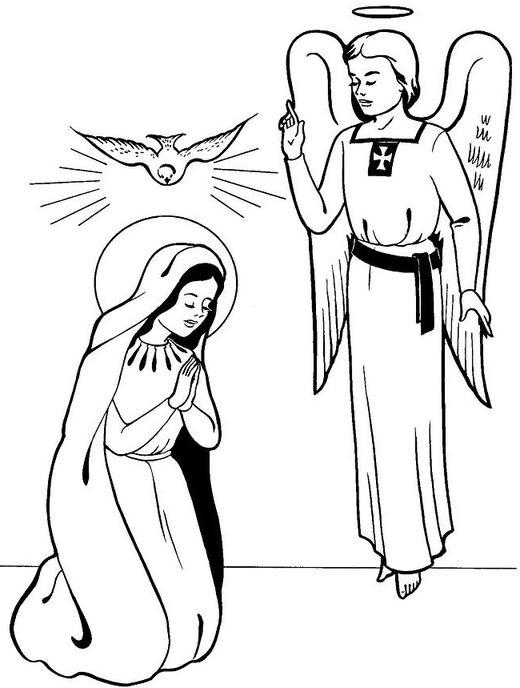

Online Safety at Home
You might find the following links helpful.
Thinkuknow:

https://www.thinkuknow.co.uk/?utm_source=Thinkuknow&utm_campaign=f4fd0dd4ee-TUK_ONLINE_SAFETY_AT_HOME_05_05_20&utm_medium=email&utm_term=0_0b54505554-f4fd0dd4ee-55347765

ThinkUKnow have created a page to support parents and young people online. The site includes home activity packs with simple 15 minute activities support children's understanding of online safety at a time.
There is also parent support information for primary and secondary age groups.
The resources can be found here: https://www.thinkuknow.co.uk/parents/Support-tools/home-activity-worksheets

Be SMART: Online Safety Video Lessons for 6 - 9 year olds (Childnet)
Childnet have released six new easy-to-follow videos for parents and children to work through together. The 10 - 15 minute videos offer simple, clear online safety advice using fun activities, games and discussion. There are optional follow-up activities to extend children's learning.
The videos can be found here: https://www.childnet.com/resources/video-lessons

BBC Bitesize:

https://www.bbc.co.uk/academy/en/articles/art2018030716351894

Handwashing Advice

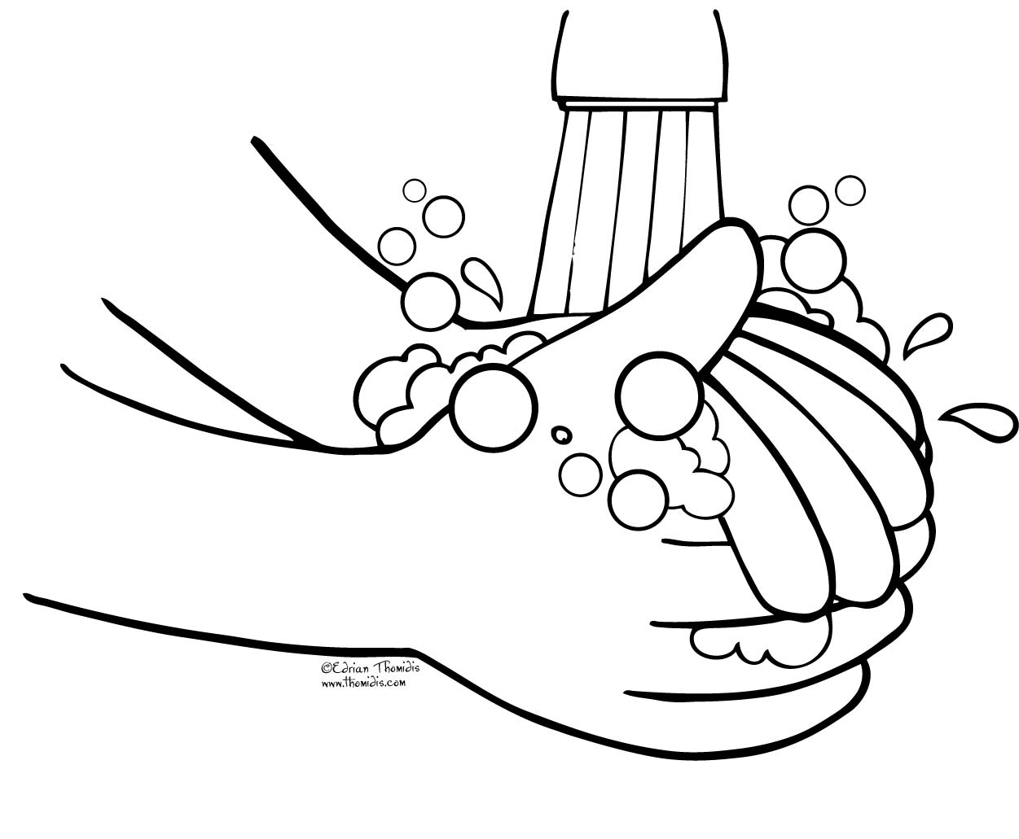

We know that it is essential that everyone washes their hands more often, using soap and water for at least 20 seconds. Hand washing with soap employs mechanical action that loosens bacteria and viruses from the skin, rinsing them into the drain. Drying hands afterwards makes the skin less hospitable to the virus. Hand sanitiser can be effective if soap is not available or the situation makes using soap less feasible (i.e. when outside) but using hand sanitiser provides none of the virus-destroying friction that rubbing your hands together and rinsing with water provides.
The latest guidance and video on hand washing can be found at: https://www.nhs.uk/live-well/healthy-body/best-way-to-wash-your-hands/

Christian Meditation

We appreciate what a challenging time this is for many children and their families.

Recently the World Community for Christian Meditation (WCCM) has worked to develop videos which provide short meditation sessions which children and young people can participate in, whether in school or based at home. These sessions are inspired by meditation in the tradition of John Main OSB.

Full details are available here: https://www.cathchild.org.uk/meditation-with-children-young-people/
Participating in Mass during the Coronavirus Outbreak
Please see the website for the Diocese of Westminster https://rcdow.org.uk/ for links and further information or follow the links on our school website (Religious Education page or Parents’ page).

Spend One Hour With Jesus In The Blessed Sacrament
You are greatly needed!
"The Church and the world have a great need of Eucharistic adoration." (Pope John Paul II, Dominicae Cenae)
https://www.ewtn.co.uk/live/adoration
Support for Prayer from Ten Ten

- Sunday Liturgy for Families - https://www.tentenresources.co.uk/sunday-liturgy-for-families
- Daily Prayers for Home - https://www.tentenresources.co.uk/daily-prayers-for-home

Short Story Competition

We are encouraging Enfield young authors in years 1-8 to enter and they can do this from home.

The link to the attached materials is below:

https://traded.enfield.gov.uk/thehub/enfield-learns-together/short-story-competition

A new national creative writing competition for ages 7-17, has been launched today on Life in Lockdown. Until midnight on Friday the 17th of July, you can submit a piece of writing about what life has been like in lockdown and during the coronavirus.

This could be a personal experience, a poem, or a creative story. All of you will have had a unique experience that is only yours, and only you can capture in words.

Your entry should be 700 words or under and you should submit in your age category.

Your work will then be read by a published author, who will then pick out the five best entries from your age group. These entries will then be included in a book published by John Catt Educational called ‘Generation Lockdown Writes.’

For further information go to generationlockdown.co.uk.

PLEASE SUPPORT OUR PARISH!
Because churches are currently closed at present donations to our church have fallen considerably and the bills continue to come in!
Father John knows that times are not easy at the moment but if you can please
just put your money in a parish collection envelope or any envelope and pop it through Father John’s letterbox or
drop your donation in to us at school and we will pass it on to Father John.
New Picture Book - Everybody Worries

Everybody Worries is Jon Burgerman’s brand new picture book designed to support children who may be feeling worried about Coronavirus and in particular the everyday changes to their lifestyle that it has brought about.

With colourful characters and rhyming text, this original picture book from the author of Everybody Has a Body is designed to reassure young children that their worries are valid and also includes practical ways to help them to process and articulate their emotions

Author Jon Burgerman commented, “I decided to write a book about worry and stress and how normal it is and how we can try and mitigate it. I think we might not acknowledge that small children worry as much as they do. Without a means of expressing their anxieties, the stress can manifest and have adverse effects.
It’s important to talk openly about what is going on and that the feelings we’re experiencing are being felt by a lot of people, and that by sharing and caring for each other we can try and make it a little better.”

The book is offered free of charge and can be read on screen via the Oxford Owl website.
Click here to view the book.

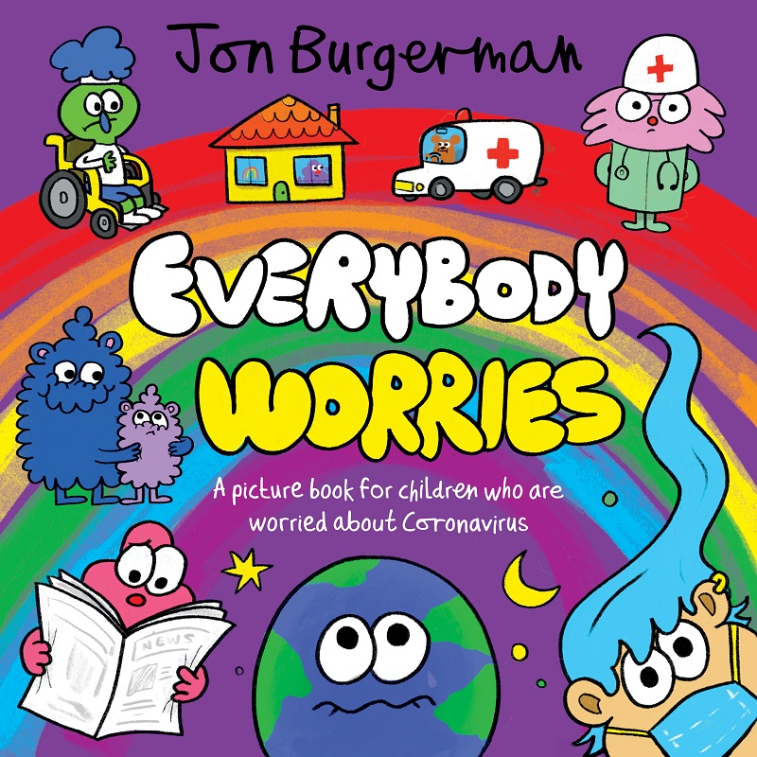
Some suggested websites that can help you stay connected:

Reading Rockets - Click Here (Lean how to write different types of letters to stay connected with friends and family)

Primary Resources - Click Here - (Free resources and templates for letter writing)

BBC Newsround - Click Here - (Stay connected with what is going on around you.)

Support for Mental Health

Emotion Wheel - https://www.mentallyhealthyschools.org.uk/media/2001/emotion-wheel.pdf (The emotion wheel can be used with children of all ages who are struggling to express their current feelings.)

Emotional Check-in - https://www.mentallyhealthyschools.org.uk/media/2003/emotional-check-in.pdf (A written resource supports children and young people to not only express their feelings but identify why they are feeling a particular way.)

Anxiety Thermometer -https://www.mentallyhealthyschools.org.uk/media/2022/anxiety-thermometer.pdf (Using a feelings thermometer is a great tool to help children recognise what feelings they might be experiencing in any given moment.)

Sentence Starters
https://www.mentallyhealthyschools.org.uk/media/2005/sentence-starters.pdf (Sentence starters can be useful prompts for children who are struggling to order their thinking or express the way they feel.)

Don’t forget to log on to the school website -

stmarysenfield.co.uk

Best Wishes

Thank you for your continued support for our school. It is greatly appreciated by all members of our school community.

Continue to send us your home learning photographs and remember to let us know how you are. We always love to hear from you.

You continue to be in our thoughts and prayers each day here at school.

Stay safe please.

Miss M. Creed
Headteacher

June is the Month of the Sacred Heart of Jesus

Ask and you shall receive
Seek and you shall find
Knock and it shall be opened unto you
O Sacred Heart of Jesus I place all my trust in you.

We often take for granted that God loves us. In June we focus specifically on the Heart of Jesus. Jesus is the one who loved us even to the point of dying for us.

In most cultures the heart is the symbol of love; it is what is deep inside us. We speak of a person having a kind heart or a hard heart.

When the Church was gripped with fear of God’s anger, a French sister, St. Margaret Mary Alacoque, was given visions of the Sacred Heart of Jesus in 1673 which assured us that God loves us and that we are to serve without excessive fear. At the same time, we must be careful about sin and pray for those who sin.

Dear Friends, let us love one another because love comes from God. Whoever loves is a child of God and knows God. Whoever does not love, does not know God, for God is love. God showed his love for us by sending his only Son into the world, so that we might have life through him. No one has ever seen God, but if we love one another God lives in us and his love is made perfect in us. (1 John 4:7-9, 11-12)

Love is a word that is much used and often badly used. Love is not just a feeling but it is rather the fact that we do good things for other people, such as forgiving them, helping them, showing them kindness. If we love others, then we can get a better idea of how God loves us. We think of this great love.

The Bible is God’s love-letter to his people.
The cross shows us God’s immense love for us.

The chalice reminds us of Jesus’ love for us in the Mass and Holy Communion.

May the love of Jesus surround us.
May the love of Jesus forgive us.
May the love of Jesus help us to love one another.

Cardinal: Pray fervently for the coming of the Holy Spirit
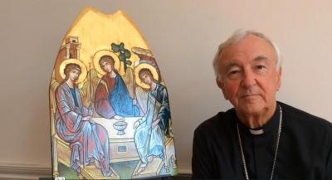

On the Solemnity of the Ascension, Cardinal Vincent recorded this message, reflecting on these days leading up to Pentecost and encouraging everyone to spend time in fervent, focused prayer on the Vigil of Pentecost, Saturday 30th May, for the coming of the Holy Spirit.

https://rcdow.org.uk/cardinal/news/cardinal-pray-fervently-for-the-coming-of-the-holy-spirit/

