# **ST MARY’S CATHOLIC PRIMARY SCHOOL**

## NEWSLETTER May 2020

Welcome to a new month in school, the month of our patron, St. Mary. I hope you and your family are well and that all is going well at home.

The home learning plan continues to be to make new work available every two weeks which can be accessed on the school website <http://stmarysenfield.co.uk/welcome> .

Just click on the Home Learning tab on the left hand side of the Welcome page. Scroll down under the relevant year group heading to find the newest work.

You can also look on the class page for additional links which may be helpful. The BBC Bitesize site now also has some good home learning support. <https://www.bbc.co.uk/bitesize/dailylessons>

The Oak National Academy has recently launched its online classroom and resource hub. The Academy offers 180 video lessons each week for schools to use, across a broad range of subjects. The lessons cover children in Reception through to Year 10 and are free to use by both teachers and young people. The Oak National Academy can be accessed here:

|  |
| --- |
| <https://www.thenational.academy/> |

Please just work through any school work you do at your own child’s pace. Don’t worry if you are not up to date. Just do the best you can. Remember that if you or your child has difficulty accessing the work please contact the school office and we can arrange to have a pack printed off for you to collect from the school.

If you have any questions about the work, need any support or just want to say hello please contact the teacher via the year group e-mail address or via the school address. I know the teachers would love to hear from you.

Year Group Addresses:

[nursery@stmarys.enfield.sch.uk](mailto:nursery@stmarys.enfield.sch.uk)

[reception@stmarys.enfield.sch.uk](mailto:reception@stmarys.enfield.sch.uk)

[year1@stmarys.enfield.sch.uk](mailto:year1@stmarys.enfield.sch.uk)

[year2@stmarys.enfield.sch.uk](mailto:year2@stmarys.enfield.sch.uk)

[year3@stmarys.enfield.sch.uk](mailto:year3@stmarys.enfield.sch.uk)

[year4@stmarys.enfield.sch.uk](mailto:year4@stmarys.enfield.sch.uk)

[year5@stmarys.enfield.sch.uk](mailto:year5@stmarys.enfield.sch.uk)

[year6@stmarys.enfield.sch.uk](mailto:year6@stmarys.enfield.sch.uk)

**Weekly Phone Calls**

Continue to expect a call home each week from your child’s teacher. This is simply to say hello and to keep in touch. Our staff are really enjoying the calls and having the opportunity to catch up with you and your child.



**Wednesday Word**

Have you started to read ‘The Wednesday Word’ yet?

*The Wednesday Word* is a gift to you and your family because of your connection with our Catholic school.  
  
Every Wednesday, a ‘word’ (inspired by the Sunday Gospel) will be suggested for you and your family to talk about in your home.

This weekly Family Time is structured around the Sunday Gospel because evidence shows that Gospel values really do help family relationships to thrive.

Regularly spending quality time with children is without doubt one of the most important aspects of parenting. *The Wednesday Word* seeks to support you in this important task: to help you and your children maintain a special closeness throughout the school years.

*The Wednesday Word* 'Family Time' leaflet is designed to ensure that all family members feel included. It presents an effective way for even the busiest of parents to enrich relationships with their children through spending a very special 5 or 10 minutes together each week.

We suggest Wednesdays for *Family Time* because it is the day that the Catholic Church dedicates to St Joseph – the Patron Saint of Families. But rather than miss out, any other night would do just as well.

The Wednesday Word is currently available online:

<http://www.wednesdayword.org/index.html>



**The Angelus**

**In the summer term we try to learn / say The Angelus each day at 12 noon in all classes from Year 2 (from summer term) – Year 6.** This is a wonderful prayer which reminds us that God the Son became man in order to save us.

You might like to say this prayer with your child at home. It can be said in the morning, at noon or in the evening.

The Angelus

The Angel of the Lord declared to Mary:

And she conceived of the Holy Spirit.

Hail Mary…

Behold the handmaid of the Lord:

Be it done to me according to your word.

Hail Mary…

And the Word was made Flesh:

And dwelt among us.

Hail Mary…

Pray for us, O Holy Mother of God.

That we may be made worthy of the promises of Christ.

Let us Pray.

Pour forth, we beseech you, O Lord, your grace into our hearts, that we, to whom the Incarnation of Christ, your Son, was made known by the message of an angel, may be brought by his passion and cross to the glory of his resurrection, through the same Christ our Lord. Amen.

May the divine assistance remain always with us and may the souls of the faithful departed, through the mercy of God, rest in peace. Amen.

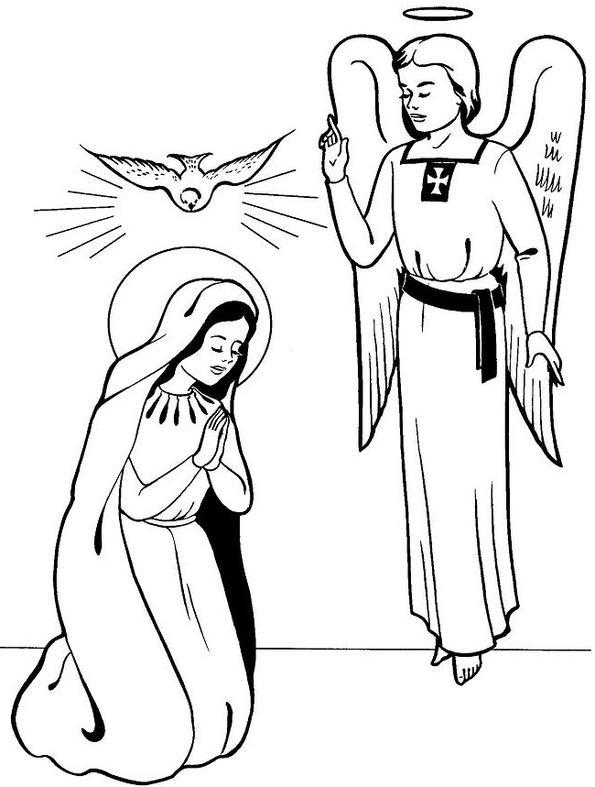

**Online Safety**

You might find the following links helpful.

Shout Out UK:

[5G & Coronavirus Conspiracy Theories Infographic](https://drive.google.com/a/shoutoutuk.org/file/d/1TADETR0wcA3QrKJl6NI_x8VjMmoqUKaO/view?usp=sharing)

[5G & Coronavirus Conspiracy Theories – Notes and Activities](https://drive.google.com/a/shoutoutuk.org/file/d/1YcfjxLDODHM2VyRwavoUuJQGPm4A0IVK/view?usp=sharing)

<https://www.shoutoutuk.org/covid-19/>

Full Fact:

<https://fullfact.org/online/5g-and-coronavirus-conspiracy-theories-came/>

Let’s Talk About it:

<https://www.ltai.info/>

**Sexting:**

There is concern about an increased risk of online grooming and sexting, due to increased time spent on the internet by young people.

Sexting is the exchange of sexual messages or self-generated sexual images or videos through a mobile phone network or internet. Sexting can leave a child vulnerable to bullying, blackmail, online grooming or abuse. It’s also a criminal offence to create or share explicit images of a child, even if the person doing it is a child.

Information for parents can be found [here](http://www.itsnotokay.co.uk/parents/online-safety-and-sexting/).

**Public Health England has updated their guidance for households with possible coronavirus (COVID-19) infection**

Public Health England has published guidance for households with grandparents, parents and children living together where someone is at risk or has symptoms of coronavirus (COVID-19) infection.

The guidance can be found here:

|  |
| --- |
| * <https://www.gov.uk/government/publications/covid-19-stay-at-home-guidance> |

**Coronavirus (COVID-19) testing eligibility extended to help protect the most vulnerable**

The government has announced that anyone in England showing symptoms of coronavirus (COVID-19) who has to leave the home to go to work, or is aged 65 and over, is eligible for testing along with members of their households with symptoms. This is in addition to all essential workers with symptoms. Testing can be booked through a new online system.

Guidance on coronavirus (COVID-19) testing, including who is eligible for a test, how to get tested and the different types of test available can be found here:

|  |
| --- |
| * <https://www.gov.uk/guidance/coronavirus-covid-19-getting-tested> |

**Handwashing Advice**

We know that it is essential that everyone washes their hands more often, using soap and water for at least 20 seconds. Hand washing with soap employs mechanical action that loosens bacteria and viruses from the skin, rinsing them into the drain. Drying hands afterwards makes the skin less hospitable to the virus. Hand sanitiser can be effective if soap is not available or the situation makes using soap less feasible (i.e. when outside) but using hand sanitiser provides none of the virus-destroying friction that rubbing your hands together and rinsing with water provides.

The latest guidance and video on hand washing can be found at:

|  |
| --- |
| * <https://www.gov.uk/guidance/coronavirus-covid-19-information-for-the-public> |

The e-Bug project is led by Public Health England and has a dedicated webpage for learning resources on hand washing and respiratory hygiene.

Resources are currently available for KS1, KS2 and KS3 and can be used in various settings including schools and at home:

|  |
| --- |
| * <https://e-bug.eu/> |

**Christian Meditation**

We appreciate what a challenging time this is for many children and their families.

Recently the World Community for Christian Meditation (WCCM) has worked to develop videos which provide short meditation sessions which children and young people can participate in, whether in school or based at home.  These sessions are inspired by meditation in the tradition of John Main OSB.

Full details are available here: <https://www.cathchild.org.uk/meditation-with-children-young-people/>

**Participating in Mass during the Coronavirus Outbreak**

Please see the website for the Diocese of Westminster <https://rcdow.org.uk/> for links and further information or follow the links on our school website (ReligiousEducation page or Parents’ page).



**Spend One Hour With Jesus In The Blessed Sacrament**

You are greatly needed!  
"The Church and the world have a great need of Eucharistic adoration." (Pope John Paul II, Dominicae Cenae)

<https://www.ewtn.co.uk/live/adoration>

**Support for Prayer from Ten Ten**

-**Sunday Liturgy for Families** - <https://www.tentenresources.co.uk/sunday-liturgy-for-families>

- **Daily Prayers for Home** - <https://www.tentenresources.co.uk/daily-prayers-for-home>

- **Assembly Video for Home** - <https://www.tentenresources.co.uk/living-your-best-life>

**Pope Francis urges Catholics to unite through praying the Rosary in May**

34.4K364

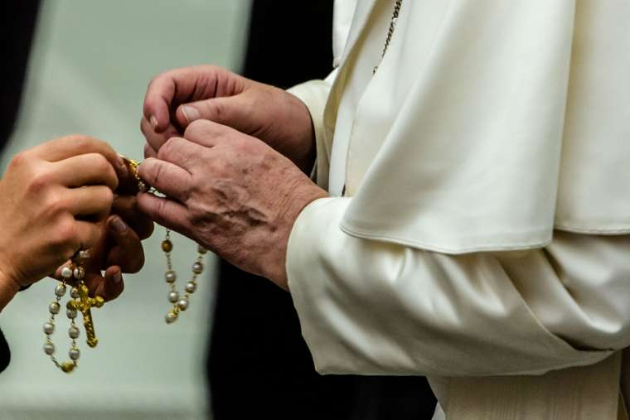

Pope Francis sent a letter encouraging Catholics to pray the rosary throughout May. He also shared two new prayers to implore the help of the Virgin Mary during the coronavirus pandemic.

“Contemplating the face of Christ with the heart of Mary our Mother will make us even more united as a spiritual family and will help us overcome this time of trial,” Pope Francis said in a letter April 25.

He urged families and individuals to “rediscover the beauty of praying the rosary at home in the month of May,” which is traditionally a time of increased devotion to the Blessed Virgin Mary.

With his letter, the pope included two prayers to Our Lady to recite at the end of the rosary, which he said he would also pray throughout May “in spiritual union with all of you.”

In the first prayer, Mary’s help is invoked “to conform ourselves to the will of the Father and to do what Jesus tells us.”

In the second, longer prayer, the Virgin Mary is asked to “turn your merciful eyes towards us amid this coronavirus pandemic,” and her intercession is asked “that this great suffering may end and that hope and peace may dawn anew.”

The prayer asks for Mary’s comfort for those who mourn and for those who are anxious about the future, and prays for health care workers, scientists, and national leaders.

The prayer also asks Mary to “be close to those who assist the sick night and day, and to priests who, in their pastoral concern and fidelity to the Gospel, are trying to help and support everyone.”

“Mary, Consolation of the afflicted, embrace all your children in distress and pray that God will stretch out his all-powerful hand and free us from this terrible pandemic, so that life can serenely resume its normal course,” the prayer says.

In his letter, Francis said people can pray the rosary as a group or individually, whatever fits their situation best. “The key to doing this is always simplicity,” he underlined, adding that the internet is a good resource for finding prayers to follow.

During May, it is a tradition to pray the rosary “at home within the family,” he said, noting that the restrictions of the COVID-19 pandemic “have made us come to appreciate all the more this ‘family’ aspect, also from a spiritual point of view.”

Pope Francis concluded his letter by saying “I keep all of you in my prayers, especially those suffering most greatly, and I ask you, please, to pray for me.”

“I thank you, and with great affection I send you my blessing.”

*Below you can find the full text of the prayers shared by Pope Francis:*

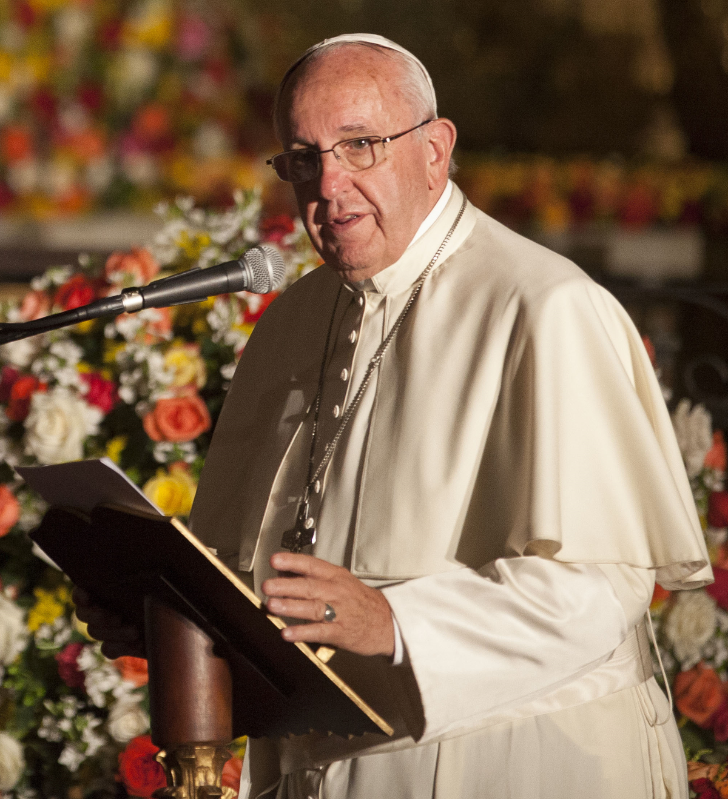

**First Prayer:**

O Mary, You shine continuously on our journey as a sign of salvation and hope. We entrust ourselves to you, Health of the Sick, who, at the foot of the cross, were united with Jesus’ suffering, and persevered in your faith.

“Protectress of the Roman people”, you know our needs, and we know that you will provide, so that, as at Cana in Galilee, joy and celebration may return after this time of trial.

Help us, Mother of Divine Love, to conform ourselves to the will of the Father and to do what Jesus tells us. For he took upon himself our suffering, and burdened himself with our sorrows to bring us, through the cross, to the joy of the Resurrection. Amen.

We fly to your protection, O Holy Mother of God; Do not despise our petitions in our necessities, but deliver us always from every danger, O Glorious and Blessed Virgin.

**Second Prayer:**

“We fly to your protection, O Holy Mother of God”.  
In the present tragic situation, when the whole world is prey to suffering and anxiety, we fly to you, Mother of God and our Mother, and seek refuge under your protection.

Virgin Mary, turn your merciful eyes towards us amid this coronavirus pandemic. Comfort those who are distraught and mourn their loved ones who have died, and at times are buried in a way that grieves them deeply. Be close to those who are concerned for their loved ones who are sick and who, in order to prevent the spread of the disease, cannot be close to them. Fill with hope those who are troubled by the uncertainty of the future and the consequences for the economy and employment.

Mother of God and our Mother, pray for us to God, the Father of mercies, that this great suffering may end and that hope and peace may dawn anew. Plead with your divine Son, as you did at Cana, so that the families of the sick and the victims be comforted, and their hearts be opened to confidence and trust.

Protect those doctors, nurses, health workers and volunteers who are on the frontline of this emergency, and are risking their lives to save others. Support their heroic effort and grant them strength, generosity and continued health.

Be close to those who assist the sick night and day, and to priests who, in their pastoral concern and fidelity to the Gospel, are trying to help and support everyone.

Blessed Virgin, illumine the minds of men and women engaged in scientific research, that they may find effective solutions to overcome this virus.

Support national leaders, that with wisdom, solicitude and generosity they may come to the aid of those lacking the basic necessities of life and may devise social and economic solutions inspired by farsightedness and solidarity.

Mary Most Holy, stir our consciences, so that the enormous funds invested in developing and stockpiling arms will instead be spent on promoting effective research on how to prevent similar tragedies from occurring in the future.

Beloved Mother, help us realize that we are all members of one great family and to recognize the bond that unites us, so that, in a spirit of fraternity and solidarity, we can help to alleviate countless situations of poverty and need. Make us strong in faith, persevering in service, constant in prayer.

Mary, Consolation of the afflicted, embrace all your children in distress and pray that God will stretch out his all-powerful hand and free us from this terrible pandemic, so that life can serenely resume its normal course.

To you, who shine on our journey as a sign of salvation and hope, do we entrust ourselves, O Clement, O Loving, O Sweet Virgin Mary. Amen.

**Don’t forget to log on to the school website -**

**stmarysenfield.co.uk**

**Best Wishes**

Thank you for your continued support for our school. It is greatly appreciated by all members of our school community.

Continue to send us your home learning photographs and letting us know how you are.

You continue to be in our thoughts and prayers each day here at school.

Stay safe please.

Miss M. Creed

Headteacher

### Prayer to Our Lady

All hail to you Mary, most favoured by God

O teach us to follow the path you once trod.

When Gabriel had spoken you humbly said, ‘Yes’

May we have the courage God’s word to confess.

To those for whom sickness and sadness are near,

Show Jesus your first-born, our Saviour from fear.

With Joseph your husband you cared for our Lord,

Guide parents and children to life’s one reward

You spoke at the wedding and Christ gave the wine.

He now gives his people the true bread divine.

We trustfully echo the prayer of your Son

That all of God’s children may love and be one.

God’s life was your living with him you found peace.

May his loving presence in us now increase.



|  |  |
| --- | --- |
| |  | | --- | | *Random Acts of Kindness* | |

|  |  |
| --- | --- |
| |  | | --- | | https://mcusercontent.com/6b341178fc20f6586567e68cd/images/a04283f3-f010-47e8-96f0-f2b3312abcfe.jpg | |

|  |  |
| --- | --- |
| |  | | --- | | The Mental Health Foundation, a charity with a mission to help people understand, protect and sustain their mental health, have put together some top tips for supporting those that are struggling.   * Call a friend that you haven’t spoken to for a while * Tell a family member how much you love and appreciate them * Make a cup of tea for someone you live with * Arrange to have a cup of tea and virtual catch up with someone you know * Help with a household chore at home * Arrange to watch a film at the same time as a friend and video call * Tell someone you know that you are proud of them * Tell someone you know why you are thankful for them * Send a motivational text to a friend who is struggling * Send someone you know a joke to cheer them up * Send someone you know a picture of a cute animal * Send an inspirational quote to a friend * Send an interesting article to a friend * Contact someone you haven’t seen in a while and arrange a phone call * Spend time playing with your pet * Reach out to call a friend, family member or neighbour who is experiencing loneliness or self-isolation * Donate to a charity * Lend your ear – call a colleague and ask how they’re finding it all * Give praise to your colleague for something they’ve done well * Arrange to have a video lunch with a colleague * Send an inspirational story of kindness from around the world to someone you know * Donate to foodbanks * Offer to skill share with a friend via video call - you could teach guitar, dance etc. * Offer support to vulnerable neighbours * Offer to send someone a takeaway or a meal   [https://www.mentalhealth.org.uk/](https://rpbooks.us15.list-manage.com/track/click?u=6b341178fc20f6586567e68cd&id=62aa981b88&e=b57d2f10d5) | |

**The Book of Hopes**

**This book may help give hope and a more positive outlook for children in lockdown**

*Edited by Katherine Rundell, with contributions from more than 100 children’s writers and illustrators.*

Completely free for all children and families, the extraordinary collection of short stories, poems, essays and pictures has contributions from more than 110 children’s writers and illustrators, including Lauren Child, Anthony Horowitz, Greg James and Chris Smith, Michael Morpurgo, Liz Pichon, Axel Scheffler, Francesca Simon, Jacqueline Wilson – and Katherine herself.

The collection, published by Bloomsbury, is dedicated to the doctors, nurses, carers, porters, cleaners and everyone currently working in hospitals.

<https://literacytrust.org.uk/family-zone/9-12/book-hopes/>

**Short Story Competition**

We are encouraging Enfield young authors in years 1-8 to enter and they can do this from home.

The link to the attached materials is below:

<https://traded.enfield.gov.uk/thehub/enfield-learns-together/short-story-competition>



**MESSAGE FROM CAFOD - Unprecedented emergency in every country we work in!**

We are facing an unprecedented emergency in every country we work in; and we are also mindful, each day, of people in our own Catholic community here in England and Wales who are unable to attend Mass; people worried and overstretched; of those who have tragically lost loved ones, and of those who were already enduring loneliness and are now in isolation. We need to respond in faith, hope and love. And so in faith, hope and love, we are reaching out to you.

Coronavirus is affecting [every country we work in](https://cafod.org.uk/News/International-news/Coronavirus-response). The poorest and excluded are most vulnerable. Food prices have risen with borders closing; the poorest are losing their jobs and income with wholesale shutdowns. As you can imagine, the outlook is very serious in places where healthcare is inadequate, and washing regularly and social distancing are luxuries. Half the world’s population can’t access basic healthcare, and already struggle to feed their families; and they now face the threat of hunger as the coronavirus shuts down markets and jobs.

- [cafod.org.uk/parishes](https://cafod.org.uk/Fundraise/Parish-fundraising) has **a two-minute video message about the appeal** .

***If you are able to help please donate via the CAFOD website or***

***just put your money in an envelope and pop it through Father John’s letterbox or***

***drop your donation in to us at school and we will pass it on to Father John.***

**PLEASE SUPPORT OUR PARISH!**

Because churches are currently closed at present donations to our church have fallen considerably and the bills continue to come in!

Father John knows that times are not easy at the moment but if you can please

***just put your money in a parish collection envelope or any envelope and pop it through Father John’s letterbox or***

***drop your donation in to us at school and we will pass it on to Father John.***



**Rosary Prayers:**

**The** [**Apostles Creed**](http://www.how-to-pray-the-rosary-everyday.com/apostles-creed.html)

I believe in God, the Father Almighty, Creator of Heaven and earth. And in Jesus Christ, His only Son, our Lord. Who was conceived by the power of the Holy Spirit, born of the Virgin Mary, suffered under Pontius Pilate, was crucified, died, and was buried. He descended into hell. On the third day He rose again. He ascended into heaven and sits at the right hand of God, the Father Almighty. From there He shall come to judge the living and the dead. I believe in the Holy Spirit, the Holy Catholic Church, the Communion of Saints, the forgiveness of sins, the resurrection of the body and life everlasting. Amen.

**The Our Father**

Our Father, who art in heaven; hallowed be Thy name; Thy kingdom come; Thy will be done on earth as it is in heaven. Give us this day our daily bread; and forgive us our trespasses as we forgive those who trespass against us, and lead us not into temptation; but deliver us from evil. Amen.

**The Hail Mary**

Hail Mary, full of grace, the Lord is with thee; blessed art thou among women and blessed is the fruit of thy womb, Jesus. Holy Mary, Mother of God, pray for us sinners, now and at the hour of our death. Amen.



**Glory be to the Father**

Glory be to the Father, and to the Son, and to the Holy Spirit. As it was in the beginning, is now, and ever shall be, world without end. Amen.

**Fatima Prayer**

O my Jesus, forgive us our sins. Save us from the fires of hell, lead all souls to heaven especially those in most need of your mercy.



**Hail Holy Queen**

Hail, Holy Queen, Mother of Mercy, Hail our life, our sweetness and our hope, to you do we cry, poor banished children of Eve; to you do we send up our sighs, mourning and weeping in this vale of tears; turn, then most gracious Advocate, your eyes of mercy towards us, and after this, our exile, show unto us the blessed fruit of your womb Jesus. O clement, O loving, O sweet Virgin Mary! Pray for us, O holy Mother of God, that we may be made worthy of the promises of Christ.

**Let us Pray**

Let us pray, O God, whose only begotten Son, by His life death and Resurrection, has purchased for us the reward of eternal life. Grant we beseech Thee that while meditating upon these mysteries of the most holy rosary of the Blessed Virgin Mary, we may imitate what they contain and obtain what they promise through the same Christ our Lord. Amen.



