CATHOLIC CHURCH OF MARY, MOTHER OF GOD
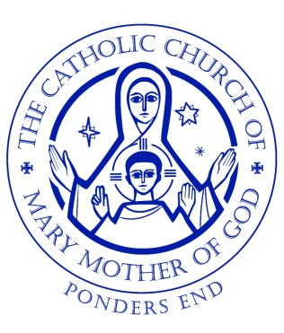
Parish Novena for the Holy Souls – November 2021

Thursday 4th – after morning Mass
Friday 5th – after evening Mass
Saturday 6th – after morning Mass
Sunday 7th – after evening Mass
Monday 8th – after morning Mass
Tuesday 9th – after morning Mass
Wednesday 10th - after morning Mass
Thursday 11th - after morning Mass
Friday 12th - after evening Mass

