Statement on the Four-Week National Lockdown in England and a Call to Prayer
Wednesday, November 4th, 2020 @ 6:16 pm

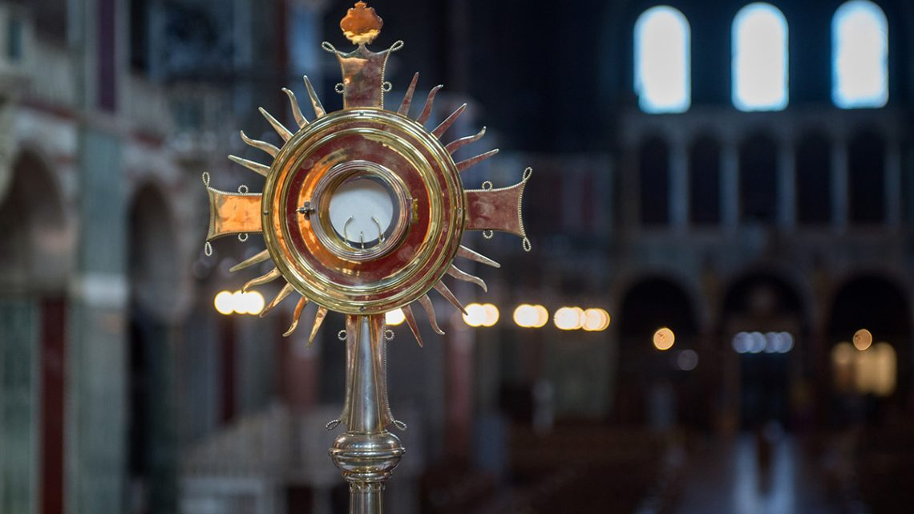
Today, Parliament passed into law the Regulations governing many aspects of activity in the whole of England until Wednesday, 2 December.
These Regulations prohibit the gathering of people for communal worship in churches and other religious buildings.
Churches remain open and in use for activities other than communal worship, including personal prayer and support for those in need.
Funeral Masses and funeral services may be held. Please refer to the Regulations (for places of worship see paragraph 18) and associated Guidance.
Despite profound misgivings it is important that we, as responsible citizens, observe these Regulations, which have the force of law:
“Remind them to be obedient to the officials in authority; to be ready to do good at every opportunity”
Titus 3:1
We do this in solidarity with so many others on whom are being imposed restrictions which impact severely on their lives and livelihoods.
It is also important to recognise that these Regulations are not an attack on religious belief. However, they do demonstrate a fundamental lack of understanding of the essential contribution made by faith communities to the well-being, resilience and health of our society.
At this difficult moment, we ask that, as a Catholic community, we make full use of our churches as places of individual prayer and sources of solace and help.

Daily Prayer
We must sustain each other in our patterns of prayer, joining a national shared moment of prayer each day at 6pm, and observing the Vigil of Christ the King (21 November) as a day of prayer for the ending of this pandemic.
We encourage you all in your practical service and support of each other and those around you in need.
This pathway of prayer and service is the royal road we are to take as a gracious witness in our society today.
Cardinal Vincent Nichols
President
Archbishop Malcolm McMahon OP
Vice-President
Issued: Wednesday, 4 November 2020

