Official Prayers for the Year of the Word
Here are four prayers for 'The God who Speaks' Scripture campaign.

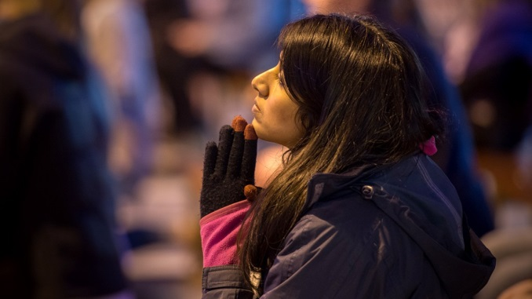

Please use these wherever you feel you can. They are provided for both individual and group use:
Living God,
you walk alongside us
and speak to us throughout the Scriptures.
Your Son, Jesus Christ, listens to our hopes and fears
and shows us how to live for one another.
Send us the Holy Spirit to open our hearts and minds
so that we may be your witnesses throughout the world. Amen
V. Your word is our path and your truth is our light.
R. This day and every day.

Our Lady of the Annunciation
Pray for us

St Matthew
Pray for us
St Jerome
Pray for us

Longer Prayer to the God Who Speaks
Creator and Source of all, you spoke to Moses calling your people into life.
He asked for your name and you revealed your mystery.
“I am who I am, who I will be, where I will be”. Your divine life, beyond our inadequate images, beyond our fragile attempts to know and control. And gradually, through your prophets, you opened our minds and hearts to the immensity of the mystery of your creative mercy.
Word made Flesh, you came among us to open up a way and a life true to your mystery and true to our desire; a Word that both speaks in our hearts and through the vastness of your cosmos.
Holy Spirit, from the first Pentecost you enabled us to hear the Word in our own reality and respond to it among companions from every race and tongue. Provoke us now to return to that divine word in Creation, that Word en-fleshed in Jesus, that Word spoken and recorded in the Holy Scriptures.
Touch our minds and hearts today as we read alone, as we proclaim in the liturgy, as we study together and, inspired anew, help us to become that Word for all who seek the way, the truth, and the life.
Amen.
(David McLoughlin)

Pilgrim Prayer for the Year
Pilgrim God,
you walk alongside us
and speak to us throughout the Scriptures:
in the message of the prophets,
the songs of David
and the vision of Paul.
Your Son, Jesus Christ, listens to our hopes and fears
and shows us how to live:
in our love of neighbour
our desire for justice,
and in our dying and rising each day.
Send us the Holy Spirit to open our hearts and minds
so that we may be your witnesses throughout the world:
in our protection of the vulnerable,
our words and actions
and in our communion with the earth.
Amen
V. Your word is our path and your truth is our light.
R. This day and every day.
Our Lady of the Annunciation
Pray for us
St Matthew
Pray for us
St Jerome
Pray for us
Risen Lord,
Your disciples walking on the road to Emmaus began to sense your presence as you explained the Scriptures to them.
As we study the Scriptures today may our hearts burn too,
kindled by the Spirit, with the love of God, and the delight of your teaching,
that we may see with your eyes, heal with your hands, walk in your ways and love with your heart. Amen
(Fr John Deehan)

