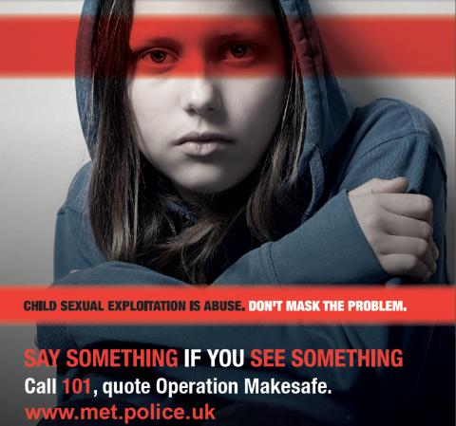 |  | Is my child at risk of exploitation?
SIgns of Concern  - Possessions - Are they returning home with unexplained amounts of money or gifts?  - Mobile Phones – Do they have more than one mobile handset or Sim cards not purchased by yourself?  - Behavior - Has your child’s attitude changed negatively at home and/or towards education?  - Change of Friends - Does your child have older friends who you do not know?  - Missing - Is your child often returning home late, ignoring boundaries & frequently going missing?  - Is there a change in appearance, clothing, personal hygiene, talking differently, tiredness?  - Unexplained injuries – Bruises, marks & reluctance to seek medical attention.  - Online use – Spending more time on line, distancing from family, friends & usual activities  - Coping Mechanisms – Alcohol /drugs or Self Harm  AdviCe  - Talk to your child & let them know they are not to blame  - Encourage your child to express their daily feelings & being open to listen to any concerns they may have  - Be aware of friends & the people your child is associating with  - Report your concerns to; Police, Social Worker, Teacher, GP, Youth Worker etc  - Report your child missing to Police |  |  | IMportant contacts  Police - 999 or 101  Police care about the safety of children and young people. If you think your child is in immediate danger then call 999 or you can report concerns by dialing 101.  Barnardo’s| Tel: 020 8550 8822 |www.barnardos.org.uk  Barnardo’s provides a range of services to children, young people and families across the UK. Services address problems including sexual exploitation, substance misuse and homelessness.  NSPCC – Child Protection helpline| Tel: 0808 800 5000  You can ring the NSPCC Helpdesk to report concerns and get advice if you are concerned your child is being exploited. They are available 24 hours a day  FRANK| Tel: 0800 77 66 00 |www.talktofrank.com  A free service providing advice to people of all ages about drugs; can provide information about local support services.  Crimestoppers |Tel: 0800 555 111 | www.crimestoppers-uk.org  Crimestoppers guarantees anonymity to all callers and website users. If you are concerned a young person is being sexually exploited, call or visit their webiste to provide information.  PACE – Parents against Child Sexual Exploitation |Tel: 01132 405226  Offers a national support team who can talk to you about your immediate concerns, help you to assess the level of danger your child is in and signpost you to agencies in your area. They take calls during office hours.  Think You Know | www.thinkuknow.co.uk  CEOP (Child Exploitation Online Protection). Provide information about helping your children to stay safe on-line. You can report on-line concerns to them.  Missing People Charity | Tel: 116 000 |www. missingpeople.org.uk  Missing People is the only charity in the UK which specialises in, and is dedicated to, bringing missing children and adults back together with their families.  The Children’s Society | www.childrenssociety.org.uk  A national charity that runs local projects, helping children and young people when they are at their most vulnerable, and have nowhere left to turn.  Parents Protect | Tel 0808 1000 900 |www.parents.co.uk  Information and resources which aim to raise awareness about child sexual abuse, answer questions and give adults the information, advice, support and facts they need to help protect children.

