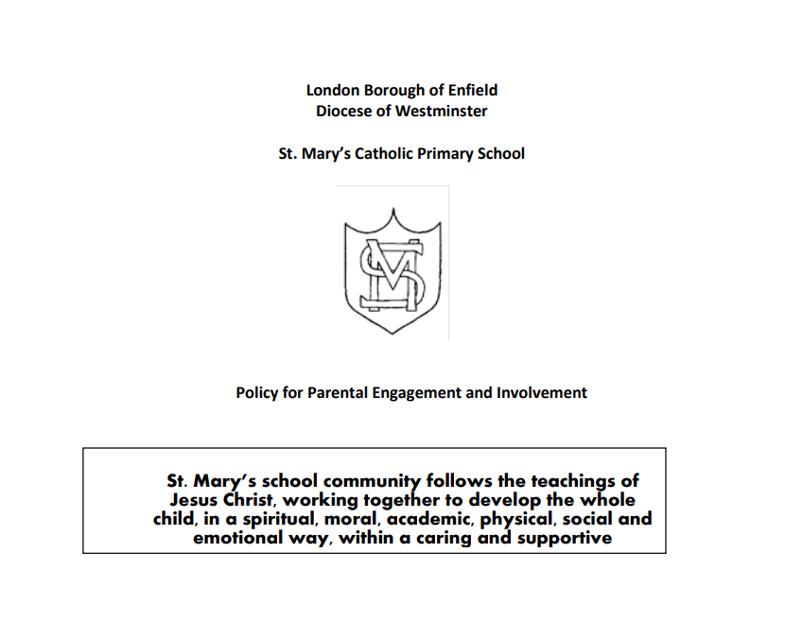

Intent
All parents and carers are equally valued as part of our school community. Children’s learning is improved when we work in partnership with their parents or carers, and their wider family. We therefore believe in close cooperation with all families, and in regular consultation between the home and the school.

Implementation
Involvement in the life of the school
Families are invited to regular events; joining us for Mass, workshops, productions, activities and celebrations with the school.
Monthly newsletters are sent home, and each family should receive a copy of the school prospectus.
Parents can also access all of this information on the school website: www.stmarysenfield.co.uk

Involvement in children’s learning
We operate an open door policy in school and parents and carers can talk with teachers before and after school on an informal basis on most days.
Appointments to see a member of staff can be made through the school office, and can be set up for as soon as required in most instances.
There are opportunities for parents to have a discussion with their child’s teacher throughout the year but particularly at parent consultations in the spring term.
Teachers value opportunities to celebrate successes, review learning targets and listen to parental views.
An annual report on each child’s academic and personal development is made available in the summer term. An acknowledgement slip is attached, and parents may meet with the teacher to discuss the contents of the report.
Regular curriculum information and workshops are organised to assist parents and carers in supporting their child’s learning.
Policy documents, schemes of work and National Curriculum guidance are readily available for parents and carers to view.
Class teachers send out termly letters to each family, detailing the aspects of learning each child will undertake and how families might support that learning, for example by visiting museums, galleries, theatres with the classes.
Homework is given on a regular basis depending on your child’s age. We value parental support regarding the completion of these tasks, many of which contain guidance for helpers.
National Curriculum assessments as well as records of progress and achievement are also readily available in pupils’ individual folders.
Parents and carers can expect to be spoken to discreetly if there are any concerns regarding their child.

Types of help at school
We welcome parents coming in to school as volunteers and anyone interested should contact the school office in the first instance. In order to safeguard children we always carry out DBS checks and request references.
Parents and carers offer valued support when they respond to invitations to accompany school groups on educational visits.
Parents and carers are invited, where possible, to visit classes and groups of children to give talks or demonstrations on areas of interest in which they are experts.
The Governing Body will seek parents, elected by other parents, to serve on the governing body.
Parents and carers are invited to information sessions and workshops on different curriculum areas to develop their own understanding of what and how their children are learning so that they are confident in supporting them at home.

Consultation
Our home-school agreement, signed by pupils, parents and the school, details the responsibilities and expectations of all parties.
The school will make every effort to consult parents and carers, both formally and informally, about their views on school life, children’s learning and new initiatives.
The school values regular feedback, and will make every effort to act on parents’ and carers’ views, wherever possible.
All staff can be approached informally before and after school, and will always take careful account of any information forwarded to them.
Periodically the school will seek parental views more formally, through an annual survey, or a questionnaire on a particular theme.
After an Ofsted inspection parents and carers will receive a summary of the findings, and the report will be available to view on the school website.

Impact
• to enhance the learning experiences of all pupils;
• to encourage parents and carers to be involved in the children’s learning;
• to provide a partnership between home and school, seeking to ensure that families feel welcome and valued;
• to ensure that maximum use is made of all adults’ skills to enrich learning opportunities.
• To encourage parents and carers to develop and extend their own learning.

The governing body will monitor the implementation of this policy.
This policy will be reviewed annually.
Policy updated January 2026

