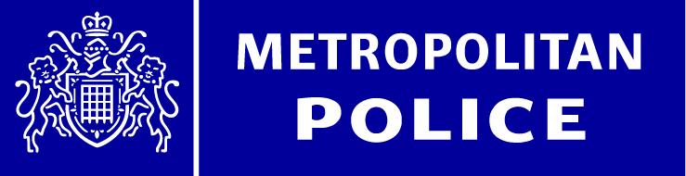

Dear Parent/Carer,

We find ourselves in unchartered territory during this International Covid19 Pandemic. Whilst the majority of us are having to deal with new ways in which we live, work and educate, a small number of individuals are taking advantage of this situation and using it for their own criminal gains. There have been a number of identified scams that have been posted to online social media and mobile phone direct messaging platforms, email and door to door contact. As your Safer Schools Officer, we would like to encourage both parents/carers and pupils alike to stop, think and research the authenticity prior to engaging or re-posting any message in order to prevent becoming a victim of this criminal activity.

The attached document is from law enforcement, government and private sectors partners who are working together to encourage members of the public to be more vigilant against fraud. You can also find our Little Book of Cyber Scams and animations videos for online safety and fraud prevention at www.met.police.uk/littlemedia

Follow the Government advice to protect the NHS and save lives.

Kind regards

Jacqui Penn PS 522NA
Jacqui.penn@met.police.uk

Velda Ewen PS 517NA
Velda.ewen@met.police.uk

