CATHOLIC CHURCH OF MARY, MOTHER OF GOD
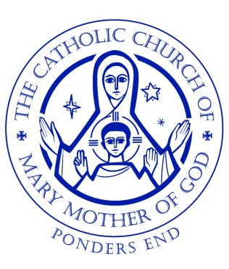
Parish Novena for the Holy Souls – November 2019

Friday 22nd – after 7.30pm Mass
Saturday 23rd – after 9.30am Mass
Sunday 24th – 5.15pm before Evening Mass
Monday 25th – after 9.30am Mass
Tuesday 26th – after 9.30am Mass
Wednesday 27th - after 9.30am Mass
Thursday 28th - after 9.30am Mass
Friday 29th - after 7.30pm Mass
Saturday 30th - after 9.30am Mass

