Pope Francis' Guide to Lent: What You Should Give Up This Year
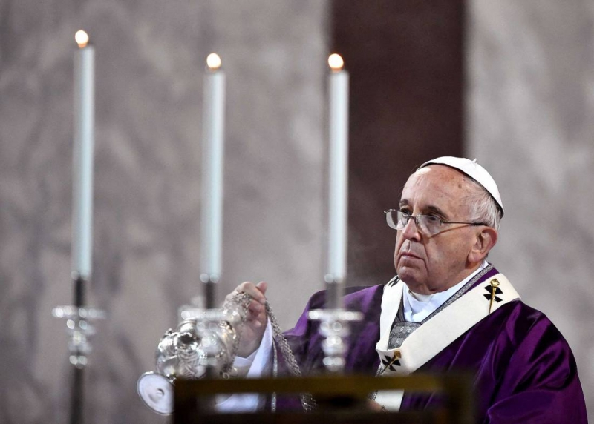
Christopher J. Hale
Lent

Christians around the world mark the beginning of Lent with the celebration of Ash Wednesday. This ancient day and season has a surprising modern appeal.
Priests and pastors often tell you that outside of Christmas, more people show up to church on Ash Wednesday than any other day of the year—including Easter. But this mystique isn't reserved for Christians alone. The customs that surround the season have a quality to them that transcend religion.
Perhaps most notable is the act of fasting. While Catholics fast on Ash Wednesday and on Fridays during the Lenten season, many people—religious or not—take up this increasingly popular discipline during the year.
But Pope Francis has asked us to reconsider the heart of this activity this Lenten season. According to Francis, fasting must never become superficial. He often quotes the early Christian mystic John Chrysostom who said: "No act of virtue can be great if it is not followed by advantage for others. So, no matter how much time you spend fasting, no matter how much you sleep on a hard floor and eat ashes and sigh continually, if you do no good to others, you do nothing great."
But this isn't to downplay the role of sacrifice during the Lenten season. Lent is a good time for penance and self-denial. But once again, Francis reminds us that these activities must truly enrich others: "I distrust a charity that costs nothing and does not hurt."
So, if we're going to fast from anything this Lent, Francis suggests that even more than candy or alcohol, we fast from indifference towards others.
In his annual Lenten message, the pope writes, "Indifference to our neighbour and to God also represents a real temptation for us Christians. Each year during Lent we need to hear once more the voice of the prophets who cry out and trouble our conscience."
Describing this phenomenon he calls the globalization of indifference, Francis writes that "whenever our interior life becomes caught up in its own interests and concerns, there is no longer room for others, no place for the poor. God's voice is no longer heard, the quiet joy of his love is no longer felt, and the desire to do good fades." He continues that, "We end up being incapable of feeling compassion at the outcry of the poor, weeping for other people's pain, and feeling a need to help them, as though all this were someone else's responsibility and not our own."
But when we fast from this indifference, we can begin to feast on love. In fact, Lent is the perfect time to learn how to love again. Jesus—the great protagonist of this holy season—certainly showed us the way. In him, God descends all the way down to bring everyone up. In his life and his ministry, no one is excluded.
"What are you giving up for Lent?" It's a question a lot of people will get these next few days. If you want to change your body, perhaps alcohol and candy is the way to go. But if you want to change your heart, a harder fast is needed. This narrow road is gritty, but it isn't sterile. It will make room in ourselves to experience a love that can make us whole and set us free.
Now that's something worth fasting for.

