Faith Sharing for Lent 2020 - ‘A Word for Lent’

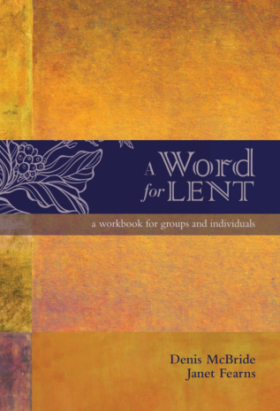

Title: A Word for Lent: A Workbook for Groups and Individuals.
Authors: Denis McBride and Janet Fearns

Description: ‘A Word for Lent’ invites us to see salvation gradually unfold in our own lives and also in the lives of Gospel women and men whose stories are as relevant today as they were 2000 years ago. Beautiful works of art accompany us on each stage of our journey through ‘A Word for Lent’. Enjoy this journey through the Gospels of Lent, and may it be an eye-opening and surprising experience of seeing salvation, perhaps where and when we least expect it.

Contents:
Six Lenten Gospels:
- Temptation
- Transformation
- Acceptance
- Celebration
- Forgiveness
- Passion
A Word for Lent- PDF to Download

