Message of His Holiness Pope Francis

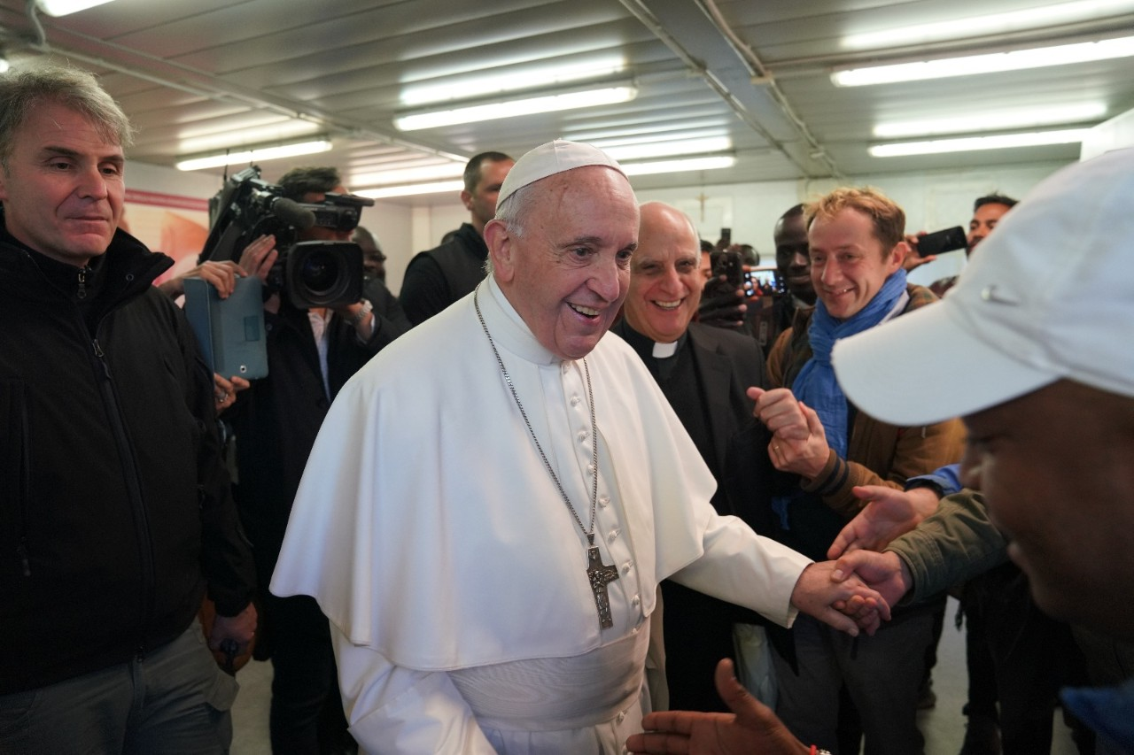

FOURTH WORLD DAY OF THE POOR
33rd Sunday in Ordinary Time
15 November 2020

“Stretch forth your hand to the poor” (Sir 6:7)

“Stretch forth your hand to the poor” (Sir 6:7). Age-old wisdom has proposed these words as a sacred rule to be followed in life. Today these words remain as timely as ever. They help us fix our gaze on what is essential and overcome the barriers of indifference. Poverty always appears in a variety of guises, and calls for attention to each particular situation. In all of these, we have an opportunity to encounter the Lord Jesus, who has revealed himself as present in the least of his brothers and sisters (cf. Mt 25:40).
1. Let us take up the Old Testament book of Sirach, in which we find the words of a sage who lived some two hundred years before Christ. He sought out the wisdom that makes men and women better and more capable of insight into the affairs of life. He did this at a time of severe testing for the people of Israel, a time of suffering, grief and poverty due to the domination of foreign powers. As a man of great faith, rooted in the traditions of his forebears, his first thought was to turn to God and to beg from him the gift of wisdom. The Lord did not refuse his help.
From the book’s first pages, its author presents his advice concerning many concrete situations in life, one of which is poverty. He insists that even amid hardship we must continue to trust in God: “Do not be alarmed when disaster comes. Cling to him and do not leave him, so that you may be honoured at the end of your days. Whatever happens to you, accept it, and in the uncertainties of your humble state, be patient, since gold is tested in the fire, and chosen men in the furnace of humiliation. Trust him and he will uphold you, follow a straight path and hope in him. You who fear the Lord, wait for his mercy; do not turn aside in case you fall” (2:2-7).
2. In page after page, we discover a precious compendium of advice on how to act in the light of a close relationship with God, creator and lover of creation, just and provident towards all his children. This constant reference to God, however, does not detract from a concrete consideration of mankind. On the contrary, the two are closely connected.
This is clearly demonstrated by the passage from which the theme of this year’s Message is taken (cf. 7:29-36). Prayer to God and solidarity with the poor and suffering are inseparable. In order to perform an act of worship acceptable to the Lord, we have to recognize that each person, even the poorest and most contemptible, is made in the image of God. From this awareness comes the gift of God’s blessing, drawn by the generosity we show to the poor. Time devoted to prayer can never become an alibi for neglecting our neighbour in need. In fact the very opposite is true: the Lord’s blessing descends upon us and prayer attains its goal when accompanied by service to the poor.
3. How timely too, for ourselves, is this ancient teaching! Indeed, the word of God transcends space and time, religions and cultures. Generosity that supports the weak, consoles the afflicted, relieves suffering and restores dignity to those stripped of it, is a condition for a fully human life. The decision to care for the poor, for their many different needs, cannot be conditioned by the time available or by private interests, or by impersonal pastoral or social projects. The power of God’s grace cannot be restrained by the selfish tendency to put ourselves always first.
Keeping our gaze fixed on the poor is difficult, but more necessary than ever if we are to give proper direction to our personal life and the life of society. It is not a matter of fine words but of a concrete commitment inspired by divine charity. Each year, on the World Day of the Poor, I reiterate this basic truth in the life of the Church, for the poor are and always will be with us to help us welcome Christ’s presence into our daily lives (cf. Jn 12:8).
4. Encountering the poor and those in need constantly challenges us and forces us to think. How can we help to eliminate or at least alleviate their marginalization and suffering? How can we help them in their spiritual need? The Christian community is called to be involved in this kind of sharing and to recognize that it cannot be delegated to others. In order to help the poor, we ourselves need to live the experience of evangelical poverty. We cannot feel “alright” when any member of the human family is left behind and in the shadows. The silent cry of so many poor men, women and children should find the people of God at the forefront, always and everywhere, in efforts to give them a voice, to protect and support them in the face of hypocrisy and so many unfulfilled promises, and to invite them to share in the life of the community.
The Church certainly has no comprehensive solutions to propose, but by the grace of Christ she can offer her witness and her gestures of charity. She likewise feels compelled to speak out on behalf of those who lack life’s basic necessities. For the Christian people, to remind everyone of the great value of the common good is a vital commitment, expressed in the effort to ensure that no one whose human dignity is violated in its basic needs will be forgotten.
5. The ability to stretch forth our hand shows that we possess an innate capacity to act in ways that give meaning to life. How many outstretched hands do we see every day! Sadly, it is more and more the case that the frenetic pace of life sucks us into a whirlwind of indifference, to the point that we no longer know how to recognize the good silently being done each day and with great generosity all around us. Only when something happens that upsets the course of our lives do our eyes become capable of seeing the goodness of the saints “next door”, of “those who, living in our midst, reflect God’s presence” (Gaudete et Exsultate, 7), but without fanfare. Bad news fills the pages of newspapers, websites and television screens, to the point that evil seems to reign supreme. But that is not the case. To be sure, malice and violence, abuse and corruption abound, but life is interwoven too with acts of respect and generosity that not only compensate for evil, but inspire us to take an extra step and fill our hearts with hope.
6. A hand held out is a sign; a sign that immediately speaks of closeness, solidarity and love. In these months, when the whole world was prey to a virus that brought pain and death, despair and bewilderment, how many outstretched hands have we seen! The outstretched hands of physicians who cared about each patient and tried to find the right cure. The outstretched hands of nurses who worked overtime, for hours on end, to look after the sick. The outstretched hands of administrators who procured the means to save as many lives as possible. The outstretched hands of pharmacists who at personal risk responded to people’s pressing needs. The outstretched hands of priests whose hearts broke as they offered a blessing. The outstretched hands of volunteers who helped people living on the streets and those with a home yet nothing to eat. The outstretched hands of men and women who worked to provide essential services and security. We could continue to speak of so many other outstretched hands, all of which make up a great litany of good works. Those hands defied contagion and fear in order to offer support and consolation.
7. This pandemic arrived suddenly and caught us unprepared, sparking a powerful sense of bewilderment and helplessness. Yet hands never stopped reaching out to the poor. This has made us all the more aware of the presence of the poor in our midst and their need for help. Structures of charity, works of mercy, cannot be improvised. Constant organization and training is needed, based on the realization of our own need for an outstretched hand.
The present experience has challenged many of our assumptions. We feel poorer and less self-sufficient because we have come to sense our limitations and the restriction of our freedom. The loss of employment, and of opportunities to be close to our loved ones and our regular acquaintances, suddenly opened our eyes to horizons that we had long since taken for granted. Our spiritual and material resources were called into question and we found ourselves experiencing fear. In the silence of our homes, we rediscovered the importance of simplicity and of keeping our eyes fixed on the essentials. We came to realize how much we need a new sense of fraternity, for mutual help and esteem. Now is a good time to recover “the conviction that we need one another, that we have a shared responsibility for others and the world… We have had enough of immorality and the mockery of ethics, goodness, faith and honesty… When the foundations of social life are corroded, what ensues are battles over conflicting interests, new forms of violence and brutality, and obstacles to the growth of a genuine culture of care for the environment” (Laudato Si’, 229). In a word, until we revive our sense of responsibility for our neighbour and for every person, grave economic, financial and political crises will continue.
8. This year’s theme – “Stretch forth your hand to the poor” – is thus a summons to responsibility and commitment as men and women who are part of our one human family. It encourages us to bear the burdens of the weakest, in accord with the words of Saint Paul: “Through love serve one another. For the whole law is fulfilled in one word: ‘You shall love your neighbour as yourself’… Bear one another’s burdens, and so fulfil the law of Christ” (Gal 5:13-14; 6:2). The Apostle teaches that the freedom bestowed through the death and resurrection of Jesus Christ makes us individually responsible for serving others, especially the weakest. This is not an option, but rather a sign of the authenticity of the faith we profess.
Here again, the book of Sirach can help us. It suggests concrete ways to support the most vulnerable and it uses striking images. First, it asks us to sympathize with those who are sorrowing: “Do not fail those who weep” (7:34). The time of pandemic forced us into strict isolation, making it impossible even to see and console friends and acquaintances grieving the loss of their loved ones. The sacred author also says: “Do not shrink from visiting the sick” (7:35). We have been unable to be close to those who suffer, and at the same time we have become more aware of the fragility of our own lives. The word of God allows for no complacency; it constantly impels us to acts of love.
9. At the same time, the command: “Stretch forth your hand to the poor” challenges the attitude of those who prefer to keep their hands in their pockets and to remain unmoved by situations of poverty in which they are often complicit. Indifference and cynicism are their daily food. What a difference from the generous hands we have described! If they stretch out their hands, it is to touch computer keys to transfer sums of money from one part of the world to another, ensuring the wealth of an elite few and the dire poverty of millions and the ruin of entire nations. Some hands are outstretched to accumulate money by the sale of weapons that others, including those of children, use to sow death and poverty. Other hands are outstretched to deal doses of death in dark alleys in order to grow rich and live in luxury and excess, or to quietly pass a bribe for the sake of quick and corrupt gain. Others still, parading a sham respectability, lay down laws which they themselves do not observe.
Amid all these scenarios, “the excluded are still waiting. To sustain a lifestyle which excludes others, or to sustain enthusiasm for that selfish ideal, a globalization of indifference has developed. Almost without being aware of it, we end up being incapable of feeling compassion at the outcry of the poor, weeping for other people’s pain, and feeling a need to help them, as though all this were someone else’s responsibility and not our own” (Evangelii Gaudium, 54). We cannot be happy until these hands that sow death are transformed into instruments of justice and peace for the whole world.
10. “In everything you do, remember your end” (Sir 7:36). These are the final words of this chapter of the book of Sirach. They can be understood in two ways. First, our lives will sooner or later come to an end. Remembering our common destiny can help lead to a life of concern for those poorer than ourselves or lacking the opportunities that were ours. But second, there is also an end or goal towards which each of us is tending. And this means that our lives are a project and a process. The “end” of all our actions can only be love. This is the ultimate goal of our journey, and nothing should distract us from it. This love is one of sharing, dedication and service, born of the realization that we were first loved and awakened to love. We see this in the way children greet their mother’s smile and feel loved simply by virtue of being alive. Even a smile that we can share with the poor is a source of love and a way of spreading love. An outstretched hand, then, can always be enriched by the smile of those who quietly and unassumingly offer to help, inspired only by the joy of living as one of Christ’s disciples.
In this journey of daily encounter with the poor, the Mother of God is ever at our side. More than any other, she is the Mother of the Poor. The Virgin Mary knows well the difficulties and sufferings of the marginalized, for she herself gave birth to the Son of God in a stable. Due to the threat of Herod, she fled to another country with Joseph her spouse and the child Jesus. For several years, the Holy Family lived as refugees. May our prayer to Mary, Mother of the Poor, unite these, her beloved children, with all those who serve them in Christ’s name. And may that prayer enable outstretched hands to become an embrace of shared and rediscovered fraternity.
Rome, Saint John Lateran, 13 June 2020
Memorial of Saint Anthony of Padua

Franciscus

