

**St Mary’s SEN Information Report**



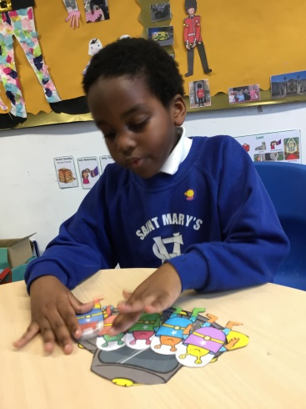 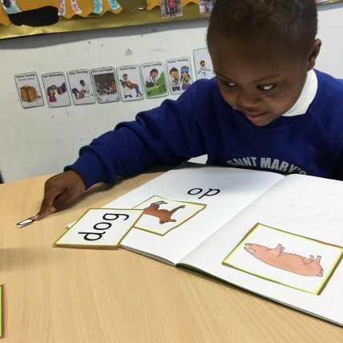

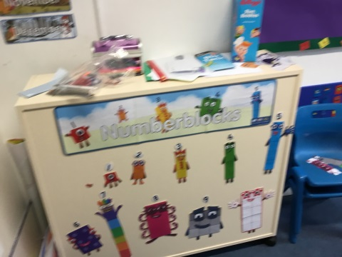

|  |
| --- |
| Contents Page |
| P.1 Title page |
| P.2 Contents page |
| P.3 Background to our School |
| P.4 Identifying needs of pupils |
| P.5 How do we help? Provision of resources and staffing |
| P.7 Assessment |
| P.8 Health and well-being |
| P.9 External Services |
| P.10 Staff training |
| P.11 Physical environment  Induction and transition |
| P.12 Parents carers and families |
| P.13 Contact information |
| P.14 Appendix |

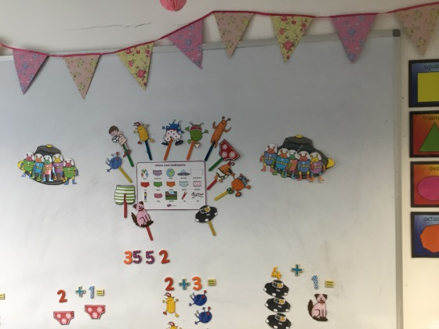 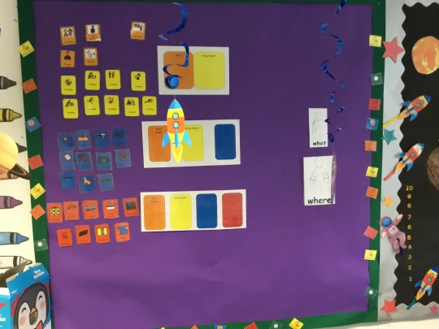

|  |
| --- |
| HOW WE SUPPORT CHILDREN/YOUNG PEOPLE WITH SPECIAL EDUCATIONAL NEEDS OR DISABILITIES |
| **Our vision and how we hope to achieve it**  Our mission statement places the unique individual at the heart of all that we do:  ‘St Mary’s school community follows the teachings of Jesus Christ, working together to develop the whole child, in a spiritual, moral, academic, physical, social and emotional way, within a caring and supporting environment.’ This states our clear commitment as a school therefore, to meeting the needs of all pupils. For those pupils with Special Educational Needs (SEN), the school recognises and has regard to The Children and Families Act 2014 and the statutory guidance in the SEN and Disability Code of Practice (July 2014) which sets out the duties, policies and procedures relating to Part 3 of this Act and associated regulations.  Section 19 of the Children and Families Act sets out the principles which underpin the Code of Practice. In making provision for pupils with SEN the school has a responsibility to consider these principles which are designed to support:   * The participation of children, their parents and young people in decision-making. * The early identification of children and young people’s needs and early intervention to support them. * Greater choice and control for young people and parents over support * Collaboration between education ,health and social services to provide support * High quality provision to meet the needs of children and young people with SEN * A focus on inclusive practice and removing barriers to learning * Successful preparation for adulthood |
| **Type of school we are**  St Mary’s is a two form entry voluntary aided Catholic primary school with a nursery taking children from 3 years to 11 years. There are currently 411 pupils are on roll including the nursery. 22% of pupils are eligible for free school meals, just slightly below the national figure of 23%. 3.4% of pupils currently have an Education, Health and Care Plan, which is higher than national (1.6%). 14.1% of pupils have SEN support compared to 12.6.6% nationally. 50% of pupils have English as an additional language which is more than double the national figure(21%) and 95% come from minority ethnic backgrounds compared to 31.65 nationally. The % of absence missed for all pupils in 2018-2019 was 2.3%, below the national figure of 4.8% and in the lowest 10% for all school over the last three years. The % of persistent absence for pupils with special educational needs (3.2%) was in the lowest 20% of all schools in 2019 as well as 2018 and 2017. |
| **Our Ofsted rating**  Our Diocesan Section 48 Inspection in October 2019 rated the school as Outstanding for Religious Education and Outstanding for The Catholic Life of the School  Our last Section 8 Inspection in June 2018 rated the school as Good. |
| **How we know if a child/young person has special educational needs**  ‘A pupil has SEN where their learning or disability calls for special educational provision, namely provision different or additional to that normally available to pupils of the same age’(Code of Practice July 2014).  The four broad areas of need which may require additional provision are:   * Communication and interaction * Cognition and learning * Social, emotional and mental health difficulties * Sensory and / or physical needs   Your child’s needs may not necessarily fit in to a specific category and any provision we make in school will reflect a full understanding of the range of your child’s difficulties which may well be inter-related. Some difficulties may be quite clear early on in your child’s development and some may become apparent as your child progresses through school.   * We use baseline assessments (the school had begun trialling the new EYFS Baseline in September 2019) when your child enters nursery / reception to check where your child is in their development as they begin school and continue to measure progress each half term against the Development Matters Bands and Early learning Goals. At this stage we would be looking particularly at language and social skills and as your child moves on to a more formal curriculum, teachers would be monitoring how your child acquires a basic understanding of literacy and numeracy. * As part of the school’s Assertive Mentoring system, all pupils in school have targets for all areas of learning (these include academic and attitude - behaviour, punctuality, attendance, uniform) which are set out in their Assertive Mentoring folders. These targets are agreed with pupils and shared with parents. The aim of this holistic approach is to foster independence through pupils’ ownership of their individual goals, whatever their ability. Targets and progress are reviewed half termly. * If progress seems to be less than expected the SEN teacher will carry out additional assessments. These may include the Salford reading Tests well as YARC Reading and Wigan Maths assessments. These help us to identify more specifically, aspects your child may be having difficulty with. * When a difficulty becomes apparent a discussion would initially take place between yourself and your child’s class teacher and in consultation with the special educational needs co-ordinator (SENCo) if appropriate at this stage. This discussion may be initiated by you or the teacher. We hope that you would approach the class teacher as soon as you have concerns. This may be in the form of speaking to the class teacher at the end of the day and arranging a time for further discussion, or phoning the school to arrange a convenient time to meet, or by e-mail or letter. * The SENCo is also available to talk to you an early stage before any formal discussions. |
| **What we do to help children/young people with special educational needs**  The school offers a continuum of support for pupils, from differentiated work set within the classroom by the class teacher, to more highly individualised programmes delivered outside the classroom. The SENCo and SEN support teachers plan programmes and interventions with the class teachers and other support staff.  SEN provision currently available in school includes:   * Language groups for year groups as appropriate, including reception. These are run outside the classroom by teaching assistants following advice from the Speech and Language Service. The SENCo monitors the groups and liaises with the Speech and Language Service to ensure the groups are targeting children accurately. * Group teaching outside the classroom with support teachers is usually for specific work on literacy and mathematics. The support teachers will liaise with the class teacher as to the focus of this work and the class teacher monitors progress closely. * Phonological Awareness Programme for infants in small groups (can be individual pupils) led by teaching assistants or support teachers. Pupil progress is apparent back in the classroom as children begin to tackle reading and writing tasks with confidence. * Additional phonics work in small groups usually with infant teaching assistants under teacher direction. * ‘15 Minutes-a-Day’ catch up reading intervention runs for 12 weeks by teaching assistants specifically trained on this programme. Children are put on the programme following discussion between the SENCo and class teacher. * Individual teaching time with the SEN or other support teacher for more intensive literacy or numeracy work. This may be for up to two hours a week. Progress would be monitored half termly with this type of support. * ‘Spelling Made Easy’ programme-delivered outside the classroom by SEN teacher or teaching assistant – may run for long period of time (individual, paired or small groups of pupils). * ‘Toe-by-Toe’ – individual reading programme. SEN teacher works with pupils outside the classroom. * ‘Rainbow Readers’ – audio supported reading scheme – teaching assistants mange pupils on the scheme under class teacher direction. * Positive behaviour programmes – devised by the school or in consultation with the behaviour support service. * Tiger Teams – a six week motor skills programme run by a teaching assistant. Children are identified by SENCo and class teacher. * Colourful Semantics is used in classes and in intensive teaching groups to support reading comprehension and writing, following training and advice from the speech and language therapy service.     Your child could receive a range of different types of support throughout their time in school depending on where they are in their development. The emphasis will change and their needs could become more complex or lessen as they grow. No two pupils are the same and the school offers the most appropriate support at the time for each pupil. |
| **How we adapt our teaching for children/young people with special educational needs**   * All class teachers differentiate their planning and their teaching for all lessons. This means that they think about the language they are using when they are delivering the lessons, the questions they ask and how they support all children in being able to tackle tasks by themselves. * Our aim in school is for all pupils whatever their level of ability to develop into independent learners. This does not mean that they will not get help but that once they show they understand what they have to do, they will be expected and encouraged to think for themselves and persevere even when something is a bit challenging. * Teachers will therefore plan independent work tasks so that different groups (or individuals ) in the class are working in different ways (using thinking maps, word banks, writing frames and key words for example) and with a range of resources which your child can choose to use, at a varying pace. They may work intensively for a period of time with the teacher, the teaching assistant and by themselves throughout a lesson. Obviously your child is encouraged to ask for help if they are unsure of something, but you would not expect to see your child sitting in a lesson waiting for an adult – this would not be independent learning. * Some of the work your child may do outside the classroom may be teaching them how to ask for help at the appropriate time, to foster independence back in the class. |
| **How we decide what resources we can give to a child/young person with special educational needs**   * The SENCo in consultation with key external agencies (in particular the educational psychologist and the speech and language service) and SEN staff decides where priorities seem to be within the school each year. This may be in a specific phase with groups of children or individuals with highly complex needs. * Resources are then allocated to balance the wider SEN within the school with those of individual pupils who may need the support of several agencies and a number of support staff. * There may be times when external professionals can offer whole staff training which improves staff awareness and confidence in dealing with specific SEND issues that affect individuals and groups of children in their classes. * Where external agencies have recommended specific resources and strategies for your child these would be implemented by the school and you would be involved in the discussion about how your child will access this. * The SENCo and SEN teachers look at all the children who need group or individual support across the school and plan time-tables for all the staff working with these children. Over the year your child may need more or less support depending on their rate of progress which is monitored and assessed each half term by their class teacher and the SENCo. When support is adjusted you would be informed by your child’s teacher if it is the more general type of support, at the termly IEP review, or at a formal review if your child’s needs are more complex and they have a more individualised plan involving more staff and probably external professionals as well. |
| **How we check that a child/young person is making progress and how we keep parents informed**   * All children in school are continually assessed – during lessons as your child’s teacher judges understanding through questioning and marking books (if your child is in nursery or reception there are a range of ways in which the teachers are able to judge your child’s progress and you would be informed of these when you meet the teacher at the parent consultations) and through formal half termly assessments in core subjects. These assessments are analysed by senior teachers responsible for the subject as well as the SENCo. Comparisons can be made for individuals with their peers and age related national expectations. * When a child seems to be falling behind, you would be asked to come in and meet with your child’s teacher (you may have already raised concerns yourself anyway). This meeting may or may not involve the SENCo depending on the level of concern. Initial support would be agreed and an arrangement made to review progress through a learning support plan. * It may be that a programme is agreed with you that involves a daily or weekly communication dairy between home and school. This is often the case if there is a behavioural element. (You would of course always be informed immediately of any serious incidents). * If progress continues to be a concern the level of support may be intensified – an individual intervention outside the classroom for a fixed period of time for example. When progress for your child still appears to be insufficient, programmes and interventions may be replaced or adapted. You would be consulted and involved in changes to your child’ programme at a review of their progress – usually termly but possibly sooner if an intervention is for a specific set time eg. six week block of work. * If difficulties persist, the SENCo, SEN teacher and class teacher would discuss the next steps with you and at this stage, it may be decided with your permission, that a referral should be made to an external agency such as speech and language services, the educational psychology service or SWERRL (formerly behaviour support service). * The school would then implement any advice from the outside agency (a usual period of time to monitor the impact of this type of advice would be a term). * Although academic progress is the key indicator of your child succeeding in school, it may be that they make good progress but still have other needs that need specific support in school. Ways of monitoring these would need to be appropriate to the type of difficulty. Criteria for judging success would be agreed at review meetings and recorded with all other information on an individualised education plan. * In a few cases it may be agreed by all the adults working with your child, that the complexity of their needs warrants us making an application to the local authority for a statutory assessment, possibly leading to an Education, Health and Care Plan (EHCP). You as parents can apply for statutory assessment at any time yourselves. * These Education, Health and Care Plans are formally reviewed annually and involve all adults who are working with the child. * If your child has difficulties which are clearly more complex and severe the process of referral for additional support and advice would be made as soon as necessary. The timing of how support is planned and implemented depends entirely on each individual child. However external professionals and the local authority’s SEN services would expect us to use our own staff and resources in school as effectively as possible before applying for additional externally funded support. |
| **Support we offer for children / young people’s health and general wellbeing**  All children are encouraged in school to express their views and opinions in a wide range of ways, this may be structured - through participation in the School Council, Circle Time or Philosophy for Children sessions for example, or less structured through an ethos of openness in which all pupils are encouraged to speak to the adults they are with on a daily basis, as well as the head teacher and deputy head, who both have an open door policy. Your child may have times when they are unsettled or dealing with a specific problem and they will be given daily special time with the member of staff they relate well to. In a recent re-accreditation of the School’s Inclusion Quality Mark, the assessor remarked that St Mary’s pupils were ‘definitely children who had a voice.’ (report July 2017)  Medical:   * If your child has any medical needs the school welfare assistant (J.O’Shea) will invite you in to school to set up a care plan (in consultation with the school nurse). These plans are available in the medical room. * The plans are up-dated regularly and you can contact the school welfare assistant at any time. * All medicines are carefully monitored and recorded and under no circumstances would a child ever be given another child’s medication. * If your child is taking antibiotics, the school will only administer these if your child has been prescribed medicine to be taken at least four times a day. * Asthma pumps are kept in the medical room. They are used by the children themselves under adult supervision. * If your child needs an epi-pen in school, one is kept in the classroom and the other in the medical room (with easy access in the case of an emergency). * You will be contacted if we have any concerns at all about your child in school. We will liaise with the school nurse and make arrangements for you to meet with her if you need to. * If your child receives a minor injury in school they will bring a letter home indicating where they have been hurt. (You would be contacted immediately if anything more serious happened).   Social:   * All children are fully included in all activities wherever possible. All children are encouraged to work and play together. * New children in the school are provided with a buddy. * Year six pupils are trained as buddies and help younger children resolve conflict and play successfully together in the playground. * Individual children may be assigned a buddy if they are having problems socialising in the playground. * Staff in the playground monitor the children and encourage them to interact. If there are any concerns they notify the class teacher. * Lunch-time clubs for infants and juniors are open to all children but children who benefit from some adult support during playtime will be invited to go along. * The school runs social language groups for children who find it hard to understand the complexity of social interaction.   Behaviour:   * Your class teacher would be the first person to speak to you if your child was having behavioural difficulties. * If necessary a behaviour plan may be drawn up between your child and their teacher, following discussion with you. Your child would agree the rules (in their own words) they would need to follow in order to improve their behaviour. There would be rewards and sanctions and you would be informed on a regular basis (daily or weekly) of progress, through an agreed system of communication – home/school diary, phone call, good notes home. * If behaviour remains a persistent problem the school may refer to the behaviour support service (SWERRL) requesting support and advice. You would be involved in any discussion and would need to give your permission before a referral was made. If SWERRL agreed the referral you would be invited in to a planning meeting in which targets and a behaviour programme would be drawn up. You would be invited to a follow-up review once the block of work was completed. * You would be informed of any incidents involving your child – either by phone or letter and would be invited in to discuss it with either your child’s class teacher and or the SENCo (deputy head) or head teacher.   Attendance:   * Good attendance is critical to the success of your child in school and the continuity is even more important if your child is working on a specific intervention or with individual support. * The school should be informed in writing of any absences. * If you are unsure when your child should return to school after an illness, the school office will always advise you. * The head teacher will write to you if your child’s attendance falls below a certain level but you should speak to either the head or deputy if there are specific reasons which are making it difficult for you to ensure your child’s regular attendance. |
| **Specialist external services we use when we think extra help is needed**  Pupils in our school access additional specialist provision from:   * Houndsfield and Suffolks Language Units * Additional Resource Provision (based in other schools within the borough)   We refer to the following services for advice and outreach:  Autism Advisory Service  Joseph Clarke Service for Visual Impairment  The Educational Psychology Service  The Speech and Language Service  Children and Adolescent Mental Health Service  Blanch Neville Service for Hearing Impairment  SWERRL (formerly Primary Behaviour Support Service)  School Nurse and Health Visitor  Physiotherapy  Occupational Therapy  Enfield Parent Support Service  Parent Support Unit  Children’s Services  Joint Services for Children with Disabilities  If we feel that your child would benefit, we will complete an Enfield Early Help form with you, requesting one or more of the above services. This is logged with Enfield who pass the request on to the specific agency. In most cases the school then completes another referral form (which you would come in to school to sign) for whichever service your child needs to access. |
| **The training our staff have had or are getting**   * All staff are regularly trained in child protection procedures (every year) and designated members of staff attend the local authority two day training course every two years. This is not to deal with SEND issues specifically but to ensure that staff are confident that they can keep all our pupils safe whatever their needs. * All staff also have up-to-date first aid training and where appropriate paediatric first aid training. * Whole staff training takes place regularly to disseminate knowledge and strategies which ensure a consistency of approach and confidence in teaching pupils with a range of SEND. In the past this has included staff inset on theories of attachment disorder in pupils as well as Makaton and Approach training. * Staff have been trained in the use of Colourful Semantics to support pupils in the classroom and group interventions. * Training delivered by the relevant professionals, has included understanding and making provision for dyslexia, working with language difficulties, recognising attachment disorder, developing strategies for autistic spectrum disorders (as well as workshops for developing resources for pupils with autism) and emotional and behavioural difficulties. * Individual teachers and support staff attend high quality training specific to individual pupils they are working with. * The SENCo liaises with external agencies to organise in-house training for specific programmes for teaching assistants or teachers. * When SWERRL is working with individual children in school, the relevant teaching assistant will observe and have follow-up liaison time so that they can continue the work once the intervention has finished. * Staff also receive training from the school nurse on administering epi-pens as well as specific advice if relevant to individual pupils at a particular time (eg. Sickle Cell Anaemia). * Staff have received training on the SEN Code of Practice and its implications for teachers (and other staff) as well as the children they teach. |
| **How we include children/young people in activities and school trips**  Risk assessments are completed before all activities or trips take place. This means that we can discuss with you any considerations which need to be taken into account and adaptations made if necessary.   * All children are included in all activities with their peers. * Staffing on all trips meets the DFE minimum ratio and the school ensures that individual children have an adult to accompany them on a 1:1 basis if this is necessary to ensure their safety or allow them to participate fully on the trip or activity. * If your child has emotional / behavioural issues, for specific trips or activities the school will plan with you and this may mean that we agree that it is best you accompany your child on the trip. * Children are prepared in advance for any trip / activity. * All adults accompanying a trip whether school staff or volunteers, will read and sign the risk assessment. |
| **Our school environment**   * There are two disabled parking spaces outside the school. * There are disabled changing and toilet facilities situated in the main corridor, and two further disabled toilets in the lower junior corridor and on the first floor. * The school is accessible to wheelchairs. * There is a lift to reach the upper floors. * There is a stair lift in the corridor connecting the infant and lower junior classrooms. * Classrooms are fitted with a radio transmitter hearing system for use with hearing aid users. * When a child with special needs enters the school their needs are carefully assessed and any equipment provided as necessary. The school will apply for funding to purchase equipment recommended by agencies such as the physiotherapy or occupational therapy services. * The school is secure and has restricted access. |
| **How we prepare for children/young people joining our school and leaving our school** (some of the arrangements set out below will be adapted or temporarily suspended due to Covid-19 infection risks)   * All children starting in our nursery and reception classes have a home visit. This gives you the opportunity to discuss your child in an environment you feel comfortable in. lf your child has been allocated early years transition support the learning support assistant will accompany school staff on the visit. * Nursery or reception staff will visit your child in their current setting if practical. * Discussion will take place with staff working with your child and other professionals involved. * Children starting reception have an induction visit to school – this is an opportunity to discuss any concerns that the school may not have been made aware of. * Children in reception can make a graduated move to a full day in school – your child’s class teacher will discuss how they are coping with you and build up at a rate which is manageable for your child. * If your child starts further up the school, we will request any information relevant to your child and discuss with you what plans needs to be made to ensure we have everything in place to ensure a smooth transition. * All teachers discuss pupils’ individual needs with the next teacher and where appropriate the SENCo always adds relevant information. * If your child needs additional preparation for moving to a new class the staff (SENCo, SEN teacher and relevant staff) will prepare a transition booklet for your child with key information and photographs to lessen anxiety about transition. * If your child is in year six, the SENCo will make arrangements to discuss your child’s needs with the secondary school. * If your child has complex needs, all relevant professionals (including the SENCo or head of year from the secondary school) would be invited to a transition meeting at the beginning of the summer term of year six. * Speech and Language Services provide a secondary transition programme for specific pupils in year six. |
| **How parents are involved in school life**  We encourage all parents to discuss any worries or concerns about their child with key members of staff at the earliest opportunity, To facilitate this the head teacher and deputy head are on the door every morning and evening for informal discussions, or to arrange a more private conversation at another time.   * We operate an open door policy in school and the class teacher is available at the end of the day for a brief conversation. Any more in-depth discussion can be arranged at this time. * Curriculum evenings are held each term to up-date parents on ways of supporting your children at home. * The school will access the translation service when needed and there are members of staff who may be able to interpret for you. * We encourage and welcome you as volunteers in the school (subject to DBS checks). |
| **Who to contact for more information or to discuss a concern**  In the first instance you would speak to your child’s class teacher but the SENCo is Mrs O’Neill and you may make an appointment at any time to discuss issues that you feel need addressing outside the normal classroom situation or less formally, when you drop off or pick up your child.  If you have SEND concerns before your child starts school you will be put in contact with Mrs O’Neill to make arrangements for your child when they come in to school.  The link governors for SEN are Mrs W.Allen and Mrs B.Ijewere  Although we would always endeavour to resolve any issues with you regarding your child in school, as soon as problems arise, there may be an occasion when you feel that you need to make a complaint. The member of staff to contact in this situation is Mrs C.Brennan. The process for this can be found in the Complaints Procedure in the policy section of the school’s website:  [www.stmarysenfield.co.uk](http://www.stmarysenfield.co.uk)    The Enfield local offer provides information on all professional services and support for families with children with additional needs:  [www.enfield.gov.uk/SEND](http://www.enfield.gov.uk/SEND) |
| **Appendix**  The list below may be useful for reference when dealing with professionals in a range of services and special educational needs in particular (it is not an exhaustive list)  ASD: Autism Spectrum Disorder  CAMHS: Child and Adolescent Mental Health Services  CCG: Clinical Commissioning Groups  COP: Code of Practice  CYP: Child or Young Person  EHCP: Education, Health & Care Plan  EISS: Early Intervention Support Service  EP: Educational Psychologist  EPSS: Enfield Parent Support Service  EWO: Education Welfare Officer  HI: Hearing Impairment  IEP: Individual Education Plan  JSDC: Joint service for disabled children  LA: Local Authority  MLD: Moderate Learning Difficulty  MSI: Multi-Sensory Impairment  OT: Occupational Therapy/Therapist  PD: Physical Disability  PMLD: Profound and Multiple Learning Difficulties  PR: Parental Responsibility  PSU: Parent Support Service  PT: Physiotherapy/Physiotherapist  PSP: Pastoral Support Plan  SALT/SLT: Speech & Language Therapy/Therapist  SEN: Special Educational Needs  SENCo: Special Educational Needs Co-ordinator  SEND Special Educational Needs and Disabilities  SLCN: Speech, Language & Communication Needs  SLD: Severe Learning Difficulties  SpLD: Specific Learning Difficulties  SWERRL: (formerly Primary Behaviour Support Service)  TA: Teaching Assistant  TAF: Team Around the Family  VI: Visual Impairment |

|  |
| --- |
| Our offer to children with special educational needs and disabilities was prepared in July 2014 and is reviewed annually.  Last review July 2020 |