St Mary’s Catholic Primary School

SCHOOL PROSPECTUS 2019-2020


Love, Listen and Learn.

St Mary’s Catholic Primary School

Durants Road
Ponders End
Enfield
Middx EN3 7DE

Headteacher: Tel: 020 8804 2396

Miss M. Creed Fax: 020 8292 2571
Chair of Governors:
Mrs. H. Allan

Dear Parents,

Welcome to St Mary’s School. We feel privileged to have your child and hope that the time s/he spends with us will be both happy and worthwhile.

We believe that school life must be a partnership between the child’s home, school and parish. Children need to be aware of their parents and teachers working together. It gives them security and confidence which they need if they are to develop good attitudes to learning, and to become part of the faith community.

As parents you have an important part to play in your child’s education and there are many ways in which you can support him/her and our school.

We hope you will find the information in this handbook helpful. It will explain how we seek to educate your child, how the school is organised and how you can help. The primary years are very special ones and no child gets a second chance at them. We assure you of our very best efforts to make your child’s years at St Mary’s School as happy and productive as possible.

Yours sincerely

Miss M. Creed
Headteacher

Contents

Letter from the Headteacher | page 1
Contents | page 2
Mission Statement | page 3
The Aims of the School | page 4
Aims for Each Child | page 6
Admission Criteria and Appeals Procedure | page 8
Children with Special Educational Needs | page 13
School Organisation | page 26
Attendance | page 28
Behaviour | page 31
National Curriculum Assessments at Key Stage 1 | page 35
National Curriculum Assessments at Key Stage 2 | page 37
Religious Education, Sex Education and Child Protection | page 39
Homework | page 42
School Uniform | Page 45
How Parents can help | page 46
The Support of Parents and Friends of St. Mary’s | page 48
Routine Administration | page 49
Charging and Remission Policy /School Fund | page 52
Danger from cars parked on yellow Zig-Zag lines | page 55
Parent Consultation / Medical Care | page 55
Complaints | page 58

OUR SCHOOL MOTTO IS ‘LOVE, LISTEN AND LEARN’
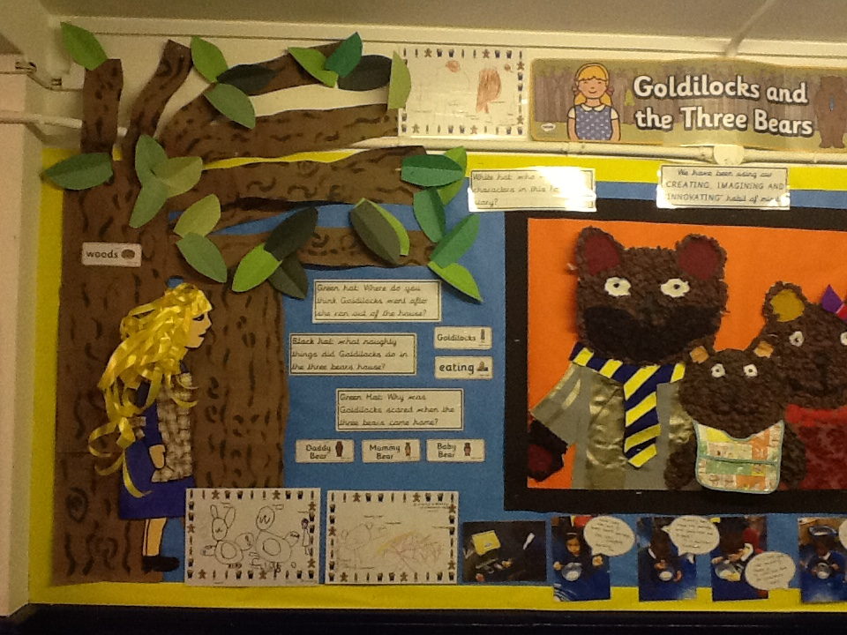

Mission Statement

St Mary’s school community follows the teachings of Jesus Christ, working together to develop the whole child, in a spiritual, moral, academic, physical, social and emotional way, within a caring and supportive environment.



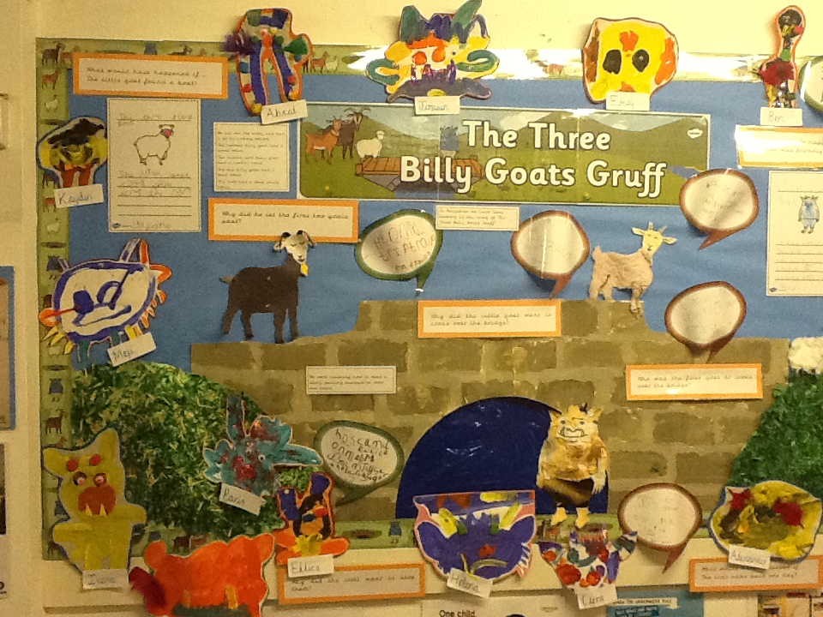

The Aims of our School

We will endeavour to create a Catholic Ethos in our school, which reflects the Gospel values, through the love, care and respect we show to each other, and to all who come to our school. We will teach the beliefs, traditions and practices of the Catholic Faith.

Through the prayer and worship in school we will try to be a living community of people celebrating their love for God and one another.

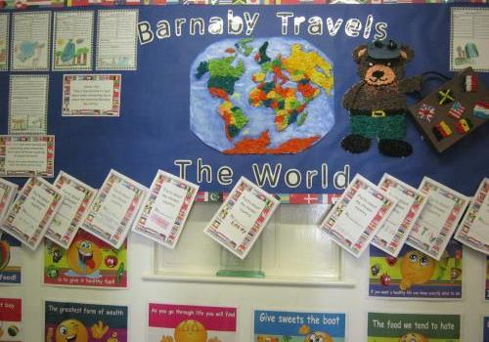

We believe the quality of the curriculum, with Religious Education at its core, is of prime importance and will focus on the development of the whole child. We will at all times try to make provision for children with special needs, so that all members of our school community achieve their potential.

We will help the children to develop an awareness of and respect for other religions and cultural backgrounds, as we believe this to be an essential preparation for adult life.

We believe that good communication between governors, staff, parents and children is important for the well-being of our school, and we will work in partnership with the wider community especially the home and parish in developing each child’s potential.

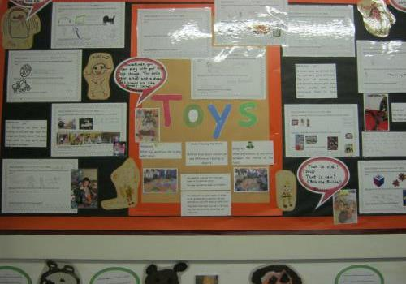

Aims for Each child at St Mary’s C.P.S.

- Whilst at St Mary’s School I will learn about being a Christian, I will experience the beliefs, traditions and practices of the Catholic Faith.

- I will achieve as much as I possibly can in each area of the National Curriculum.



- I will know how to learn and enjoy learning, and will view work in a positive and conscientious manner.

- I will co-operate and communicate with others effectively, independently and in a group, and try to win and lose graciously.

- I will tolerate and respect the religious beliefs, views and values of others, understand the need for good behaviour and moderate my behaviour accordingly. I will respect the belongings and property of others.

- If I have a problem I know I can find someone who will discuss it with me.

- I will try to learn from mistakes and accept there is always room for improvement.

- I will share a sense of responsibility for my school, parish, local community and the wider environment.

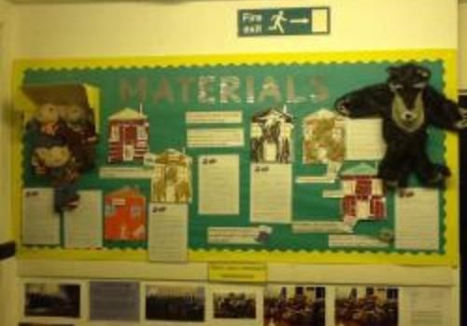

ST. MARY’S CATHOLIC PRIMARY SCHOOL

ADMISSION POLICY FOR ACADEMIC YEAR 2019/2020

St. Mary’s Catholic Primary School was founded by the Catholic Church to provide education for children of Catholic families. Whenever there are more applications than places available, priority will always be given to Catholic children in accordance with the oversubscription criteria listed below. The school is conducted by its governing body as part of the Catholic Church in accordance with its trust deed and instrument of government and seeks at all times to be a witness to Our Lord Jesus Christ.

As a Catholic school, we aim to provide a Catholic education for all our pupils. At a Catholic school, Catholic doctrine and practice permeate every aspect of the school’s activity. It is essential that the Catholic character of the school’s education be fully supported by all families in the school. We therefore hope that all parents will give their full, unreserved and positive support for the aims and ethos of the school. This does not affect the right of an applicant who is not Catholic to apply for and be admitted to a place at the school in accordance with the admission arrangements.

The governing body is the admission authority and has responsibility for admissions to the school. The local authority undertakes the co-ordination of admission arrangements during the normal admission round. The governing body has set its Published Admissions Number (PAN) at 60 children for the school year which begins in September 2019. Applications for Reception are welcome from families whose child reaches his/her 4th birthday between 1st September 2018 and 31st August 2019.

The governing body will admit twins and all siblings from multiple births where one of the children is the last ranked within the school’s PAN.

PUPILS WITH AN EDUCATION, HEALTH AND CARE PLAN (EHC)

The admission of pupils with an Education, Health and Care Plan (EHC) is dealt with by a completely separate procedure. (This used to be called a Statement of Special Educational Needs). Details of this separate procedure are set out in the Special Educational Needs Code of Practice. If your child has an EHC plan you must contact your local authority SEN officer. Children with this school named in their EHC Plan will be admitted. The admission of children with an EHC Plan will reduce the number of places available to other children (see note 1).

OVERSUBSCRIPTION CRITERIA

Where there are more applications for places than the number of places available, places will be offered according to the following order of priority:
- Catholic ‘looked after’ children and previously ‘looked after’ children (see notes 2-5);

- Baptised Catholic children with a Certificate of Catholic Practice, who are resident in the Parish of Mary, Mother of God, Ponders End (see notes 6, 7, & 13);

- Other baptised Catholic children for whom St. Mary’s Catholic Primary School is the nearest Catholic school (see note 6);

- Other baptised Catholic children (see note 6);

- Other ‘looked after’ children and previously ‘looked after’ children. (see notes 2-5);

- Children of catechumens and members of an Eastern Christian Church (see notes 8&9);

- Any other children.

Within each of the categories listed above, the provisions below will be applied in the following order:
- The Governing Body will give top priority, within a category, to an application where compelling evidence is provided at the time of application, from an appropriate professional such as a doctor, priest or social worker, of an exceptional social, medical, pastoral or other need of the child, which can only be met at this school.

- The attendance of a brother/sister at the school at the time of enrolment will increase the priority of an application within a category, so that the application will be placed at the top of the category in which the application is made, after children in (i) above.

APPLICATIONS IN PREVIOUS YEARS

For the past five years the governing body has been unable to offer places to any applicants beyond oversubscription (criterion 4) except in 2014 to four applicants (criterion 7) and 2 applicants (criterion 9) and in 2017 to one applicant (criterion 6), three applicants (criterion 7) and 1 applicant (criterion 9). As the school is usually oversubscribed by Catholic candidates, it is unlikely that applicants who are not Catholics will obtain a place.

TIE BREAK

Where the offer of places to all the applicants in any of the sub-categories listed above would still lead to oversubscription, the places up to the admission number will be offered to those living nearest to the school as measured in a straight line from the applicant’s home to the school as measured by the Local Authority (LA). If two or more applications are received from the same block of flats, the applicant with the lower door number will be classed as nearest and offered a place because they are likely to be closer to the ground floor and, therefore, the school. In the event of distances being the same for two or more children where this would determine the last place to be allocated, random allocation will be carried out by the local authority’s computerised allocation system.

APPLICATION PROCEDURE for 2019 – 2020

To apply for a place at this school in the normal admission round, you must complete an online application form from your local authority (paper forms are also available on request). If you are applying under criteria 2, 3, 4 or 6 you should also complete the School’s Supplementary Information Form (SIF). Whilst this is not compulsory, the information on the SIF enables the Governing Body to assess your application fully against the School’s criteria in the event of oversubscription. Please return the SIF (in person or by post) to the school, together with all other relevant paperwork required for your application. If you do not complete both of the forms described above and return them by 15th January 2019, the Governing Body will be obliged to consider your application using only the documents available. If you don’t return the SIF on time your child may receive a lower ranking because of this and not be offered a place.

You will be advised of the outcome of your application, on or about Monday 16th April 2019. This information will also be available on line for those who have submitted an online application. Parents should accept or decline the place as soon as possible. If you are unsuccessful (unless your child was offered a place at a school you ranked higher) you will be informed of the reasons, related to the oversubscription criteria listed above and you will have right of appeal to an independent appeal panel. Should you wish to appeal please contact the school as soon as possible for an appeal form on which you must list your reasons for making an appeal. Appeals should be submitted to the school in writing by Friday 24th May 2019.
LATE APPLICATIONS

Applications received after the closing date will be dealt with after the initial allocation process has been completed. If the school is oversubscribed it is very unlikely that late applicants will obtain a place.

RECEPTION YEAR DEFERRED ENTRY

A child is entitled to a full-time school place in the September following his/her 4th birthday. Applicants may defer entry to school up until compulsory school age i.e. the first day of term following the child’s fifth birthday. Application is made in the usual way and then the deferral until January or April is requested. The place will then be held until the first day of the spring or summer term as applicable. Entry may not be deferred beyond compulsory school age or beyond the year for which the application has been made. Therefore applicants whose children have birthdays in the summer term may only defer until the 1st April 2020. Upon receipt of the offer of a place a parent should notify the school as soon as possible if they wish to defer until the spring or summer term.

PART-TIME ATTENDANCE

Applicants may also request that their child attend part-time until statutory school age is reached. Upon receipt of the offer of a place a parent should notify the school as soon as possible if they wish to take up a part-time place.

ADMISSION OF CHILDREN OUTSIDE THEIR NORMAL AGE GROUP

A request may be made for a child to be admitted outside his/her normal age group e.g. if the child is gifted and talented or has experienced problems such as ill-health. In addition, the parents of a summer born child i.e. a child born between 1st April – 31st August, may request that the child be admitted out of his/her normal age group, starting reception at 5 years of age. Any such request should be made in writing to the governing body. The governing body will make its decision based on the circumstances of each case and in the best interests of the child, taking into account school organisation issues and the views of the parents and any professionals involved. Parents must have received the agreement of the governing body before any admission application for delayed entry is made. If permission is received then the parents will make their admission application for the year in which they wish their child to start school. Applications cannot be held over from one academic year to the next. If permission is refused then parents must make their admission application at the normal time.

WAITING LIST

In addition to their right of appeal, unsuccessful candidates will be offered the opportunity to be placed on a waiting list. This list will be maintained in order of the oversubscription criteria set out above and not in the order in which applications are received or added to the list. Waiting lists for admission will operate throughout the school year and will be held open until 31st July 2020 unless applicants request in writing to remain on the list. Inclusion in the school’s waiting list does not mean that a place will eventually become available.

IN-YEAR APPLICATIONS

An application for admission can be made for any child at any time outside the normal admissions round. Applications should be made directly to the school by contacting the head teacher (02088042396). If a place is available and there is no waiting list the child will be admitted. If there is a waiting list, then applications will be ranked by the Governing Body in accordance with the oversubscription criteria as set out above. If a place cannot be offered at this time then you may ask for the reasons and you will be informed of your right of appeal to an independent panel and your child will be placed on the waiting list.

FAIR ACCESS

The school is committed to taking its fair share of children who are vulnerable and/or hard to place, as set out in locally agreed protocols. Accordingly, outside the normal admissions round, the Governing Body is empowered to give absolute priority to a child where admission is requested under any local protocol that has been agreed by both the local authority and the Governing Body for the current school year. The Governing Body has this power even when admitting the child would mean
exceeding the published admission number.

NURSERY CHILDREN

For children currently attending the school’s nursery, application to the reception class of the school must be made in the normal way to the home local authority. Attendance at the nursery does not guarantee a place in Reception.

CHANGE OF DETAILS

If any of the details on either of your forms changes between the date of application and the receipt of the letter of offer or refusal, you must inform the School and the local authority immediately. If misleading information is given or allowed to remain on either of your forms, the Governing Body reserves the right to withdraw the place, even if the child has already started at the School.

NOTES (these notes form part of the oversubscription criteria)

- An Education, Health and Care Plan is a plan made by the local authority under S.37 of the Children and Families Act 2014, specifying the educational provision required for a child.

- A ‘Looked after child’ has the same meaning as in S.22(1) of the Children Act 1989, and means any child in the care of a local authority or provided with accommodation by them in the exercise of their social services functions (e.g. children with foster parents at the time of making an application to the school.) A previously ‘looked after’ child is a child who was looked after, but ceased to be so because he or she was adopted or became subject to a child arrangements order or a special guardianship order.

- ‘Adopted’. An adopted child is any child who has been formally adopted, having previously been in care and whose parent/ guardian can give proof of this.

- ‘Child Arrangements Order’. A Child Arrangements order is an order under the terms of the Children Act 1989 s.8 settling the arrangements to be made as to the person with whom the child is to live. Children ‘looked after’ immediately before the order is made qualify in this category.

- ‘Special Guardianship Order’. A special guardianship order is an order under the terms of the Children Act 1989 s.14A appointing one or more individuals to be a child’s special guardian(s). A child ‘looked after’ immediately before the order is made qualifies in this category.

- ‘Catholic’ means a member of a Church in full communion with the See of Rome. This includes the Eastern Catholic Churches. This will be evidenced by a Certificate of Baptism in a Catholic church or a Certificate of Reception into full communion with the Catholic Church. For the purposes of this policy this includes a looked after child in the process of adoption and living with a Catholic family, where a letter from a priest demonstrates that the child would have been baptised were it not for his/her status as a looked after child. For a child to be treated as Catholic, evidence of Catholic baptism or reception in the Catholic Church will be required. Those who have difficulty obtaining written evidence of baptism should contact their parish priest who, after consulting with the diocese will decide how the question of baptism is to be resolved and how written evidence is to be produced in accordance with the law of the Church.

- ‘Certificate of Catholic Practice’ means a certificate issued by the family’s parish priest (or the priest in charge of the church where the family attends Mass) in the form laid down by the Bishops’ Conference of England and Wales. It will be issued if the priest is satisfied that at least one Catholic parent or carer (along with the child, if he or she is over seven years old) have (except when it was impossible to do so) attended Mass on Sundays and holydays of obligation for at least five years (or, in the case of the child, since the age of seven, if shorter). It will also be issued when the practice has been continuous since being received into the Church if that occurred less than five years ago. It is expected that most Certificates will be issued on the basis of attendance. A Certificate may also be issued by the priest when attendance is interrupted by exceptional circumstances which excuse from the obligation to attend on that occasion or occasions. Further details of these circumstances can be found in the guidance issued to priests: http://rcdow.org.uk/education/governors/admissions

- ‘Catechumen’ means a member of the catechumenate of a Catholic Church. This will normally be evidenced by a Certificate of Reception into the Order of Catechumens for a child aged 7 or over. For a child under 7 years of age it will be the certificate of the parent.

- ‘Eastern Christian Church’ includes Orthodox Churches, and is normally evidenced by a Certificate of Baptism or Reception from the authorities of that Church.

- ‘Brother’ or ‘Sister’ includes:

- All natural brothers and sisters, half-brother and sisters, adopted brothers and sisters, stepbrothers and sisters, foster brothers and sisters, whether or not they are living at the same address, and

- The child of a parent’s partner where that child lives for at least part of the week in the same family unit at the same address as the applicant.

- A ‘Parent’ means all natural parents, any person who is not a parent but has parental responsibility for the child or any adult with legal responsibility for the child.

- ‘Resident’ – A child is deemed to be resident at a particular address when he/she resides there for more than 50% of the school week.

Parish Boundaries – for the purposes of this Policy, parish boundaries are as shown on the attached map and will be applied to the admission arrangements for 2019-2020.

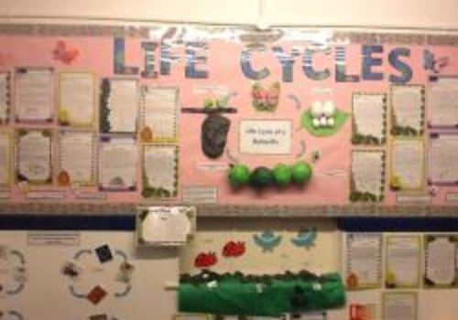

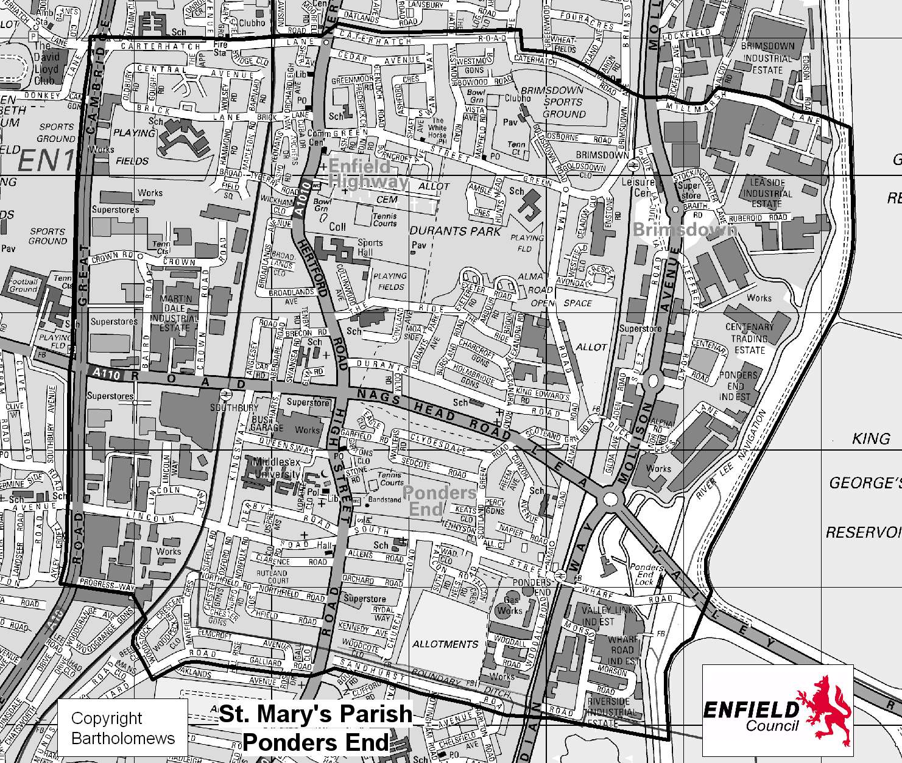

St Mary’s SEN Information Report

HOW WE SUPPORT CHILDREN/YOUNG PEOPLE WITH SPECIAL EDUCATIONAL NEEDS OR DISABILITIES
Our vision and how we hope to achieve it
Our mission statement places the unique individual at the heart of all that we do:
‘St Mary’s school community follows the teachings of Jesus Christ, working together to develop the whole child, in a spiritual, moral, academic, physical, social and emotional way, within a caring and supporting environment.’ This states our clear commitment as a school therefore, to meeting the needs of all pupils. For those pupils with Special Educational Needs (SEN), the school recognises and has regard to The Children and Families Act 2014 and the statutory guidance in the SEN and Disability Code of Practice (July 2014) which sets out the duties, policies and procedures relating to Part 3 of this Act and associated regulations.
Section 19 of the Children and Families Act sets out the principles which underpin the Code of Practice. In making provision for pupils with SEN the school has a responsibility to consider these principles which are designed to support:
- The participation of children, their parents and young people in decision-making.
- The early identification of children and young people’s needs and early intervention to support them.
- Greater choice and control for young people and parents over support
- Collaboration between education ,health and social services to provide support
- High quality provision to meet the needs of children and young people with SEN
- A focus on inclusive practice and removing barriers to learning
- Successful preparation for adulthood
Type of school we are

St Mary’s is a two form entry voluntary aided Catholic primary school with a nursery taking children from 3 years to 11 years. There are currently 419 pupils are on roll including the nursery. 22% of pupils are eligible for free school meals. This is a little below the national average (23.5%). 2.8% of pupils have an Education, Health and Care Plan, which is slightly lower than national (2.9%). However with four more proposed plans for 2019 the % will rise to 3.3%. 15.5% of pupils have SEN support compared to 14.6% nationally. 48% of pupils have English as an additional language which is more than double the national figure(21%) and 95% come from minority ethnic backgrounds compared to 31.65 nationally. The % of absence missed for all pupils in 2017-2018 was 2.64%, below the national figure of 4.8% and in the lowest 10% for all school over the last three years. The % of pupils with persistent absence was just over 2% well below the national figure of 11.2%.

Our Ofsted rating
Our last Section 8 Inspection in June 2018 rated the school as Good
Our Diocesan Section 48 Inspection in October 2014 rated the school as Grade 1 for Religious Education and 1* for The Catholic Life of the School

How we know if a child/young person has special educational needs
‘A pupil has SEN where their learning or disability calls for special educational provision, namely provision different or additional to that normally available to pupils of the same age’(Code of Practice July 2014).
The four broad areas of need which may require additional provision are:
- Communication and interaction
- Cognition and learning
- Social, emotional and mental health difficulties
- Sensory and / or physical needs

Your child’s needs may not necessarily fit in to a specific category and any provision we make in school will reflect a full understanding of the range of your child’s difficulties which may well be inter-related. Some difficulties may be quite clear early on in your child’s development and some may become apparent as your child progresses through school.

- We use baseline assessments (the school will be trialling the new EYFS Baseline in September 2019) when your child enters nursery / reception to check where your child is in their development as they begin school and continue to measure progress each half term against the Development Matters Bands and Early learning Goals. At this stage we would be looking particularly at language and social skills and as your child moves on to a more formal curriculum, teachers would be monitoring how your child acquires a basic understanding of literacy and numeracy.
- As part of the school’s Assertive Mentoring system, all pupils in school have targets for all areas of learning (these include academic and attitude - behaviour, punctuality, attendance, uniform) which are set out in their Assertive Mentoring folders. These targets are agreed with pupils and shared with parents. The aim of this holistic approach is to foster independence through pupils’ ownership of their individual goals, whatever their ability. Targets and progress are reviewed half termly.
- If progress seems to be less than expected the SEN teacher will carry out additional assessments. These include the Salford reading Tests well as YARC Reading and Wigan Maths assessments. These help us to identify more specifically, aspects your child may be having difficulty with.
- When a difficulty becomes apparent a discussion would initially take place between yourself and your child’s class teacher and in consultation with the special educational needs co-ordinator (SENCo) if appropriate at this stage. This discussion may be initiated by you or the teacher. We hope that you would approach the class teacher as soon as you have concerns. This may be in the form of speaking to the class teacher at the end of the day and arranging a time for further discussion, or phoning the school to arrange a convenient time to meet, or by e-mail or letter.
- The SENCo is also available to talk to you an early stage before any formal discussions.

What we do to help children/young people with special educational needs
The school offers a continuum of support for pupils, from differentiated work set within the classroom by the class teacher, to more highly individualised programmes delivered outside the classroom. The SENCo and SEN support teachers plan programmes and interventions with the class teachers and other support staff.
SEN provision currently available in school includes:
- Language groups for year groups as appropriate, including reception. These are run outside the classroom by teaching assistants following advice from the Speech and Language Service. The SENCo monitors the groups and liaises with the Speech and Language Service to ensure the groups are targeting children accurately.
- Group teaching outside the classroom with support teachers is usually for specific work on literacy and mathematics. The support teachers will liaise with the class teacher as to the focus of this work and the class teacher monitors progress closely.
- Phonological Awareness Programme for infants in small groups (can be individual pupils) led by teaching assistants or support teachers. Pupil progress is apparent back in the classroom as children begin to tackle reading and writing tasks with confidence.
- Additional phonics work in small groups usually with infant teaching assistants under teacher direction.
- ‘15 Minutes-a-Day’ catch up reading intervention runs for 12 weeks by teaching assistants specifically trained on this programme. Children are put on the programme following discussion between the SENCo and class teacher.
- Individual teaching time with the SEN or other support teacher for more intensive literacy or numeracy work. This may be for up to two hours a week. Progress would be monitored half termly with this type of support.
- ‘Spelling Made Easy’ programme-delivered outside the classroom by SEN teacher – may run for long period of time (individual, paired or small groups of pupils).
- ‘Toe-by-Toe’ – individual reading programme. SEN teacher works with pupils outside the classroom.
- ‘Rainbow Readers’ – audio supported reading scheme – teaching assistants mange pupils on the scheme under class teacher direction.
- Positive behaviour programmes – devised by the school or in consultation with the behaviour support service.
- Tiger Teams – a six week motor skills programme run by a teaching assistant. Children are identified by SENCo and class teacher.
- Colourful Semantics is used in classes and in intensive teaching groups to support reading comprehension and writing.

Your child could receive a range of different types of support throughout their time in school depending on where they are in their development. The emphasis will change and their needs could become more complex or lessen as they grow. No two pupils are the same and the school offers the most appropriate support at the time for each pupil.

How we adapt our teaching for children/young people with special educational needs
- All class teachers differentiate their planning and their teaching for all lessons. This means that they think about the language they are using when they are delivering the lessons, the questions they ask and how they support all children in being able to tackle tasks by themselves.
- Our aim in school is for all pupils whatever their level of ability to develop into independent learners. This does not mean that they will not get help but that once they show they understand what they have to do, they will be expected and encouraged to think for themselves and persevere even when something is a bit challenging.
- Teachers will therefore plan independent work tasks so that different groups (or individuals ) in the class are working in different ways (using thinking maps, word banks, writing frames and key words for example) and with a range of resources which your child can choose to use, at a varying pace. They may work intensively for a period of time with the teacher, the teaching assistant and by themselves throughout a lesson. Obviously your child is encouraged to ask for help if they are unsure of something, but you would not expect to see your child sitting in a lesson waiting for an adult – this would not be independent learning.
- Some of the work your child may do outside the classroom, may be teaching them how to ask for help at the appropriate time, to foster independence back in the class.

How we decide what resources we can give to a child/young person with special educational needs
- The SENCo in consultation with key external agencies (in particular the Educational Psychologist and the Speech and Language Service) and SEN staff decides where priorities seem to be within the school each year. This may be in a specific phase with groups of children or individuals with highly complex needs.
- Resources are then allocated to balance the wider SEN within the school with those of individual pupils who may need the support of several agencies and a number of support staff.
- There may be times when external professionals can offer whole staff training which improves staff awareness and confidence in dealing with specific SEND issues that affect individuals and groups of children in their classes.
- Where external agencies have recommended specific resources and strategies for your child these would be implemented by the school and you would be involved in the discussion about how your child will access this.
- The SENCo and SEN teachers look at all the children who need group or individual support across the school and plan time-tables for all the staff working with these children. Over the year your child may need more or less support depending on their rate of progress which is monitored and assessed each half term by their class teacher and the SENCo. When support is adjusted you would be informed by your child’s teacher if it is the more general type of support, at the termly IEP review, or at a formal review if your child’s needs are more complex and they have a more individualised plan involving more staff and probably external professionals as well.
How we check that a child/young person is making progress and how we keep parents informed
- All children in school are continually assessed – during lessons as your child’s teacher judges understanding through questioning and marking books (if your child is in nursery or reception there are a range of ways in which the teachers are able to judge your child’s progress and you would be informed of these when you meet the teacher at the parent consultations) and through formal half termly assessments in core subjects. These assessments are analysed by senior teachers responsible for the subject as well as the SENCo. Comparisons can be made for individuals with their peers and age related national expectations.
- When a child seems to be falling behind, you would be asked to come in and meet with your child’s teacher (you may have already raised concerns yourself anyway). This meeting may or may not involve the SENCo depending on the level of concern. Initial support would be agreed and an arrangement made to review progress.
- It may be that a programme is agreed with you that involves a daily or weekly communication dairy between home and school. This is often the case if there is a behavioural element. (You would of course always be informed immediately of any serious incidents).
- If progress continues to be a concern the level of support may be intensified – an individual intervention outside the classroom for a fixed period of time for example. When progress for your child still appears to be insufficient, programmes and interventions may be replaced or adapted. You would be consulted and involved in changes to your child’ programme at a review of their progress – usually termly but possibly sooner if an intervention is for a specific set time e.g. six week block of work.
- If difficulties persist, the SENCo, SEN teacher and class teacher would discuss the next steps with you and at this stage, it may be decided with your permission, that a referral should be made to an external agency such as speech and language services, the educational psychology service or behaviour support service.
- The school would then implement any advice from the outside agency (a usual period of time to monitor the impact of this type of advice would be a term).
- Although academic progress is the key indicator of your child succeeding in school, it may be that they make good progress but still have other needs that need specific support in school. Ways of monitoring these would need to be appropriate to the type of difficulty. Criteria for judging success would be agreed at review meetings and recorded with all other information on an individualised education plan.
- In a few cases it may be agreed by all the adults working with your child, that the complexity of their needs warrants us making an application to the local authority for a statutory assessment, leading to an Education, Health and Care Plan (EHCP). You as parents can apply for statutory assessment at any time yourselves.
- These Education, Health and Care Plans are formally reviewed annually and involve all adults who are working with the child.
- If your child has difficulties which are clearly more complex and severe the process of referral for additional support and advice would be made as soon as necessary. The timing of how support is planned and implemented depends entirely on each individual child. However external professionals and the local authority’s SEN services would expect us to use our own staff and resources in school as effectively as possible before applying for additional externally funded support.

Support we offer for children / young people’s health and general wellbeing

All children are encouraged in school to express their views and opinions in a wide range of ways, this may be structured - through participation in the School Council, Circle Time or Philosophy for Children sessions for example, or less structured through an ethos of openness in which all pupils are encouraged to speak to the adults they are with on a daily basis, as well as the head teacher and deputy head, who both have an open door policy. Your child may have times when they are unsettled or dealing with a specific problem and they will be given daily special time with the member of staff they relate well to. In a recent re-accreditation of the School’s Inclusion Quality Mark, the assessor remarked that St Mary’s pupils were ‘definitely children who had a voice.’ (report July 2017)

Medical:
- If your child has any medical needs the school welfare assistant (Mrs O’Shea) will invite you in to school to set up a care plan (in consultation with the school nurse). These plans are available in the medical room.
- The plans are up-dated regularly and you can contact the school welfare assistant at any time.
- All medicines are carefully monitored and recorded and under no circumstances would a child ever be given another child’s medication.
- If your child is taking antibiotics, the school will only administer these if your child has been prescribed medicine to be taken at least four times a day.
- Asthma pumps are kept in the medical room. They are used by the children themselves under adult supervision.
- If your child needs an epi-pen in school, one is kept in the classroom and the other in the medical room (with easy access in the case of an emergency).
- You will be contacted if we have any concerns at all about your child in school. We will liaise with the school nurse and make arrangements for you to meet with her if you need to.
- If your child receives a minor injury in school they will bring a letter home indicating where they have been hurt. (You would be contacted immediately if anything more serious happened).

Social:
- All children are fully included in all activities wherever possible. All children are encouraged to work and play together.
- New children in the school are provided with a buddy.
- Year six pupils are trained as buddies and help younger children resolve conflict and play successfully together in the playground.
- Individual children may be assigned a buddy if they are having problems socialising in the playground.
- Staff in the playground monitor the children and encourage them to interact. If there are any concerns they notify the class teacher.
- Lunch-time clubs for infants and juniors are open to all children but children who benefit from some adult support during playtime will be invited to go along.
- The school runs social language groups for children who find it hard to understand the complexity of social interaction.

Behaviour:
- Your class teacher would be the first person to speak to you if your child was having behavioural difficulties.
- If necessary a behaviour plan may be drawn up between your child and their teacher, following discussion with you. Your child would agree the rules (in their own words) they would need to follow in order to improve their behaviour. There would be rewards and sanctions and you would be informed on a regular basis (daily or weekly) of progress, through an agreed system of communication – home/school diary, phone call, good notes home.
- If behaviour remains a persistent problem the school may refer to the behaviour support service (SWERRL) requesting support and advice. You would be involved in any discussion and would need to give your permission before a referral was made. If SWERRL agreed the referral you would be invited in to a planning meeting in which targets and a behaviour programme would be drawn up. You would be invited to a follow-up review once the block of work was completed.
- You would be informed of any incidents involving your child – either by phone or letter and would be invited in to discuss it with either your child’s class teacher and or the SENCo (deputy head) or head teacher.

Attendance:
- Good attendance is critical to the success of your child in school and the continuity is even more important if your child is working on a specific intervention or with individual support.
- The school should be informed in writing of any absences.
- If you are unsure when your child should return to school after an illness, the school office will always advise you.
- The head teacher will write to you if your child’s attendance falls below a certain level but you should speak to either the head or deputy if there are specific reasons which are making it difficult for you to ensure your child’s regular attendance.

Specialist external services we use when we think extra help is needed

Pupils in our school access additional specialist provision from:
- Houndsfield and Suffolks Language Units
- Additional Resource Provision (based in other schools within the borough)

We refer to the following services for advice and outreach:

Autism Advisory Service
Joseph Clarke Service for Visual Impairment
The Educational Psychology Service
The Speech and Language Service
Children and Adolescent Mental Health Service
Blanch Neville Service for Hearing Impairment
SWERRL (formerly Primary Behaviour Support Service)
School Nurse and Health Visitor
Physiotherapy
Occupational Therapy
Enfield Parent Support Service
Parent Support Unit
Children’s Services
Joint Services for Children with Disabilities

If we feel that your child would benefit, we will complete an Enfield Early Help form with you, requesting one or more of the above services. This is logged with Enfield who pass the request on to the specific agency. In most cases the school then completes another referral form (which you would come in to school to sign) for whichever service your child needs to access.

The training our staff have had or are getting

- All staff are regularly trained in child protection procedures (every year) and designated members of staff attend the local authority two day training course every two years. This is not to deal with SEND issues specifically but to ensure that staff are confident that they can keep all our pupils safe whatever their needs.
- All staff also have up-to-date first aid training and where appropriate paediatric first aid training.
- Whole staff training takes place regularly to disseminate knowledge and strategies which ensure a consistency of approach and confidence in teaching pupils with a range of SEND. Last year the Primary Behaviour Support Service delivered staff inset on theories of attachment disorder in pupils and other training has included basic Makaton and Approach training.
- Staff have been trained in the use of Colourful Semantics to support pupils in the classroom and group interventions.
- Training delivered by the relevant professionals, has included understanding and making provision for dyslexia, working with language difficulties, recognising attachment disorder, developing strategies for autistic spectrum disorders (as well as workshops for developing resources for pupils with autism) and emotional and behavioural difficulties.
- Individual teachers and support staff attend high quality training specific to individual pupils they are working with.
- The SENCo liaises with external agencies to organise in-house training for specific programmes for teaching assistants or teachers.
- When the behaviour support service is working with individual children in school, the relevant teaching assistant will observe and have follow-up liaison time so that they can continue the work once the SWERRL intervention has finished.
- Staff also receive training from the school nurse on administering epi-pens as well as specific advice if relevant to individual pupils at a particular time (e.g. Sickle Cell Anaemia).
- Staff have received training on the SEN Code of Practice and its implications for teachers (and other staff) as well as the children they teach.

How we include children/young people in activities and school trips
Risk assessments are completed before all activities or trips take place. This means that we can discuss with you any considerations which need to be taken into account and adaptations made if necessary.
- All children are included in all activities with their peers.
- Staffing on all trips meets the DFE minimum ratio and the school ensures that individual children have an adult to accompany them on a 1:1 basis if this is necessary to ensure their safety or allow them to participate fully on the trip or activity.
- If your child has emotional / behavioural issues, for specific trips or activities the school will plan with you and this may mean that we agree that it is best you accompany your child on the trip.
- Children are prepared in advance for any trip / activity.
- All adults accompanying a trip whether school staff or volunteers, will read and sign the risk assessment.

Our school environment

- There are two disabled parking spaces outside the school.
- There are disabled changing and toilet facilities situated in the main corridor, and two further disabled toilets in the lower junior corridor and on the first floor.
- The school is accessible to wheelchairs.
- There is a lift to reach the upper floors.
- There is a stair lift in the corridor connecting the infant and lower junior classrooms.
- Classrooms are fitted with a radio transmitter hearing system for use with hearing aid users.
- When a child with special needs enters the school their needs are carefully assessed and any equipment provided as necessary. The school will apply for funding to purchase equipment recommended by agencies such as the physiotherapy or occupational therapy services.
- The school is secure and has restricted access.

How we prepare for children/young people joining our school and leaving our school
- All children starting in our nursery and reception classes have a home visit. This gives you the opportunity to discuss your child in an environment you feel comfortable in. lf your child has been allocated early years transition support the learning support assistant will accompany school staff on the visit.
- Nursery or reception staff will visit your child in their current setting if practical.
- Discussion will take place with staff working with your child and other professionals involved.
- Children starting reception have an induction visit to school – this is an opportunity to discuss any concerns that the school may not have been made aware of.
- Children in reception can make a graduated move to a full day in school – your child’s class teacher will discuss how they are coping with you and build up at a rate which is manageable for your child.
- If your child starts further up the school, we will request any information relevant to your child and discuss with you what plans needs to be made to ensure we have everything in place to ensure a smooth transition.
- All teachers discuss pupils’ individual needs with the next teacher and where appropriate the SENCo always adds relevant information.
- If your child needs additional preparation for moving to a new class the staff (SENCo, SEN teacher and relevant staff) will prepare a transition booklet for your child with key information and photographs to lessen anxiety about transition.
- If your child is in year six, the SENCo will make arrangements to discuss your child’s needs with the secondary school.
- If your child has complex needs, all relevant professionals (including the SENCo or head of year from the secondary school) would be invited to a transition meeting at the beginning of the summer term of year six.
- Speech and Language Services provide a secondary transition programme for specific pupils in year six.

How parents are involved in school life
We encourage all parents to discuss any worries or concerns about their child with key members of staff at the earliest opportunity, To facilitate this the head teacher and deputy head are on the door every morning and evening for informal discussions, or to arrange a more private conversation at another time.

- We operate an open door policy in school and the class teacher is available at the end of the day for a brief conversation. Any more in-depth discussion can be arranged at this time.
- Curriculum evenings are held each term to up-date parents on ways of supporting your children at home.
- The school will access the translation service when needed and there are members of staff who may be able to interpret for you.
- We encourage and welcome you as volunteers in the school (subject to DBS checks).

Who to contact for more information or to discuss a concern
In the first instance you would speak to your child’s class teacher but the SENCo is Mrs O’Neill and you may make an appointment at any time to discuss issues that you feel need addressing outside the normal classroom situation or less formally, when you drop off or pick up your child.

If you have SEND concerns before your child starts school you will be put in contact with Mrs O’Neill to make arrangements for your child when they come in to school.

The link governors for SEN are Mrs W.Allen and Mrs B.Ijewere

Although we would always endeavour to resolve any issues with you regarding your child in school, as soon as problems arise, there may be an occasion when you feel that you need to make a complaint. The member of staff to contact in this situation is Mrs C.Brennan. The process for this can be found in the Complaints Procedure in the policy section of the school’s website:

www.stmarysenfield.co.uk

The Enfield local offer provides information on all professional services and support for families with children with additional needs:
www.enfield.gov.uk/SEND
Appendix
The list below may be useful for reference when dealing with professionals in a range of services and special educational needs in particular (it is not an exhaustive list)

ASD: Autism Spectrum Disorder
CAMHS: Child and Adolescent Mental Health Services
CCG: Clinical Commissioning Groups
COP: Code of Practice
CYP: Child or Young Person
EHCP: Education, Health & Care Plan
EISS: Early Intervention Support Service
EP: Educational Psychologist
EPSS: Enfield Parent Support Service
EWO: Education Welfare Officer
HI: Hearing Impairment
IEP: Individual Education Plan
JSDC: Joint service for disabled children
LA: Local Authority
MLD: Moderate Learning Difficulty
MSI: Multi-Sensory Impairment
OT: Occupational Therapy/Therapist
PD: Physical Disability
PMLD: Profound and Multiple Learning Difficulties
PR: Parental Responsibility
PSU: Parent Support Service
PT: Physiotherapy/Physiotherapist
PSP: Pastoral Support Plan
SALT/SLT: Speech & Language Therapy/Therapist
SEN: Special Educational Needs
SENCo: Special Educational Needs Co-ordinator
SEND Special Educational Needs and Disabilities
SLCN: Speech, Language & Communication Needs
SLD: Severe Learning Difficulties
SpLD: Specific Learning Difficulties
SWERRL: (formerly Primary Behaviour Support Service)
TA: Teaching Assistant
TAF: Team Around the Family
VI: Visual Impairment

Our offer to children with special educational needs and disabilities was prepared in July 2014 and is reviewed annually.

Last review July 2019

Access Arrangements

The classrooms are all on one level, with ramps to all classrooms. There are three single disabled toilets, two disabled toilets within the junior toilet block and a disabled car parking space has been allocated at the front of the school for easy access for some children. From September 2010 the school also includes classes on the first floor and a roof garden. Lift access is available to those areas.

School Organisation

At St Mary’s there are two part-time nursery classes with places for up to 52 children for the year before they become Reception age.

Mornings 8.45 am - 11.45am
Afternoons 12.30pm – 3.30pm
Nursery children attend 5 morning / afternoon sessions.

The Nursery, although an integral part of the school, is organised separately within its own building and play area.

The Nursery is run by a full-time teacher and Nursery Nurse as well as having classroom assistant help each week. Students and Secondary School pupils on work experience schemes quite regularly help in the nursery.

Parents are asked for their co-operation in helping children to settle well and adapt to life in school.

In the school, children between the ages of 5 and 11 are divided into fourteen classes based on age ranges.

When class groups are re-arranged into new groupings for the following year, the decision is made on the basis of a number of factors. We try to keep friendship groups together as far as possible.

Currently children are organised into fourteen classes as follows:

- Red Class Reception
- Amber Class Reception
- Green Class Year 1
- Orange Class Year 1
- Yellow Class Year 2
- Ruby Class Year 2
- St. Cecilia Year 3
- St. Bernadette Year 3
- St. Paul Year 4
- St. Peter Year 4
- St. Anthony Year 5
- St. Joseph Year 5
- St. Catherine Year 6
- St. Christopher Year 6

Playtimes

All children have one fifteen minute playtime in the morning as well as the lunchtime break, which is one hour. To ensure that playtimes are safe and enjoyable for all, children are asked not to bring their own toys into school. They can however use an airflow ball, skipping ropes or other equipment provided by the school.

To encourage healthy eating and to prevent litter children are asked to have a piece of fruit at morning break.

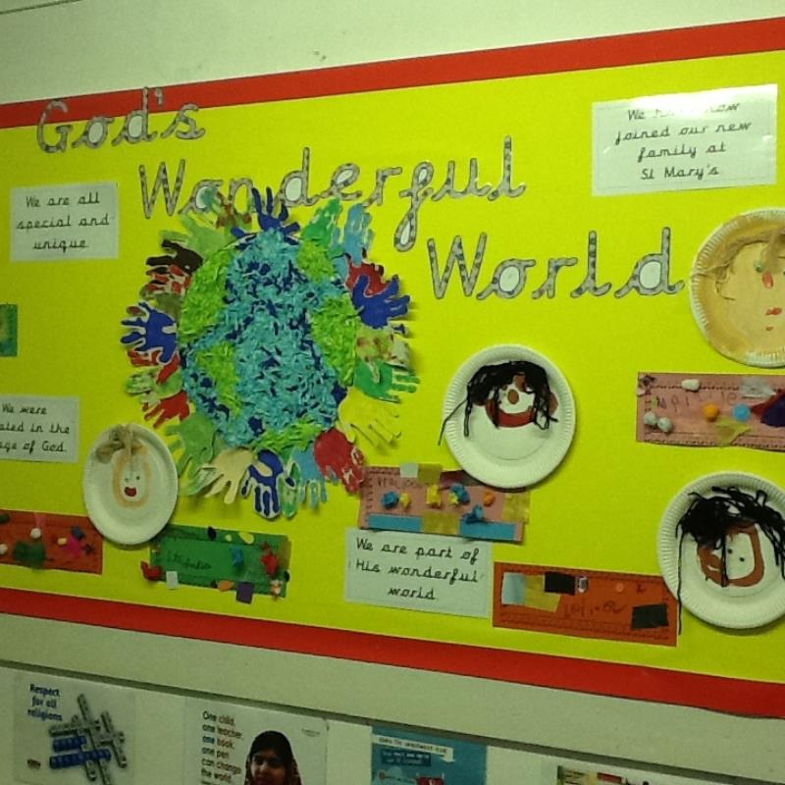

The School Day

The working week is 25 hours for Key Stage One and Reception children and 25 hours for Key Stage Two children.

 | Infants | Juniors
Morning | 9.00 – 12.00 | 9.00 - 12.30
Afternoon | 13.00 – 15.00 | 13.30 – 15.15

Children are asked not to arrive in school before 8.45 am as the playground is not supervised before this time (except if children are attending the Breakfast club which runs from 7.45am – 8.45am). Staff are on duty at the doors from 8.45 am to welcome pupils and other staff are on duty on the playground. Children go straight to the classrooms when they come in each morning. Registers are taken at 9.00 am when lessons begin.

Children arriving late should go to the School Office where they can be marked present in the register. Please do NOT take children to class if they are late; we will do that for you.



Attendance

Schools are required by law to categorise all absence into one of two categories (authorised or unauthorised) and to submit a report each half-term to the local Education Authority as well as to report individually each year to parents, about their child’s level of attendance.
Irregular attendance means that children are not able to build up their knowledge and understanding, and this can affect their confidence, friendships and sense of belonging. Cases of poor attendance and continuous late arrival are reported to the Education Welfare Officer who may make a home visit to discuss the situation with parents.

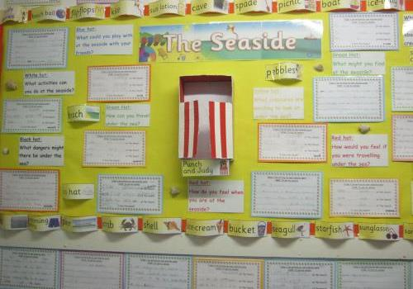

Lateness

Not only is it important for children to attend school regularly, but it is also essential that they should arrive in class on time so that they do not miss the vital start to the day’s activities. Parents can really support their children and the school by helping them to develop the habit of good attendance and punctuality. It is considered an unauthorised absence if they are not present when the register is taken after morning prayers, ten minutes later than the bell for the start of the session.

More than 2 late marks in a week will result in the school contacting the parents to discuss the situation.

Taking Children out of School

Requests to take children out of school for part of a day, for medical (please present the appointment card / letter at the school office) or other purposes should be made in writing. Please make sure that you first go to the school office so that an entry can be made in the Withdrawal Book. Whey they return to school after such a visit or appointment they should again be brought to the school office so that their return may be noted.

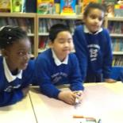

Absence due to illness

If your child is ill, then the best place for them to be is at home. Please always keep children away from school for a full 48 hours if they have been sick, and until they are better if they have an infectious complaint, including the various illnesses. Some illnesses are ‘notifiable’ and the Community Physician has to be told about their incidence by the school, so please tell us the reason for absence. It is important that in the case of sickness that the school is informed in writing on the child’s return to school. We care about your children so in the event of long term illness please keep us informed of progress. In the event of hospitalisation, please let us know so that we may visit when possible / liaise with the hospital as necessary.

Holidays during term time

In the interest of your child’s progress please do not take annual holidays during term time. School holiday dates are provided early in the year to help you plan your dates. It is vital that children do not miss time from school.

PLEASE PUT ALL REQUESTS FOR APPROVAL OF AN ABSENCE IN WRITING TO THE HEADTEACHER.
HOMEWORK WILL NOT BE ISSUED FOR HOLIDAY PERIODS.

The attendance totals in percentages for recent years are as follows:

Year | Authorised Absence | Unauthorised Absence | Actual Attendance
2009-2010 | 4.0% | 0.0% | 96.0%
2010-2011 | 3.8% | 0.0% | 96.2%
2011-2012 | 3.3% | 0.0% | 96.7%
2012-2013 | 3.66% | 0.04% | 96.3%
2013-2014 | 2.28% | 0.14% | 97.58%
2014-2015 | 2.27% | 0.10% | 97.63%
2015-2016 | 2.54% | 0.01% | 97.44%
2016-2017 | 2.41% | 0.04% | 97.55%
2017-2018 | 2.58% | 0.06% | 97.36%
2018-2019 | 2.42% | 0.08% | 97.50%
Behaviour

Good behaviour is encouraged at St Mary’s School in the following ways:
- the learning environment is regularly reviewed to ensure that it fosters good behaviour;
- we try to use positive approaches to encourage and reinforce good behaviour;
- certain sanctions are used to deter negative behaviour.

Parents are made aware immediately, verbally or by letter (with a reply slip to confirm receipt) about problem behaviour such as fighting, racism, bullying or swearing, and serious incidents are investigated thoroughly and a written record of details is kept by each class teacher / senior member of staff. Any racist or bullying incidents are reported to school governors. We believe that it is important for parents to be made aware of any problem in school as soon as we can, and how we are working to remedy it.

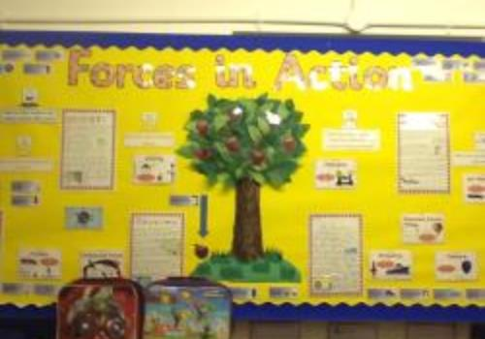

Guidelines to ensure safety, and a pleasant learning environment

Each child has the right:
- to learn, and experience a sense of achievement;
- to be treated equally and with respect;
- to be safe in the playground and in the classroom.

Children have responsibilities to:
- be considerate, and to care for and respect each other;
- respect each other’s belongings and the school’s equipment;
- wear the correct uniform for school and for PE;
- have the correct equipment for school;
- try their best;
- listen to, and co-operate with each other;
- to work sensibly in a group or on their own;
- be punctual;
- act safely;
- tell a teacher if they believe they are being bullied or if they see someone else being bullied.

In all dealings with others, we should:
- be polite;
- remember to say please, thank you and excuse me;
- say things which help people feel good about themselves;
- not tolerate ‘put-downs’;
- not tolerate teasing, or making fun of others;
- not tolerate name-calling;
- not tolerate swearing or bad language;
- not tolerate biting;
- respect the wishes of others;
- be honest and truthful.

Action against bullying

- What counts as bullying?

We define bullying as the wilful, conscious desire to hurt, threaten or frighten someone. It may be mainly physical – pushing, hurting or threat of hurting, or verbal – name calling, spreading rumours, persistent teasing. It may also be racist – racial taunts or gestures, emotional – excluding, tormenting (hiding belongings etc), ridicule or humiliation. It may also be sexual – unwanted physical contact or abusive comments.

Occurrences of behaviour which cause distress or even actual harm, but which are not intended to do so, are not bullying.

Although what is referred to as ‘teasing’ may seem trivial, it will always be considered as seriously as ‘name-calling’ as these are both unpleasant for others and lead to an atmosphere of mistrust and distress which almost always escalates into retaliation and further negative behaviour.

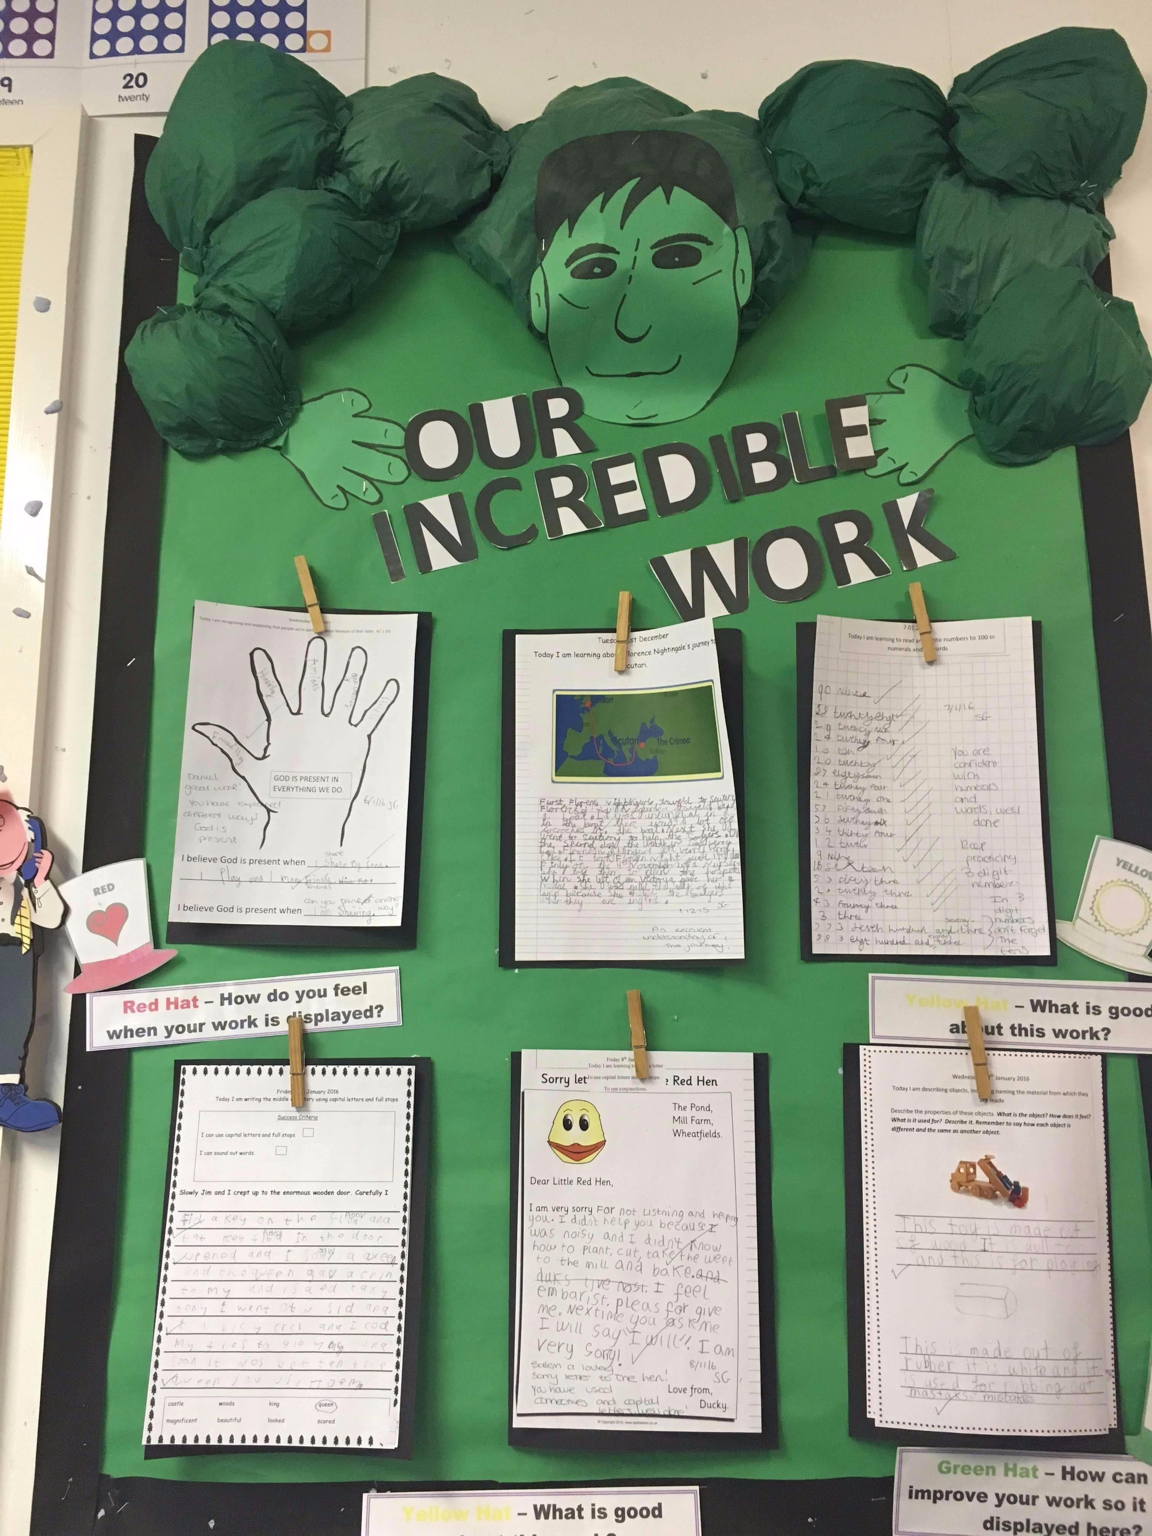

- Anti-bullying procedures

Bullying is damaging for the bully and the victim and at this school children are reminded frequently of their responsibility to tell an adult at school if they are being distressed or hurt by the behaviour of others, or if they see it happening to those around them. They are also asked to talk to their parents about incidents that happen to them in school. We always tell children that it is wrong to retaliate either physically or verbally, and that they should tell an adult instead.

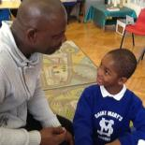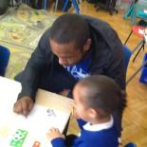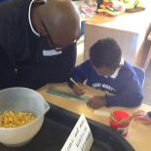

When a child reports that they are being hurt or upset we will:

- Take the problem seriously.
- Investigate the incident.
- Interview those responsible, and victims separately.
- Interview any witnesses.
- Decide an appropriate action, e.g.:

- obtaining apology from bullies to victim;
- decide appropriate punishment for bully;
- inform parents of bully;
- insist on return of items borrowed or stolen/or victim being compensated;
- encourage bully to change behaviour.

6. If required hold a follow-up meeting with victim’s parents to report progress.
- Inform all relevant staff about incident and action taken.
- Keep a written record of incident, interviews, and action taken.

We may also ask all concerned in an incident to write down their view of what happened.

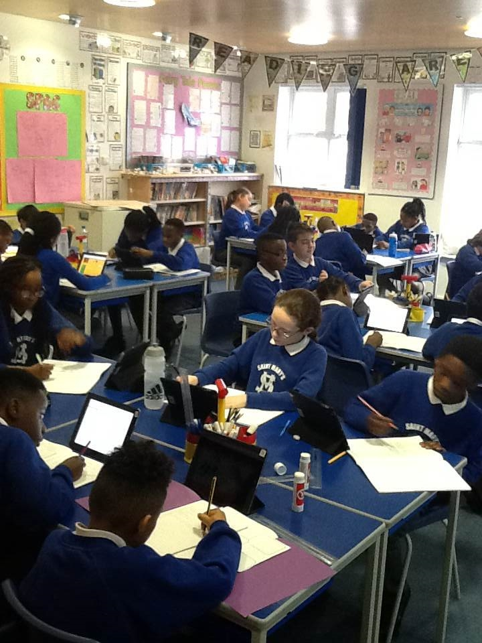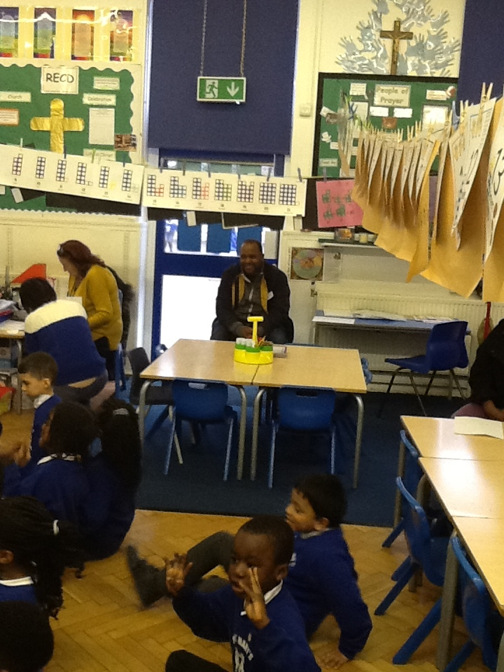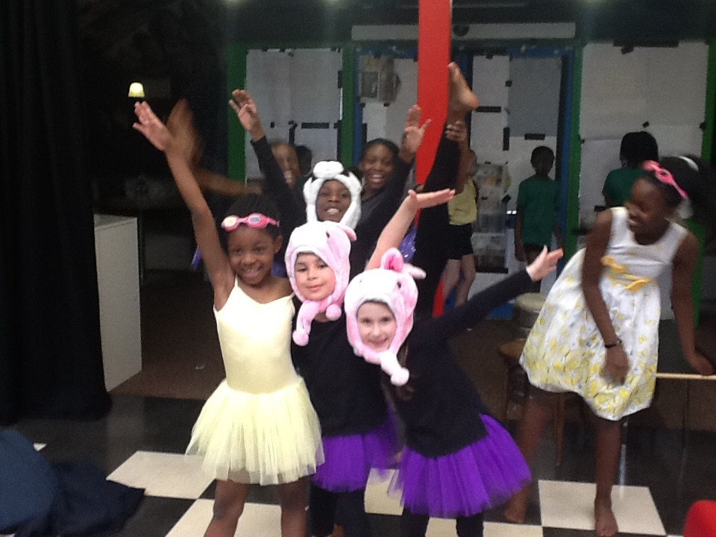

PARENTS ARE ASKED TO NOTE THAT IT IS THE POLICY OF THE SCHOOL THAT ANY INCIDENTS THAT HAPPEN AT SCHOOL SHOULD BE DEALT WITH BY THE SCHOOL.

Please make an appointment to see your child’s teacher in the first instance, if your child complains about a problem which does not seem to have been dealt with. It can cause completely unnecessary distress between parents if complaints are made to other parents. If your child complains to you after school about another child’s behaviour, please arrange to speak to your child’s class teacher as soon as possible.

Your support and co-operation is requested and is considered to be of vital importance. In the event of problems within school you will be invited to meet the class teacher / the Headteacher to discuss a satisfactory remedy for the situation. The school has a full Behaviour Policy that you can read if you wish, please ask in the school office.

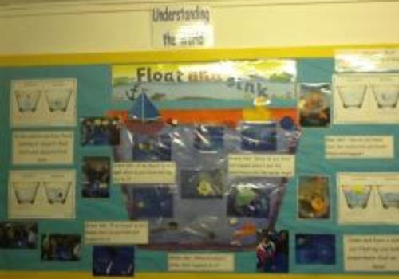

St. Mary’s Catholic Primary School

National Curriculum Assessments at End of Key Stage 1

SCHOOL RESULTS 2019

These tables show the percentage of pupils at the end of key stage 1 achieving each level in the school in 2019.

The number of pupils at the end of key stage 1: 61

Figures may not total 100 per cent because of rounding.

 | TEACHER ASSESSMENT
 |  |  | Percentage with each outcome
 |  | HNM | BLW | PK1 | PK2 | PK3 | PK4 | WTS | EXS | GDS |  | Pupils absent | Pupils  disapplied
Reading |  |  | 3 | 0 | 2 | 0 | 0 | 18 | 56 | 21 |  | 0 | 0
Writing |  |  | 3 | 2 | 0 | 0 | 0 | 16 | 57 | 21 |  | 0 | 0
Mathematics |  |  | 3 | 0 | 2 | 0 | 0 | 10 | 59 | 26 |  | 0 | 0
Science |  | 13 |  |  |  |  |  |  | 87 |  |  | 0 | 0

ATTAINMENT

Percentage of pupils achieving the expected standard in English reading, English writing and mathematics teacher assessments | 74%
Percentage of pupils working at greater depth in English reading, English writing and mathematics teacher assessments | 18%

HNM Has not met the required standard for most 7 year olds.

BLW Below the standard if the key stage – to be reported with P-scales or NOTSEN as appropriate.

PK1-PK4 Pre-key Stage Standard 1-4 .

WTS Working towards the expected standard.

EXS Working at the expected standard.

GDS Working at greater depth at the expected standard.

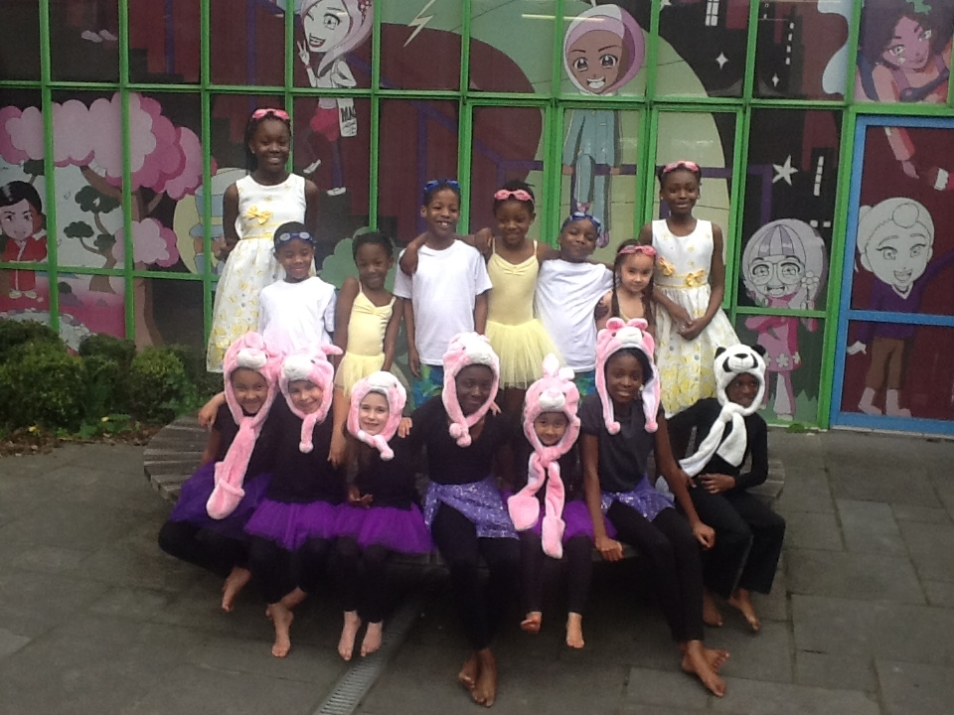
St. Mary’s Catholic Primary School

2019 Key Stage 2 school results

These tables show the percentage of children in the school achieving each level at the end of Key Stage 2.

Number of children at the end of Key Stage 2: 56

 | TEACHER ASSESSMENT
 | Percentage with each outcome
 | HNM | BLW | PK1/2 | PK3 | PK4 | PK5 | PK6 | WTS | EXS | GDS | A | D | L | F | P
Reading |  | 0 | 0 | 0 | 2 | 0 | 2 |  |  |  | 0 | 0 | 0 | 0 | 0
Writing |  | 0 | 0 | 2 | 0 | 0 | 2 | 9 | 64 | 23 | 0 | 0 | 0 | 0 | 0
Mathematics |  | 0 | 0 | 0 | 4 | 0 | 0 |  |  |  | 0 | 0 | 0 | 0 | 0
Science | 18 |  |  |  |  |  |  |  | 82 |  | 0 | 0 | 0 | 0 | 0

 |  |  | TEST RESULTS
 |  |  | Percentage with each outcome
 | A | B |  | L | M | T | F | P | H | Q | AS | NS | U | J
Reading | 0 | 5 |  | 0 | 0 | 0 | 0 | 0 | 0 | 0 | 80 | 14 | 0 | 0
Grammar, Spelling and Punctuation | 0 | 5 |  | 0 | 0 | 0 | 0 | 0 | 0 | 0 | 91 | 4 | 0 | 0
Mathematics | 0 | 5 |  | 0 | 0 | 0 | 0 | 0 | 0 | 0 | 88 | 7 | 0 | 0

ATTAINMENT

Percentage of pupils achieving the expected standard in English reading, English writing and mathematics | 77%
Percentage of pupils achieving a higher standard in English reading, English writing and mathematics | 7%
Pupils’ average scaled score in English reading | 105
Pupils’ average scaled score in mathematics | 106

HNM Has not met the required standard for most 11 year olds.

BLW Below the standard of the pre-key stage – to be reported with P-scales or NOTSEN as appropriate.

PK1 Pre-key stage Standard 1. PK4 Pre-key stage Standard 4.

PK2 Pre-key stage Standard 2. PK5 Pre-key stage Standard 5.

PK3 Pre-key stage Standard 3. PK6 Pre-key stage Standard 6.

WTS Working towards the expected standard.

EXS Working at the expected standard.

GDS Working at greater depth at the expected standard.

A Absent

D Disapplied

L Left

F Pupil will take test in the future

P Pupil has taken test in the past

B Working below the level of the test

M Missing

T Unable to access test

H Pupil cheating

Q Maladministration

AS Achieved Standard

NS Not Achieved Standard

U Unable to assess test

J Just arrived in the school

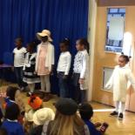
Religious Education

The religious teaching in the school is taught in accordance with the attainment targets for Religious Education set out by the Diocese of Westminster, and the Religious Education Curriculum Directory produced by the Bishops of England and Wales. However, the school considers religious education to be significantly more than merely a subject, or an isolated aspect of the curriculum. It is a part of the ‘hidden curriculum’ of our Catholic school, and religious teaching and experience permeate every aspect of the curriculum. Religious education is a continuous process which encompasses the example we show one another, our relationships, and the respect, care and consideration, tolerance and forgiveness that we show each individual, as well as the beliefs, practices and traditions of our faith.

The school has a full Policy Statement about Religious Education which is available from the school office for you to read.

Using the Liturgical seasons, Feast days, the Scriptures and the teaching of the Church, the school continues, broadens, extends and develops the sense of spirituality which children have already received in the family. As parents, you are your children’s first and best teachers in the ways of faith and spirituality. You willingly accepted this role and ministry when you presented your child for Baptism.

If your child’s faith is going to be an important part of her or his life, then parents, parish and the school all have a key role to play. No one group can succeed alone. The home lends credibility to the school, and the parish to the school, and to the home. To achieve success, all three groups need to work closely together.

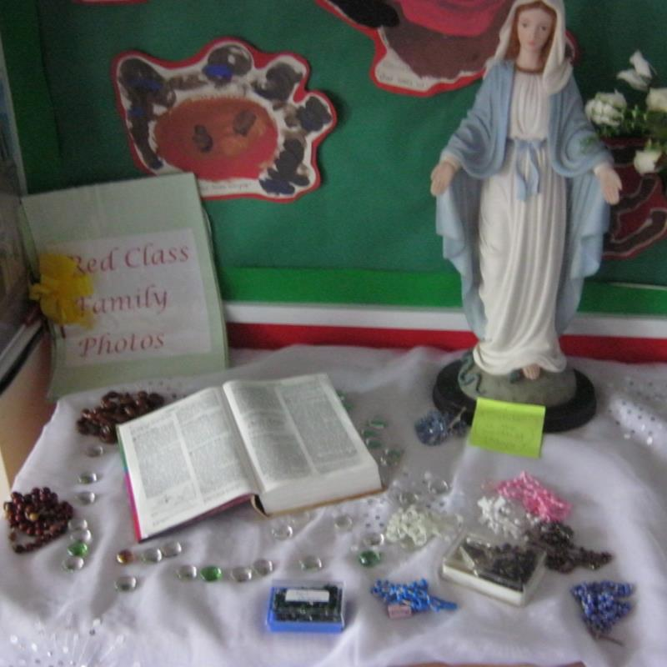
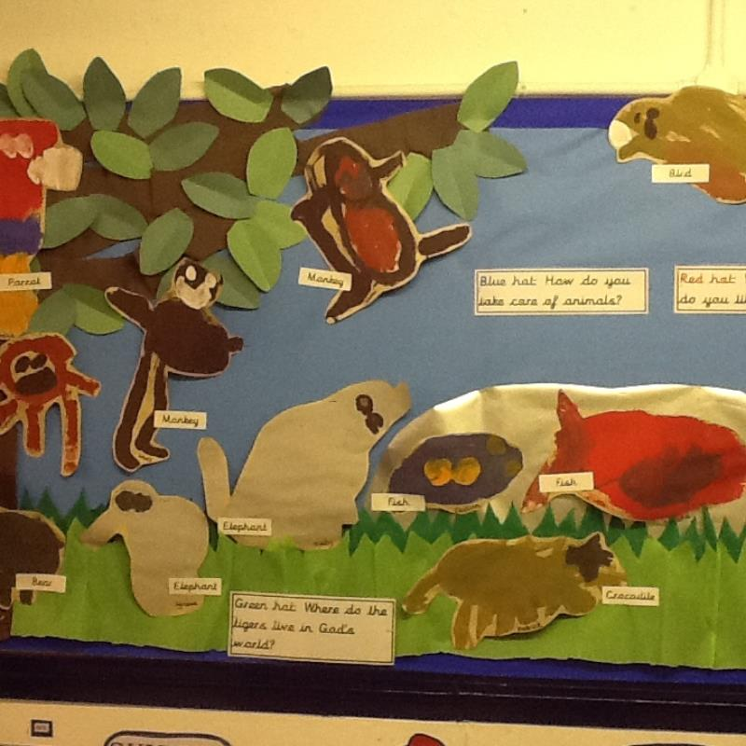

Sex Education

The school does not consider this to be a subject in isolation, or an area of the curriculum in its own right; neither does the school consider it solely under the umbrellas of either Science or RE. Knowledge in this delicate area is part of the gradual process of growing up, and is a partnership between home and school. A very wide programme which covers Education for Personal Relationships under the headings of ‘Ourselves’, ‘Relationships’, Growth’ and ‘Health & Safety’ is part of the curriculum, and includes those aspects of sex education which are relevant to children of primary school age. The school has a full Policy Statement which you can read if you wish. Please ask for a copy in the school office.

Child Protection

The Area Child Protection Committee with members from Social Services, Health Departments, Police, NSPCC, the Education Department and others have published procedures on Child Protection.

The procedures give clear instructions to staff in school to immediately inform the Education Department and Social Services that an allegation of abuse has been made. It is the school’s duty to follow these instructions. A copy of the Child Protection policy is available for inspection in school and is published on the school website.

All staff are trained in Child Protection.

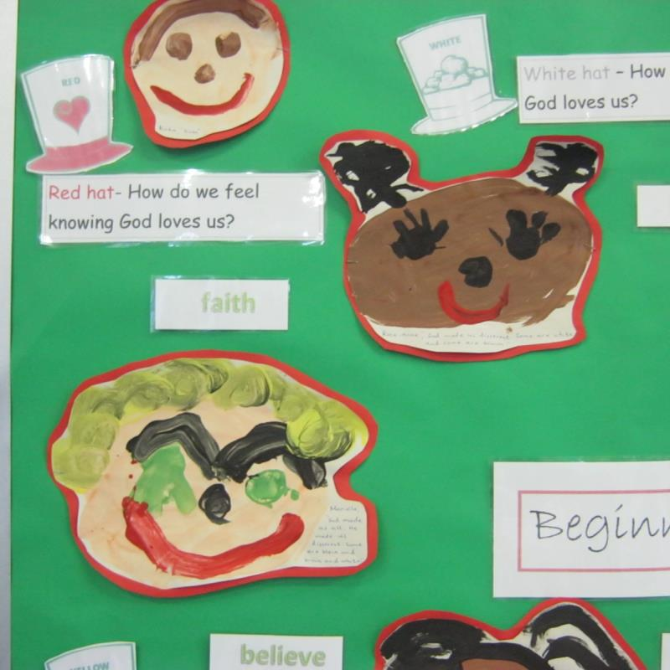

Education Support Services

Full use is made by the school of the various support services offered by the Education Authority which include the School Health Service (vision, hearing and dental checks), School Psychological Service, Educational Welfare, Social Services and Child Family Service.

Homework

Key Stage One

This table is a guide to the average time which may be spent on the activities; with younger children particularly, it is important to find a time when they are able to enjoy reading with you or memorising spellings or number facts. All children should read daily. A short time, regularly, is much better than persevering when your child is not able to concentrate.

Year | Reading (daily) | Other work
Reception  Year 1  Year 2  Nursery | 10 minutes – reading to your child, and listening to them reading.  15 minutes – reading to and listening to child read  20 minutes – reading to and with your child.  Weekly book chosen by child to share | Word games, phonic work practising each new sound, and comprehension tasks.  Phonic work, language activities, number work.  Language activities and spelling, number work.  Interest Book

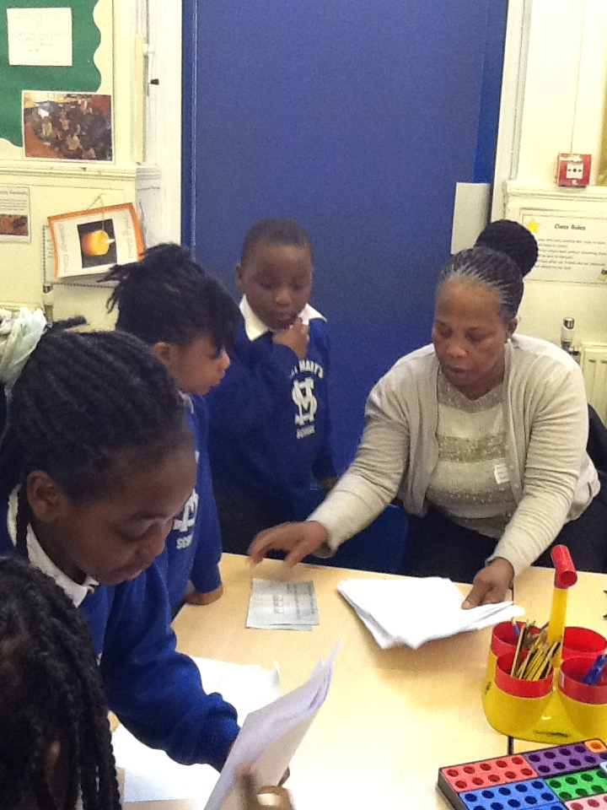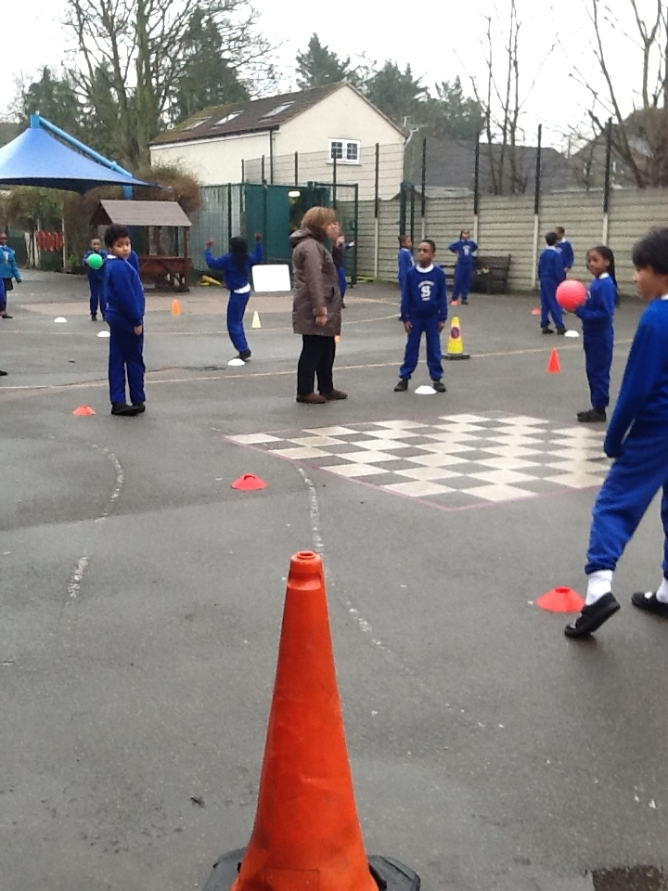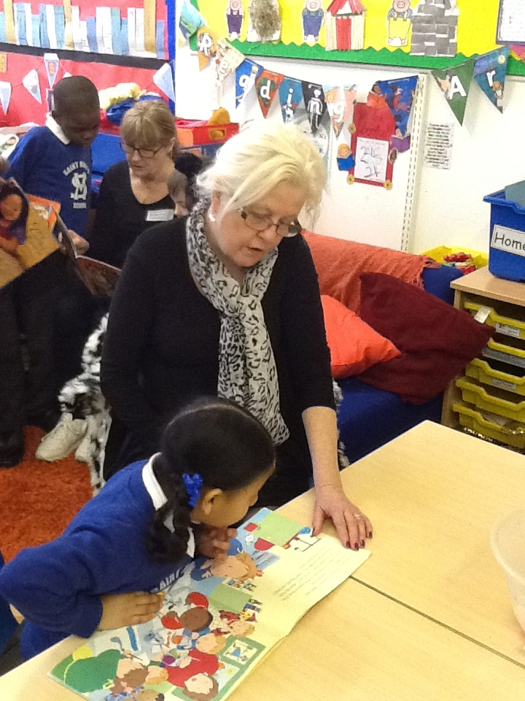

Key Stage Two

Children in each year are encouraged to read each evening and also to practise spellings and multiplication tables. It is very important that all Junior children continue to read to an adult, regularly, as well as to themselves.

Older children have diaries where they list their homework. They are expected to have these signed by parents after completing and showing work at home. Signing the diary or the piece of homework lets teachers know that parents have supervised or checked work. If parents are not happy with the finished standard of homework, they should not avoid signing the diary, but rather write a quick note to the teacher instead.

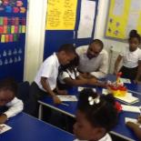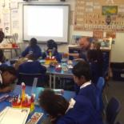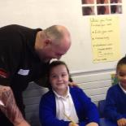

Children should be encouraged to do homework thoroughly. Often written homework has to be completed in school exercise books, and it is definitely a good idea for parents to look through the book to see what has been covered, and occasionally, if possible, to talk with children about the work. It is a good way for parents to see how children are getting on – e.g. can they remember what to do? Have they brought home the necessary materials?

Homework is never intended to be exhausting, tiring, or upsetting, and, on the contrary, many children actually enjoy the tasks set! Tasks reinforce and extend class work, and teachers appreciate support from parents with homework. Some children need a lot of help with their homework whereas others can work happily alone. Please stop children attempting to complete homework if your child has spent enough time, or has become tired or upset. It is important to let the teacher know about this the following day by sending a short note.

Class | Reading | Other work
Year 3  Year 4  Year 5  Year 6 | 20 minutes daily  20 minutes daily  20 minutes daily  20 minutes daily | Maths and Language tasks, including spelling and tables (and RE / topic work occasionally) – 15 minutes per day, set on Friday for Wednesday.  Maths, Language, spellings, tables (and RE / topic work occasionally) set weekly on Friday for Wednesday- about 20 minutes per day.  Maths, Language, spellings, tables (and RE / topic work occasionally) set each evening - about 30 minutes per day.  4 / 5 pieces of work per week – deadlines given and displayed in classroom.

How can I help my child

Here are some ways you can help your child do well at school:

- Make sure you know what homework is set and encourage your child to do it thoroughly.

- Encourage them to follow up interests and talk about them.

- Try to keep up to date with what your child is learning at school by reading the Teacher’s termly letter, talking regularly to your child and attending open evenings.

- Find opportunities for your child to use numbers in everyday situations and encourage mental problem solving.

- Help your child to be ready to learn and not tired when they go to school.

- At home, ensure that your child reads each evening and sign the reading record book

Please see your child’s teacher / ask at the school office for an up to date copy of the Homework Policy.

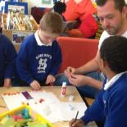

School Uniform
All children are expected to wear the school uniform; this encourages a sense of identity and belonging.

 | Girls | Boys
Winter | Grey Skirt or Pinafore | Grey trousers/shorts
 | St Mary’s Sweatshirt | St Mary’s Sweatshirt
 | White/Grey socks | Grey Socks
 | Grey / Navy tights | White Polo Shirt
 | White Polo Shirt | Black Shoes (No Trainers)
 | Black Shoes (No Trainers)
 | Dark grey tailored trousers
Summer | Dark blue and white check dress | Grey trousers / shorts
 | Royal Blue Cardigan | St. Mary’s Sweatshirt
 | White Socks | Grey Socks
 | Black/White/Navy Sandals | Black/Navy Shoes/Sandals
 | No Open toe Sandals | No Open toe Sandals
 |  | White Polo shirt
PE Kit | Dark Blue Shorts | Dark Blue Shorts
 | White crew neck T-Shirt | White crew neck T-Shirt
 | Black Plimsolls | Black Plimsolls
 | White socks | White socks

Please make sure your child wears sensible shoes – no fashion shoes please, low heels and NO trainers. In Summer time children may wear black or navy blue sandals, but ‘jellies’ or open toes sandals are not part of the school uniform.


Children who wear wellingtons or boots to school should bring a change of footwear.

Jewellery (chains, bracelets, rings) should NOT be worn to school. Children with pierced ears may wear small studs only but not on PE days. Hooped or hanging earrings are not allowed.

Short hair must be in a plain neat style. Lines, logos or designs are not permitted.
Hairstyles should be suitable for school i.e. long hair should be tied back, away from the face.

Hair accessories (hair bands and elastic ties) should be in school colours (blue and white).

Each child should have their own PE kit and a bag in which to keep it. Children change for PE for reasons of hygiene. It would be helpful if you could equip older children with a change of socks.

Reversible School Coat, St. Mary’s School Cap and Winter Hat are available from the school office – these are optional.
All clothing, bags and personal possessions must be clearly marked with your child’s name.



How Parents can help and support their child (see also ‘Homework’)

- Join the Home Reading Scheme – this is a scheme where teachers enable parents to help the children to read at home, and which aims to make reading a very positive and enjoyable experience.

- Read to your child every day if possible. Take your child to the public library and encourage him/her to look at books.

- Talk to your child, discuss arrangements for going out, shopping, travelling etc., and encourage your child to join in any activities which give opportunities for conversation.

- Put your child to bed at a reasonable time so that he/she can get enough sleep, especially if the following day is a school day.

- Make sure your child reaches school on time, and thus has a good start to the day.

- Pray as a family – join in the church services with your child and explain to them what is happening. Read and tell stories from the children’s Bible.

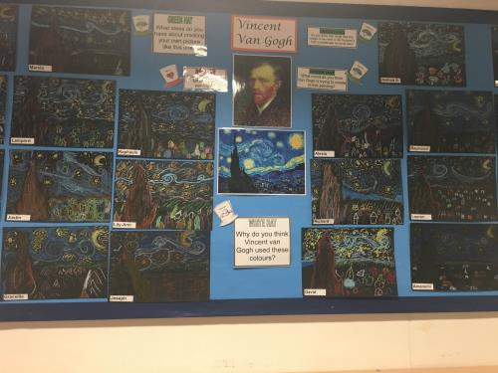

Parental Help in School

If you have time to spare on a regular basis we would welcome your help in school. There are many ways in which you can help us.

You can help with: art and craft activities
helping with our reading scheme
accompanying class outings
cooking
gardening
making costumes
computers
supervising groups
the library
playing board games

If you feel able to help us, in any way, please call at the office or speak to the Headteacher.

With so many talented parents there must be other areas we have not included – but we would like to hear your suggestions.

Please remember that all those who help in school must be D.B.S. checked!

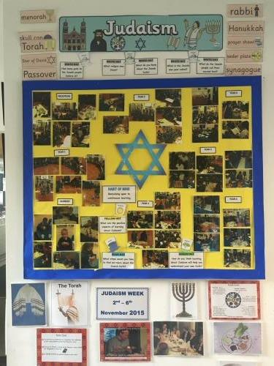

The Support of Parents and Friends of the School

We are fortunate at St Mary’s to have an energetic and very supportive group of parents.

Parents support both fund raising events and social events for the Parents and Children of St Mary’s School.

For many years parents have provided vital assistance in both financial and practical terms. Monies raised and projects undertaken have provided many essential items fundamental to the teaching and education of St Mary’s pupils.

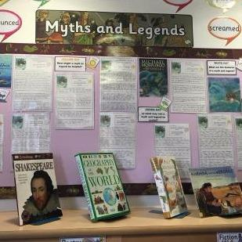

Routine Administration

School Meals

We are fortunate to have our school meals cooked on the premises (the school has a newly refurbished kitchen). Please speak to the office staff for up to date information about school dinner costs and how to pay.

School meals cost £2.50 per day / £12.50 per week (from September 2016).
Please pay weekly in advance on Parentpay.

Your child may be entitled to free meals. To qualify for free school meals parents or guardians must be in receipt of:
- Income support
- Income based job seekers allowance
- Asylum seekers subsistence payment (support under part VI of the Immigration and Asylum Act 1999)
- Child tax credit (but not working tax credit) only and have an annual income of less than £16,190

Please contact Pupil Support, Ground Floor, Civic Centre or 0208 37935367 if you believe your child qualifies for free meals.

It is quite acceptable for children to bring their own packed lunch. These should be healthy and balanced and packed in a suitable box (labelled clearly with the child’s name). We ask that no glass containers be brought to school.

Our lunchtime supervisors (they are assisted by our teaching assistants who work full time in the classrooms with the children) are an important part of our school team and children are expected to be obedient and polite to them at all times.

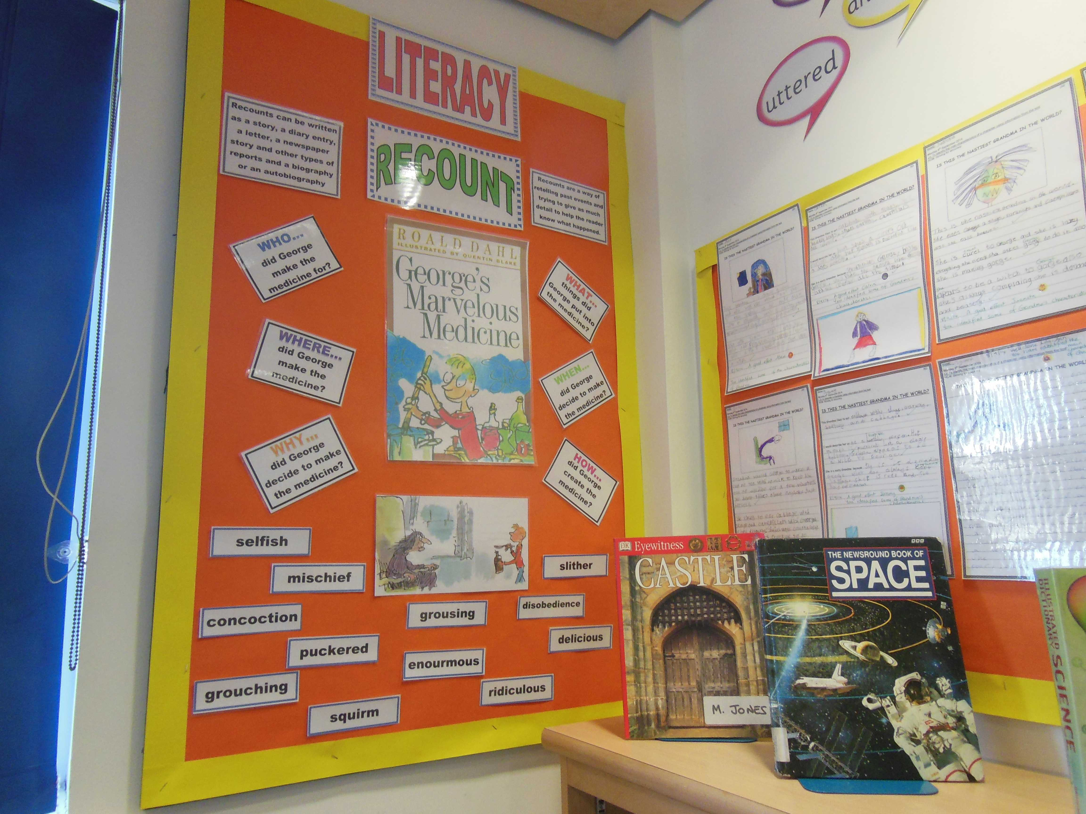

Children’s Property

Children are responsible for looking after their own property at school. Everything must be clearly labelled with your child’s name. Valuables should not be brought to school. Please discourage your child from bringing his/her own toys which may become lost or broken.

Lost Property

Items found are put on a shelf in the main corridor – please ask if you need help to locate the lost property area.

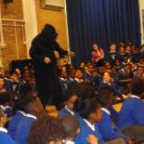

Early Closures

Parents are always reminded of early closures. On the last day of each term the school closes at 1.30pm.

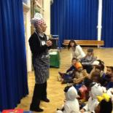
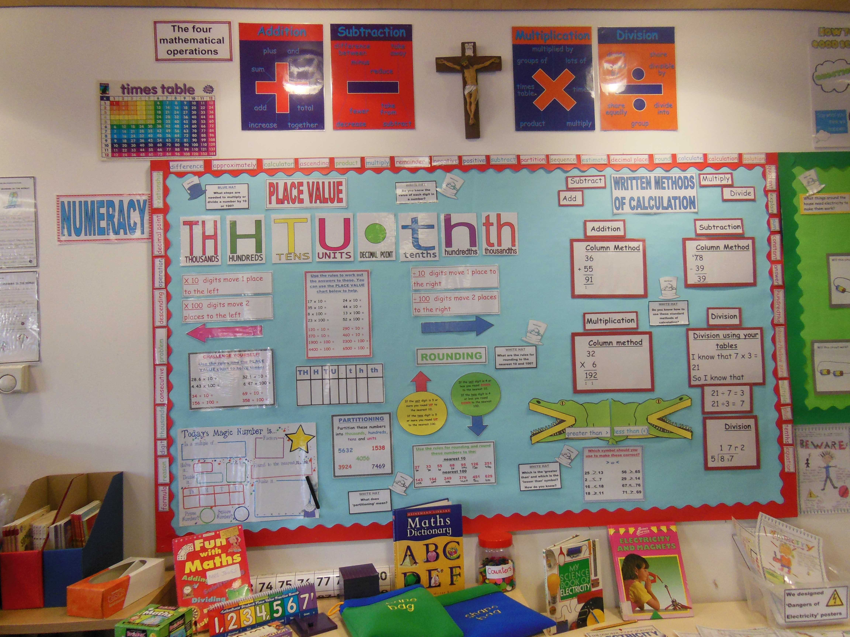
Charging Policy

This Charging Policy informs staff and parents about charging for School activities. It conforms to the requirements of the guidance detailed in ‘The Department for Education’s Governance Handbook’, March 2019 and ‘Charging for School Activities Advice’, May 2018.
In accordance with these guidelines, St Mary’s Catholic School:

- Will not charge for books, materials, equipment and transport provided during school hours by the Local Authority (LA) or by the school to carry pupils between the school and an activity.

- Will not charge for any activities which take place in School time, apart from instrumental tuition for individual pupils or pupils in groups of up to four.

- May charge for School-Time activities by inviting parents and others to make voluntary contributions. Children of parents who do not contribute will not be treated differently from those who do make contributions

- Will have the right to cancel an activity if there are insufficient voluntary contributions to make the activity possible.

- May charge for board and lodgings on residential visits, except for pupils whose parents are in receipt of:

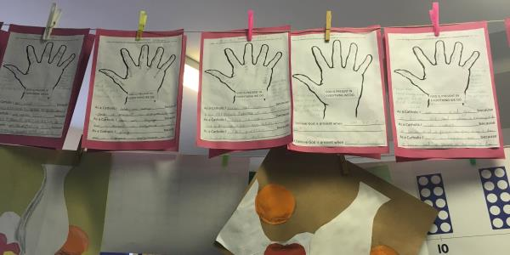

- Income Support (IS);
- Universal Credit in prescribed circumstances;
- Income-Based Jobseekers Allowance (IBJSA);
- Support under the Immigration, Asylum and Nationality Act 2006;
- Child Tax Credit, provided that Working Tax Credit is not also received and the family’s income (as assessed by Her Majesty’s Revenue and Customs) does not exceed £16,190 (Financial Year 2019/20.
  - The guarantee element of State Pension Credit:
- The Headteacher will inform parents of the right to claim free activities if they are receiving these benefits.

- May permit organisations to charge parents when such an organisation is acting independently of the School or the LA, to arrange an activity to take place during school hours and parents want their children to join in the activity.

- May charge for activities (optional extras), which happen outside School hours when these activities are not necessary part of the National Curriculum.

- Parents are asked to make a contribution towards replacing damaged or lost school property caused wilfully or negligently by their children.

- Any debts incurred by the school will be written-off in accordance with the regulations detailed in the LB Enfield Schools’ Finance Manual.

- The Governors will review this policy on an annual basis.
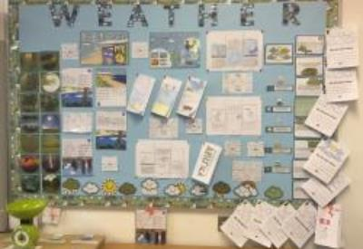

School Fund

Each family is asked to make the following contributions towards the cost of repairs and general maintenance and improvements, which are the Governors’ responsibility. All contributions are voluntary.

1 Child- £2.00 per week, £25.50 per term, £76.00 per year.

2 Children - £2.50 per week , £32.00 per term, £95.00 per year.

3 Children - £3.00 per week, £38.00per term , £114.00per year.

Danger to Children from Cars Parked on the Yellow Zig-Zag Lines

It is with regard to your children’s safety that your attention is drawn to the vital co-operation that is necessary from you to avoid accidents to children entering the school premises.

Parents are reminded that it is an offence to park or wait or stop to let people out of the area on the yellow zig-zag lines and we are grateful to the vast majority of parents who do co-operate. Any cars that stop on the zig-zag obstruct the view of passing drivers and put our children’s lives in danger, we therefore have no alternative but to put this matter in the hands of the police should violations occur.

While we realise that finding a parking place may be difficult, it is better to have to walk a bit than to endanger children’s lives by creating a hazard outside the school.

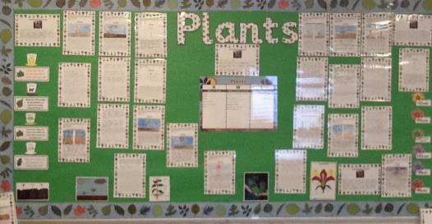

Parent/Teacher Consultation

We believe in a developing partnership between home and school, through regular contact and consultations with parents. Throughout their time at St Mary’s each child’s progress is regularly monitored and reported to parents. Consultation evenings take place in the autumn, spring and summer terms. Parents are invited to select a time to come and view their child’s work and talk with the class teachers and agree targets for their children. If longer consultations are necessary, appointments may be made to extend the consultations.

At the end of the academic year, school reports are sent home, and parents are given the opportunity to discuss them.
The Headteacher welcomes the opportunity to meet parents. It is advisable to telephone or contact the school office to ensure availability. Parental involvement is an important factor which influences a pupil’s progress, and we hope that parents will not hesitate to contact us about any matters of concern.

Regular letters are sent home by pupil post to keep parents informed of all events and developments in the school.

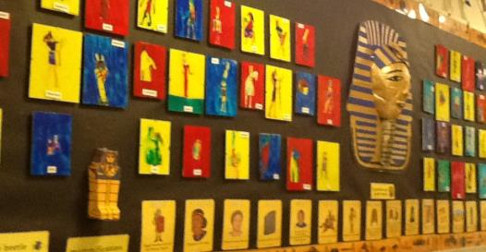

Medical Care

In case of accident or injury, first aid and care is provided by our Welfare Assistant who is a qualified first aider (all of our staff have first aid training). If your child is ill during the day, we will contact you by telephone and request that you come to collect him or her.

Please make sure that the information kept by the office, e.g. home telephone number and parents’ place of employment is correct and up to date.

If you need to take your child from school during the school day you must first sign the withdrawal book at the school office. This is of great importance. Please do the same when returning your child.
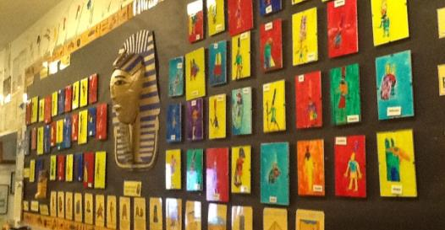

Please note the following:

- If your child has a serious or recurring medical problem you should send details to us so that we are able to note this on the record card.

- If your child has been sick, then they should not return to school for at least 48 hours.

- It is not usually permissible for your child to bring medication to school, except inhalers etc for the treatment of Asthma. If your child needs medication during the day then under certain circumstances the Welfare Assistant may be able to supervise this for you. Please ask in the School Office. Usually, it will be necessary for a parent to come to the school and administer the medicine. As a general rule, your child should be kept at home until they are fully recovered.

- In all cases of absence, an explanation addressed to the class teacher / headteacher is required. This should be in writing, but you may also give a message to a member of our office staff, or speak to your child’s teacher if you wish.

Medical Inspections

Periodically all children are seen by the School Dental and Medical Officers. Parents are informed of the time of the appointments and will be invited to attend.

The School Nurse makes regular visits to the school and is available to give advice. She is also involved in discussing with the children such topics as general health, healthy eating and hygiene.

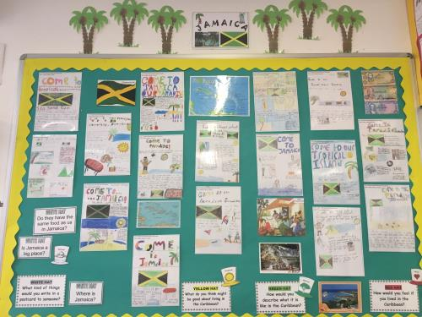

Complaints Policy

We hope that your child will have a very happy and worthwhile time at our school. If at any time you become worried or concerned about any aspect of your child’s life in school you are always welcome to come and talk to us. We will always try to help. The school has a Complaints Policy which you are welcome to read.



