The logo of the Extraordinary Missionary Month October 2019
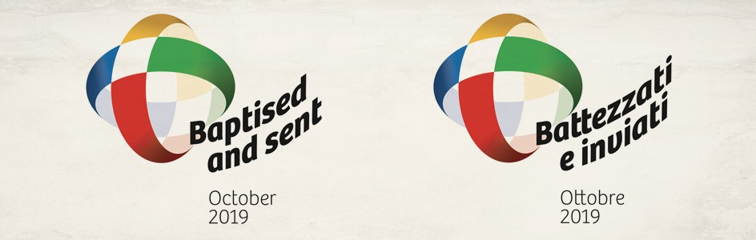

The Logo of the Extraordinary Missionary Month October 2019
The logo of the Extraordinary Missionary Month October 2019 is a missionary cross where the primary colours refer to the five continents. The Cross is the instrument and direct sign of communion between God and man for the universality of our mission, and through its vibrant colours, a sign of victory and resurrection. The world is transparent because the action of evangelization has no barriers or boundaries; it is the fruit of the Holy Spirit. Christian charity and the world transfigured in the Spirit overcome distances and open the horizon of our minds and hearts. The words Baptized and Sent next to the image indicate the two characteristics of every Christian: baptism and proclamation.

The Colours of the Logo of the Extraordinary Missionary Month October 2019
The primary colours of the Cross are referred to the five continents: red for America, green for Africa, white for Europe, yellow for Asia and blue for Oceania. The red recalls the blood of the American martyrs, seeds for a new life in the Christian faith. Green is the colour of life and symbolizes growth, fruitfulness, youth and vitality. It is also the colour of hope, one of the three theological virtues. White is the symbol of joy, the beginning of a new life in Christ: this is the challenge that the old Europe is facing, so that it may be able to regain the evangelizing strength from which it was generated thanks to so many churches and saints. Yellow is the colour of light, which nourishes itself with light by invoking the true Light. Blue is the colour symbolizing the water of life that quenches our thirst and restores us along the path to God. It is the colour of heaven, a sign of God's dwelling with us.

