Verbum Domini
Verbum Domini, or 'The Word of the Lord', is a 2010 post-synodal apostolic exhortation issued by Benedict XVI which deals with how the Church should promote the Bible.

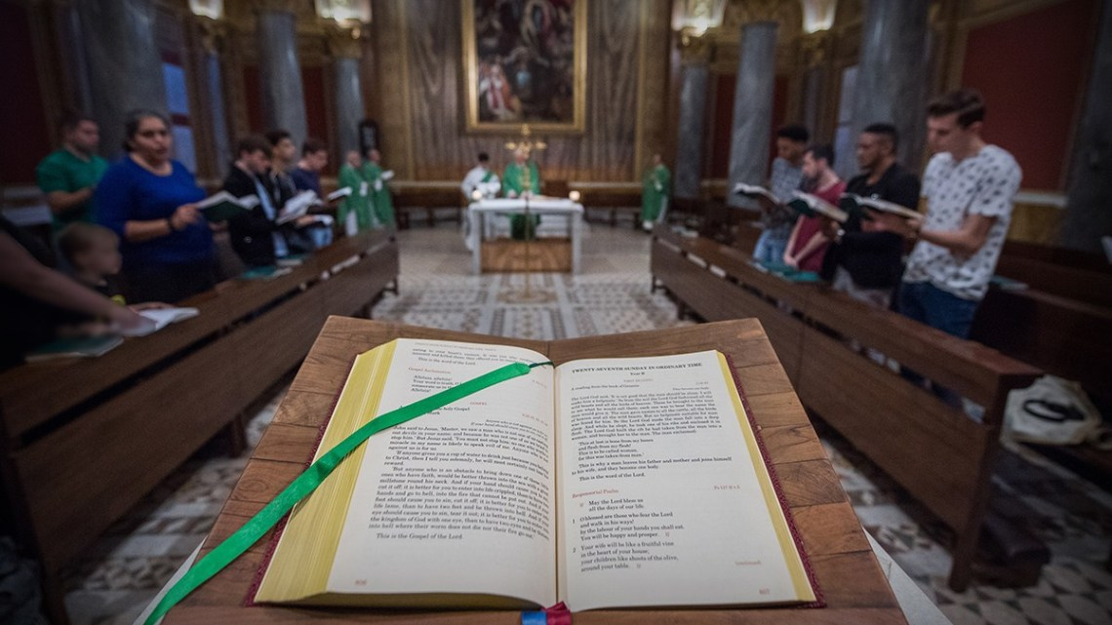
In 2008, the twelfth Synod of Bishops met to reflect on ‘The Word of God in the Life and Mission of the Church’. Following this time of discussion and theological sharing, Pope Benedict XVI summarised the Synod’s observations in his 2010 exhortation, ‘Verbum Domini’.
The document is divided into three main sections, examining the theological understanding of how God speaks (section 1), the celebration of God’s word in the liturgy, prayer and life of the Church (section 2), and the Christian responsibility to share the word of God with others (section 3).
“I wish once more to encourage all the People of God, pastors, consecrated persons and the laity, to become increasingly familiar with the sacred Scriptures. We must never forget that all authentic and living Christian spirituality is based on the word of God proclaimed, accepted, celebrated and meditated upon in the Church. This deepening relationship with the divine word will take place with even greater enthusiasm if we are conscious that, in Scripture and the Church’s living Tradition, we stand before God’s definitive word on the cosmos and on history.”
Pope Benedict, Verbum Domini, §121

Read Verbum Domini

