Science - Plants
This unit introduces children to how different plants and their parts through a number of investigations. The children will name and identify parts of flowers, plants and trees and will compare common trees. Plant seeds, monitor and investigate their growth and what affects growth. Bring plants into classroom for children to look after. Children will explore what plants need and where some plants grow. They will also revisit Animals including Humans looking specifically at sea creatures their diets and link to previous Geography topic.

Numeracy
Place value using skills partitioning into tens and ones for numbers up to 100. Recognising coins and notes and starting to unitise in order to add different values. Telling the time to half past, using before and after, days and months, seconds, minutes and hours.
Role play
Pirate ship with compass points, maps and pictures of different continents and oceans.

ICT:
Using Purple Mash to record the results of an investigation as a pictogram. (Link with numeracy).
To create an animated storybook – can link with Literacy, Geography and Science.
Internet awareness –
e-safety, learning that not everything on the internet is true.

Commotion in the Ocean
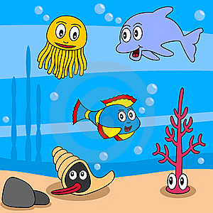
Art/DT collages, painting.
Children to make Fruit smoothies for their DT projects. Also, sea creatures (some moving) using paper and recyclables, linked to Literacy and Science. Children create collages from fruit and vegetables.

1b, 2c, 3a, 3b, 4a, 5c

Wisdom class Rosary Class
Summer Term 2
History
Queen Elizabeth II.
The children will learn about her life, her family, her roles and responsibilities.
They will find out about important events in her life and why she is a significant person in history.
Music - Children to learn more songs from the Sing Up scheme, using their voices, instruments and bodies to express the music and rhythm.

R.E.
Children will learn about how Muslim people worship God for our Islam topic. The Kingdom of God; We will be looking at the parables, their meanings and what they teach us today.
– Summer 2 2023 Ms Keevil, Ms Beckles, Mrs Aylott, Mrs Whytock
Literacy
The Snail and the Whale –poetry on travelling in the water. Creating own animated storybook linked to oceans – ICT link. Researching and writing information texts on sea creatures using Ipads. This topic is linked to Science and Geography.

PE
Athletics: The children will be practising their running, jumping, throwing and relay.

PSHE: Created to live with community. The children will learn about their relationship with the wider world.

