ENGLISH | MATHS | SCIENCE | RE
In Literacy we will be looking at fantasy stories, poems, dictionaries, glossaries and explanation texts. We will be revising and reinforcing rhyming patterns and initial and final letter sounds. Children will be creating their own fact books about plants, animals and sea creatures.  The phonics screening check will be held in June.  Reading –Children will read one to one with and adult and also part of a Monster Phonics reading group weekly.  Grammar, Punctuation – on going revision and consolidation of capital letters, full stops, simple sentence construction  Weekly spellings – to develop children’s store of vocabulary. Each week follows a different spelling pattern.  Handwriting – exercises to practise and improve letter formation, presentation. We will focus on writing words which we have been studying for our spelling focus. | Maths: – see medium term planning  This term we will be following the White Rose scheme of work for the Autumn term:  • Multiplication and Division  • Fractions  • Position and Direction  • Place Value (within 100)  • Money  • Time  Mental maths – additional weekly tests to develop children’s mental ability for rapid recall and problem solving. | Plants  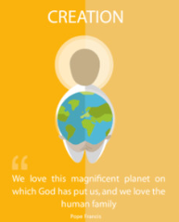  This term we will be learning about ‘Plants.’ The children will start to identify and learn the function of different parts of a plant, including trees. In class we will plant our own seeds, monitor and investigate what plants need to grow. Working Scientifically:  - Observing closely, using simple equipment  - Performing simple tests  - Identifying and classifying  - Using their observations and ideas to suggest answers to questions  - Gathering and recording data to help in answering questions. | To the Ends of the Earth  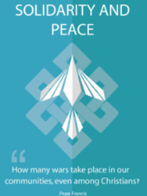  In this branch, pupils will hear the story of the Road to Emmaus, the Ascension, and the story of Pentecost. They will complete an age-appropriate narrative cycle of the life, death, and Resurrection of Jesus Christ and encounter the inspiration of the Holy Spirit in the lives of the Apostles and then the early Church.  Dialogue and Encounter  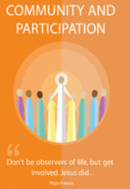  We will begin by exploring the Catholic Church and what being a Christian means to us and how we live our lives. Then, we will explore the similarities and differences between ours and others’ religions, focusing on the Jewish faith.
HUMANITIES | ICT | D&T /ART | PE
Geography  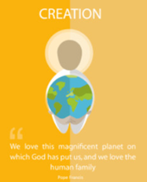  At the start of the term we will be learning Geography about how we make and use maps to look at the world and our local areas. Please look at maps with your child and encourage them to find the seven continents and five oceans.  History  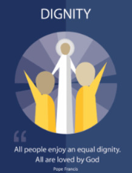  After Half-term we will explore the life of Queen Elizabeth II, the main events and duties of her long reign and what made her a significant person in History.  (Links with Literacy, Art and D&T) | ICT:  The children will be using Purple Mash to record the results of an investigation as a pictogram and to create an animated storybook. They will continue their Internet awareness training on how to use the internet safely and know that not everything on the internet is true. They will find out about the variety of devices that use the internet, learn how to login safely and use passwords to keep their creative work safe. | D&T  Cooking and Nutrition: Smoothies  This unit gives the children opportunities to develop food preparation skills with an increased focus on taste testing and ingredient choices.  Pupils who are secure will be able to:  - Describe fruits and vegetables and explain how to identify fruits.  - Name a range of places that fruits and vegetables grow.  - Describe basic characteristics of fruit and vegetables.  - Prepare fruits and vegetables to make a smoothie. | PE:  2 x 45 minute sessions, taught by a specialist coach from Non-Stop Action.
MUSIC: Sing Up!
The children will continue to learn more songs through the wonderful Sing Up scheme. This half term they will be focusing on pitched and unpitched rhythmic sounds, learning to find the beat, counting syllables and adding gesture to create a musical movement picture. The children will begin to compose musical sound effects, use percussive instruments in response to sounds and start to recognise notation. The three topics are called Football, Dawn from Sea Interludes and Musical Conversations.

PSHE- Following TenTen Life to the Full
Module 3: Created to Live in Community
Created to Live in Community explores the individual’s relationship with the wider world. Here we explore how human beings are relational by nature and are called to love others in the wider community through service, through dialogue and through working for the Common Good

