ENGLISH | MATHS | SCIENCE | RE
see medium term planning  Reading –Children will read one to one with and adult and also part of a guided reading group weekly. They will read a range of books and have a particular focus during each guided reading session.  Big Writing – develop beginnings to stories, middles and endings. Improve the use of expanded nouns. To develop writing different styles e.g. diary entries, recounts, poetry, non-chronological reports  Grammar, Punctuation – on going revision and consolidation of capital letters, full stops, commas, question marks, exclamation marks etc.  Weekly spellings – to develop children’s store of vocabulary. Each week follows a different spelling pattern. Common exception words to be tested also.  Handwriting – exercises to practise and improve letter formation, presentation. We will focus on writing words which we have been studying for our spelling focus.  SATs  Reading comprehension 1 and 2  SPAG | Maths: – see medium term planning  Mental maths – additional weekly tests to develop children’s mental ability for rapid recall and problem solving. Include investigative work at least every 2 weeks.  Tables Test- 2, 5 and 10 times tables will be tested weekly. Those who are secure to move onto the 3 an 4.  SATs  Maths reasoning and arithmetic | Our topic this term is ‘Living Things and Habitats’  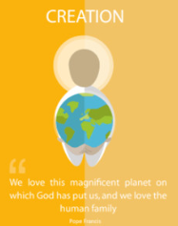  Living Things and Habitats  Children will learn to discuss the features of those things living, dead and have never been alive.  They will find, classify and label specimens into categories.  Children will learn that different habitats provide for the basic needs of different kinds of animals and plants.  Working Scientifically:  - Ask relevant questions; use different types of scientific enquiries to answer them.  - Set up simple practical enquiries, comparative and fair tests.  - Identify differences, similarities or changes related to simple scientific ideas and processes.  - Make systematic and careful observations and, where appropriate, take accurate measurements using standard units; use a range of equipment, including thermometers and data loggers.  - Record findings use simple scientific language, drawings, labelled diagrams, keys, bar charts and tables.  - Report on findings from enquiries, including oral and written explanations, displays or presentation of results and conclusions.  Science Ninja:  The children will have the opportunity to gain a science ninja sticker. These focus on the key skills:  - Recording  - Observing  - Measuring  - Equipment | This term in R.E. we will be covering branch 5: To the Ends of the Earth and Branch 6: Dialogue and Encounter  Branh 5: To the Ends of the Earth.    As pupils revisit the accounts of Ascension and Pentecost, the focus of learning is on how people are changed by the Holy Spirit. Pupils will explore how people are changed by the Holy Spirit, through the examples of the apostles, St Paul, and other saints.  Branch 6: Dialogue and Encounter  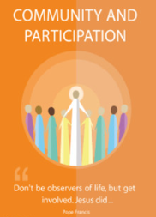  In the dialogue dimension of this branch, pupils will look at how Christians work together to support their local community, for example, food bank initiatives or care for refugees. To develop an understanding of this in a concrete way, pupils will explore a Christian charity that works across national boundaries.  In the encounter part of this branch, pupils will learn more about Judaism as part of the religious education curriculum.
HUMANITIES | ICT | D&T /ART | PE
History:  In History we will be learning about the First Flight.  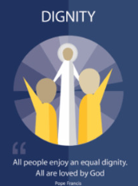  In this topic we will:  - Learn about the first powered flight  - Identify today’s major air routes  - Compare and contrast modes of transport  - Understand how aeroplanes bring the world closer together  Geography:  In Geography we will be learning about Australia.  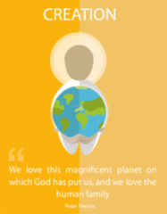  In this topic we will:  - Compare and contrast the location of Australia and United Kingdom  - Learn about the physical features of Australia  - To compare and contrast the human features of Australia and the UK  - Locate aboriginal settlements and the cities of Australia  - Understand the features of Uluru rock and the importance to Aboriginal people  - Compare and contrast the everyday life of urban and rural life in Australia | ICT:  In ICT this term the children will learning about ‘Coding’. The children will be using espresso to input algorithms. | Art:  In Art we will be learning different art skills. The children will be sketching, painting, using pastels and drawing from observation. Our topic this half term is ‘Portraits’.  D&T:  (Linked to Science topic- Animals incl Humans)  Key Skills:  - Designing a healthy wrap based on a food combination which works well together.  - Slicing food safely using the bridge or claw grip.  - Constructing a wrap that meets a design brief.  - Describing the taste, texture and smell of fruit and vegetables.  - Taste testing food combinations and final products.  - Describing the information that should be included on a label.  - Evaluating which grip was most effective | PE:  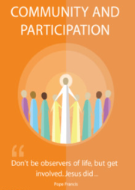  2 x 45-minute lesson taught by PE instructors from Non-Stop Action
MUSIC: Following Sing Up scheme of work.
UNIT NAMES:
Swing-a-long with Shostakovich
Charlie Chaplin
Tańczymy labada
Focus: 2- and 3-time, beat. 20th century classical music, create music to accompany a short film featuring Charlie Chaplin, pitch (high and low), duration (long and short), dynamics (loud and soft), traditional Polish dances, body percussion patterns

PSHE/RSE: Following TenTen Life to the Full.
Module 3: Created to Live in Community
Created to Live in Community explores the individual’s relationship with the wider world. Here we explore how human beings are relational by nature and are called to love others in the wider community through service, through dialogue and through working for the Common Good

