Year 2
Spring Term 2026

Geography
Literacy

- The children will be learning about different climates of the world and the living things that can live in different climates.
- The children will be reading about Paddington Bear. (Spring 2)

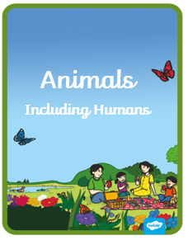
- The children will be learning how to build a stable structure that a stuffed animal can sit on
- What animals, including humans, need to survive.
- Identify the offspring of different animals.
- Identify and explain the life cycle of different animals, including humans.
- Describe the importance for humans of exercise, eating the right amounts of different types of food, and hygiene.
- The children will learn how to use the internet safely to research animal information, including their habitats
- We will study the artist George Seurat and his style of pointillism. They will create an image based on this . They will discuss what living things they might see in his landscape images.
D&T
ICT
Art
Science

